

**1.1 Problems Addressing** **10**

**1.2 Components in Solution** **11**

**1.3 Benefits of Solution** **11**

**1.4 Process Taken** **11**

**2.1 Project Scope** **12**

**2.2 Subsystem/Modules in Solution** **12**

2.2.1 Human Resource Management Subsystem 12

2.2.2 Project Management Subsystem 13

2.2.3 Account and Finance Management Subsystem 13

2.2.4 Logistics Management Subsystem 13

**2.3 List of stakeholders** **13**

**2.4 Team** **13**

**3.1 System/Modules in solution** **14**

3.1.1 List of subsystem/modules in solution 14

3.1.2 Visual Table of Contents (VTOC) of Subsystems/Modules in Solution 15

**3.2 List of Use Cases for Each Subsystem** **16**

3.2.1 Human Resource Management Use Cases 16

3.2.2 Project Management Use Cases 17

3.2.3 Account and Finance Management Use Cases 17

3.2.4 Logistics Management Use Cases 18

3.2.5 Access Management Use Cases 19

**3.3 Class Diagram of All Entities** **20**

**4.1 Human Resource Management Subsystem** **20**

4.1.1 Description 20

4.1.2 Business Objectives 21

4.1.3 Business Assumptions 21

4.1.4 Business Processes (Usage scenarios) 22

4.1.4.1 Employee Management Module 22

4.1.4.1.1 Retrieve work schedule 22

4.1.4.1.2 Submit availability slots 23

4.1.4.1.3 Generate payslip preview 24

4.1.4.1.4 Make resignation request 25

4.1.4.1.5 Generate worked hours report 26

4.1.4.1.6 Create account for new employee 28

4.1.4.1.7 Delete existing employee account 29

4.1.4.1.8 Update existing employee account 29

4.1.4.1.9 Approve resignation requests 31

4.1.4.1.10 Reject resignation requests 32

4.1.4.1.11 Generate workload report 33

4.1.4.1.12 Generate staff performance report 34

4.1.4.2 MC / Leave Management Module 35

4.1.4.2.1 Request for leave 35

4.1.4.2.2 Check status of leave request(s) 36

4.1.4.2.3 Submit insurance claim request 37

4.1.4.2.4 Approve leave request 38

4.1.4.2.5 Reject leave request 39

4.1.4.2.6 Generate report of leave records 40

4.1.4.2.7 Generate report of medical claims 41

4.1.4.3 Attendance Management Module 42

4.1.4.3.1 Validate work hours of employees 42

4.1.4.3.2 Generate report of late-coming 43

4.1.4.3.3 Generate report of overtime 44

4.1.4.3.4 Collate work hours for each employee 45

**4.2 Project Management Subsystem** **45**

4.2.1 Description 45

4.2.2 Business Objectives 46

4.2.3 Business Assumptions 46

4.2.4 Business Processes (Usage scenarios) 46

4.2.4.1 General Project Management Module 46

4.2.4.1.1 Create Project Plan 46

4.2.4.1.2 View Overall Project Progress 47

4.2.4.1.3 View Team Members’ Profile 47

4.2.4.1.4 View Cost Records 47

4.2.4.1.5 View Assigned Project Tasks 47

4.2.4.1.6 Update Status of Task 48

4.2.4.2 Tender Management Module 48

4.2.4.2.1 Create new “Invitation to Tender” (ITT) 48

4.2.4.2.2 View Invitation to Tender (ITT) Record 48

4.2.4.2.3 Remove Invitation to Tender (ITT) 48

4.2.4.2.4 Update Status of Tenders 49

4.2.4.2.5 Add Contractor Contact 49

4.2.4.2.6 View Contractor Information 49

4.2.4.2.7 Submit Tender 49

4.2.4.3 Resource Management Module 50

4.2.4.3.1 View Inventory Records 50

4.2.4.3.2 Create Inventory Request 50

4.2.4.3.3 View Overall Members’ Availability 51

4.2.4.3.4 Create Tasks 51

**4.3 Logistics Management Subsystem** **51**

4.3.1 Description 51

4.3.2 Business Objectives 52

4.3.3 Business Assumptions 52

4.3.4 Business Processes (Usage scenarios) 53

4.3.4.1 Supplier Management Module 53

4.3.4.1.1 Generate Report of Inventory Managed by Supplier 53

4.3.4.1.2 Add Supplier 53

4.3.4.1.3 Edit Supplier 54

4.3.4.1.4 Add Supplier Inventory 54

4.3.4.1.5 Remove Supplier 55

4.3.4.1.6 Remove Supplier Inventory 55

4.3.4.1.7 Generate Supplier Order Fufilment Rate 55

4.3.4.2 Inventory Management Module 56

4.3.4.2.1 Generate Inventory Stock Count 56

4.3.4.2.2 Generate Inventory Locations 56

4.3.4.2.3 Update Inventory Stock Count 57

4.3.4.2.4 Process Inventory Request for a Project 58

4.3.4.3 Procurement Management Module 59

4.3.4.3.1 Create Procurement Record for Materials 59

4.3.4.3.2 Request Stock Transfer from Supplier to Warehouse 60

4.3.4.3.3 Manage Procurement Status 61

**4.4 Account and Finance Management Subsystem** **61**

4.4.1 Description 61

4.4.2 Business Objectives 62

4.4.3 Business Assumptions 63

4.4.4 Business Processes (Usage scenarios) 63

4.4.4.1 Payables Module 63

4.4.4.1.1 Create purchase order 63

4.4.4.1.2 Record receival of goods 64

4.4.4.1.3 Make payment for invoices 65

4.4.4.1.4 Delete purchase order 66

4.4.4.1.5 View all invoices 66

4.4.4.1.6 View invoices by vendor name 66

4.4.4.2 Receivables Module 67

4.4.4.2.1 Create receivable 67

4.4.4.2.2 Process receival of services 67

4.4.4.2.3 Delete receivable 68

4.4.4.2.4 View all vendor receivables 68

4.4.4.3 Employee Payroll Module 68

4.4.4.3.1 Create salary payment 69

4.4.4.3.2 Make salary payment to employees 70

4.4.4.3.3 Process CPF contributions 70

4.4.4.3.4 View all employees’ salary page 71

4.4.4.3.5 View employee’s salary page by name 71

4.4.4.4 Report Module 71

4.4.4.4.1 View all reports 71

4.4.4.4.2 View report 71

4.4.4.4.3 Generate financial report 72

4.4.4.4.4 Edit financial report 72

**4.5 Access Management Subsystem** **73**

4.5.1 Description 73

4.5.4 Business Processes 74

4.5.4.1 Common Access Management Module 74

4.5.4.1.1 Login 74

4.5.4.1.2 Logout 74

4.5.4.1.3 Forgot password 75

4.5.4.1.4 View profile 76

4.5.4.1.5 Edit profile 77

4.5.4.2 Attendance Checking Module 78

4.5.4.2.1 Register for start of work 78

4.5.4.2.2 Register for end of work 79

4.5.4.2.3 Register for start of break 79

4.5.4.2.4 Register for end of break 79

**5.1 Human Resource Management Subsystem** **81**

5.1.1 Use Case Diagram 81

5.1.2 Use Case Description 83

5.1.2.1 Employee Management Module 83

5.1.2.1.1 Retrieve work schedule 83

5.1.2.1.2 Submit availability slots 84

5.1.2.1.3 Generate payslip preview 85

5.1.2.1.4 Make resignation request 86

5.1.2.1.5 Generate worked hours report 87

5.1.2.1.6 Create account for new employee 88

5.1.2.1.7 Delete existing employee account 90

5.1.2.1.8 Update existing employee account 91

5.1.2.1.9 Approve resignation request 93

5.1.2.1.10 Reject resignation request 94

5.1.2.1.11 Generate workload report 96

5.1.4.1.12 Generate staff performance report 97

5.1.2.2 MC / Leave Management Module 98

5.1.2.2.1 Request for leave 98

5.1.2.2.2 Check status of leave request(s) 99

5.1.2.2.3 Submit insurance claim request 100

5.1.2.2.4 Approve leave request 102

5.1.2.2.5 Reject leave request 103

5.1.2.2.6 Generate report of leave records 105

5.1.2.2.7 Generate report of medical claims 106

5.1.2.3 Attendance Management Module 108

5.1.2.3.5 Validate work hours of employees 108

5.1.2.3.6 Generate report of late-coming 109

5.1.2.3.7 Generate report of overtime 111

5.1.2.3.8 Collate work hours for each employee 112

5.1.3 Simplified Class Diagram for Employee Management Module 114

5.1.3.1 Simplified Entity Class Diagram 114

5.1.3.2 Simplified Non-Entity Class Diagram 114

5.1.4 Simplified Class Diagram for MC / Leave Management Module 115

5.1.4.1 Simplified Entity Class Diagram 115

5.1.4.2 Simplified Non-Entity Class Diagram 116

5.1.5 Simplified Class Diagram for Attendance Management Module 117

5.1.5.1 Simplified Entity Class Diagram 117

5.1.5.2 Simplified Non-Entity Class Diagram 117

**5.2 Project Management Subsystem** **117**

5.2.1 Use Case Diagram 118

5.2.2 Use Case Description 118

5.2.2.1 General Project Management Module 118

5.2.2.1.1 Create Project Plan 118

5.2.2.1.2 View Overall Project Progress 119

5.2.2.1.3 View Team Members’ Profile 120

5.2.2.1.4 View Cost Records 121

5.2.2.1.5 View Assigned Project Tasks 122

5.2.2.1.6 Update Status of Tasks 123

5.2.2.2 Tender Management Module 124

5.2.2.2.1 Create new “Invitation to Tender” (ITT) 124

5.2.2.2.2 View Invitation to Tender (ITT) Record 126

5.2.2.2.3 Remove Invitation to Tender (ITT) 127

5.2.2.2.4 Update Status of Tenders 128

5.2.2.2.5 Add Contractor Contact 130

5.2.2.2.6 View Contractor Information 131

5.2.2.2.7 Submit Tender 134

5.2.2.3 Resource Management Module 135

5.2.2.3.1 View Inventory Records 135

5.2.2.3.2 Create Inventory Request 136

5.2.2.3.3 View Overall Members’ Availability 137

5.2.2.3.4 Create Tasks 138

5.2.3 Simplified Class Diagram for General Project Management Module 139

5.2.3.1 Simplified Entity Class Diagram 139

5.2.3.2 Simplified Non-Entity Class Diagram 140

5.2.4 Simplified Class Diagram for Tender Management Module 140

5.2.4.1 Simplified Entity Class Diagram 140

5.2.4.2 Simplified Non-Entity Class Diagram 141

5.2.5 Simplified Class Diagram for Resource Management Module 142

5.2.4.1 Simplified Entity Class Diagram 142

5.2.4.2 Simplified Non-Entity Class Diagram 143

**5.3 Logistics Management Subsystem** **143**

5.3.1 Use Case Diagram 144

5.3.2 Use Case Description 145

5.3.2.1 Supplier Management Module 145

5.3.2.1.1 Generate Report of Inventory Managed by Supplier 145

5.3.2.1.2 Add Supplier 146

5.3.2.1.3 Edit Supplier 146

5.3.2.1.4 Add Supplier Inventory 147

5.3.2.1.5 Remove Supplier 149

5.3.2.1.6 Remove Supplier Inventory 150

5.3.2.1.7 Generate Supplier Order Fufilment Rate 151

5.3.2.2 Inventory Management Module 152

5.3.2.2.1 Generate Inventory Stock Count 152

5.3.2.2.2 Generate Inventory Locations 153

5.3.2.2.3 Update Inventory Stock Count 154

5.3.2.2.4 Process Inventory Request for a Project 155

5.3.2.3 Procurement Management Module 157

5.3.2.3.1 Create Procurement Record for Materials 157

5.3.2.3.2 Request Stock Transfer From Supplier to Warehouse 158

5.3.2.3.3 Manage Procurement Status 159

5.3.3 Simplified Class Diagram for Supplier Management Module 161

5.3.3.1 Simplified Entity Class Diagram 161

5.3.3.2 Simplified Non-Entity Class Diagram 162

5.3.4 Simplified Class Diagram for Inventory Management Module 163

5.3.4.1 Simplified Entity Class Diagram 163

5.3.4.2 Simplified Non-Entity Class Diagram 163

5.3.5 Simplified Class Diagram for Procurement Management Module 165

5.3.5.1 Simplified Entity Class Diagram 165

5.3.5.2 Simplified Non-Entity Class Diagram 166

**5.4 Account and Finance Management Subsystem** **167**

5.4.1 Use Case Diagram 167

5.4.2 Use Case Description 169

5.4.2.1 Payables Module 169

5.4.2.1.1 Create purchase order 169

5.4.2.1.2 Record receival of goods 170

5.4.2.1.3 Make payment for invoices 172

5.4.2.1.4 Delete purchase order 174

5.4.2.1.5 View all invoices 175

5.4.2.1.6 View invoices by vendor name 176

5.4.2.2 Receivables Module 177

5.4.2.2.1 Create receivable 177

5.4.2.2.2 Process receival of services 179

5.4.2.2.3 Delete receivable 180

5.4.2.2.4 View all vendor receivables 181

5.4.2.3 Employee payroll Module 182

5.4.2.3.1 Create salary payment 182

5.4.2.3.2 Make salary payment to employees 183

5.4.2.3.3 Process CPF contributions 185

5.4.2.3.4 View all employees’ salary page 186

5.4.2.3.5 View employee’s salary page by name 187

5.4.2.4 Reporting Module 188

5.4.2.4.1 View all reports 188

5.4.2.4.2 View report 189

5.4.2.4.3 Generate financial report 190

5.4.2.4.4 Edit financial report 191

5.4.3 Simplified Class Diagram for Payables Module 193

5.4.3.1 Simplified Entity Class Diagram 193

5.4.4 Simplified Class Diagram for Receivables Module 193

5.4.4.1 Simplified Entity Class Diagram 193

5.4.4.2 Simplified Non-Entity Class Diagram 193

5.4.4 Simplified Class Diagram for Employee Payroll Module 193

5.4.4.1 Simplified Entity Class Diagram 193

5.4.4.2 Simplified Non-Entity Class Diagram 193

5.4.5 Simplified Class Diagram for Report Module 193

5.4.5.1 Simplified Entity Class Diagram 193

5.4.5.2 Simplified Non-Entity Class Diagram 193

**5.5 Access Management Subsystem** **194**

5.5.1 Use Case Diagram 194

5.5.2 Use Case Description 195

5.5.2.1 Common Access Management Module 195

5.5.2.1.1 Login 195

5.5.2.1.2 Logout 196

5.5.2.1.3 Forgot password 196

5.5.2.1.4 View profile 198

5.5.2.1.5 Edit profile 198

5.5.2.2 Attendance Checking Module 199

5.5.2.2.1 Register for start of work 199

5.5.2.2.2 Register for end of work 200

5.5.2.2.3 Register for start of break 201

5.5.2.2.4 Register for end of break 203

5.5.3 Simplified Class Diagram for Common Access Management Module 204

5.5.3.1 Simplified Entity Class Diagram 204

5.5.3.2 Simplified Non-Entity Class Diagram 204

5.5.4 Simplified Class Diagram for Attendance Checking Management Module 205

5.5.4.1 Simplified Entity Class Diagram 205

5.5.4.2 Simplified Non-Entity Class Diagram 205

**5.6 6 Most Complex Sequence Diagrams** **206**

5.6.6.1 Create ITT 206

5.6.6.2 Process Inventory Request 207

5.6.6.3 Request Stock Transfer From Supplier 208

5.6.6.4 Validate hours of employees 209

5.6.6.5 Make payment for invoices 210

5.6.6.6 Approve Resignation Request 211

**1. Executive Summary**

Paper Free is a new software company that aims to provide innovative IT solutions for construction companies. Currently, construction companies are still utilising traditional approaches such as hardcopy paper and excel sheets to track and manage their day-to-day operations. Such methods are identified to be inefficient and unorganised. Furthermore, they increase operational costs due to the extra administrative work, which also results in a higher margin of error. The objective of Paper Free is to change that through digitalisation.

As an initiative, our team at Paper Free has built a construction management system, in order to streamline and automate business processes. This will allow companies to better track and optimise resources, as well as centralize processes as much as possible for construction companies out there.

# **1.1 Problems Addressing**

The system addresses the 4 key areas: Human Resource Management, Project Management, Accounting & Finance Management and Logistics Management.

|  |  |
| --- | --- |
| Key areas | Focus |
| Human Resource Management | * Employee Management * MC/Leave Management * Attendance Management |
| Project Management | * General Project Management * Tender Management * Resource Management |
| Accounting & Finance Management | * Payables * Receivables * Employee Payroll * Reporting |
| Logistics Management | * Supplier/Contractor Relationship Management * Inventory Management * Procurement Management |

# **1.2 Components in Solution**

The solution contains 4 componential subsystems, namely the Human Resource Management Subsystem, Project Management Subsystem, Accounting and Finance Subsystem and the Logistics Management Subsystem. The rationale behind this is to break down processes required for construction management. Each subsystem performs their unique functionalities for various stakeholders to ensure an intuitive and effective work flow. This creates a superior system compared to traditional methods employed by construction companies previously.

# **1.3 Benefits of Solution**

The solution aims to provide an improved approach to the optimisation of business processes within construction companies. The system provides a one-stop platform, which integrates all aspects of functionalities construction companies will need. Storage of important information as well as the tracking and allocation of resources will be accounted for by the system, and simplified.

Using the system ensures that the company’s automation needs are met, reduces manual labour where human mistakes are rife while guaranteeing better efficiency with a streamlined workflow tailored for construction-based businesses. With better workflow, productivity of employees increases which contributes significantly to the overall quality and rate of product delivery at the end of the day. Reducing administrative work and human errors also increases cost savings for companies, ultimately allowing profit margins to grow as well.

# **1.4 Process Taken**

Extensive research and interviews have been done on relevant stakeholders which includes the Construction Team Leaders, Construction Team Members, Human Resource Staff, Accounting Staff, Procurement Staff and Inventory Staff before crafting our solution plan.

We have decided to organise our Construction Management System into various modules and subsystems after much deliberation and thorough analysis. This is to best cater to the various needs within the organisation. The system requirements are presented through the use of an overarching use case diagram as well as their descriptions. Class diagrams and sequence diagrams based on those use cases are then formulated to visualise our system architecture and flow of processes.

**2. Introduction**

# **2.1 Project Scope**

The scope of this project is to build a Construction Management System that addresses the needs and improve current methodologies of Construction Management processes with the use of digitalisation. This includes streamlining and automating business processes as well as the tracking and allocation of resources. Further description of our proposed solution will be discussed in the following section.

# **2.2 Subsystem/Modules in Solution**

Paper Free has identified 4 subsystems to be employed within our Construction Management System – Human Resource (HR) Management Subsystem, Project Management Subsystem, Account and Finance Management Subsystem as well as the Logistics Management Subsystem. These subsystems will be further split into different modules accordingly: HR Management Subsystem – Employee Management, MC/Leave Management, Attendance Management; Project Management Subsystem - General Project Management, Tender Management, Resource Management; Account and Finance Subsystem – Payables, Receivables, Employee Payroll, Reporting; Logistics Management Subsystem – Supplier/Contractor Management, Inventory Management, Procurement Management.

## **2.2.1 Human Resource Management Subsystem**

The Human Resource (HR) Management Subsystem focuses on allowing Paper Free to perform all HR-related matters on the platform. This subsystem provides a streamlined interface for users to easily store, access and manage employees’ personal information as well as their work records. With this subsystem, Paper Free is able to validate the integrity of work records submitted by its employees through an efficient report management system. It also handles all leave requests, before consolidating all work hours and transmitting these information to the Account and Finance Management Subsystem for a smooth transaction of salary calculation.

## **2.2.2 Project Management Subsystem**

The Project Management Subsystem mainly focuses on providing general project management functionalities such as tracking project progress, timeline planning, etc. It allows companies to easily call for tenders by consolidating their Invitations to Tender (ITT). On top of that, it provides a platform for the tender and bidding process as well as to manage materials, equipment and manpower allocation to projects.

## **2.2.3 Account and Finance Management Subsystem**

The Account and Finance Management Subsystem primarily focuses on the recording of transactions for the purposes of tracking progress, payments to be made, services to be received and to create financial reports that are legally required of companies to generate periodically. On top of that, the system also has the capabilities to make payments to different stakeholders such as salary payments to employees and tender payments to contractors. This system is integrated seamlessly with Logistics and Project Management Subsystems to manage payments.

## **2.2.4 Logistics Management Subsystem**

The Logistics Management (LM) Subsystem will be implemented to provide a centralised platform and interface to manage all matters related to inventory, including suppliers, warehouses, and procurement. It will be integrated with the Account and Finance Management subsystem to manage procurement matters and also the Project Management subsystem to handle functions such as reserving inventory for specific projects.

# **2.3 List of stakeholders**

|  |  |
| --- | --- |
| **Stakeholder** | **Interaction** |
| Board of Directors | Primary stakeholder; specifies the project requirements |
| Construction Team Leaders | Project Management Subsystem |
| Construction Team Members | Project Management Subsystem |
| Human Resource Staff | Human Resource Management Subsystem |
| Accounting Staff | Account and Finance Management Subsystem |
| Procurement Staff | Logistics Management Subsystem |
| Inventory Staff | Logistics Management Subsystem |

# **2.4 Team**

|  |  |
| --- | --- |
| Team Members | Roles and Responsibilities |
| Seah Shi Lin (A0204952H) | HR Management Subsystem   * Employee Management Module * MC/Leave Management Module * Attendance Management Module |
| Terry Tan Jun Wei (A0199745H) | Project Management Subsystem   * General Project Management Module * Tender Management Module * Resource Management Module |
| Lawson Teo Khay Wee (A0204928B) |
| Javier Ong Kai Herng (A0206147L) | Logistics Management Subsystem   * Supplier/Contractor Management Module * Inventory Management Module * Procurement Management Module |
| Chandiramohan  Chandya (A0189285L) | Account and Finance Subsystem   * Payables Module * Receivables Module * Employee Payroll Module * Reporting Module   Access Management Subsystem |

**3. High-Level System Architecture**

# **3.1 System/Modules in solution**

## **3.1.1 List of subsystem/modules in solution**

|  |  |
| --- | --- |
| **Subsystems** | **List of Modules** |
| HR Management | Employee Management Module  MC/Leave Management Module  Attendance Management Module |
| Project Management | General Project Management Module  Tender Management Module  Resource Management Module |
| Logistics Management | Supplier/Contractor Management Module  Inventory Management Module  Procurement Management Module |
| Account and Finance | Payables Module  Receivables Module  Employee Payroll Module  Reporting Module |
| Access Management | Common Access Module  Attendance Module |

## **3.1.2 Visual Table of Contents (VTOC) of Subsystems/Modules in Solution**

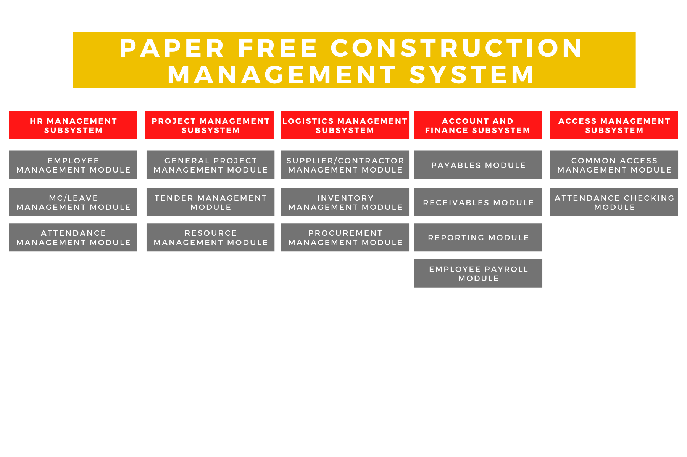

# **3.2 List of Use Cases for Each Subsystem**

## **3.2.1 Human Resource Management Use Cases**

|  |  |
| --- | --- |
| **S/N** | **Use Cases** |
| **Employee Management Module** | |
| 1 | Retrieve work schedule |
| 2 | Submit availability slots |
| 3 | Generate payslip preview |
| 4 | Make resignation request |
| 5 | Generate worked hours report |
| 6 | Create account for new employee |
| 7 | Delete existing employee account |
| 8 | Update existing employee account |
| 9 | Approve resignation requests |
| 10 | Reject resignation requests |
| 11 | Generate workload report |
| 12 | Generate staff performance report |
| **MC / Leave Management Module** | |
| 1 | Request for leave |
| 2 | Check status of leave request(s) |
| 3 | Submit insurance claim request |
| 4 | Approve leave requests |
| 5 | Reject leave requests |
| 6 | Generate report of leave records |
| 7 | Generate report of medical claims |
| **Attendance Management Module** | |
| 1 | Validate work hours of employees |
| 2 | Generate report of late-coming |
| 3 | Generate report of overtime |
| 4 | Collate work hours for each employee |

## **3.2.2 Project Management Use Cases**

|  |  |
| --- | --- |
| **S/N** | **Use Cases** |
| **General Project Management Module** | |
| 1 | Create Project Plan |
| 2 | View overall project progress |
| 3 | View team members’ profile |
| 4 | View cost records |
| 5 | View assigned project tasks |
| 6 | Update status of tasks |
| **Tender Management Module** | |
| 1 | Create new ‘Invitation to Tender’ (ITT) |
| 2 | View ‘Invitation to Tender’ (ITT) record |
| 3 | Remove ‘Invitation to Tender’ (ITT) |
| 4 | Update status of tenders |
| 5 | Add contractor contact |
| 6 | View contractor information |
| 7 | Submit tender |
| **Resource Management Module** | |
| 1 | View inventory records |
| 2 | View overall members' availability |
| 3 | Create tasks |

## **3.2.3 Account and Finance Management Use Cases**

|  |  |
| --- | --- |
| **S/N** | **Use Cases** |
| **Payables Module** | |
| 1 | Create purchase order |
| 2 | Record receival of goods |
| 3 | Make payment for invoices |
| 4 | Delete purchase order |
| 5 | View all invoices |
| 6 | View invoices by vendor name |
| **Receivables Module** | |
| 1 | Create receivable |
| 2 | Process receival of services |
| 3 | Delete receivable |
| 4 | View all vendor receivables |
| **Employee Payroll Module** | |
| 1 | Create salary payment |
| 2 | Make salary payment to employees |
| 3 | Process CPF contributions |
| 4 | View all employees’ salary page |
| 5 | View employee’s salary page by name |
| **Reporting Module** | |
| 1 | View all reports |
| 2 | View report |
| 3 | Generate financial report |
| 4 | Edit financial report |

## **3.2.4 Logistics Management Use Cases**

|  |  |
| --- | --- |
| **S/N** | **Use Cases** |
| **Supplier Management Module** | |
| 1 | Generate report of inventory managed by supplier |
| 2 | Add supplier |
| 3 | Edit supplier |
| 4 | Add supplier inventory |
| 5 | Remove supplier |
| 6 | Remove supplier inventory |
| 7 | Generate supplier order fulfilment rate |
| **Inventory Management Module** | |
| 1 | Generate inventory stock count |
| 2 | Generate inventory locations |
| 3 | Update inventory stock count |
| 4 | Process inventory request for a project |
| **Procurement Management Module** | |
| 1 | Create procurement record for materials |
| 2 | Request stock transfer from supplier to warehouse |
| 3 | Manage procurement status |

## **3.2.5 Access Management Use Cases**

|  |  |
| --- | --- |
| **S/N** | **Use cases** |
| **Common Access Management Module** | |
| 1 | Login |
| 2 | Logout |
| 3 | Forgot password |
| 4 | View profile |
| 5 | Edit profile |
| **Attendance Checking Module** | |
| 1 | Register for start of work |
| 2 | Register for end of work |
| 3 | Register for start of break |
| 4 | Register for end of break |

# **3.3 Class Diagram of All Entities**

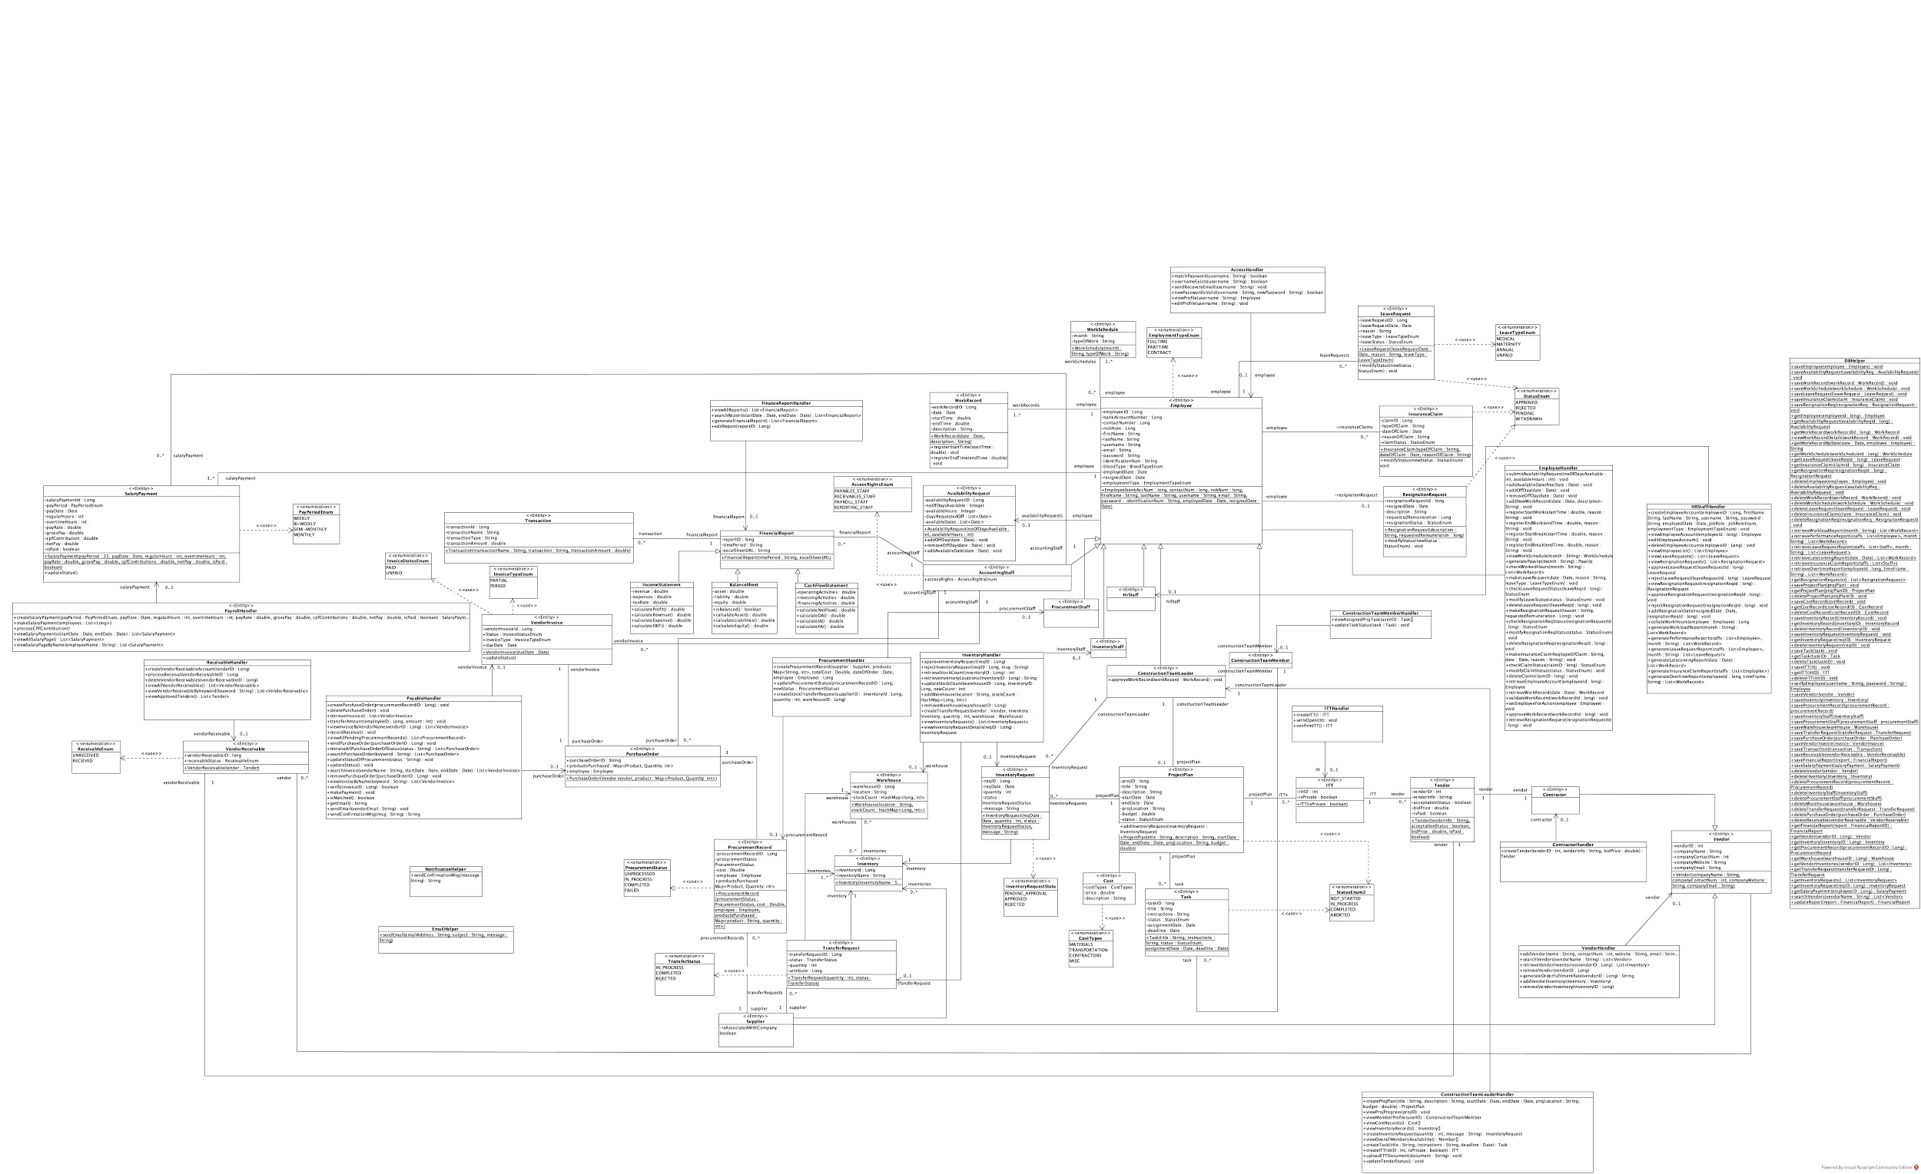

**4. Business Requirement Analysis**

# **4.1 Human Resource Management Subsystem**

## **4.1.1 Description**

The Human Resource Management Subsystem is a subsystem under the Paper Free Construction Management System containing all methods allowing all information about employees, their work records as well as their leave requests to be stored and updated. It contains three modules: Employee Management, MC/Leave Management and Attendance Management.

The Employee Management module allows HR Staff Members to push, fetch and update new information regarding employees into the system. HR Staff Members are also able to generate reports on staff performance, workload and work records. Employees are able to use this module to handle work schedule-related matters as well as make resignation requests.

The MC/Leave Management module allows all employees to submit and justify their leave requests. From there, HR Staff Members are able to manage these requests and generate reports for these leave requests.

Finally, with the Attendance Management module, the Construction Team Leader as well as other Team Leaders can validate work hours and generate attendance-related reports easily.

## **4.1.2 Business Objectives**

The Human Resource Management Subsystem aims to provide an integrated and easy-to-use platform to consolidate all attendance-related issues into one single database, allowing them to be easily persisted and handed over to the Account and Finance Management to handle payment-related manners. It is also aimed to be efficient for Team Leaders to validate work hours for accuracy of data.

## **4.1.3 Business Assumptions**

The Construction Team Leaders are required to validate the attendance records every start of day and end of day. This ensures accurate data of start and end work timings, preventing overpayment. A work report on employees’ late coming can be generated at the end of the month for the Team Leaders to check on the punctuality of the Team Members. HR Staff will also use this subsystem to create accounts for all employees of the company so that they can access the system for everyday processes.

## **4.1.4 Business Processes (Usage scenarios)**

### **4.1.4.1 Employee Management Module**

#### **4.1.4.1.1 Retrieve work schedule**

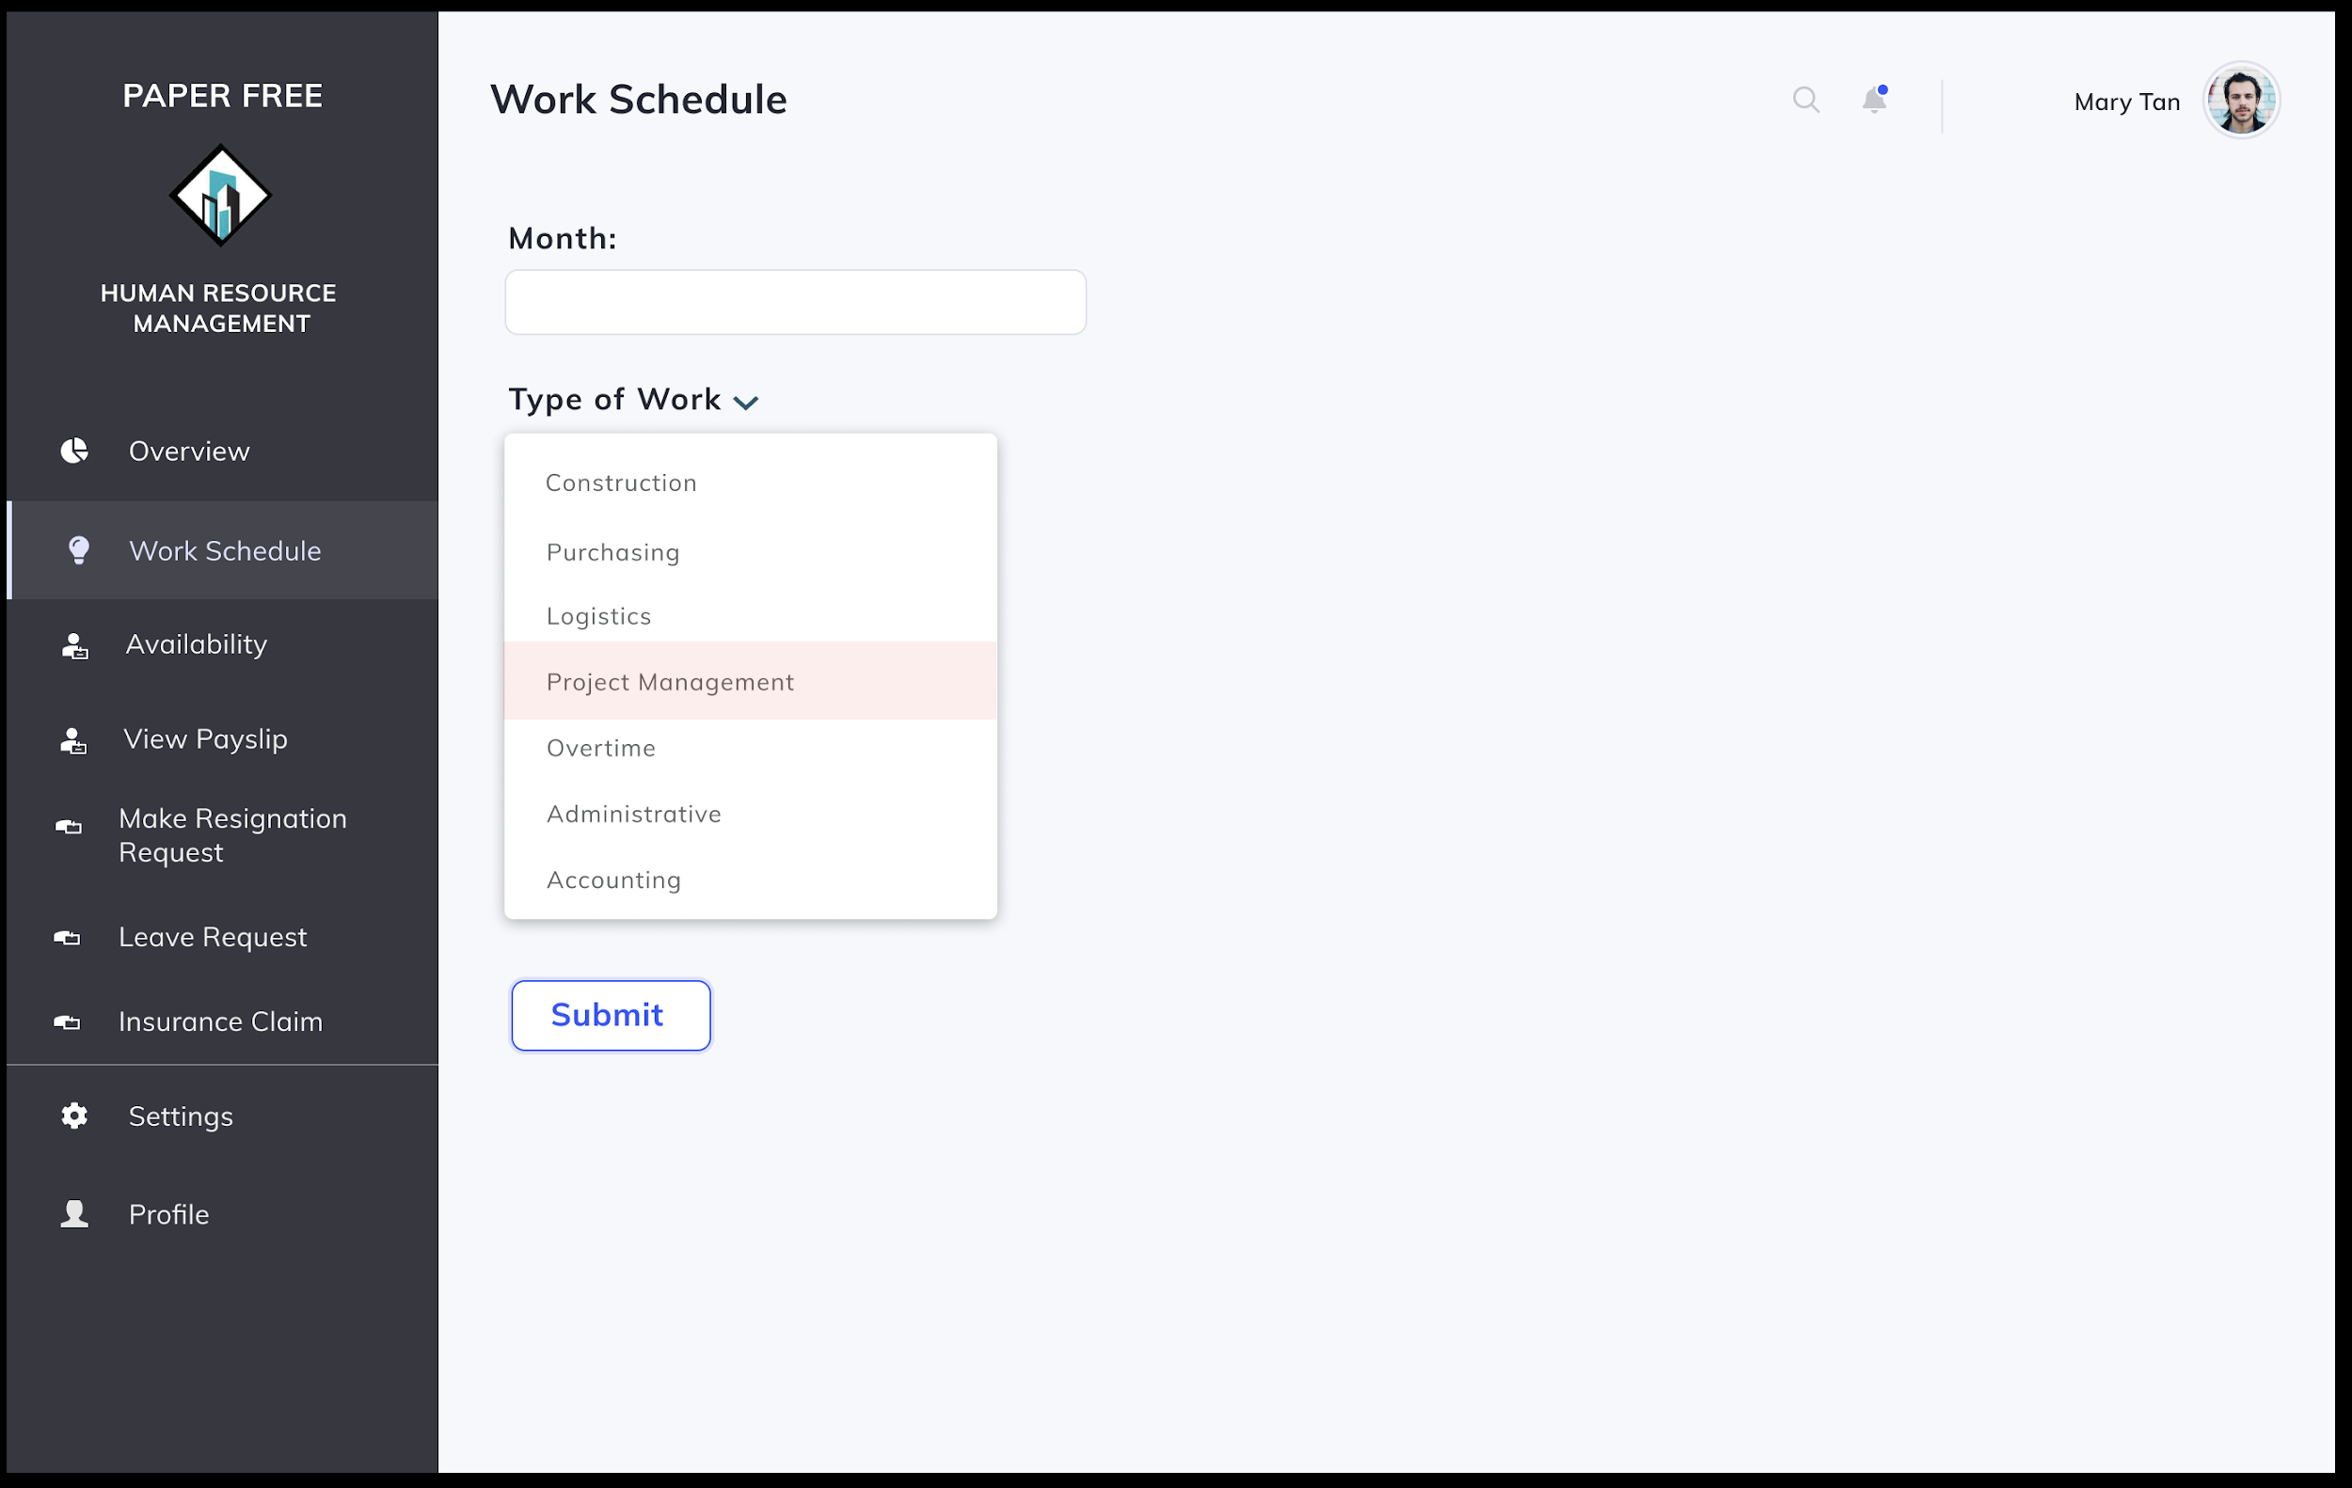

Scenario: Employee (Construction Team Member) Mary Tan wishes to retrieve work schedule for November 2020.

1. Employee Mary clicks on the Work Schedule tab on the left of the screen.
2. Mary inputs month in the text input and selects type of work from the dropdown box, submits query.
3. System shows work schedule requested.

#### **4.1.4.1.2 Submit availability slots**

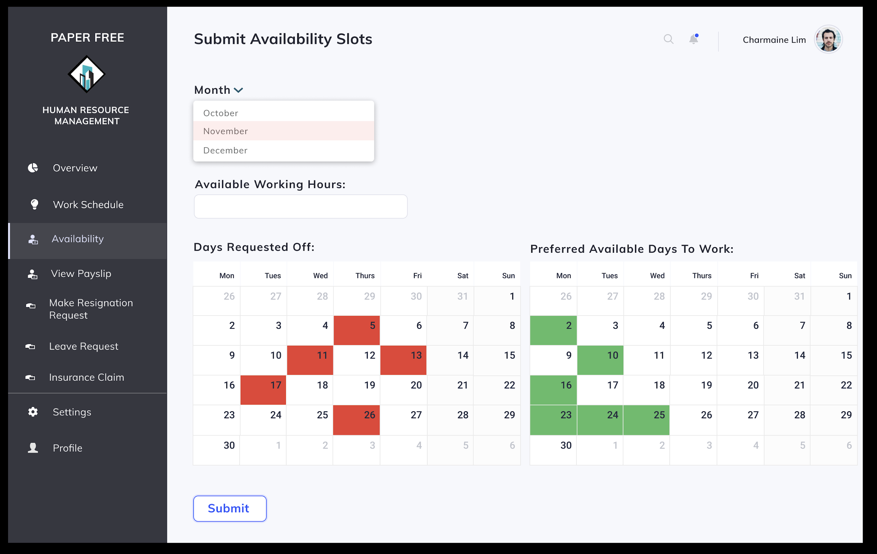

Scenario: Part-time Employee (Construction Team Member) Charmaine Lim wishes to submit her availability slot for November 2020.

1. Employee Charmaine clicks on the Availability tab on the left side of the screen.
2. Charmaine selects November from the dropdown box.
3. Charmaine adds in her available working hours, days to be requested off and preferred available days to work.
4. She then confirms her submission by clicking on the “Submit” button.
5. System saves her availability request into the system and shows a confirmation message.

#### **4.1.4.1.3 Generate payslip preview**

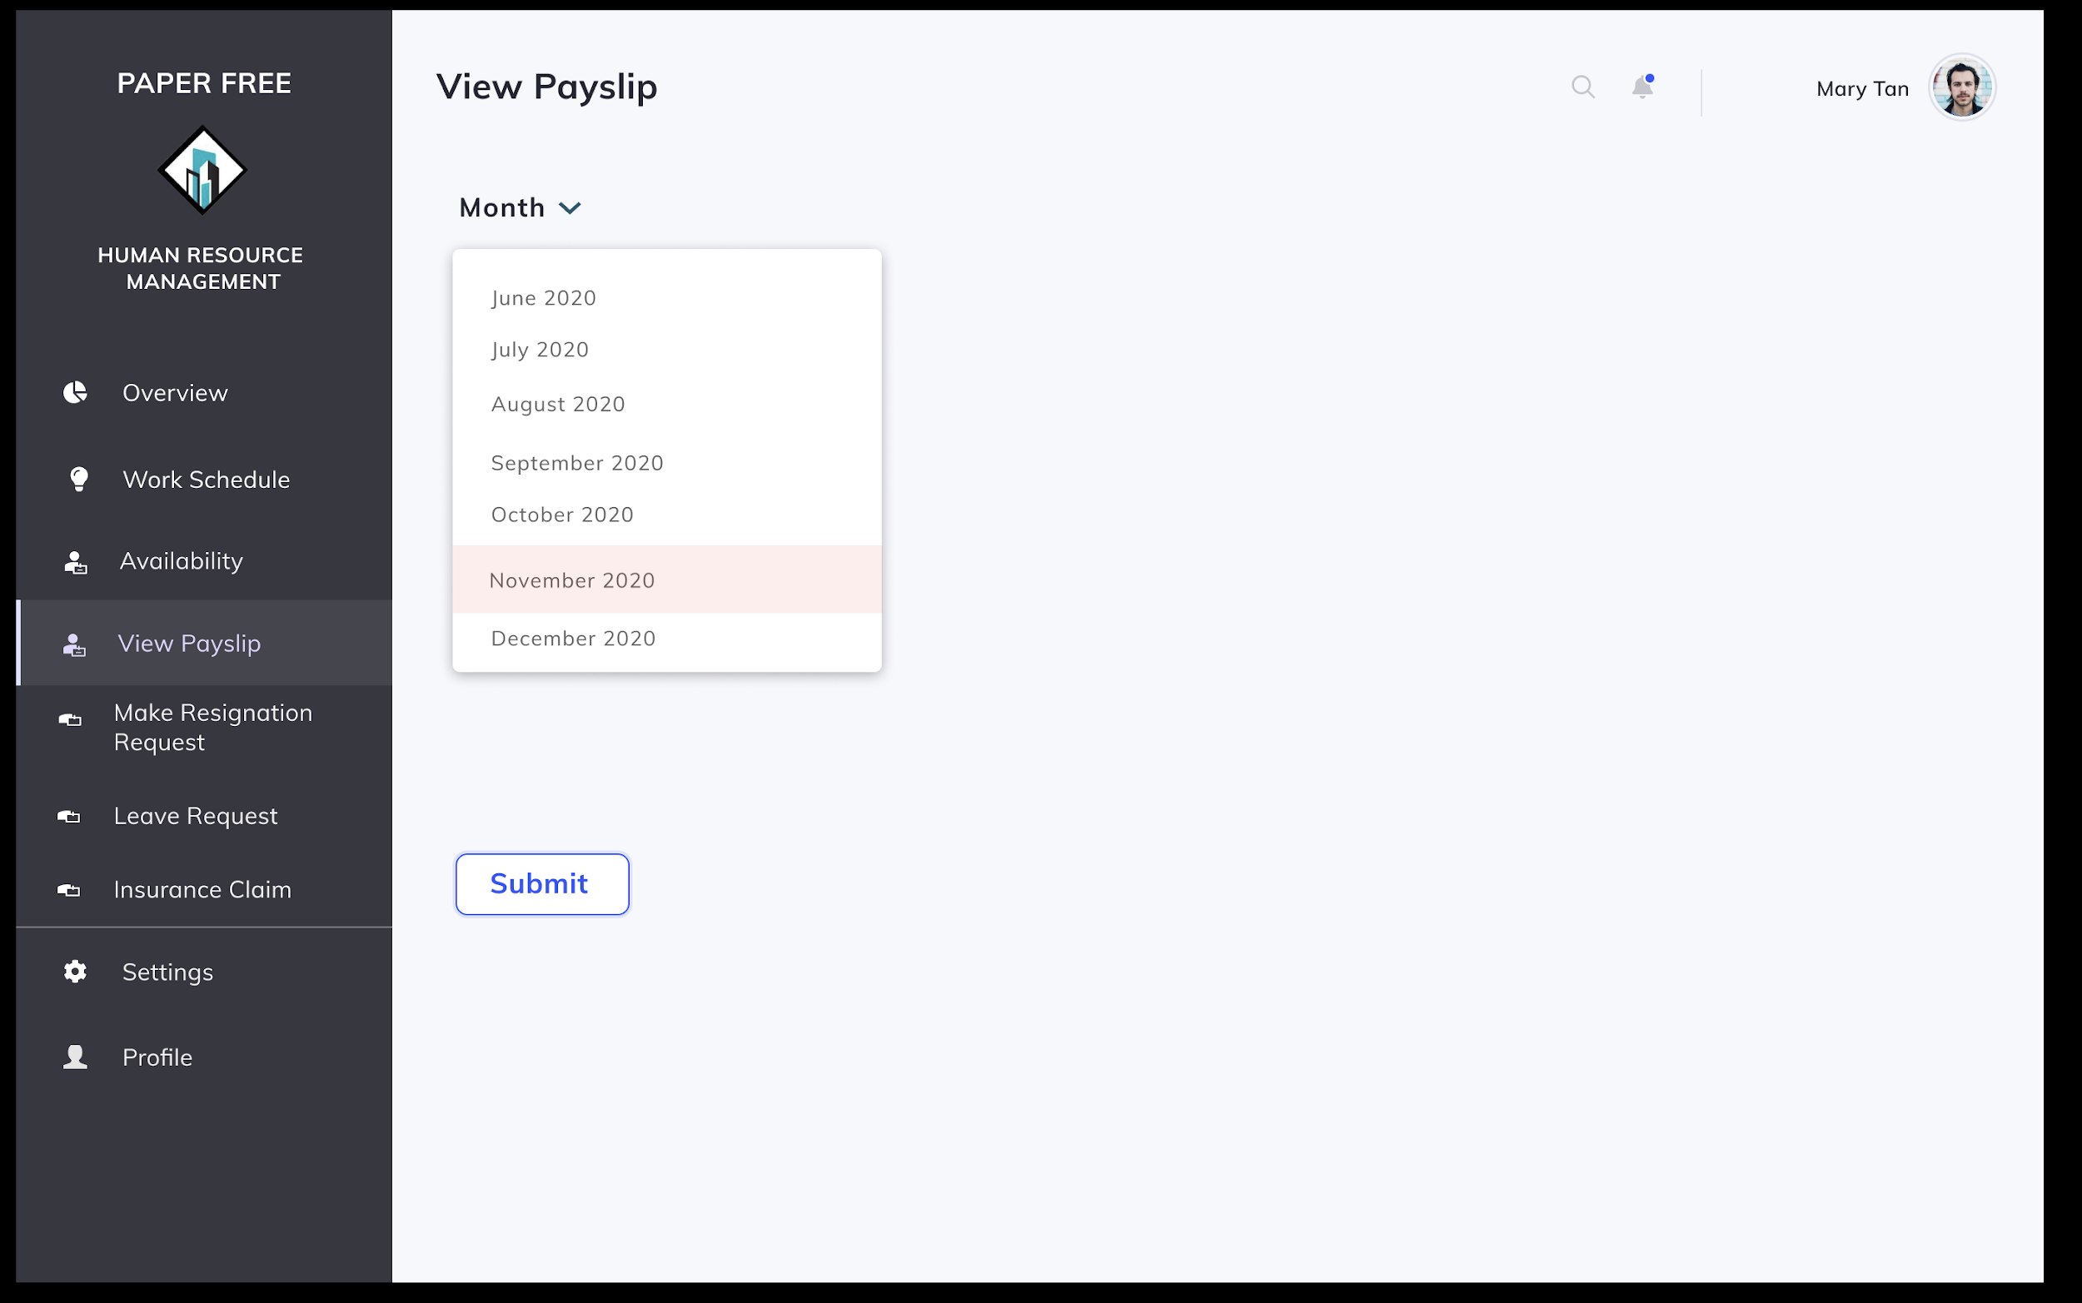

Scenario: Employee (Construction Team Member) Mary Tan wishes to retrieve her payslip for November 2020.

1. Employee Mary selects on View Payslip tab on the left of the screen.
2. Mary then selects the month of the payslip requested.
3. System displays payslip.

#### **4.1.4.1.4 Make resignation request**

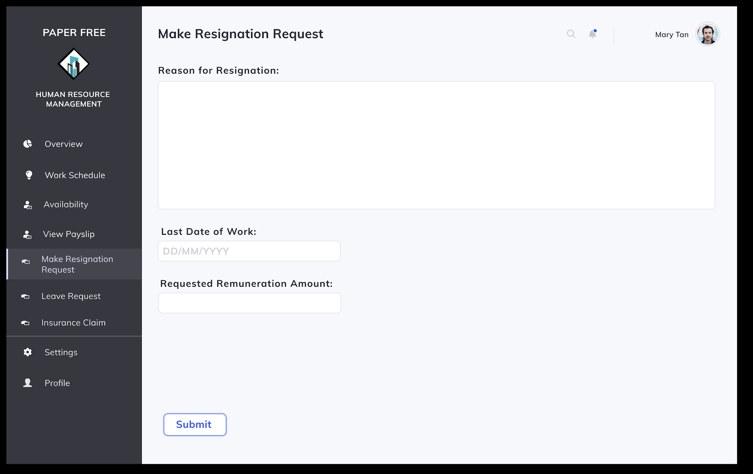

Scenario: Employee (Construction Team Member) Mary Tan wishes to make a resignation request.

1. Employee Mary selects on the Make Resignation Request tab on the left of the screen.
2. Mary fills in the form on the page by inputting the following data - reason for resignation, last date of work and requested remuneration amount.
3. Mary then confirms her request by pressing the “Submit” button.
4. System saves her request and shows a confirmation message.

#### **4.1.4.1.5 Generate worked hours report**

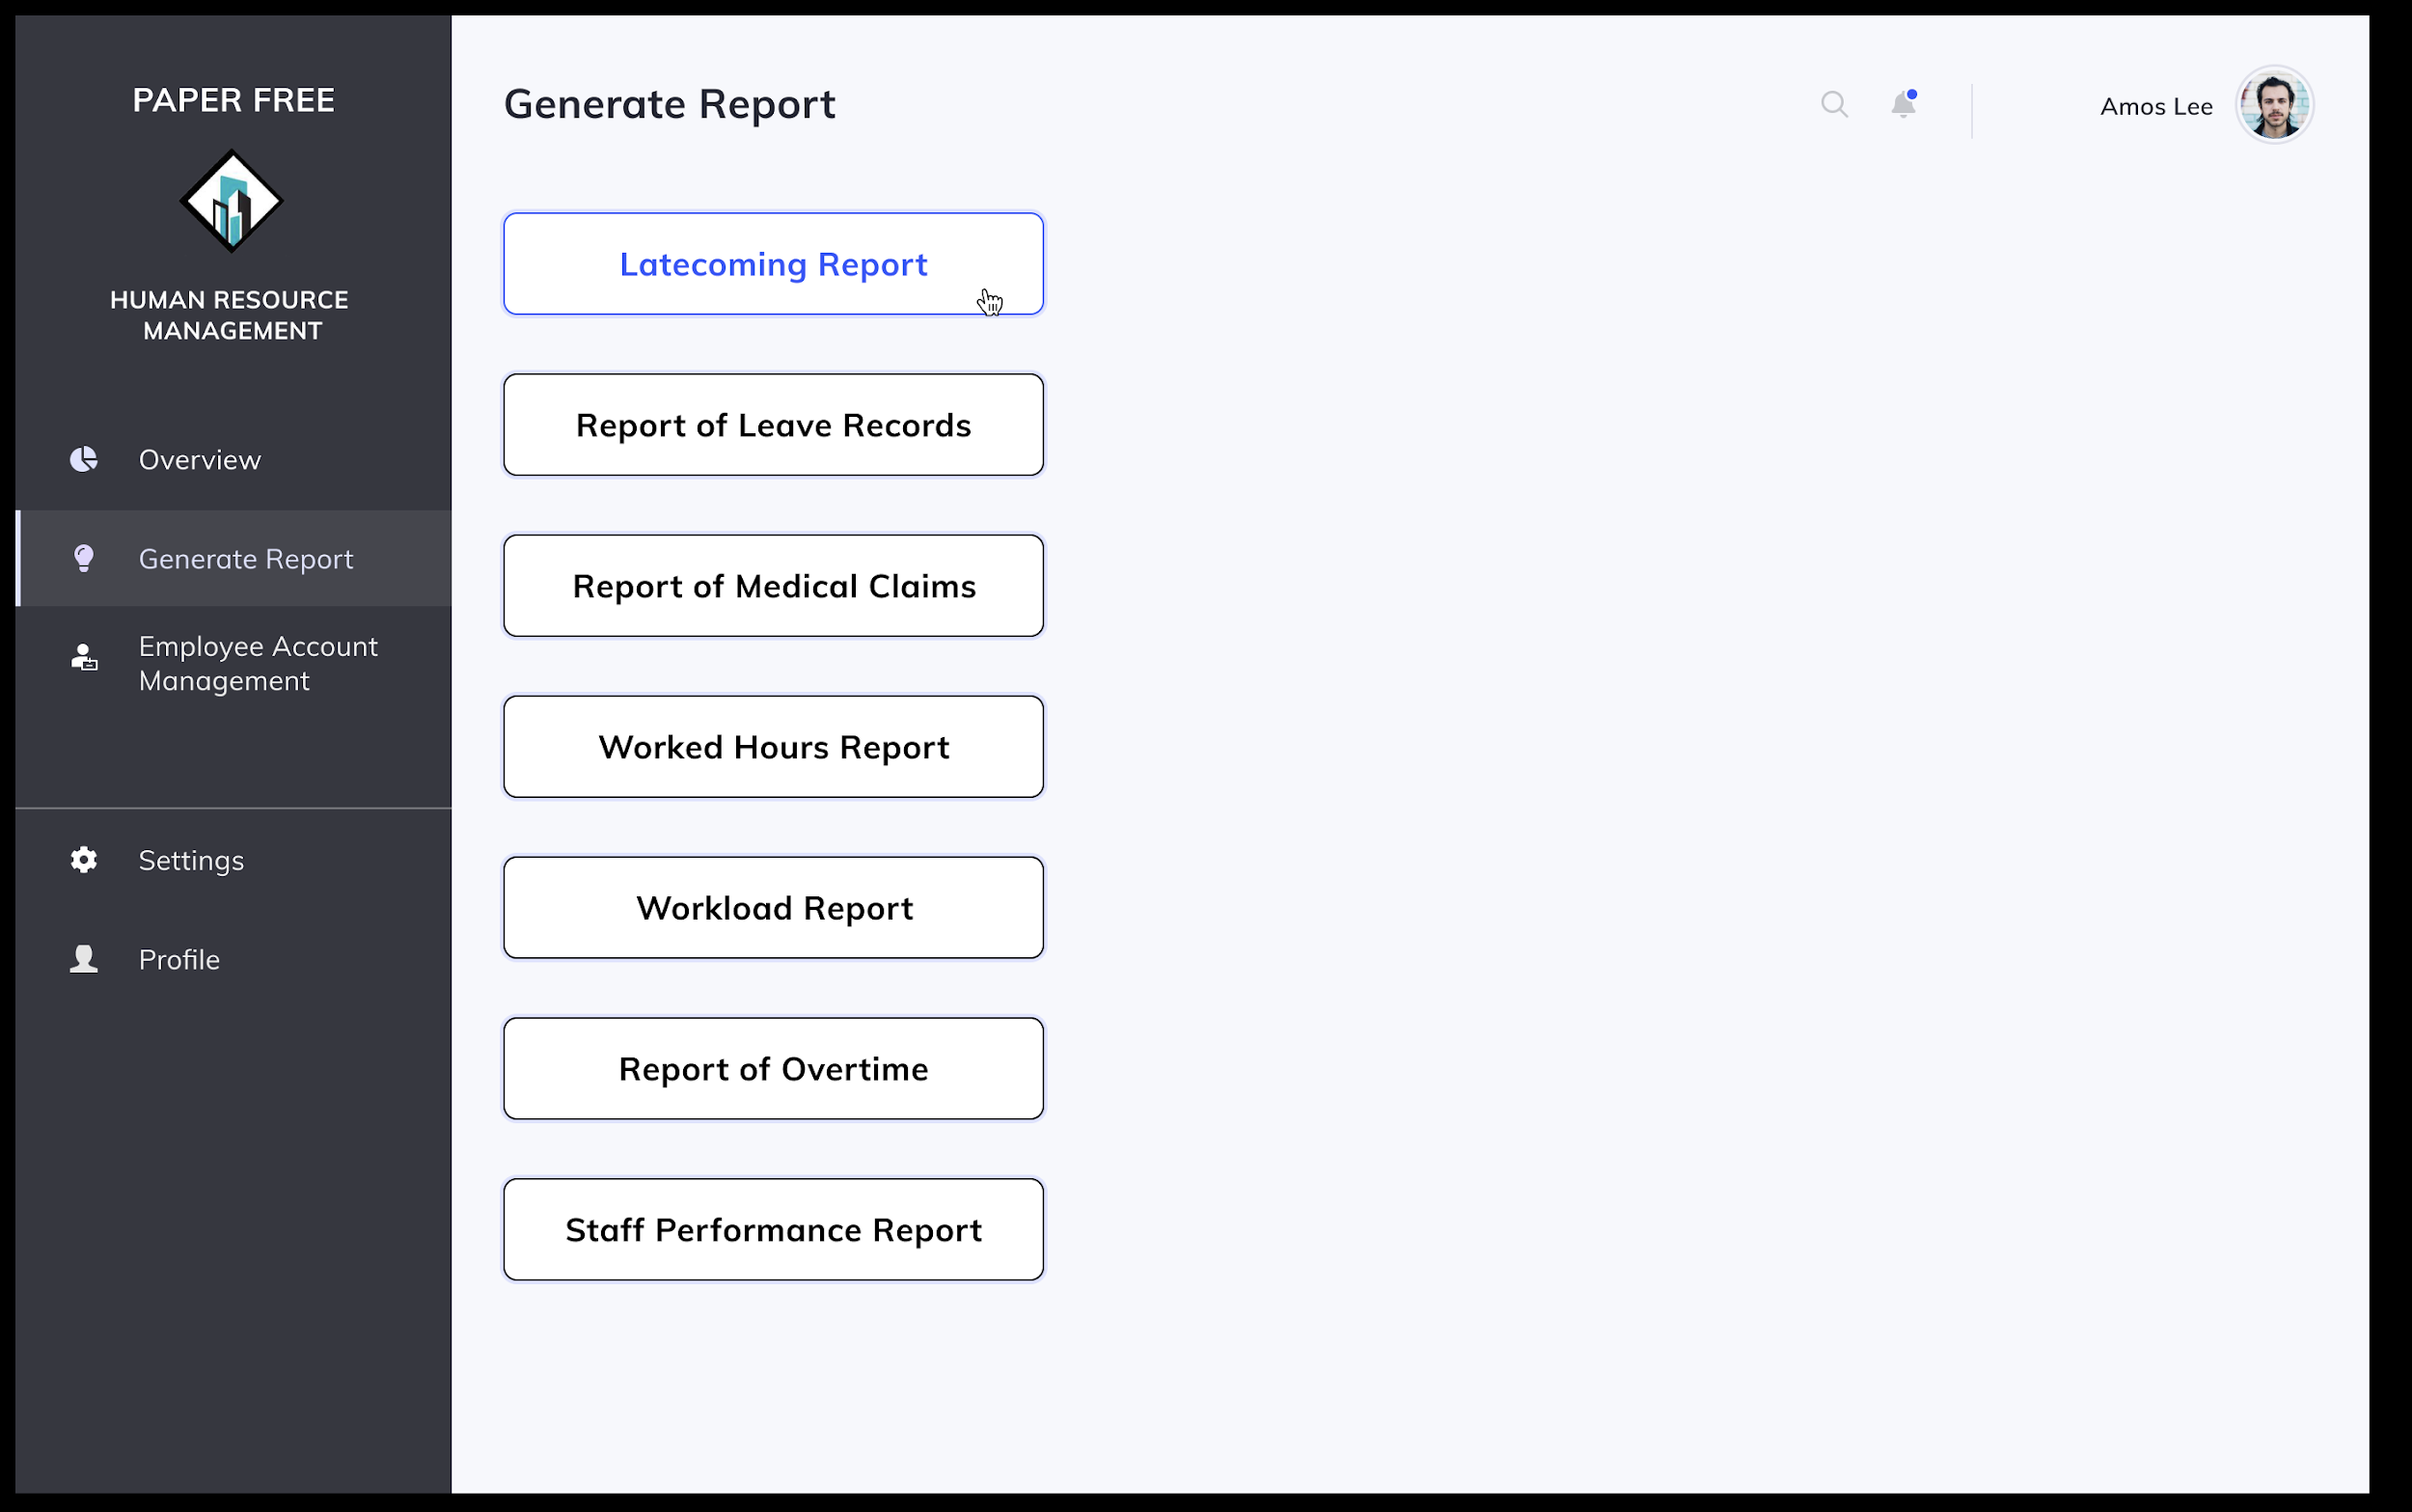

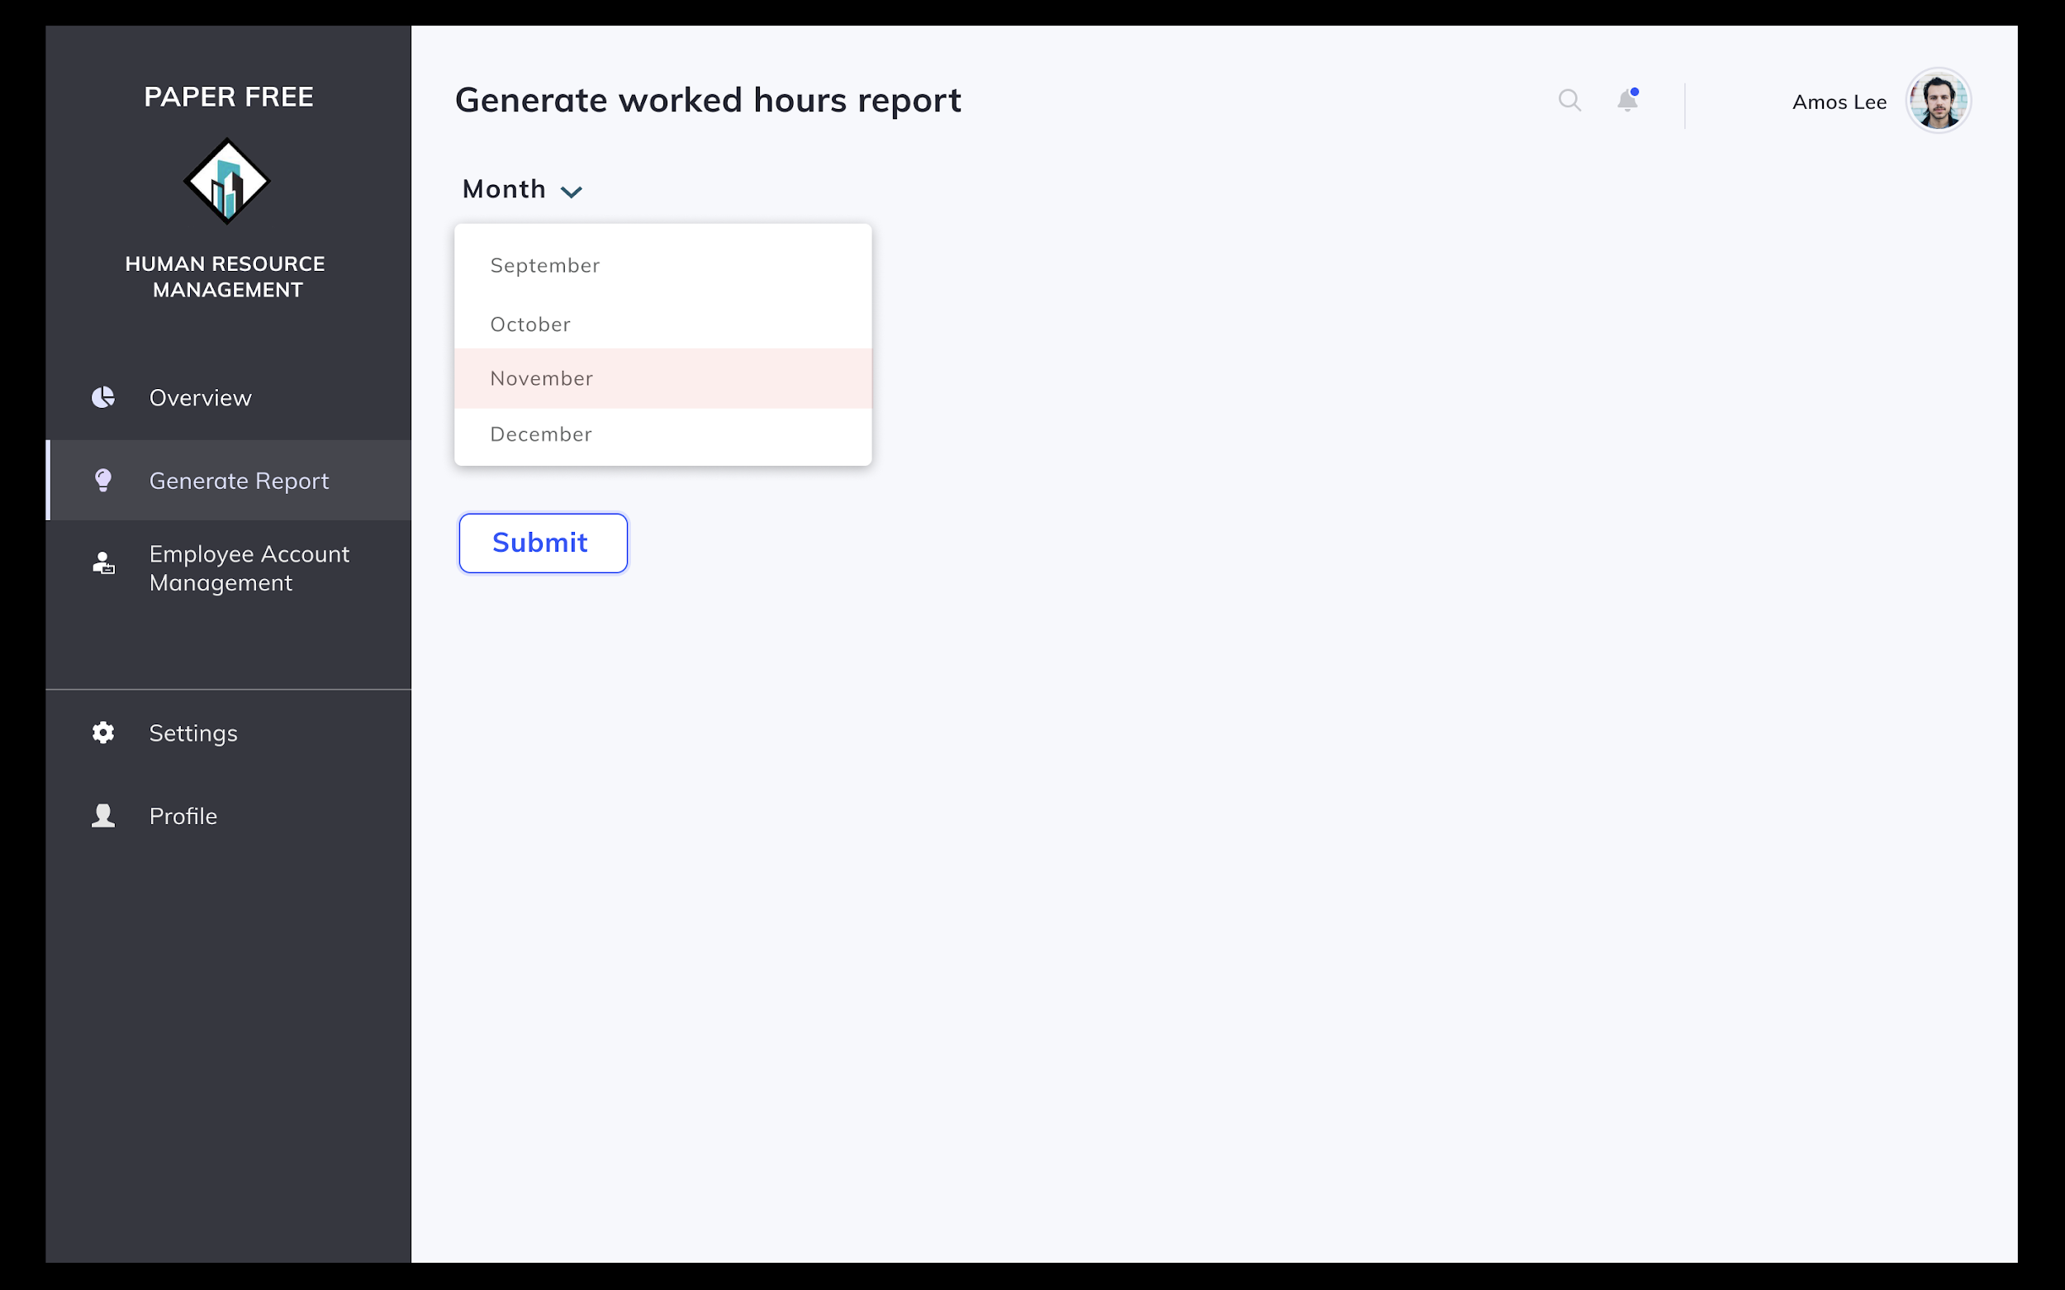

Scenario: HR Staff Amos Lee wishes to generate the worked hours report for November 2020.

1. Amos selects on the Generate Report tab on the left of the screen.
2. He then selects the option to generate worked hours report.
3. System prompts user to put in month of query.
4. Amos inputs month of query from dropdown box.
5. System displays worked hours report.

#### **4.1.4.1.6 Create account for new employee**

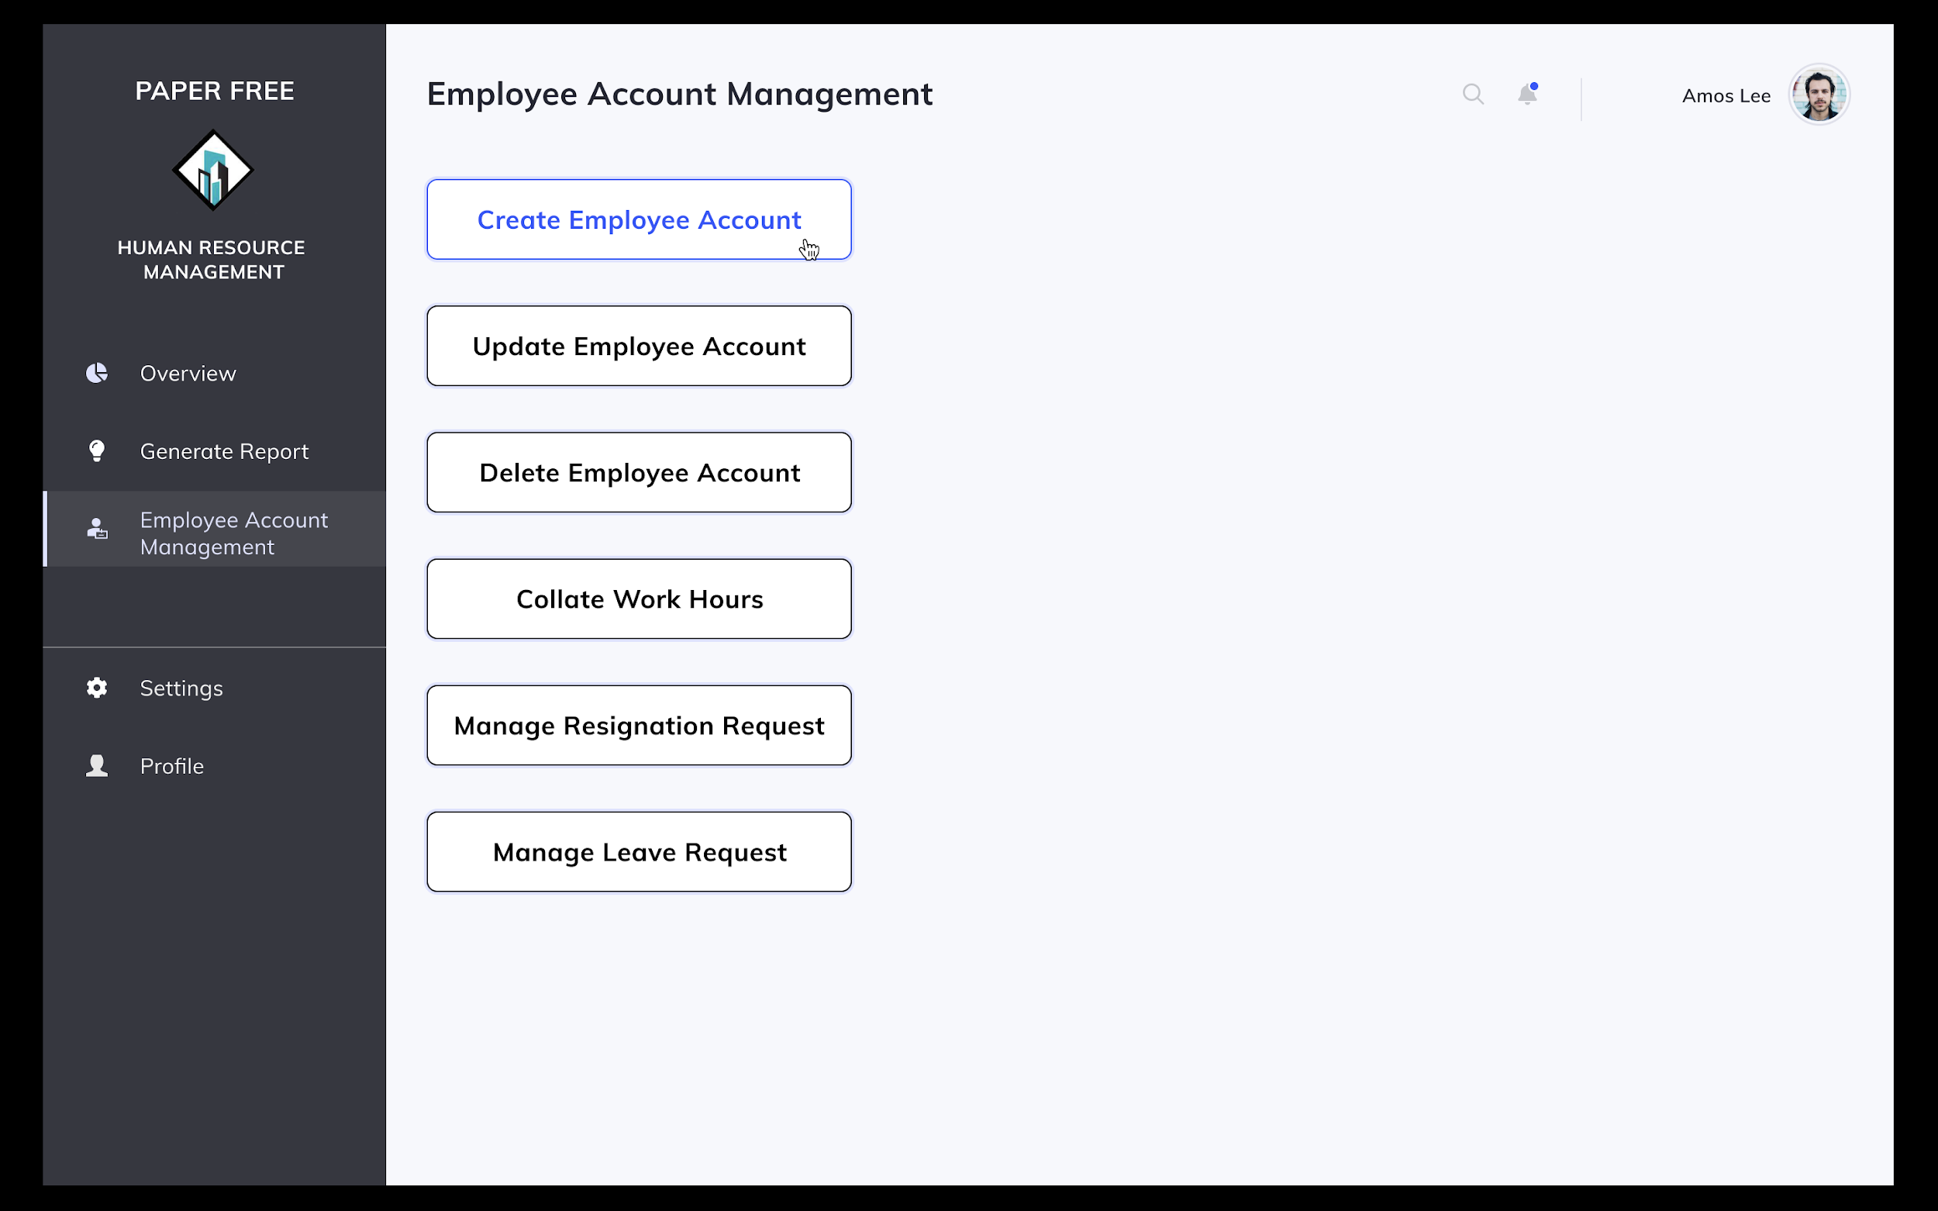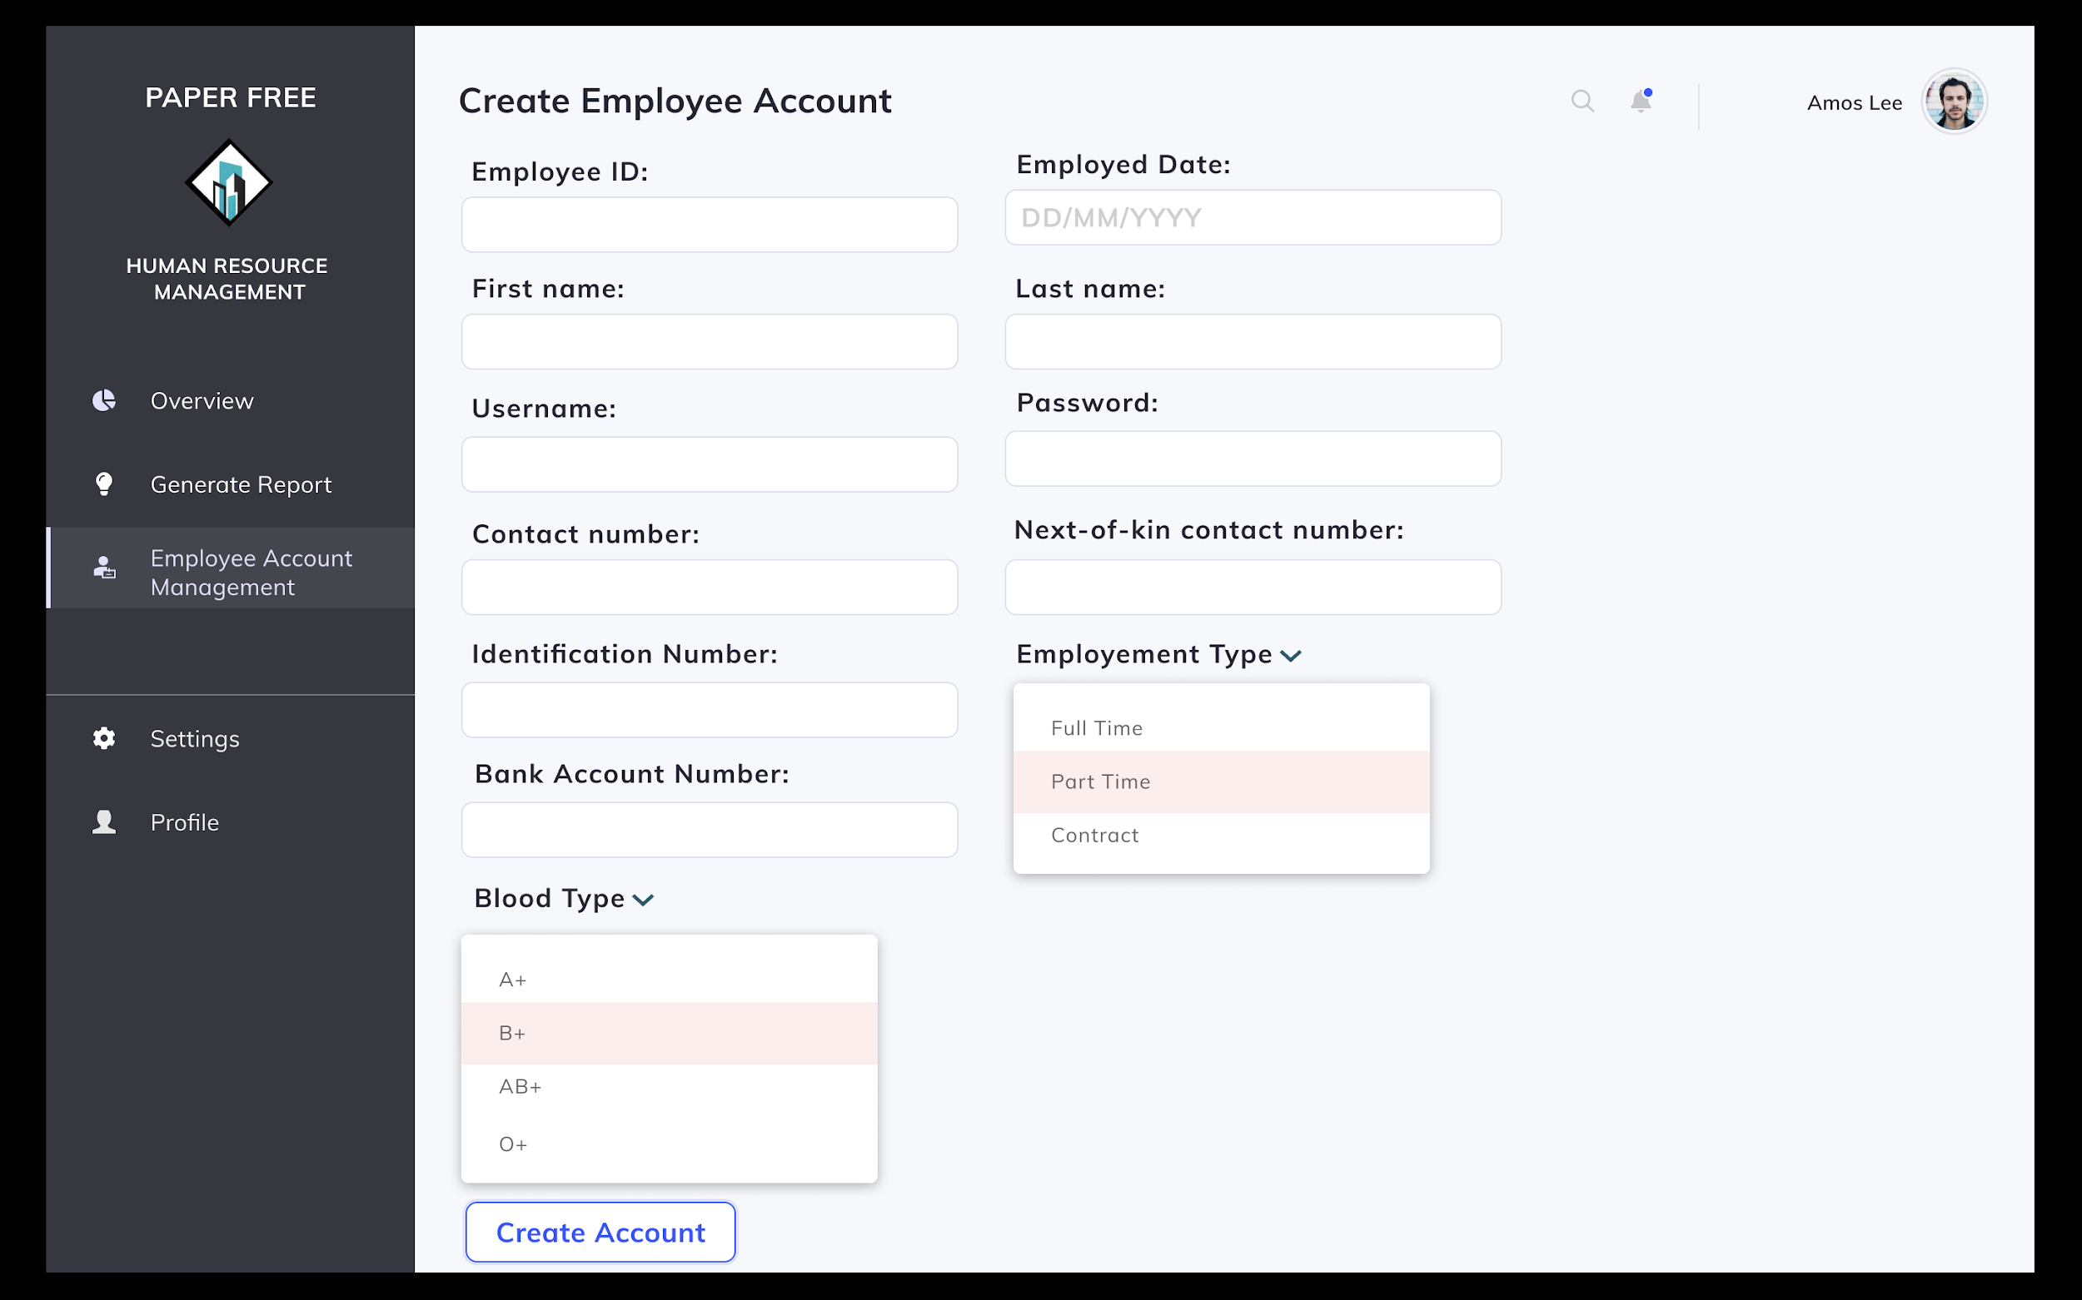

Scenario: HR Staff Amos Lee wishes to create a new account for a new employee member.

1. Amos selects on Employee Account Management tab on the left of the screen.
2. Amos selects option to create new account.
3. Amos inputs required information - employee ID, bank account number, contact number, next-of-kin contact number, first name, last name, username, password, identification number, blood type, employment type as well as employed date.
4. To confirm creation of a new account, Amos clicks on the “Create Account” button.
5. System displays confirmation message indicating creation of new account successful.

#### **4.1.4.1.7 Delete existing employee account**

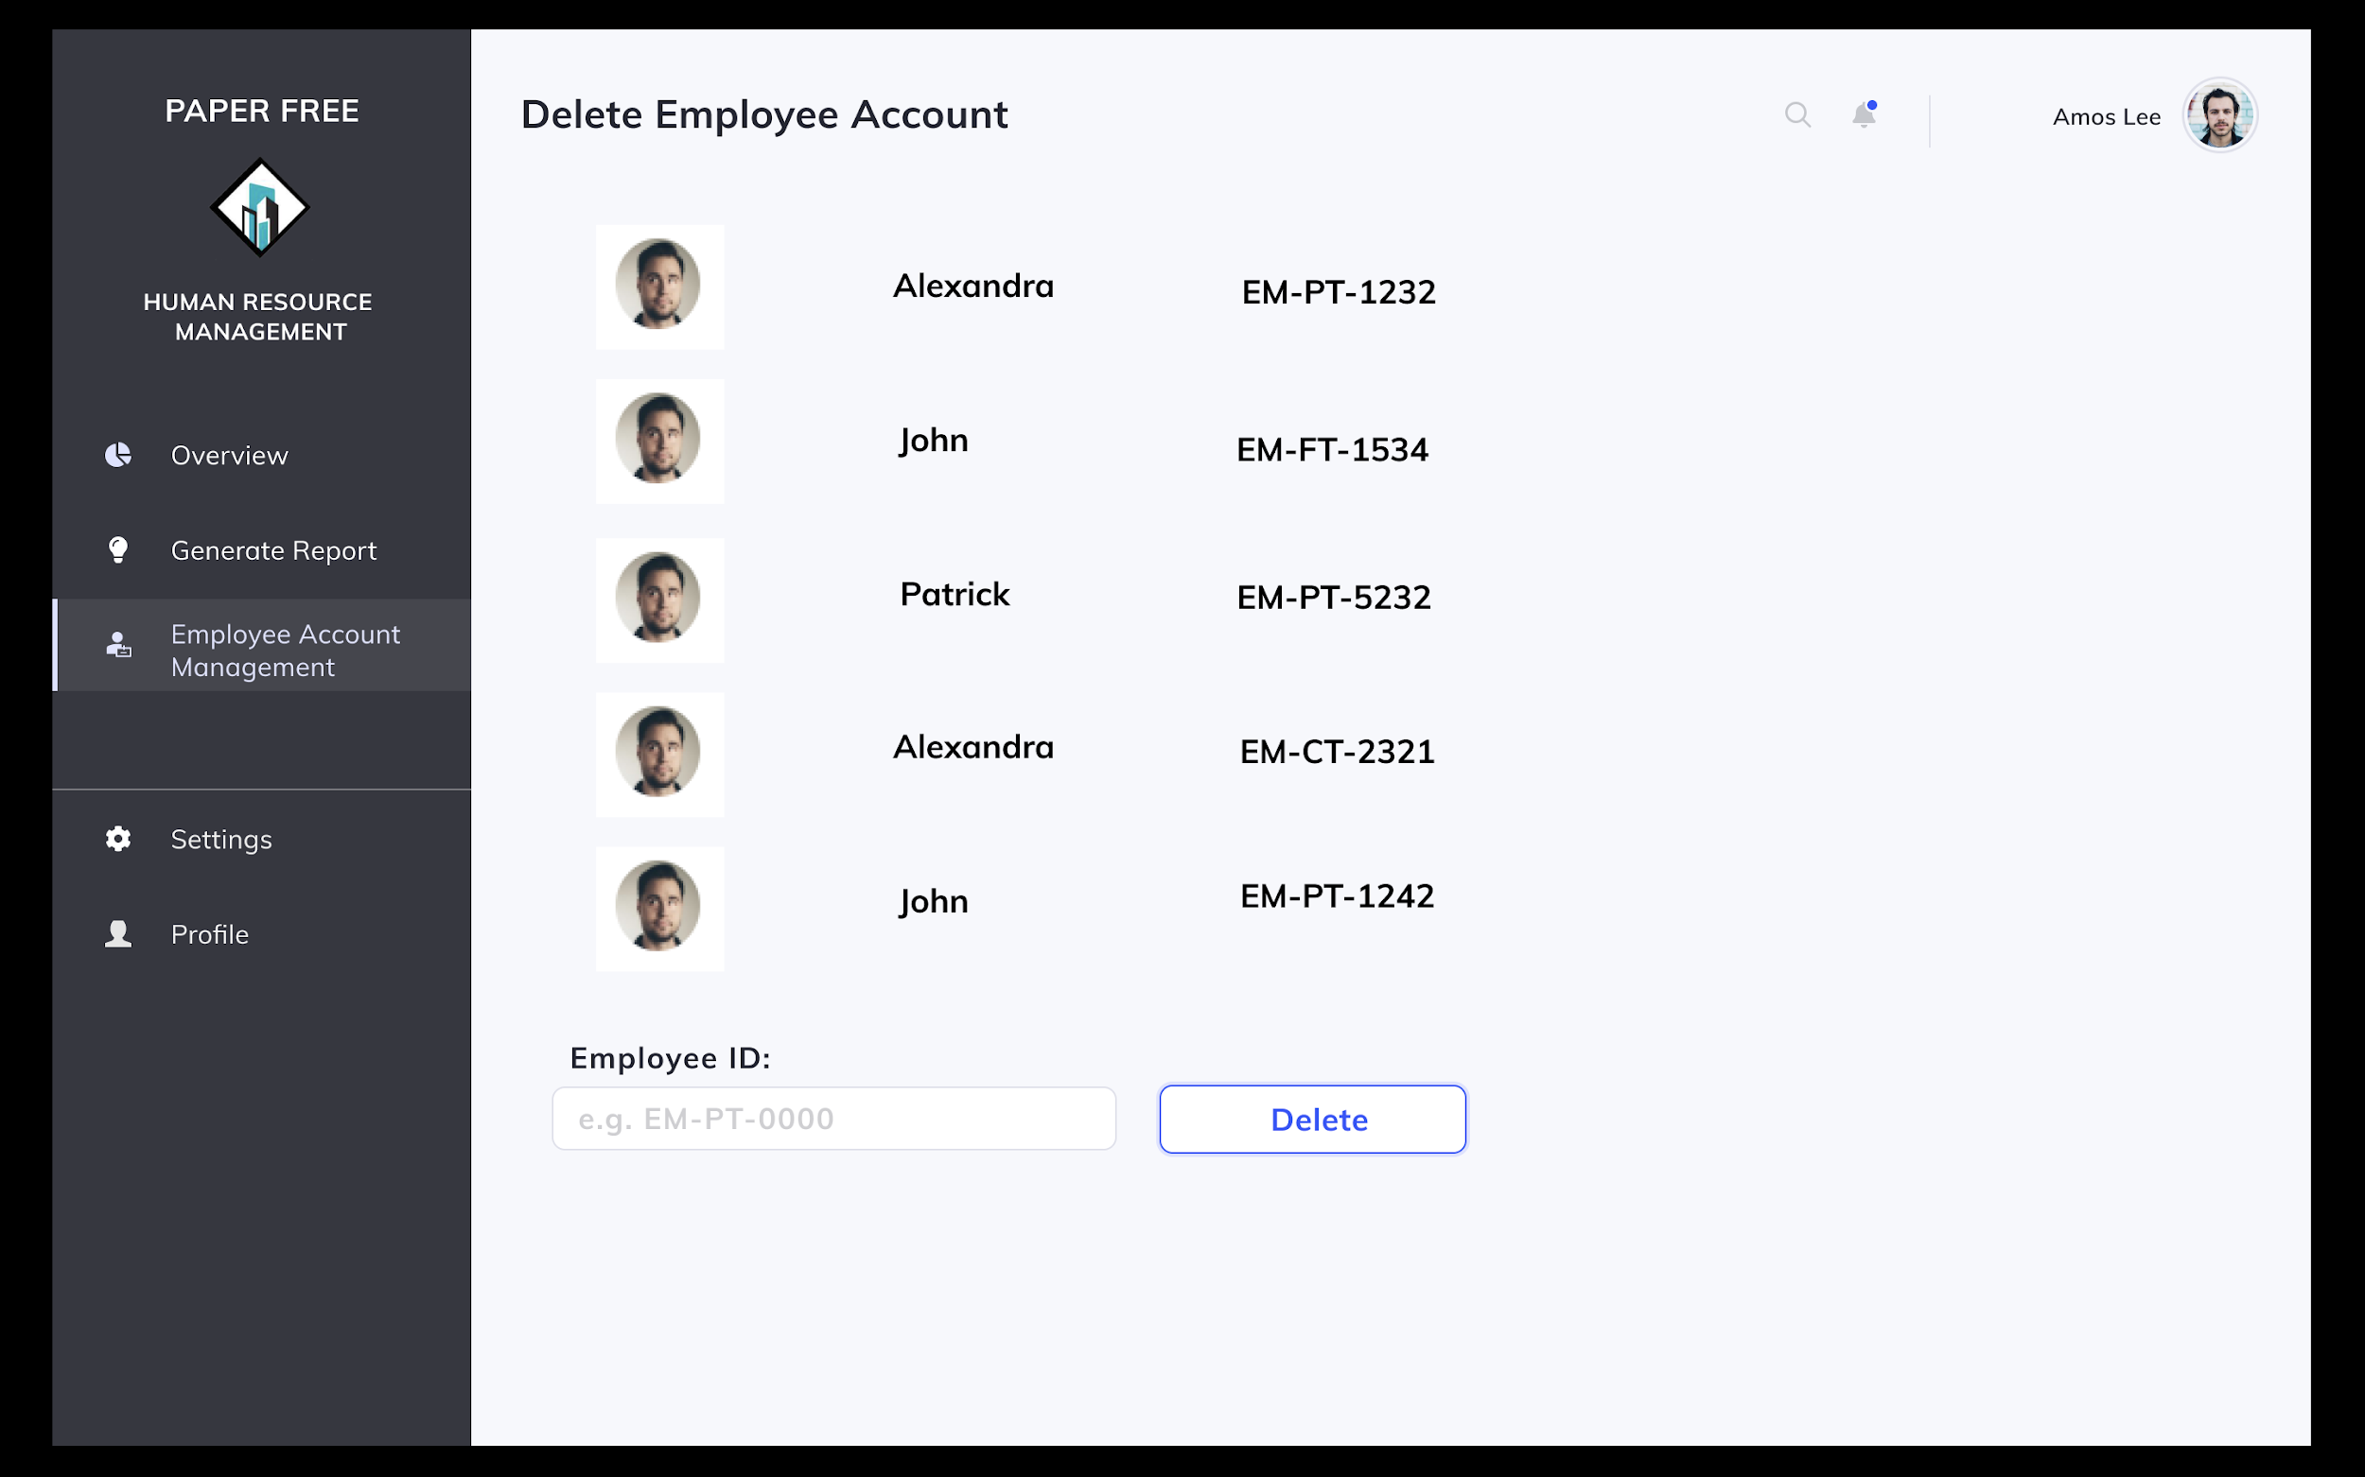

Scenario: HR Staff Amos Lee wishes to delete an existing account.

1. Amos selects on Employee Account Management tab on the left of the screen.
2. Amos selects option to delete existing account.
3. Amos inputs employee account ID of employee account to be deleted.
4. To confirm deletion of the account, Amos clicks on the “Delete” button and accepts the prompt given by the system.
5. System displays confirmation message indicating deletion of account successful.

#### **4.1.4.1.8 Update existing employee account**

Scenario: HR Staff Amos Lee wishes to update an existing account.

1. Amos selects on Employee Account Management tab on the left of the screen.
2. Amos selects option to update existing account.
3. Amos inputs employee account ID of employee account to be updated.
4. He makes all changes to the current information by clicking on the field and editing it accordingly.
5. To confirm edit, Amos clicks on the “Submit” button and accepts the prompt given by the system.
6. System displays confirmation message indicating update of account successful.

#### **4.1.4.1.9 Approve resignation requests**

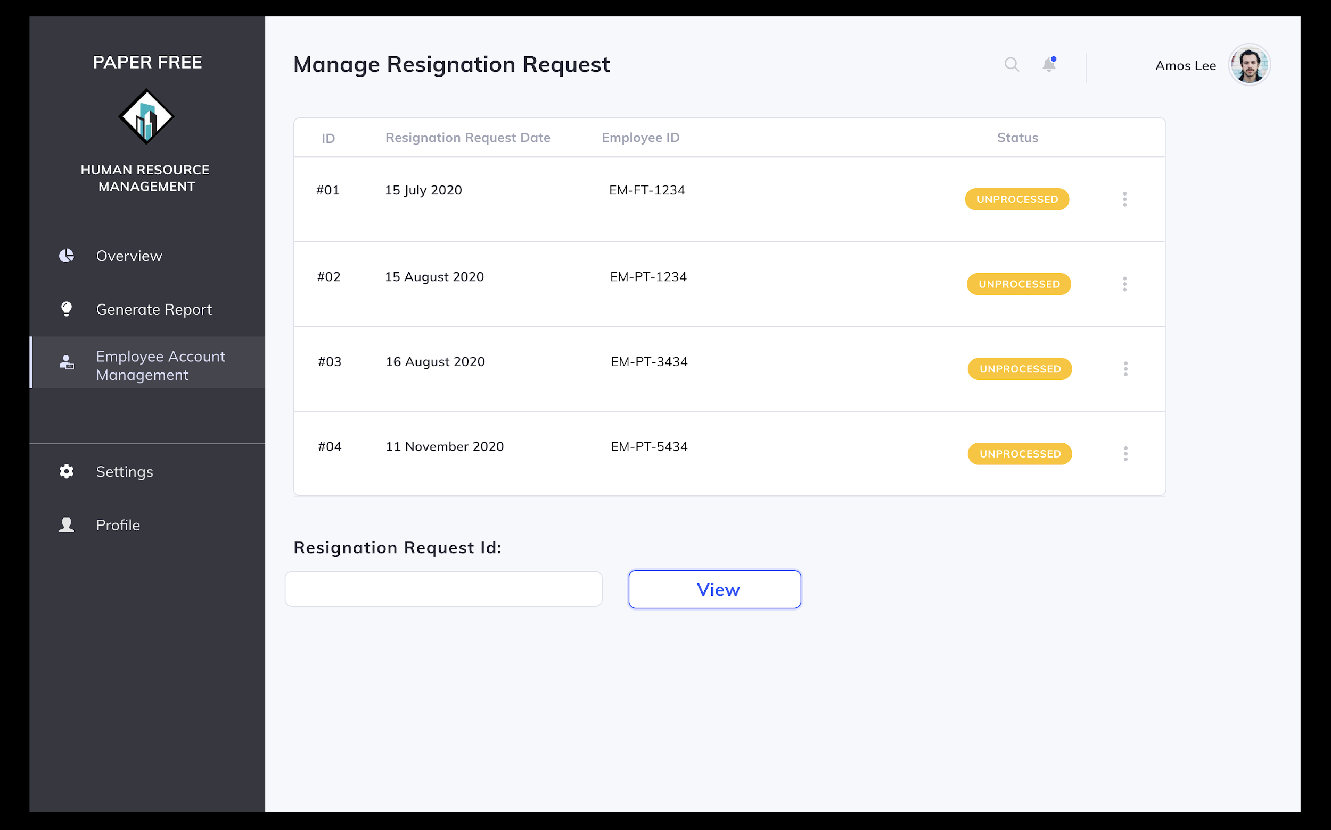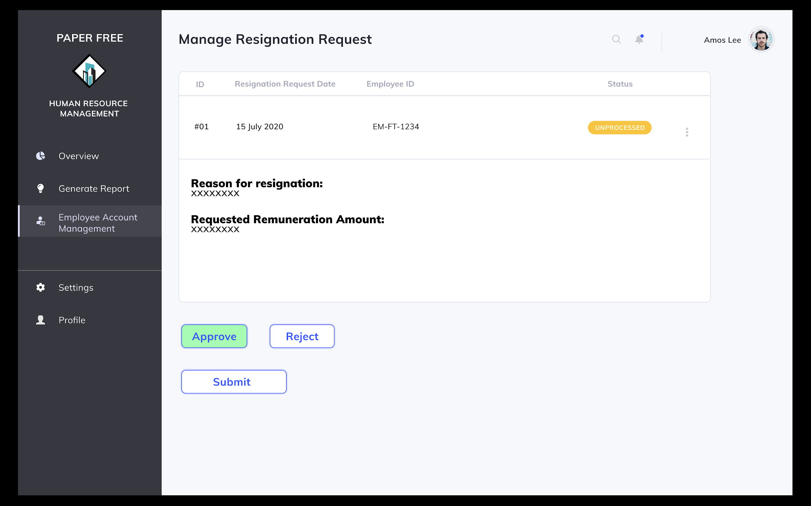

Scenario: HR Staff Amos Lee wishes to approve a resignation request..

1. Amos selects on Employee Management tab on the left of the screen.
2. Amos selects option to manage a resignation request.
3. System shows all unprocessed resignation requests in the system.
4. Amos inputs resignation request ID to be managed and clicks on the “Manage Request” option.
5. Amos clicks on “Approve” button and the “Submit” button to confirm approval of the resignation request.
6. System displays confirmation message indicating approval of resignation request was successful.

#### **4.1.4.1.10 Reject resignation requests**

Scenario: HR Staff Amos Lee wishes to reject a resignation request..

1. Amos selects on Employee Management tab on the left of the screen.
2. Amos selects option to manage a resignation request.
3. System shows all unprocessed resignation requests in the system.
4. Amos inputs resignation request ID to be managed and clicks on the “Manage Request” option.
5. Amos clicks on “Reject” button and the “Submit” button to confirm rejection of the resignation request.
6. System displays confirmation message indicating rejection of resignation request was successful.

#### **4.1.4.1.11 Generate workload report**

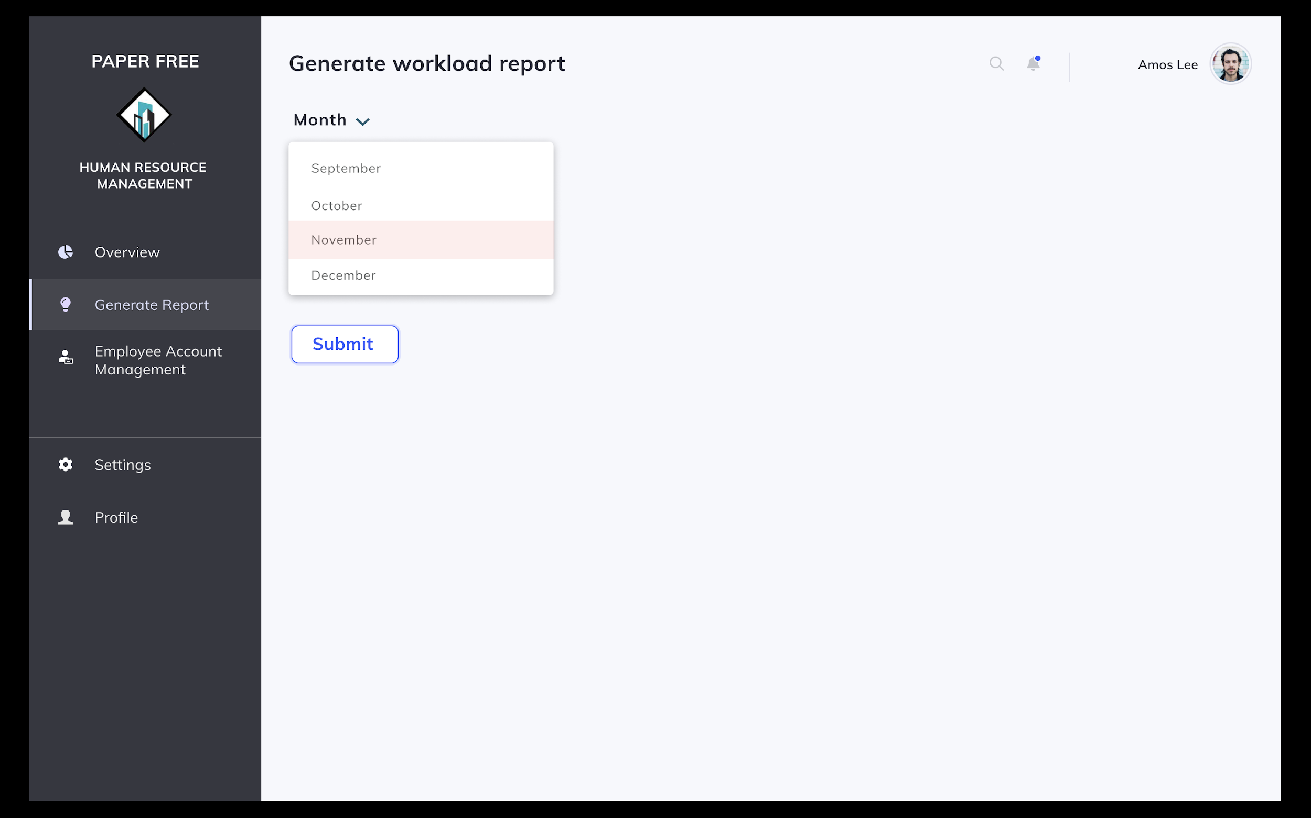

Scenario: HR Staff Amos Lee wishes to generate the workload report for November 2020.

1. Amos selects on the Generate Report tab on the left of the screen.
2. He then selects the option to generate workload report.
3. System prompts user to put in month of query.
4. Amos inputs month of query from dropdown box.
5. System displays workload report.

#### **4.1.4.1.12 Generate staff performance report**

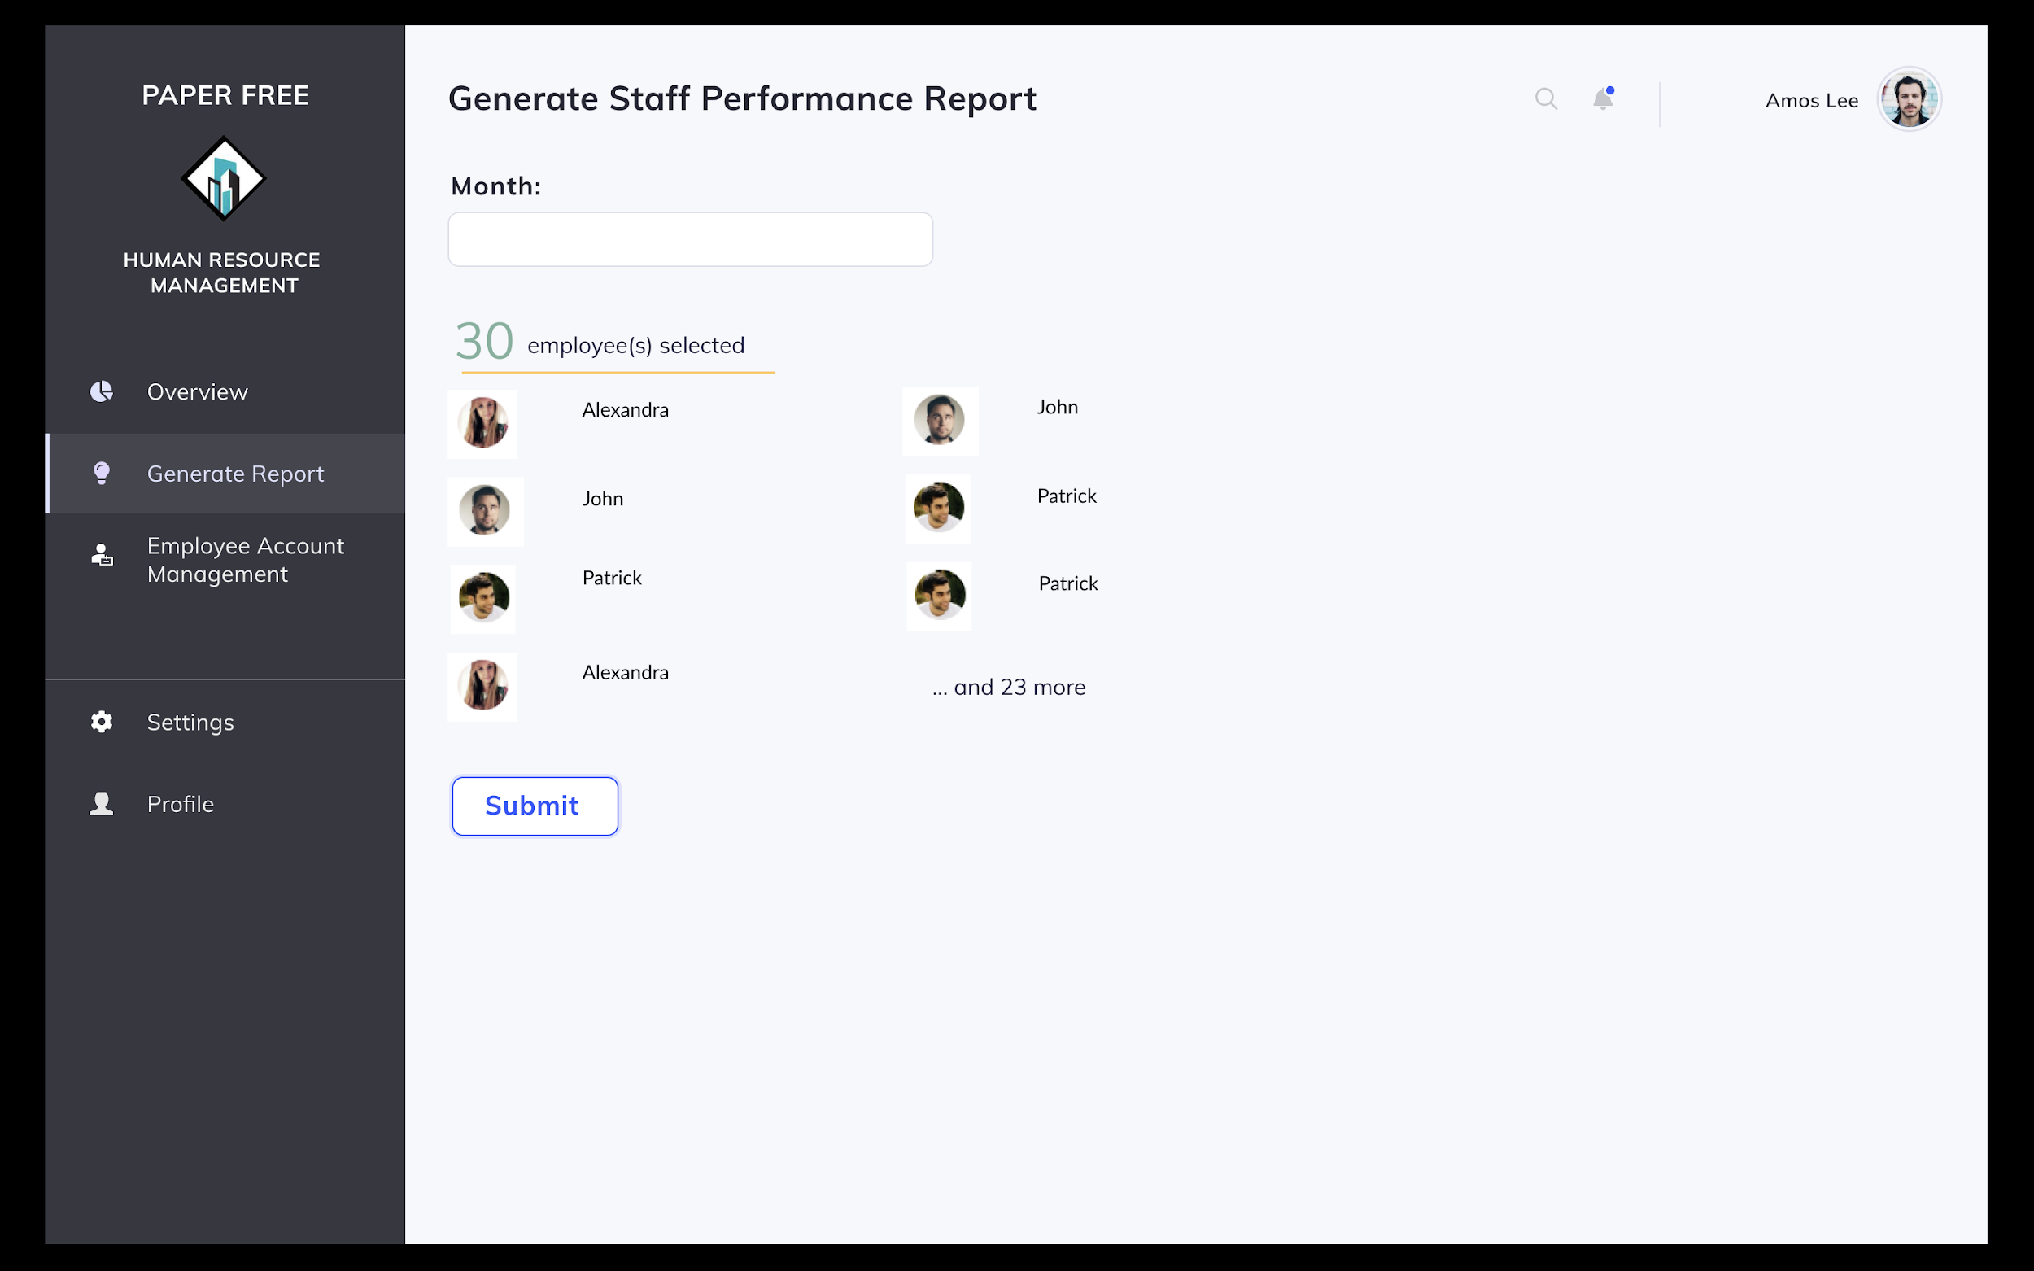

Scenario: HR Staff Amos Lee wishes to generate the staff performance report for November 2020.

1. Amos selects on the Generate Report tab on the left of the screen.
2. He then selects the option to generate staff performance report.
3. System prompts user to put in month of query and employees involved.
4. Amos inputs month of query from dropdown box and checks all relevant employees involved.
5. System displays staff performance report.

### **4.1.4.2 MC / Leave Management Module**

#### **4.1.4.2.1 Request for leave**

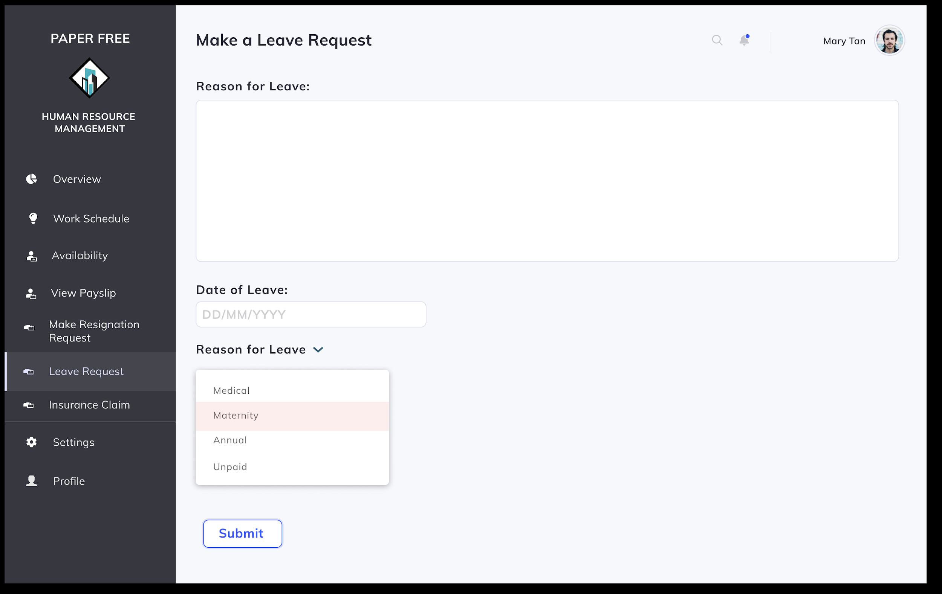

Scenario: Employee (Construction Team Member) Mary Tan wishes to request for leave.

1. Employee Mary clicks on the Leave Request(s) tab on the left of the screen.
2. Mary selects the option to Make a Leave Request.
3. Mary inputs all fields required - date requested, reason for leave and type of leave – medical, maternity, annual or unpaid.
4. To confirm submission of the leave request, she presses on the “Submit” button.
5. System displays confirmation message of leave request made indicating successful request.

#### **4.1.4.2.2 Check status of leave request(s)**

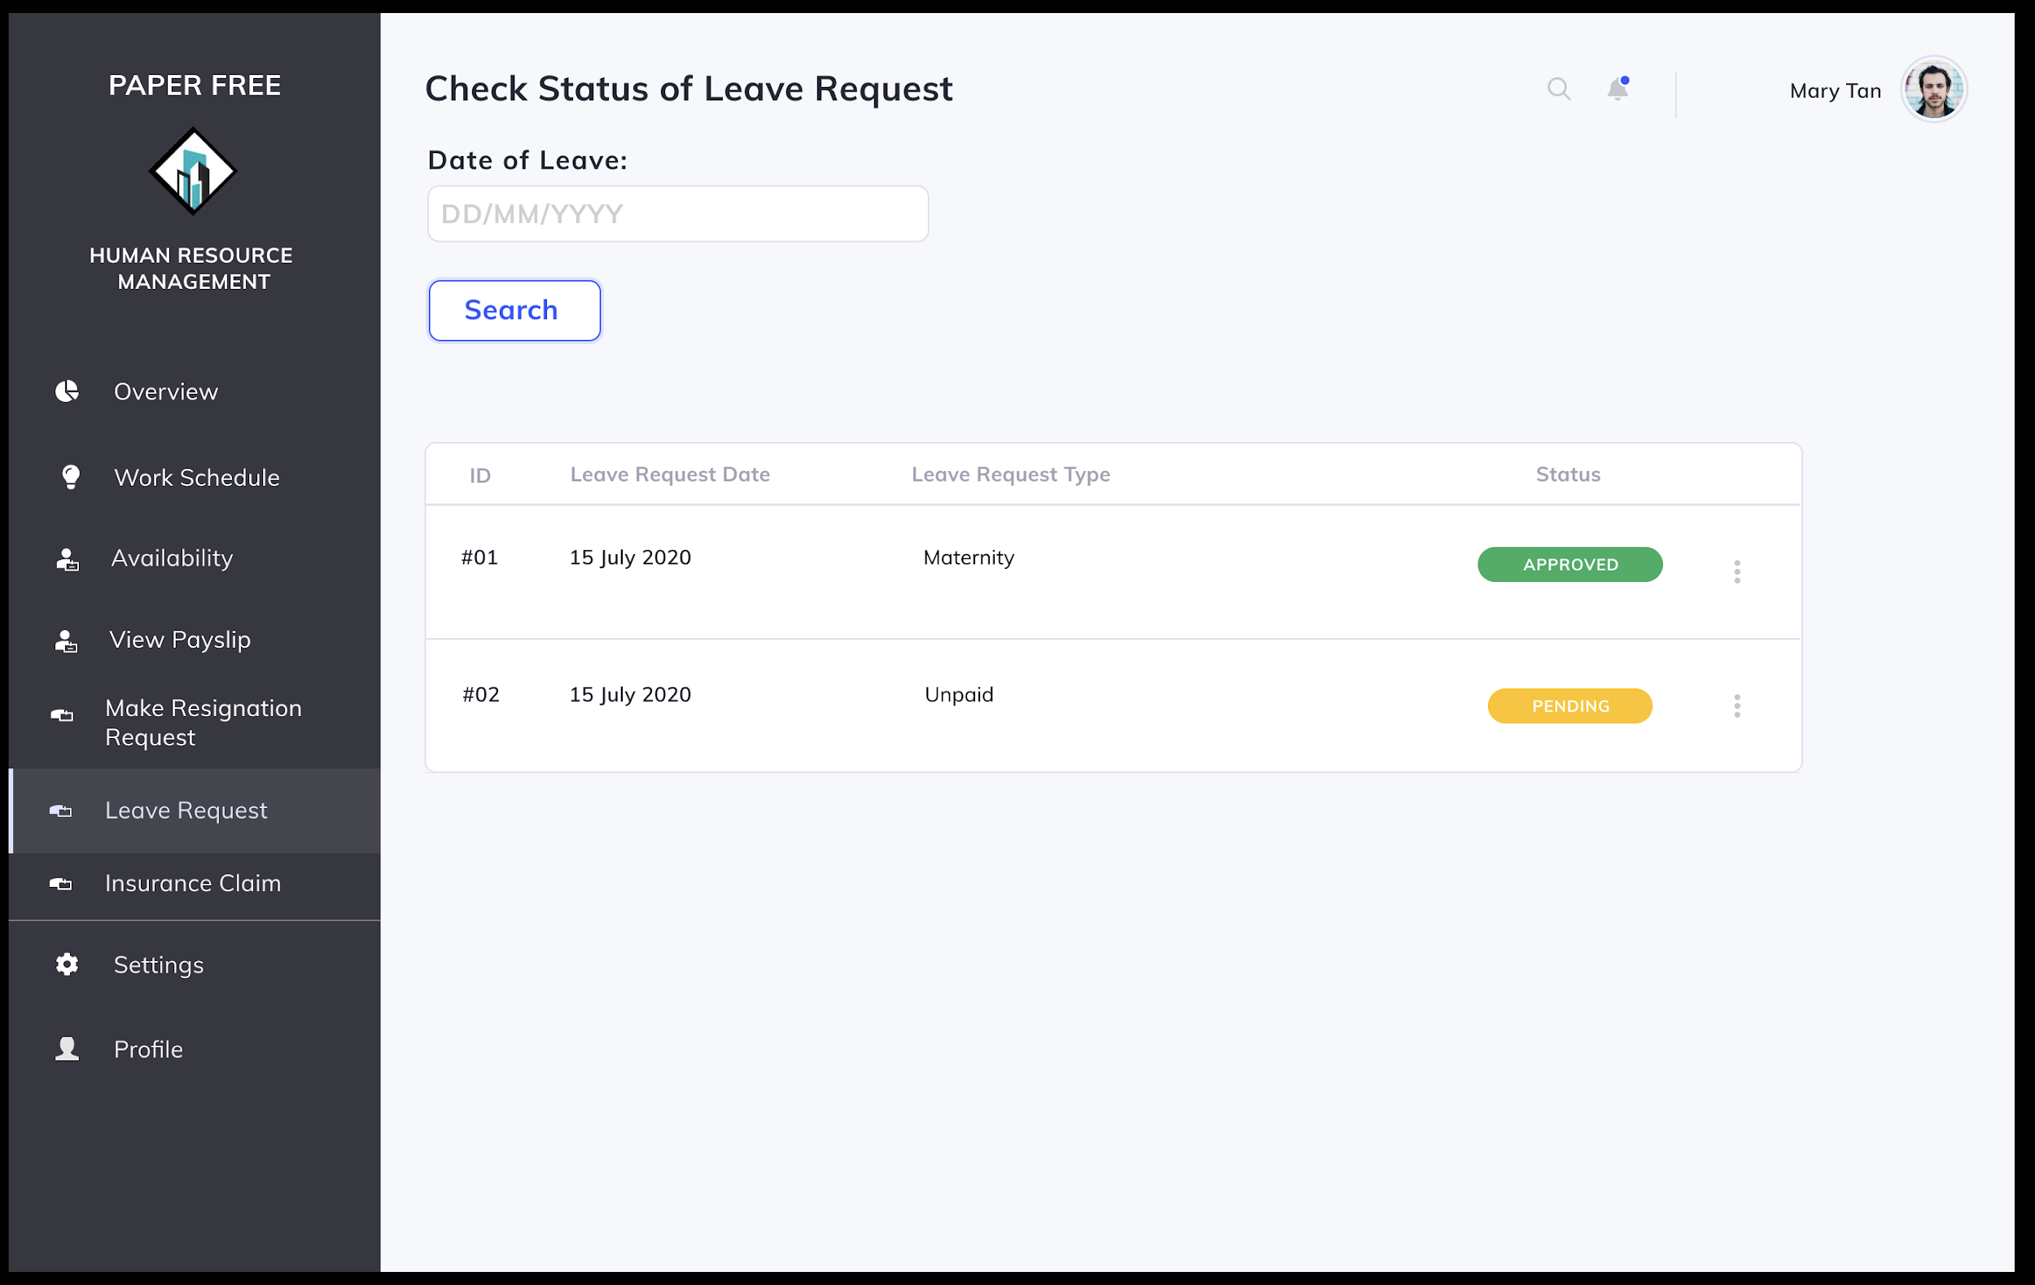

Scenario: Employee (Construction Team Member) Mary Tan wishes to request for leave.

1. Employee Mary clicks on the Leave Request(s) tab on the left of the screen.
2. Mary selects the option to Check Status of a Leave Request.
3. Mary inputs all fields required - date requested.
4. System displays status of leave request made.
5. If leave is unprocessed, Mary can choose to prompt the HR department to process her request ASAP by clicking on the “Remind” option.

#### **4.1.4.2.3 Submit insurance claim request**

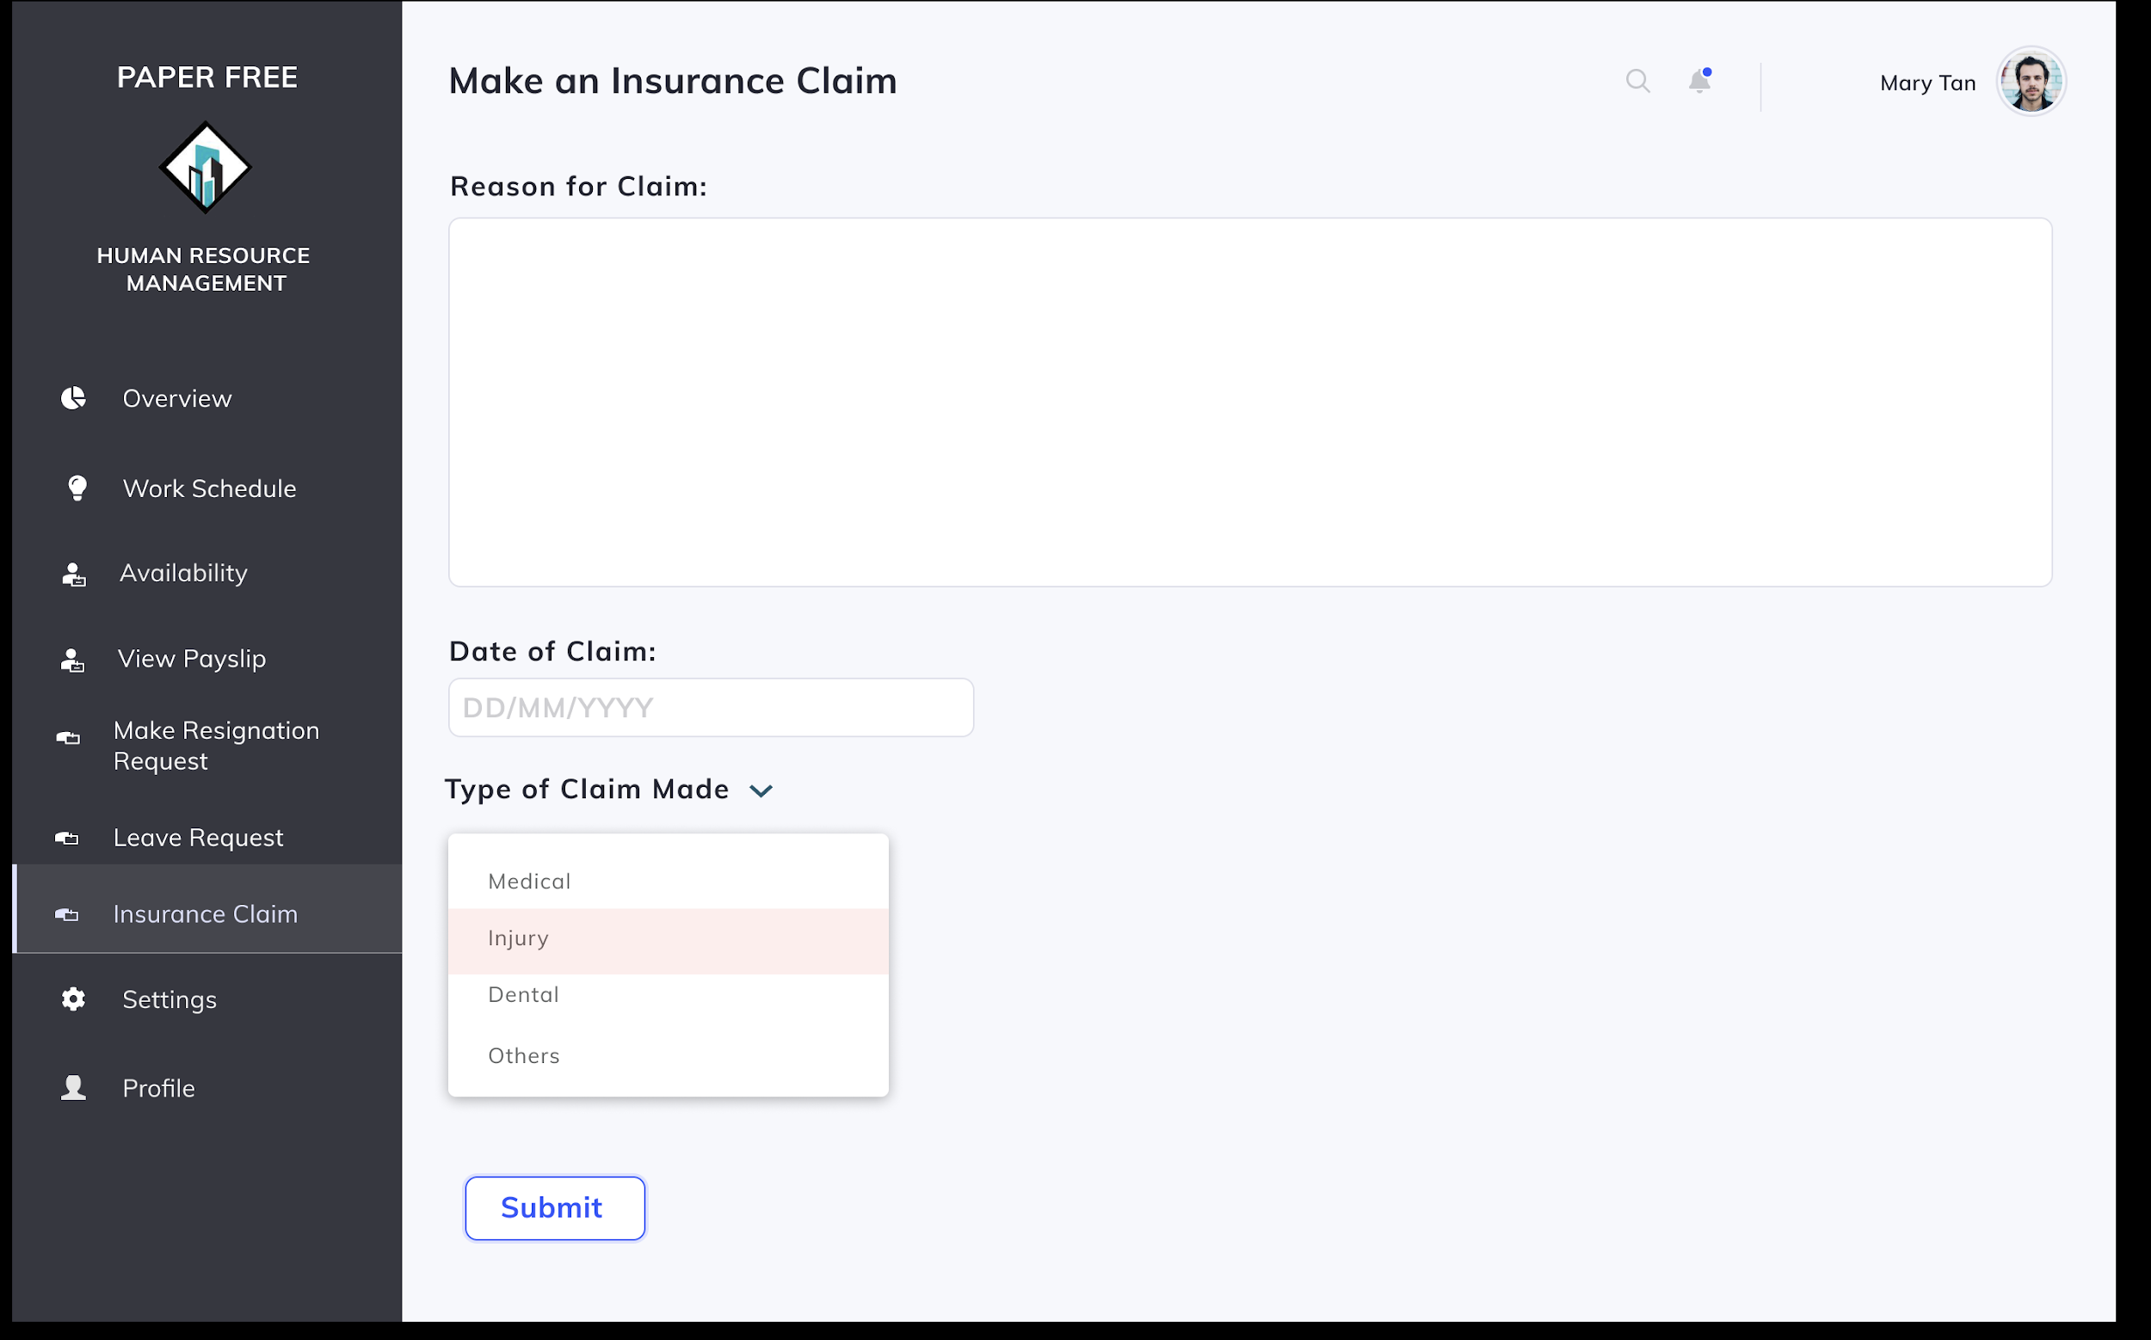

Scenario: Employee (Construction Team Member) Mary Tan wishes to submit an insurance claim request.

1. Employee Mary clicks on the Insurance Claim tab on the left of the screen.
2. Mary selects the option to Make an Insurance Claim.
3. Mary inputs all fields required - type of claim made, date of claim and reason for claim.
4. To confirm submission of the insurance claim request, she presses on the “Submit” button.
5. System displays confirmation message of insurance claim request made indicating successful request.

#### **4.1.4.2.4 Approve leave request**

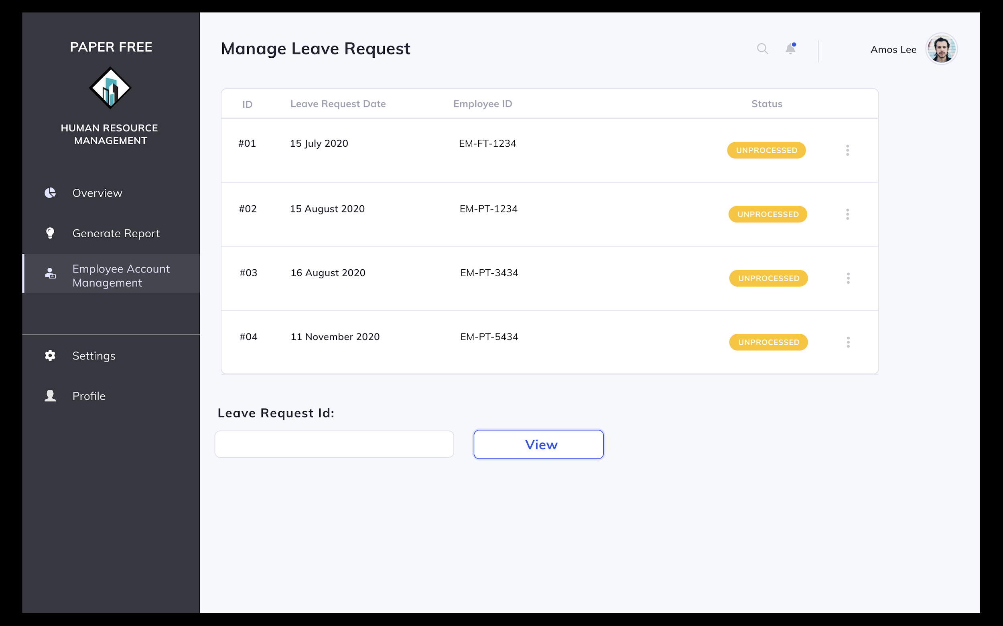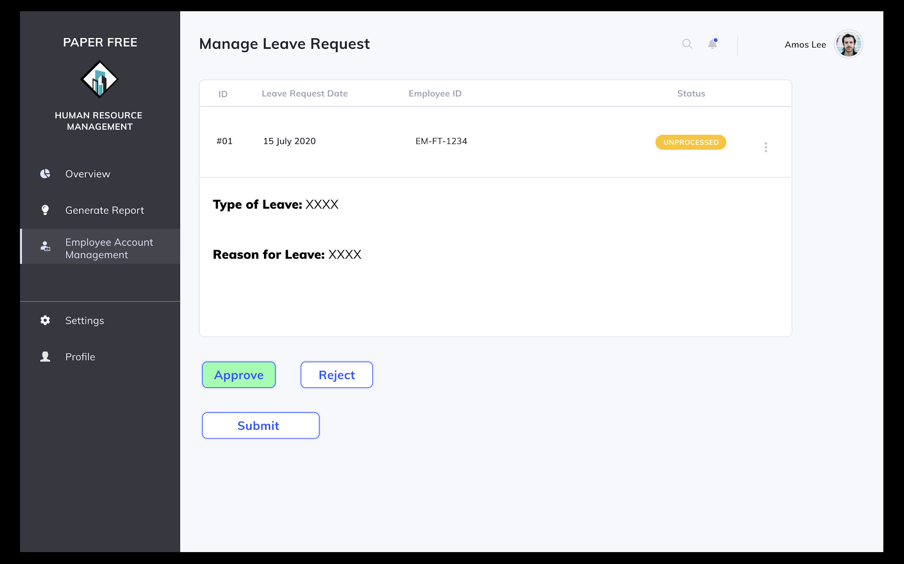

Scenario: HR Staff Amos Lee wishes to approve a leave request.

1. Amos selects on Leave Requests Management tab on the left of the screen.
2. Amos selects the option to manage a leave request.
3. System shows all unprocessed leave requests in the system.
4. Amos clicks on a specific leave request and the system shows the details of the request.
5. Amos selects option to manage the request.
6. Amos clicks on “Approve” button and the “Submit” button to confirm approval of the leave request.
7. System displays confirmation message indicating approval of the leave request was successful.

#### **4.1.4.2.5 Reject leave request**

Scenario: HR Staff Amos Lee wishes to reject a leave request.

1. Amos selects on Leave Requests Management tab on the left of the screen.
2. Amos selects the option to manage a leave request.
3. System shows all unprocessed leave requests in the system.
4. Amos clicks on a specific leave request and the system shows the details of the request.
5. Amos selects option to reject the request.
6. Amos clicks on “Reject” button and the “Submit” button to confirm rejection of the leave request.
7. System displays confirmation message indicating rejection of the leave request was successful.

#### **4.1.4.2.6 Generate report of leave records**

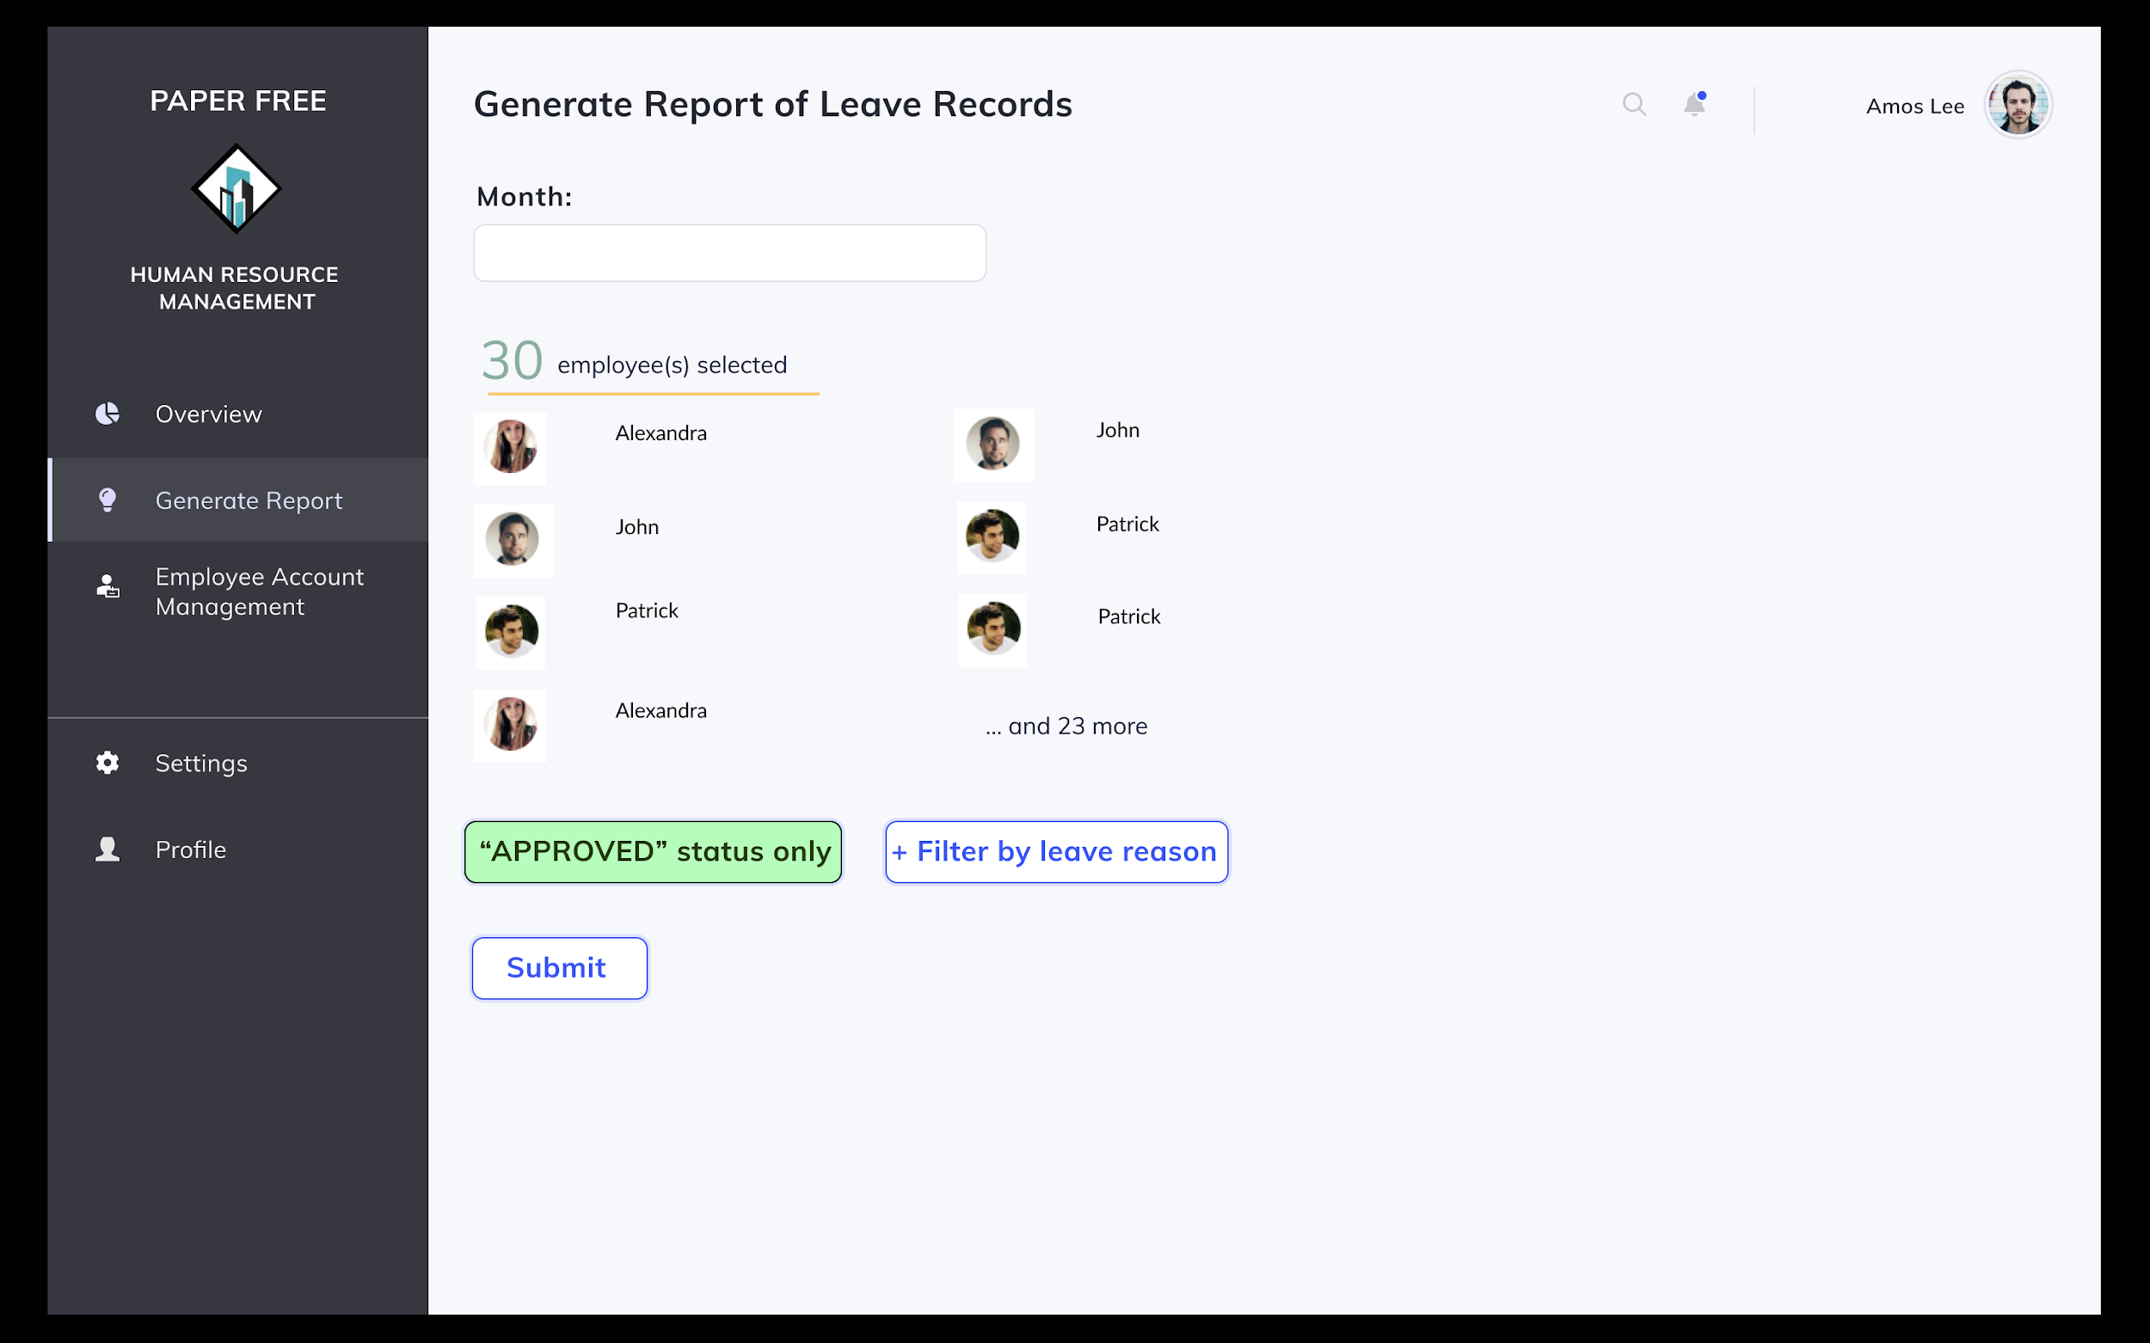

Scenario: HR Staff Amos Lee wishes to generate a report to check past leave records.

1. Amos selects on the Generate Report tab on the left of the screen.
2. He then selects the option to generate report of leave records.
3. System prompts user to put in employees involved and time window of leave requests made.
4. Amos checks all employees involved and includes time window of leave requests made using the dropdown box.
5. To confirm generation of report, Amos presses on the “Submit” button.
6. System displays report of leave records.
7. In order to narrow his results down further, Amos inputs relevant filters - approved or rejected, specific employees, reason for making the leave request and/or type of leave and clicks on the “Filter” button.
8. System displays report of leave records.

#### **4.1.4.2.7 Generate report of medical claims**

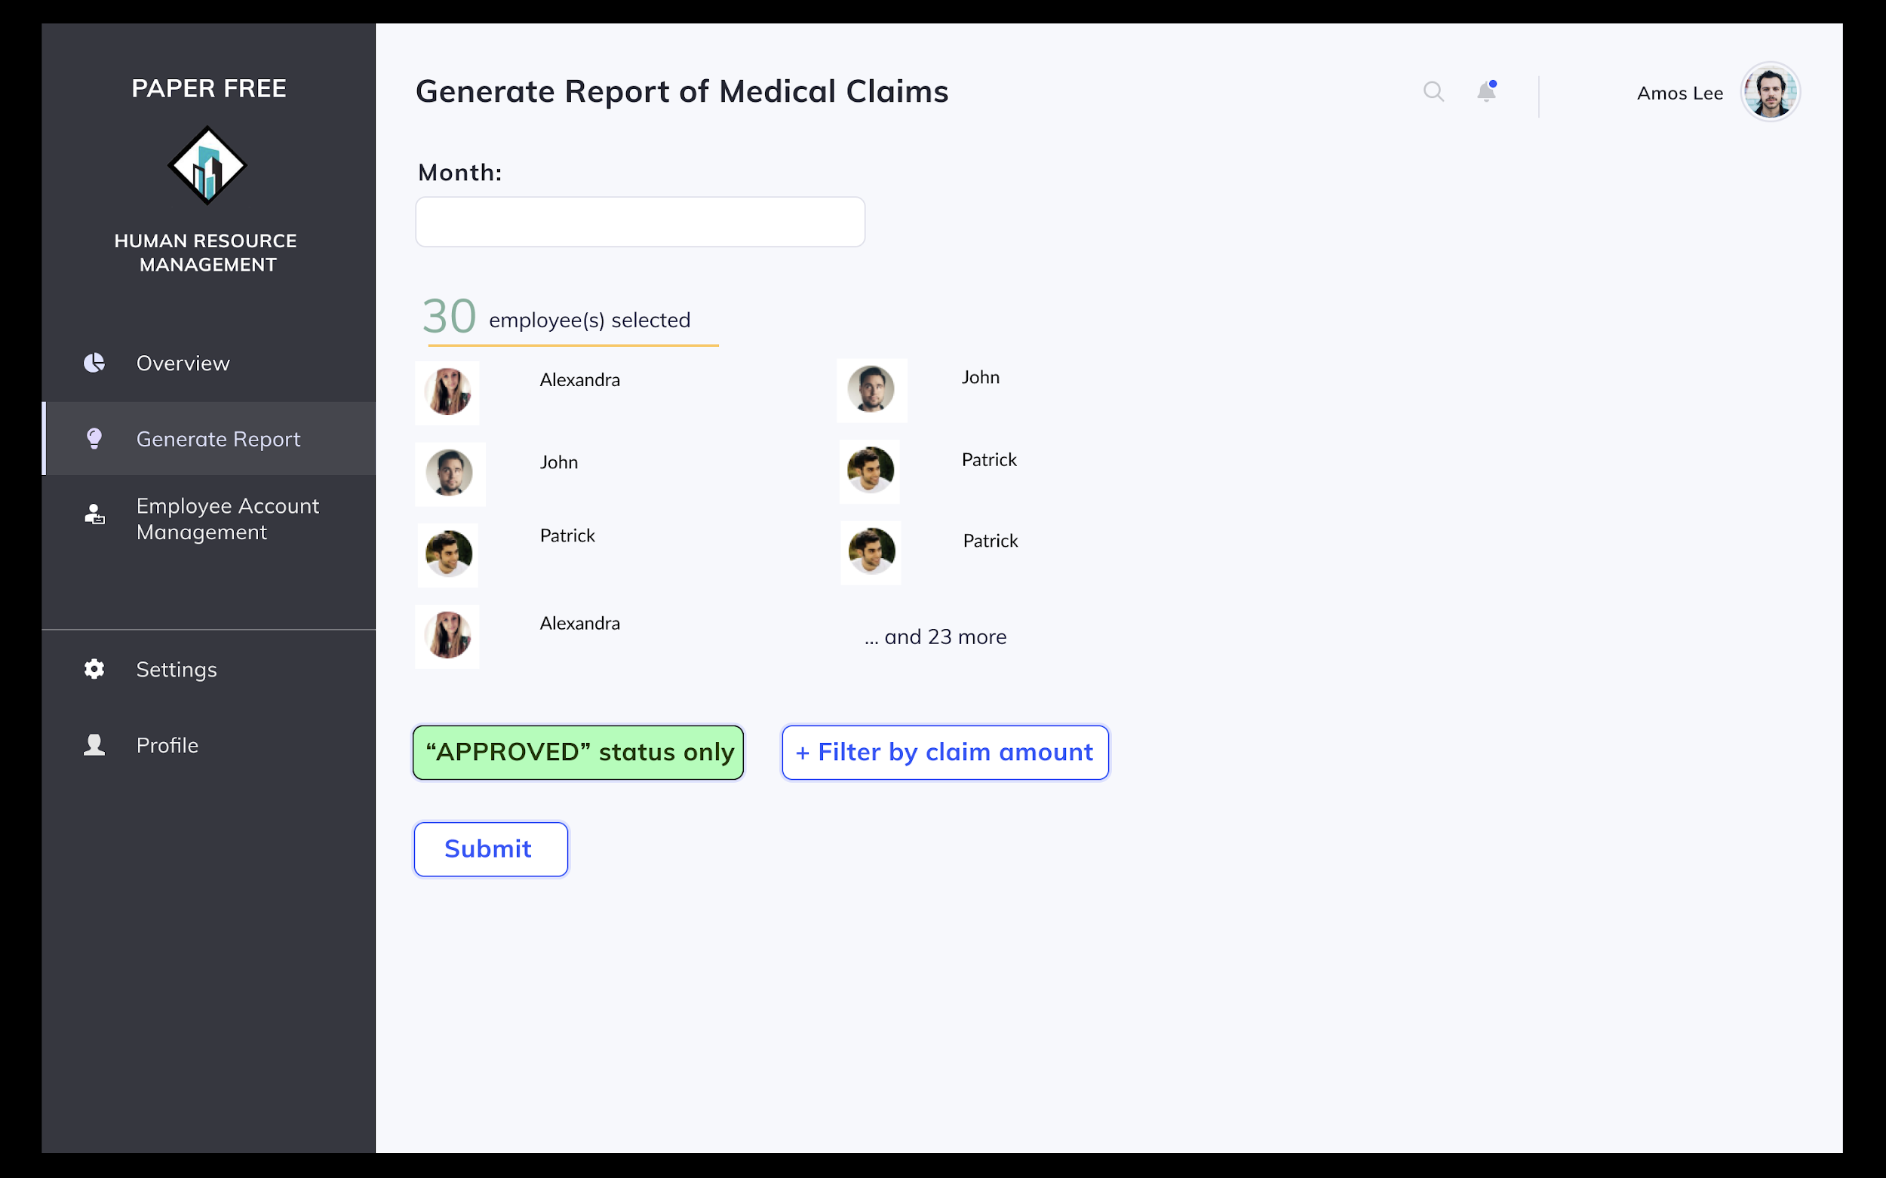

Scenario: HR Staff Amos Lee wishes to generate a report of past medical claims.

1. Amos selects on the Generate Report tab on the left of the screen.
2. He then selects the option to generate report of past medical claims.
3. System prompts user to put in employees involved and time window of claims made.
4. Amos checks all employees involved and includes time window of claims made using the dropdown box.
5. To confirm generation of report, Amos presses on the “Submit” button.
6. System displays report of past medical claims.
7. In order to narrow his results down further, Amos inputs relevant filters - approved or rejected, specific employees or by claim amount and clicks on the “Filter” button.
8. System displays report of medical claims.

### **4.1.4.3 Attendance Management Module**

#### **4.1.4.3.1 Validate work hours of employees**

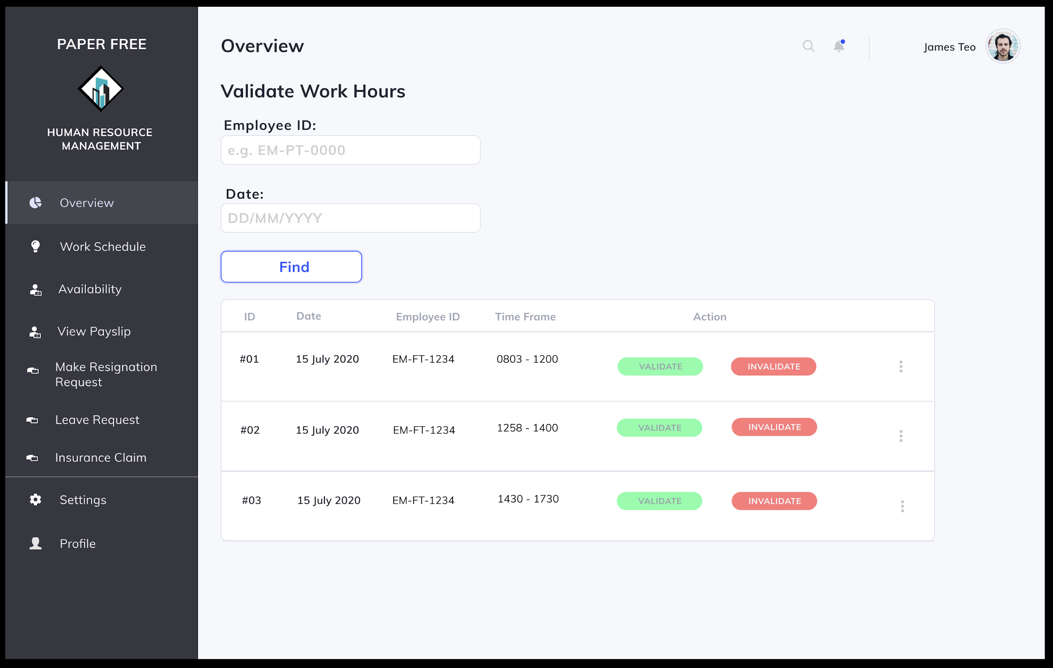

Scenario: Employee (Construction Team Leader) James Teo wants to validate the work hours of employee Mary Tan.

1. James selects on the Validate Work Hours tab on the screen.
2. He inputs Mary’s ID and date to be validated into the system.
3. System displays Mary’s work hours, start and end times.
4. James can choose to either select on the “Validate” or “Invalidate” buttons on the bottom of the screen.

#### **4.1.4.3.2 Generate report of late-coming**

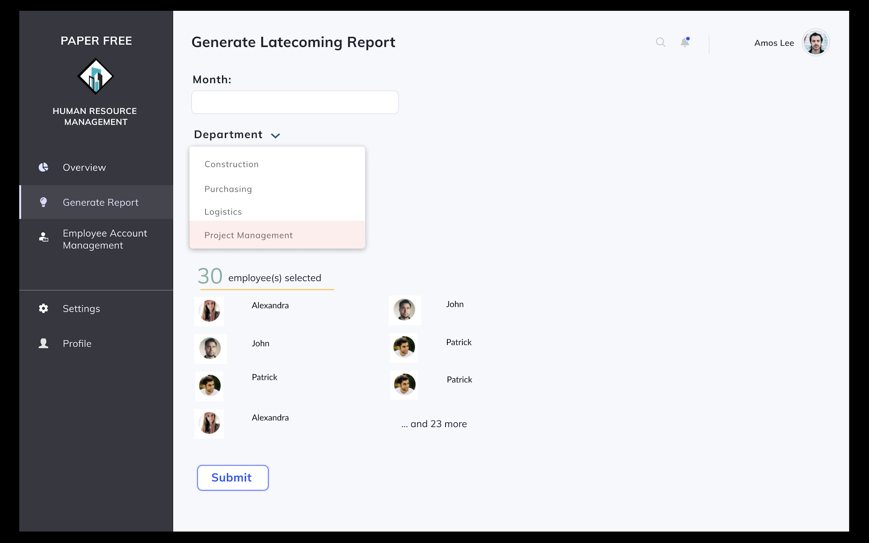

Scenario: HR Staff Amos Lee wishes to generate a report of late-coming.

1. Amos selects on the Generate Report tab on the left of the screen.
2. He then selects the option to generate report of late-coming.
3. System prompts user to input the department and employees involved and time window to be checked.
4. Amos checks all employees involved, and use the dropdown box to indicate department and time window to be checked.
5. To confirm generation of report, Amos presses on the “Submit” button.
6. System displays report of late-coming.
7. In order to narrow his results down further, Amos inputs relevant filters - specific employees and/or punctual or late statuses and clicks on the “Filter” button.
8. System displays report of late-coming.

#### **4.1.4.3.3 Generate report of overtime**

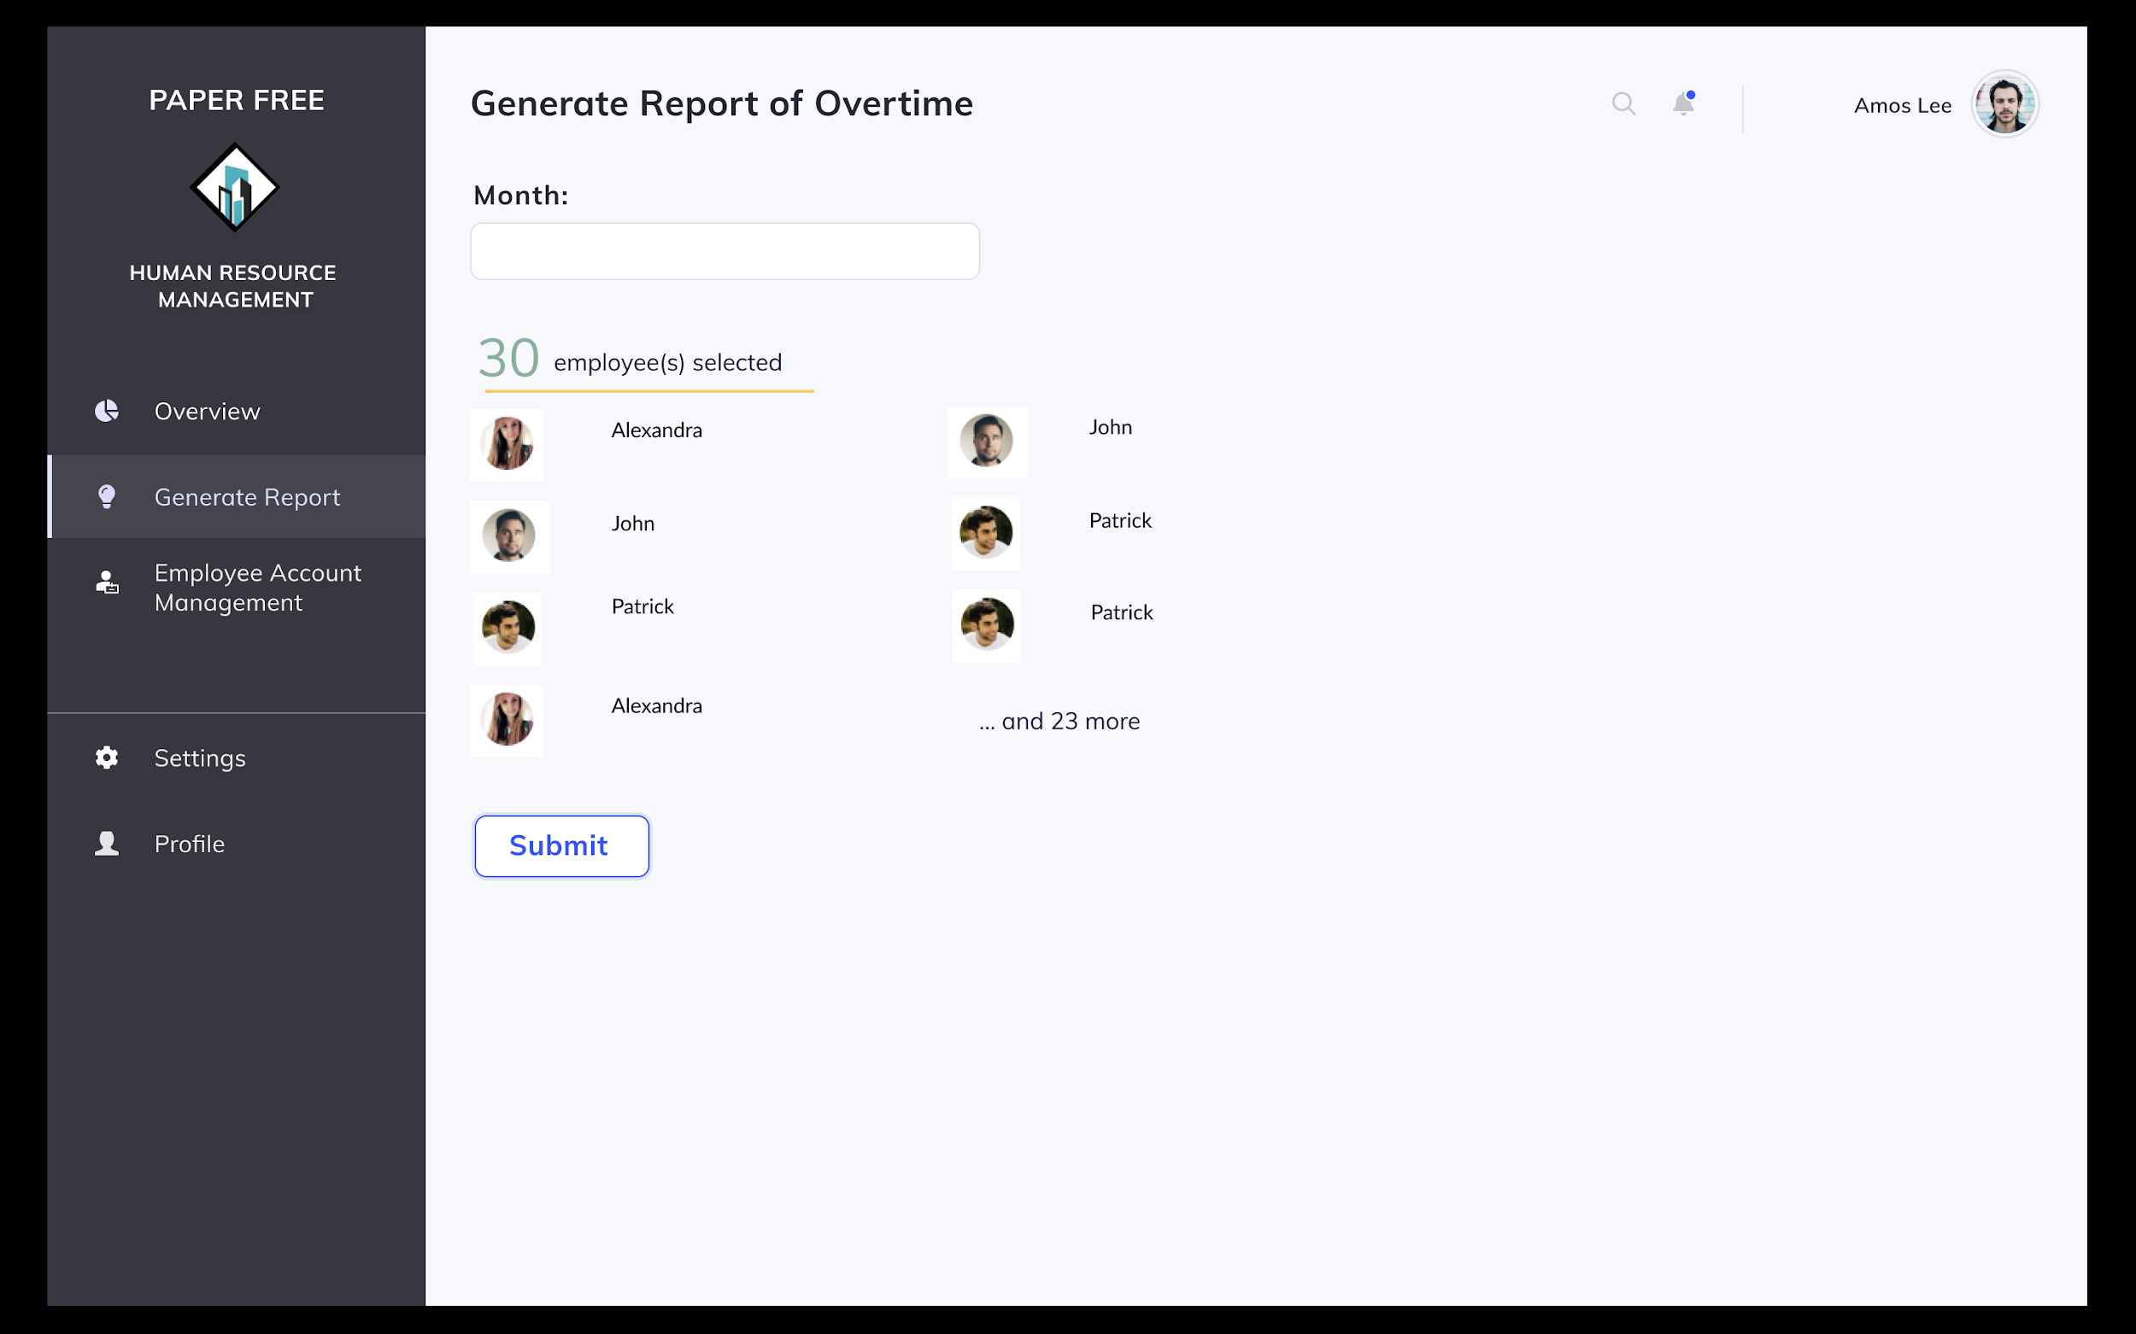

Scenario: HR Staff Amos Lee wishes to generate a report of overtime.

1. Amos selects on the Generate Report tab on the left of the screen.
2. He then selects the option to generate report of overtime.
3. System prompts user to input the employees involved and time window to be checked.
4. Amos checks all employees involved, and use the dropdown box to indicate time window to be checked.
5. To confirm generation of report, Amos presses on the “Submit” button.
6. System displays report of overtime.

#### **4.1.4.3.4 Collate work hours for each employee**

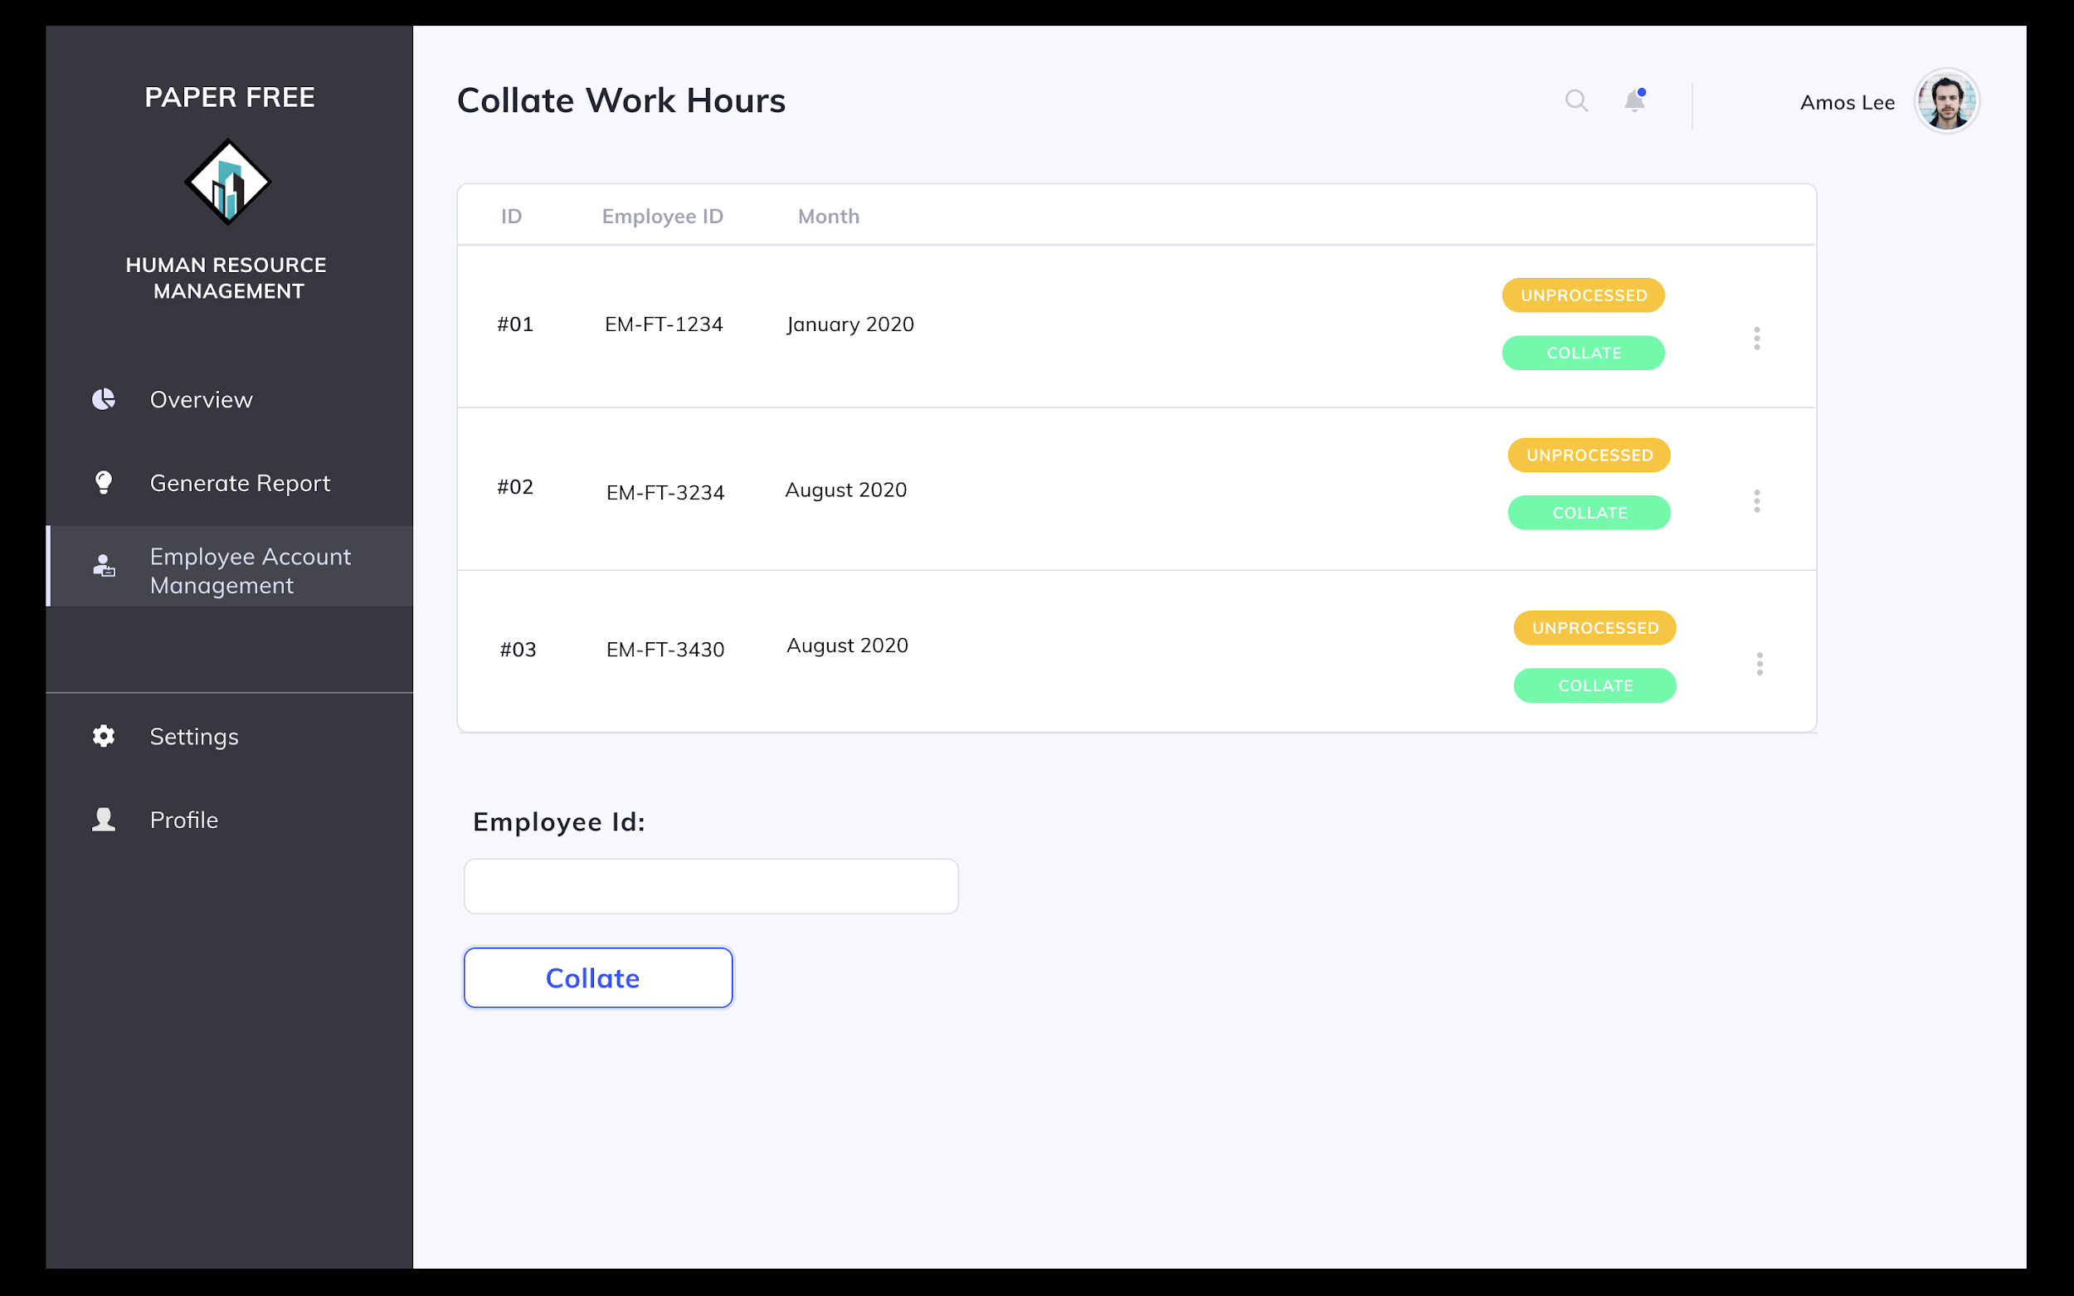

Scenario: HR Staff Amos Lee wishes to collate work hours for Employee Mary Tan.

1. Amos selects on Employee Management tab on the left of the screen.
2. Amos selects option to collate work hours.
3. Amos inputs Mary’s Employee Id into the system and time period to be collated.
4. Amos selects on “Collate” button at the bottom of the screen.
5. System displays the worked hours of the Mary according to specified time period and displays the collated version below.

# 

# **4.2 Project Management Subsystem**

## **4.2.1 Description**

The Project Management Subsystem is a subsystem that contains three modules, namely the General Project Management Module, Tender Management Module and the Resource management module.

The General Project Management Module contains methods that allow Construction Team Leaders and Construction Team Members to manage project plans and tasks, as well as view members’ profiles and cost records.

The Tender Management Module contains methods that allow Construction Team Leaders to manage Invitation to Tenders and Tenders themselves. It also allows Contractors to upload their tenders to the system.

The Resource Management Module contains methods that allow Construction Team Leaders to manage resources such as materials and manpower to a project.

## **4.2.2 Business Objectives**

The Project Management Subsystem aims to track the progress of projects, cost and productivity levels as well as facilitate timeline planning. The goal is to store all these important information in a centralised location for easy access to create an efficient project management process.

## **4.2.3 Business Assumptions**

We assume that in the company, each construction team consists of a leader and many members. The construction team leader will be in charge of a project. He/she will create a project plan and add the necessary members into the project plan accordingly. Construction team members will be allocated numerous tasks within the project by the team leader. The construction team leader is also in charge of inviting tenders from external contractors and managing them. He / she will also be able to access the cost records to view all costs regarding that particular project that they are handling.

## **4.2.4 Business Processes (Usage scenarios)**

### 4.2.4.1 General Project Management Module

#### **4.2.4.1.1 Create Project Plan**

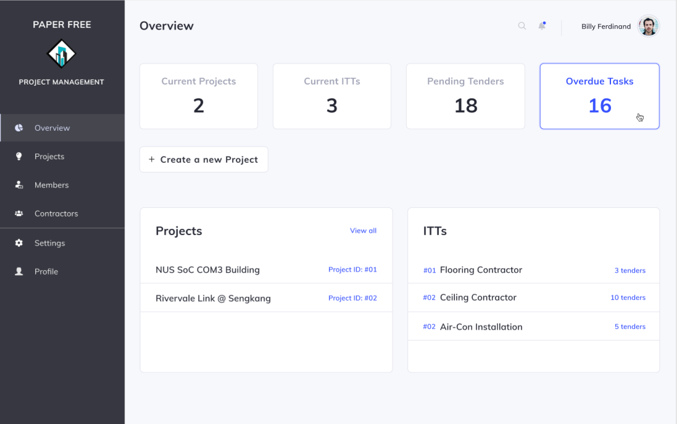

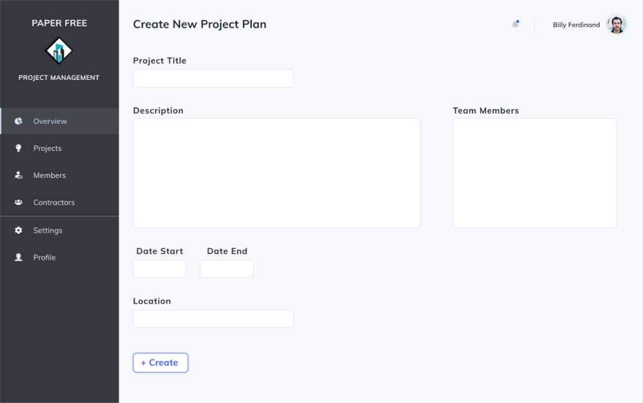

Scenario: Construction Team Leader Billy wishes to create a new project plan.

1. Construction Team Leader Billy clicks on “Create a new project”.
2. System displays fields for Billy input the title, description, time period and location of the project.
3. Billy enters the required fields and clicks the “Confirm” button.
4. System will create a new project record and save it to the database.
5. System brings Billy back to the landing page.

#### **4.2.4.1.2 View Overall Project Progress**

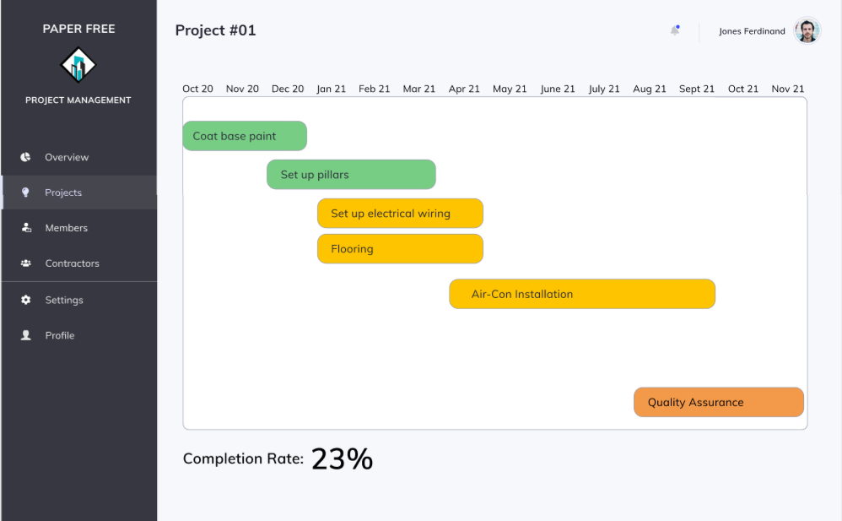

Scenario: Construction Team Leader Jones wants to check on the progress of the project.

1. Anthony clicks on a project that he wishes to view.
2. System displays all the information on that project including all completed and uncompleted tasks as well as a tabulation of the project completion rate.

#### **4.2.4.1.3 View Team Members’ Profile**

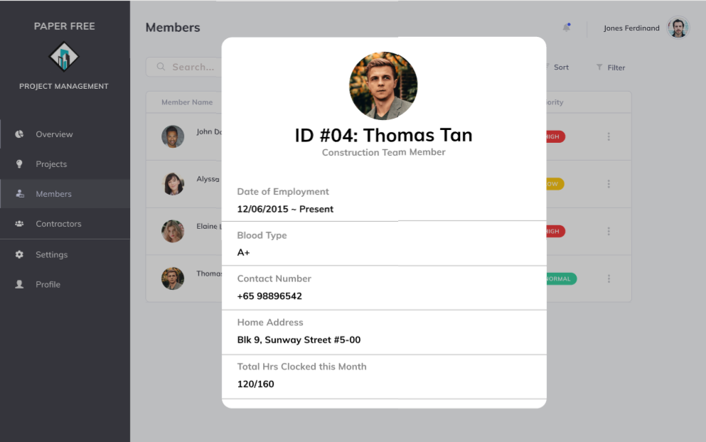

Scenario: Construction Team Leader Jones wishes to view the profile of a particular member.

1. Melvin selects the “Members” tab.
2. System displays a list of all Construction Team Members.
3. Melvin selects the member’s profile that he wants to view.
4. System displays the information of the selected member.

#### **4.2.4.1.4 View Cost Records**

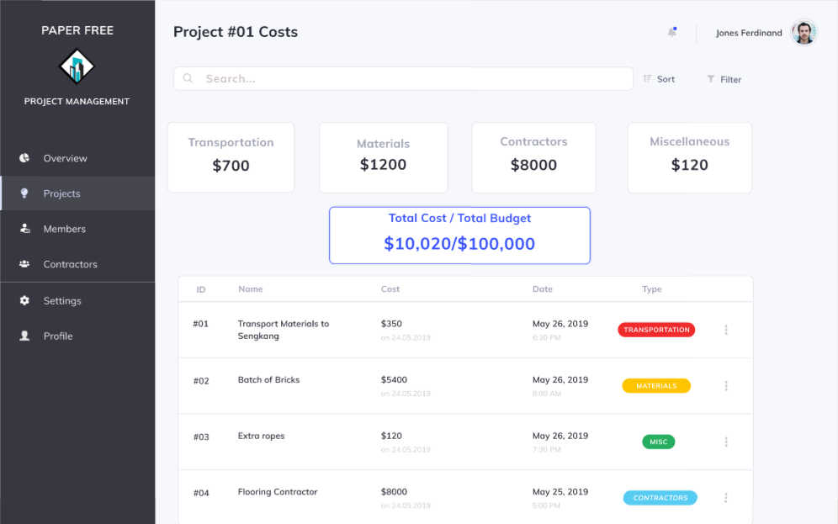

Scenario: Construction Team Leader Jones wishes to view the cost records of projects.

1. Ben searches for cost records that he wants to view by entering keywords.
2. System displays a list of all cost records associated to the keywords.
3. Ben selects a cost record.
4. System displays information of the cost record.

#### **4.2.4.1.5 View Assigned Project Tasks**

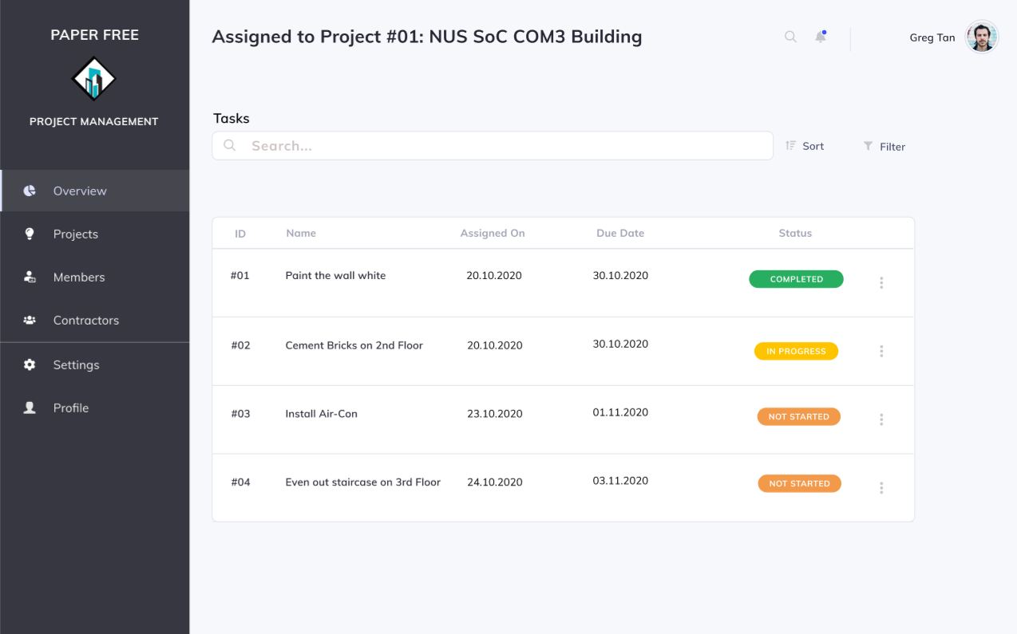

Scenario: Construction Team Member Greg wishes to view the project tasks assigned to him.

1. Greg selects “Overview”.
2. System displays list of all task.
3. Greg selects a particular task.
4. System displays all the information of that task.

#### **4.2.4.1.6 Update Status of Task**

#### 

Scenario: Construction Team Member Greg wishes to update the status of a task.

1. Greg selects a task.
2. System displays all the information of that task, including the status of the task.
3. Greg selects either the in progress, completed or uncompleted status option.
4. System updates the status of the task by storing the updated status in the database and displays the updated status.

### 4.2.4.2 Tender Management Module

#### **4.2.4.2.1 Create new “Invitation to Tender” (ITT)**

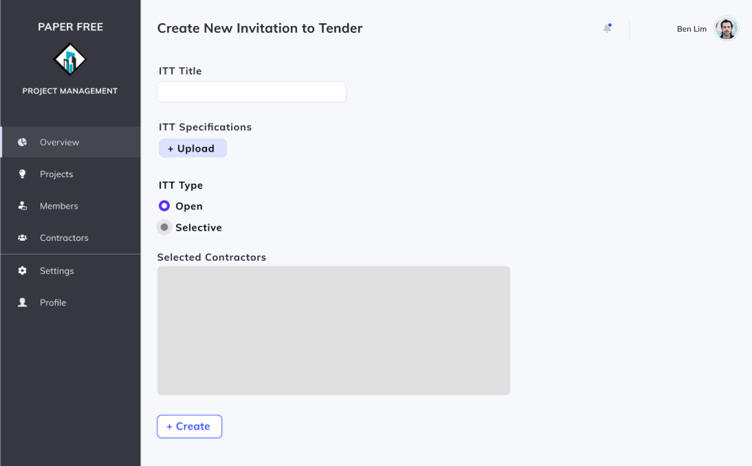

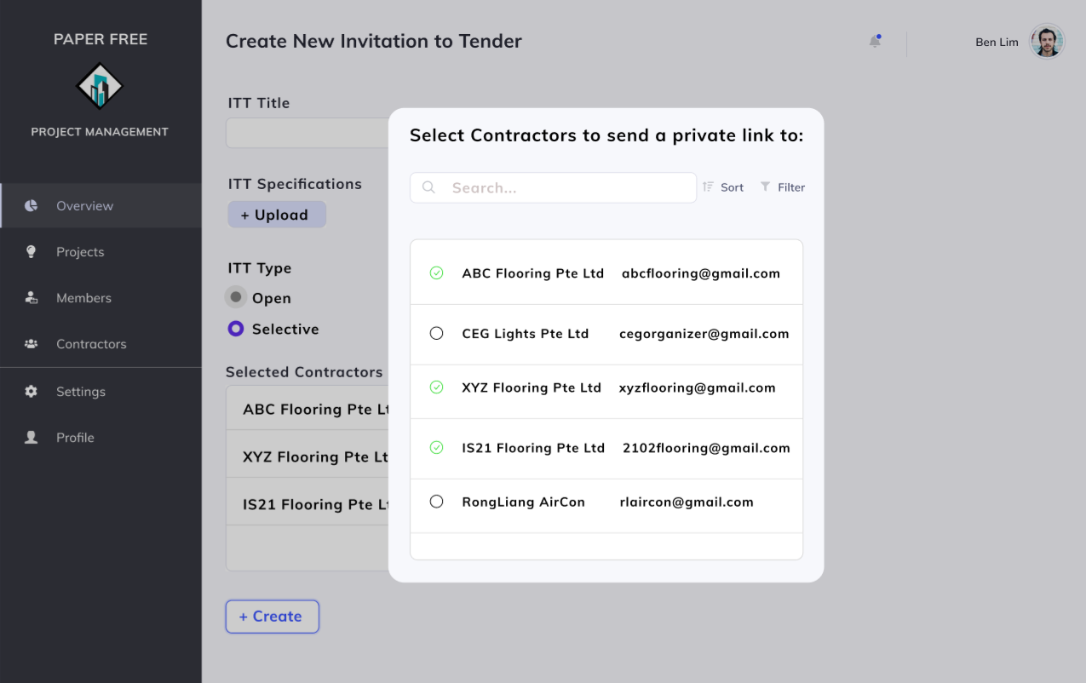

Scenario: Construction Team Leader Ben wishes to create an ITT for contractors to submit tenders for their upcoming construction project.

1. Ben creates a new ITT with pending status by uploading the document.
2. System displays a prompt for Ben to select between open or selective ITT.
3. Ben chooses the option between an open ITT or a selective ITT.
4. If Ben chooses selective ITT, he will select the intended recipients of the ITT from the database and confirm it.
5. System generates a website URL, sends it to the recipients via email and display the confirmation page.

#### **4.2.4.2.2 View Invitation to Tender (ITT) Record**

#### 

Scenario: Construction Team Leader James wishes to view an ITT.

1. James selects “View ITT”.
2. System displays a list of ITTs.
3. James selects an ITT.
4. System displays the information of the ITT.

#### **4.2.4.2.3 Remove Invitation to Tender (ITT)**

Scenario: Construction Team Leader Javier wishes to cancel the ITT and delete it.

1. Javier selects ‘Delete ITT’.
2. System prompts a confirmation popup to ask if Javier really intends to remove the ongoing ITT.
3. Javier clicks ‘Confirm’ to remove the ITT.
4. System removes the pending ITT from the website and changes the status of the ITT to cancelled.

#### **4.2.4.2.4 Update Status of Tenders**

#### 

Scenario: Construction Team Leader Melvin wishes to update the status of a submitted tender from a contractor.

1. Melvin views an ITT.
2. System displays a list of tenders and which company is it submitted by.
3. Melvin selects a tender from the list of tenders.
4. System displays tender information uploaded by contractors/suppliers as well as their company information.
5. Melvin accepts the tender by clicking ‘Accept’
6. System attaches contractor details to the ITT, updates the status of the tender to ‘Accepted’, sends a confirmation email to the winner of the tender and changes ITT status from pending to completed.

#### **4.2.4.2.5 Add Contractor Contact**

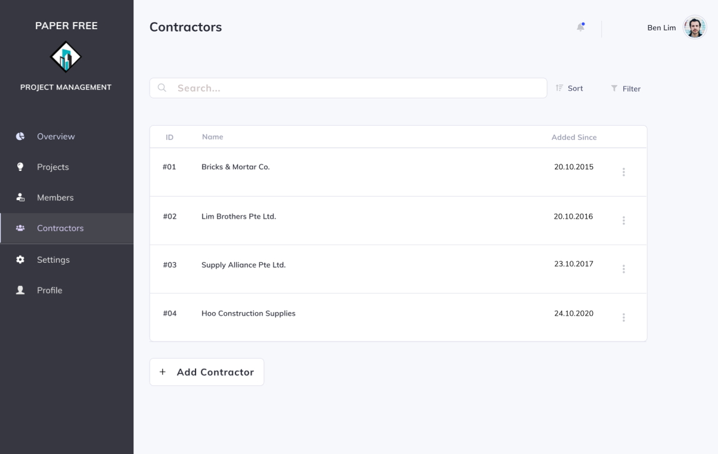

Scenario: Construction Team Leader Ben wishes to add a new contractor’s contact.

1. Ben clicks on ‘Add New Contractor’.
2. System displays fields for Ben to fill in the necessary information.
3. Ben enters the required information.
4. System displays the successful addition of contact

#### **4.2.4.2.6 View Contractor Information**

#### 

Scenario: Construction Team Leader Jones wishes to view a contractor’s information.

1. Jones clicks on ‘View Contractors’.
2. System displays a list of contractors’ information.
3. Jones selects a contractor whose details he wants to view.
4. System displays specific information of the contractor.

#### **4.2.4.2.7 Submit Tender**

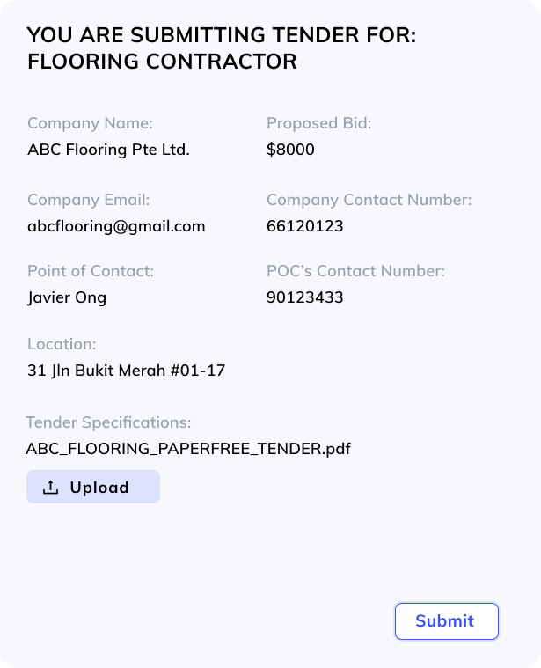

Scenario: Contractor John wishes to submit a tender for an ITT.

1. Since it is an open ITT, John visits the ITT webpage by clicking on a URL link from our main web page or any of our advertising channels.
2. System displays a web page with ITT specifications and an upload button.
3. John clicks on ‘Upload’.
4. System displays a form for the contractor to fill in necessary details.
5. John fills in required information and clicks on ‘Submit’.
6. System attaches company information to the particular tender document, and adds the tender into the database in correspondence to the ITT.

### 4.2.4.3 Resource Management Module

### **4.2.4.3.1** View Inventory Records

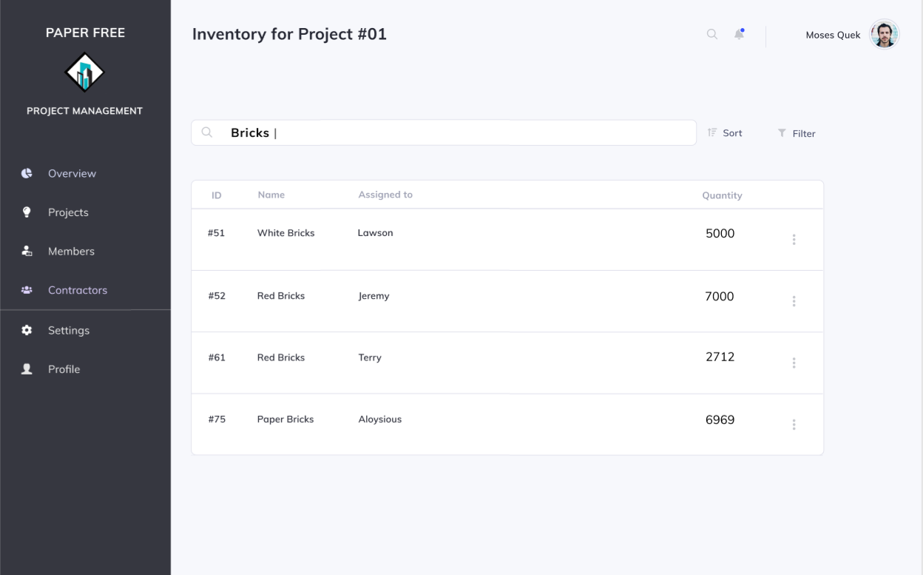

Scenario: Construction Team Leader Moses wants to view the inventory records.

1. Moses searches for inventory records by entering keywords.
2. System displays a list of inventory items associated to the keywords.
3. Moses selects a item.
4. System displays information of that item.

### 4.2.4.3.2 Create Inventory Request

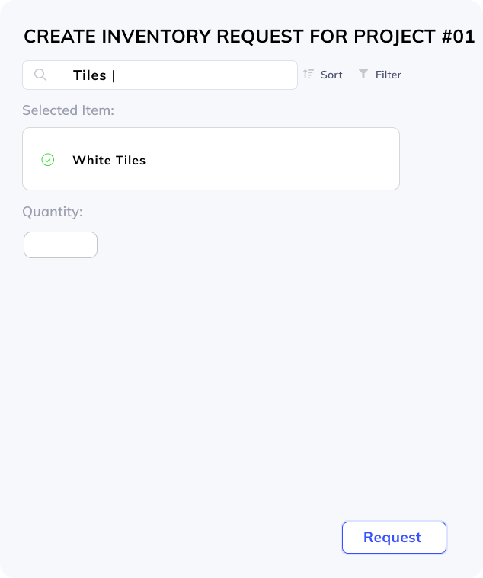

Scenario: Construction Team Leader Ben wants to request for inventory materials required for the project.

1. Ben searches for the materials needed using keywords.
2. System displays a list of materials associated with the keywords.
3. Ben selects the specific material.
4. System prompts the team leader to enter the purpose of request and quantity needed.
5. Ben enters the required information.
6. System creates a pending status material request that awaits the approval of the inventory staff and displays material request creation success.

### 4.2.4.3.3 View Overall Members’ Availability

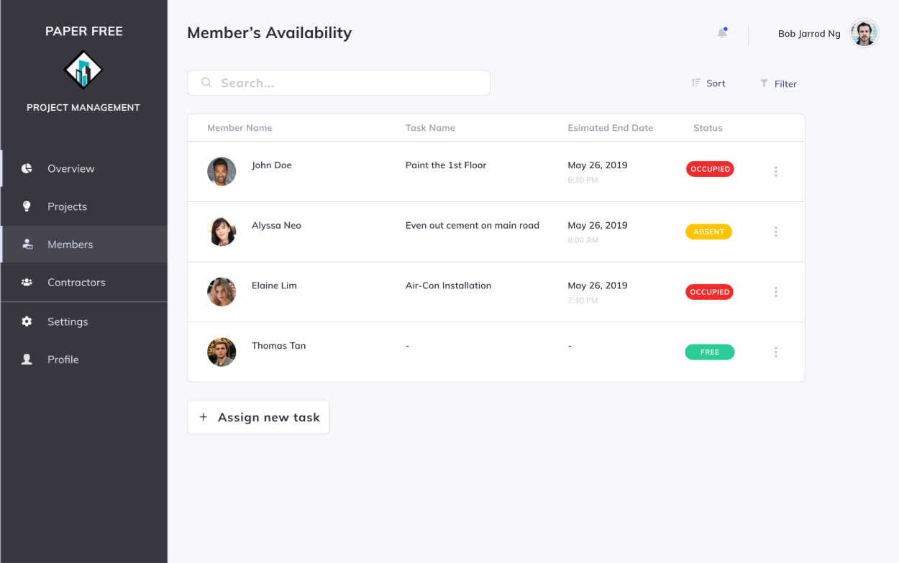

Scenario: Construction Team Leader Bob wants to assign tasks to members and needs to know the availability of members.

1. Bob selects view team members availability.
2. System displays a list of member’s availability status (available or occupied) at the current time.

### 4.2.4.3.4 Create Tasks

### 

Scenario: Construction Team Leader Parry wants to create tasks within a project for a Construction Team Member.

1. Parry selects assign new task.
2. Prompts Parry to enter date of assignment, deadline, name of members to assign the task to, title, instructions.
3. Parry enters the required details.
4. System creates task file and displays task creation success.

# **4.3 Logistics Management Subsystem**

## **4.3.1 Description**

The Logistics Management Subsystem is a subsystem that comprises three modules: Supplier Management, Inventory Management, Procurement Management.

The Supplier Management Module contains methods that allow inventory staff to add suppliers, view all the suppliers associated with the company, view supplier details, add inventory that the supplier supplies, generate all inventory supplied by a supplier, and generate the order fulfilment rate achieved by a supplier.

The Inventory Management module contains methods that allow inventory staff to keep stock of inventory, view inventory details and locations, and process inventory requests for projects.

Finally, the Procurement Management module contains methods that allow procurement staff to create procurement records, manage procurement statuses and request for stock to be transferred from existing suppliers to the company’s warehouses.

## **4.3.2 Business Objectives**

The Logistics Management Subsystem is targeted to keep track of all inventory as well as supplier details to improve efficiency and assist in procurement efforts. It also helps to simplify the process of reserving inventory for large scale companies that are working on multiple projects simultaneously while ensuring all logistics are properly accounted for. Warehouse supplies can also be easily monitored to ensure that minimal time is wasted on projects due to restocking of inventory.

## **4.3.3 Business Assumptions**

At every warehouse, there will be a terminal to update stock counts on the spot. A construction company is allowed to have more than one warehouse to store their inventory.

Procurement staff are expected to update the status of procurement records whenever there are any changes. When calculating order fulfilment rates from suppliers, only procurement records marked as completed will be deemed to be successful. Inventory transfer requests are assumed to not involve any extra costs so there is no need for the Accounting and Finance management subsystem to be involved in the process of creating transfer requests.

## **4.3.4 Business Processes (Usage scenarios)**

### 4.3.4.1 Supplier Management Module

#### **4.3.4.1.1 Generate Report of Inventory Managed by Supplier**

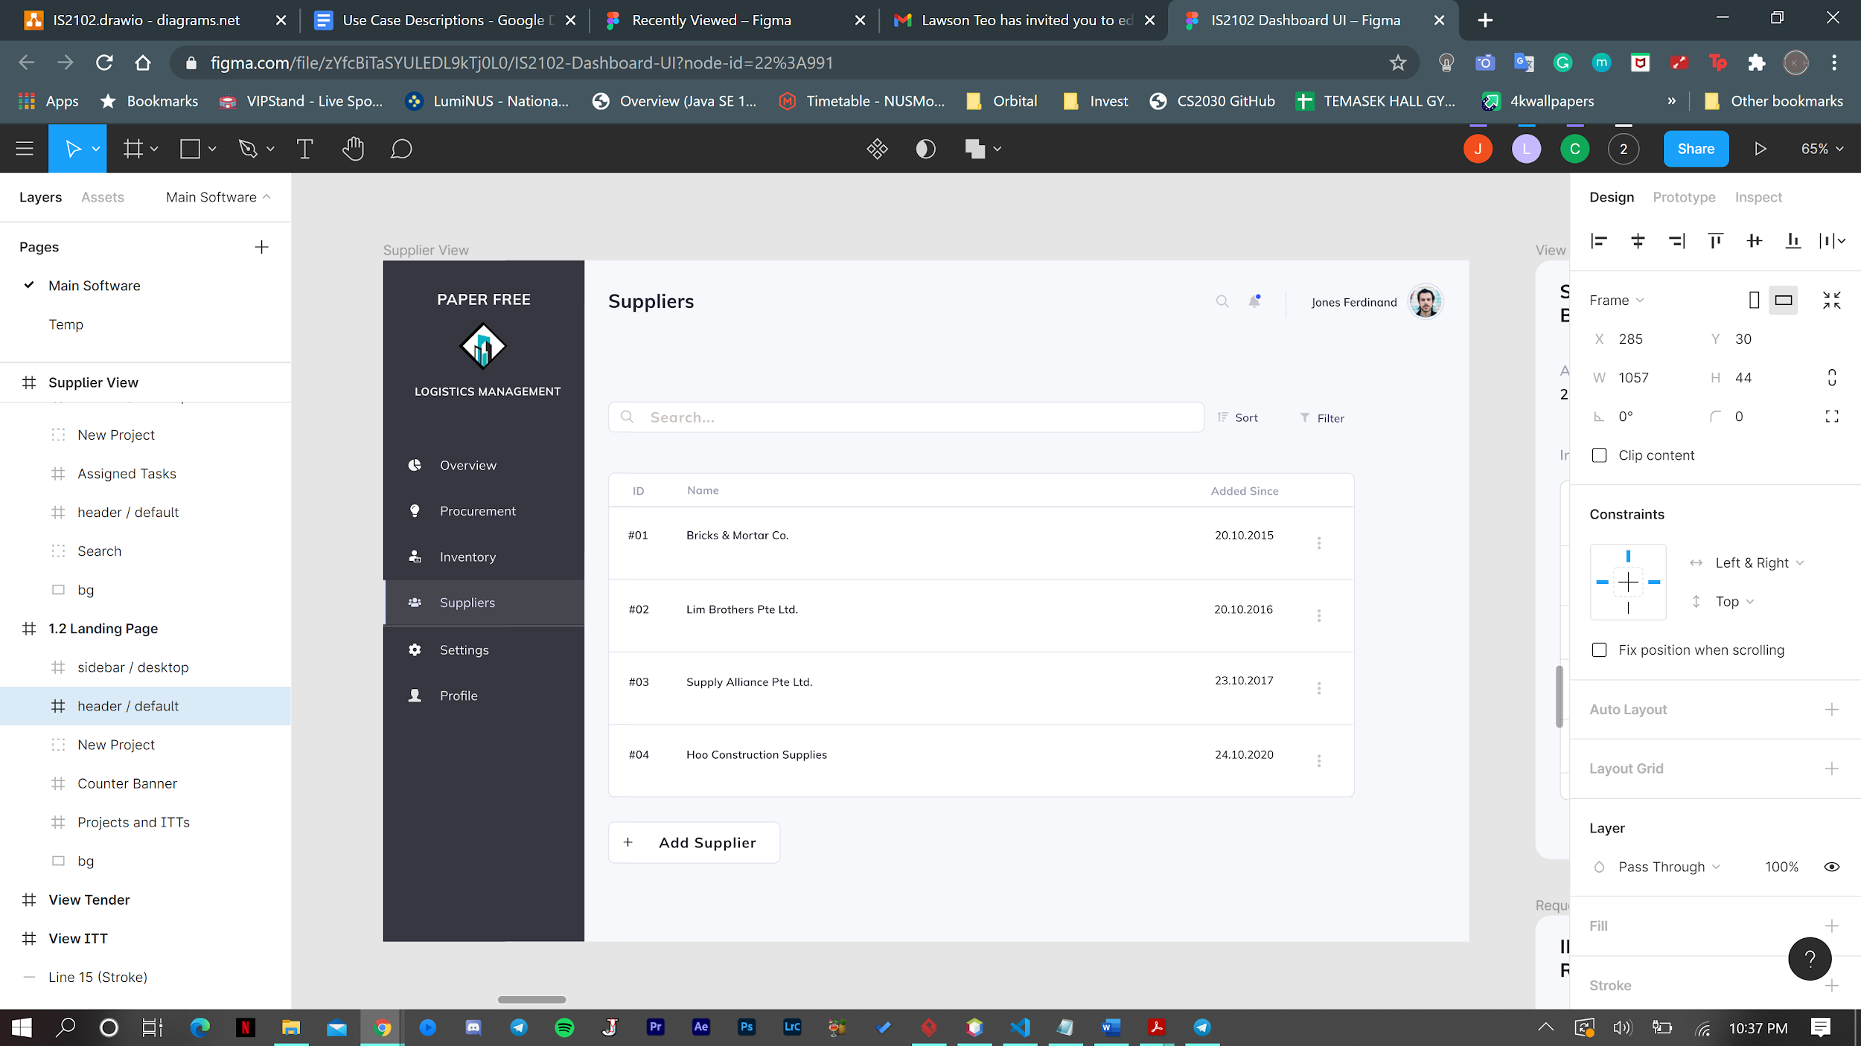

Scenario: Inventory staff Jones wishes to generate a list of all inventory supplied by Bricks & Mortar Co.

1. Inventory Staff John Tan clicks on the Suppliers tab and then inputs Bricks & Mortar into the search bar.
2. System returns list of suppliers matching name.
3. John clicks on the Bricks & Mortar Co. to display supplier information.
4. System redirects to a page that displays a list of inventory supplied by Bricks & Mortar Co.

#### **4.3.4.1.2 Add Supplier**

Scenario: Inventory staff Jones wishes to add a new Supplier ABC Bricks as one of the suppliers for the company.

1. John clicks on the Suppliers tab and clicks the Add New Supplier Button.
2. System prompts John to enter details of the new supplier with a modal window.
3. John enters company details of ABC Bricks and clicks save.
4. System saves ABC Bricks into the database.

#### 

#### **4.3.4.1.3 Edit Supplier**

Scenario: Inventory Staff John Tan wishes to edit details of Supplier Bricks & Mortar Co.

1. John clicks the Suppliers tab and searches for Bricks & Mortar Co. He then clicks Bricks & Mortar Co.
2. System shows a modal window with fields containing the details of Bricks & Mortar Co. for John.
3. John clicks on the edit button.
4. John updates the fields as required and clicks save.
5. System updates the details of Bricks & Mortar Co. that have been changed.

#### **4.3.4.1.4 Add Supplier Inventory**

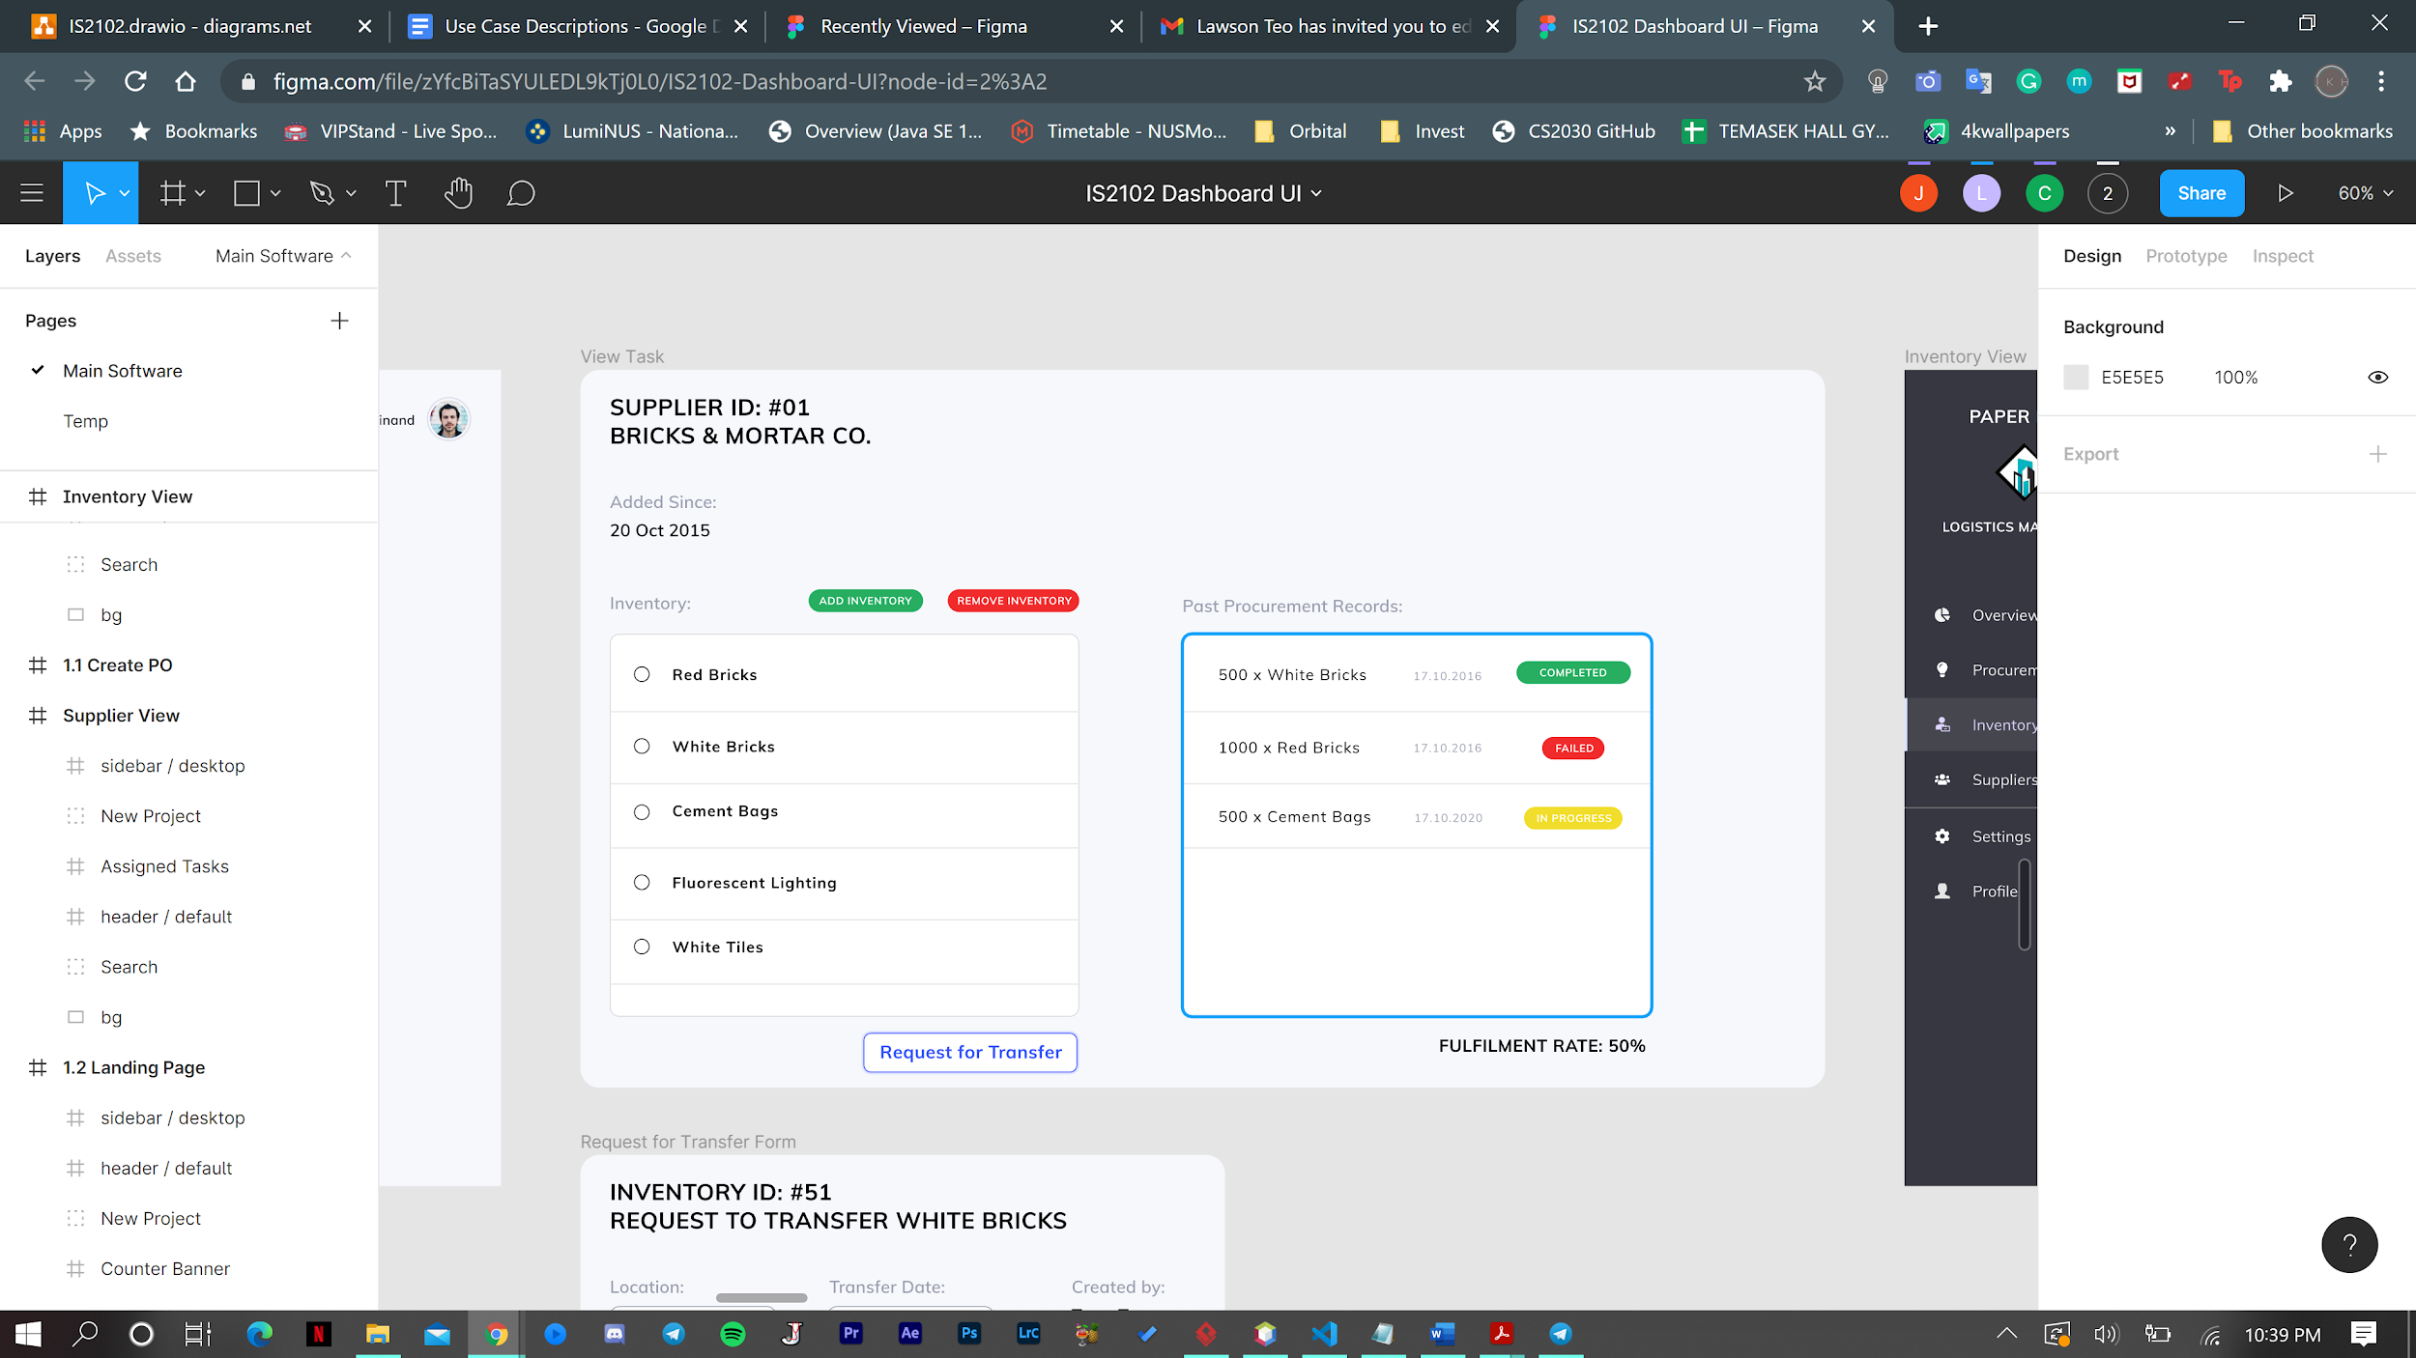

Scenario: Inventory Staff John Tan wishes to add the inventory Helmets under Supplier Bricks & Mortar Co.

1. John clicks the Suppliers tab and searches for Bricks & Mortar. He then clicks the Bricks & Mortar Co.
2. System redirects to a page that displays a list of inventory supplied by Bricks & Mortar Co.
3. John clicks on Add Inventory button at the top of the page.
4. System will show a modal window for John to input details of the new Inventory.
5. John enters Helmets into the window and clicks save.
6. System saves Helmets as an inventory supplied by Bricks & Mortar Co. and displays it in the View Inventory page.

#### **4.3.4.1.5 Remove Supplier**

Scenario: Inventory Staff John Tan wishes to remove Supplier Bricks & Mortar Co. from the system.

1. John clicks on the Remove button beside Supplier Bricks & Mortar Co. in the Suppliers tab.
2. System prompts John to confirm if he wants to Remove ABC Bricks in a modal window. John clicks the Confirm button to confirm the removal.
3. Supplier record for Bricks & Mortar Co. is accordingly removed from database. System displays the updated list of suppliers.

#### **4.3.4.1.6 Remove Supplier Inventory**

Scenario: Inventory Staff John Tan wishes to remove Helmets as an inventory supplied by ABC Bricks.

1. John clicks the Suppliers tab and searches for Bricks & Mortar Co. He then clicks on Bricks & Mortar Co.
2. System redirects to a page that displays a list of inventory supplied by ABC Bricks.
3. John clicks on the Remove Inventory button at the top of the page, then selects the item Helmets.
4. System will display a modal window for John to confirm the removal of Helmet. John clicks the Confirm button.
5. System disassociates the Helmet inventory item from Bricks & Mortar Co. in the database and displays the updated list of inventory supplied.

#### 

#### **4.3.4.1.7 Generate Supplier Order Fulfillment Rate**

Scenario: Inventory Staff John Tan wishes to generate the order fulfillment rate for Supplier Bricks & Mortar Co.

1. John clicks the Suppliers tab and searches for Bricks & Mortar Co. He then clicks on Bricks & Mortar Co.
2. The system redirects John to a page displaying the order fulfillment rate on the right and details of past orders that have been successful/failed.

### 4.3.4.2 Inventory Management Module

#### **4.3.4.2.1 Generate Inventory Stock Count**

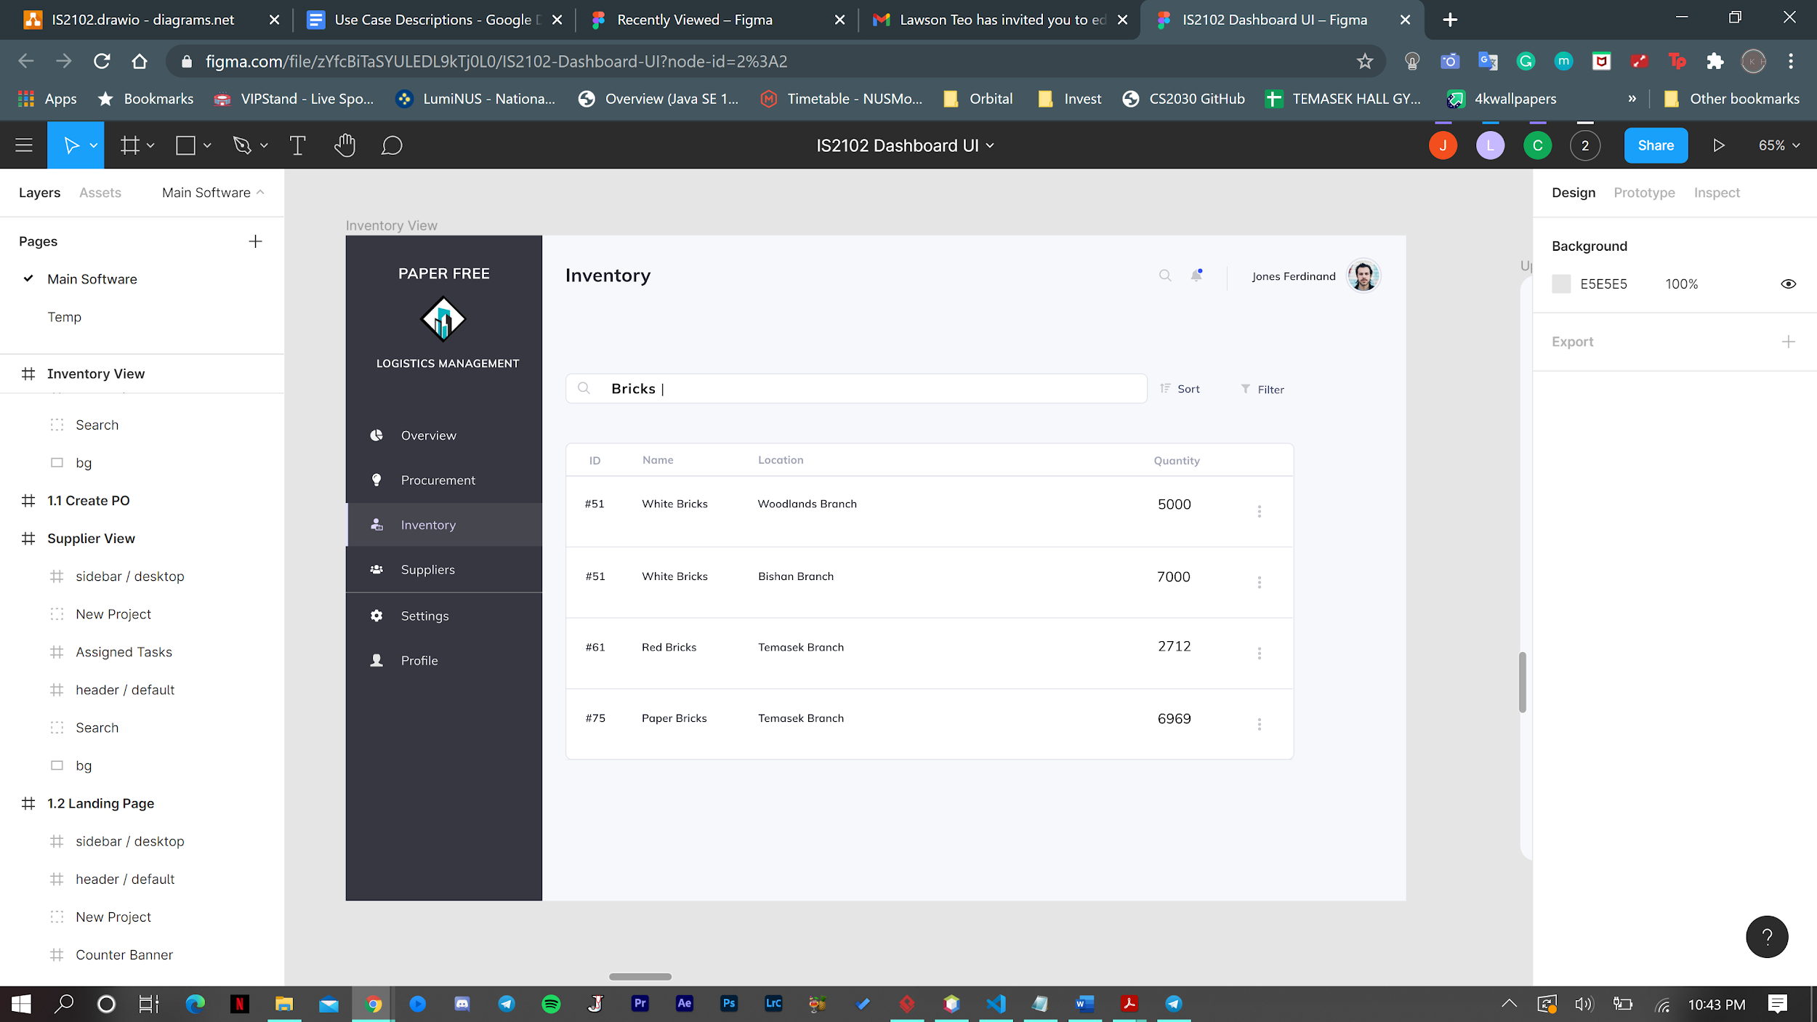

Scenario: Inventory Staff Jones Ferdinand wishes to know the stock count of Bricks the company currently owns.

1. John clicks on the inventory tab at the left of the page and enters Bricks into the search bar. John clicks the view details button beside the Helmet record.
2. System displays all the total current stock count of bricks in all warehouses.

#### 

#### **4.3.4.2.2 Generate Inventory Locations**

Scenario: Inventory Staff Jones Ferdinand wishes to find out all the locations that have bricks.

1. Jones clicks on the inventory tab at the left of the page and enters Bricks into the search bar.
2. System displays all the total stock count of helmets, with details such as the quantity in each warehouse and also the quantity used by each project.

#### 

#### **4.3.4.2.3 Update Inventory Stock Count**

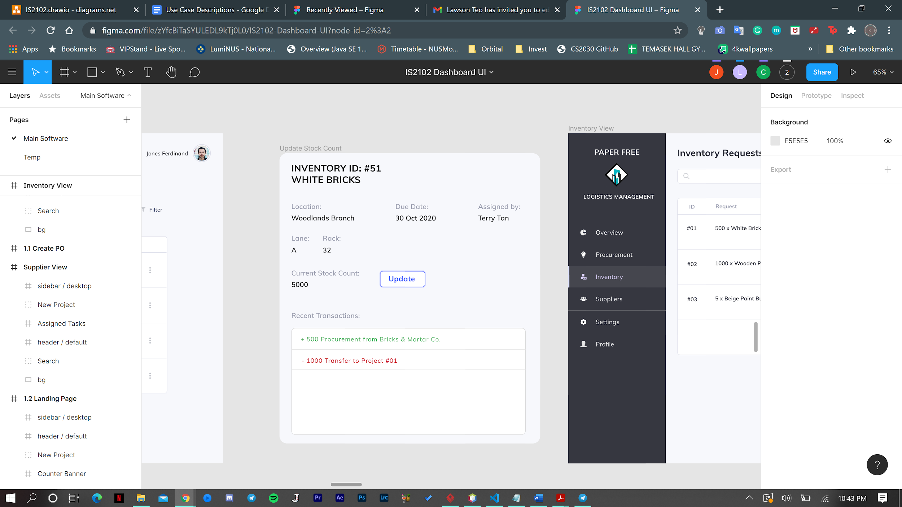

Scenario: Inventory Staff John Tan wishes to update the stock count of White Bricks at the Woodlands warehouse after a routine stock check.

1. John clicks on the inventory tab at the left of the page and enters Bricks into the search bar. John clicks the on the White Bricks record.
2. System displays a modal window with details of the inventory, including the warehouses it can be found in and the stock count at each warehouse.
3. John clicks the update button.
4. System shows a modal window for John to input the updated stock count for White Bricks. John enters the updated stock count and clicks confirm.
5. System updates the quantity of White Bricks in the Woodlands Branch in the database.

#### 

#### **4.3.4.2.4 Process Inventory Request for a Project**

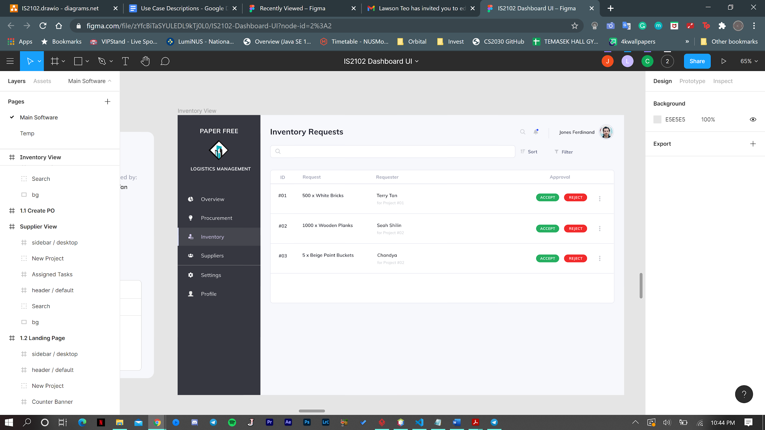

Scenario: Inventory Staff John Tan wishes to approve an inventory request for a Project from a list of requests.

1. John clicks on the Inventory Requests under the Inventory tab on the left of the screen which redirects him to a page displaying a list of ongoing inventory requests.
2. John clicks on a request and a modal window will open displaying details of the request.
3. John clicks the accept button.
4. System will save the inventory request with the updated status and send an email to the project team leader who made the inventory request.

### 4.3.4.3 Procurement Management Module

#### **4.3.4.3.1 Create Procurement Record for Materials**

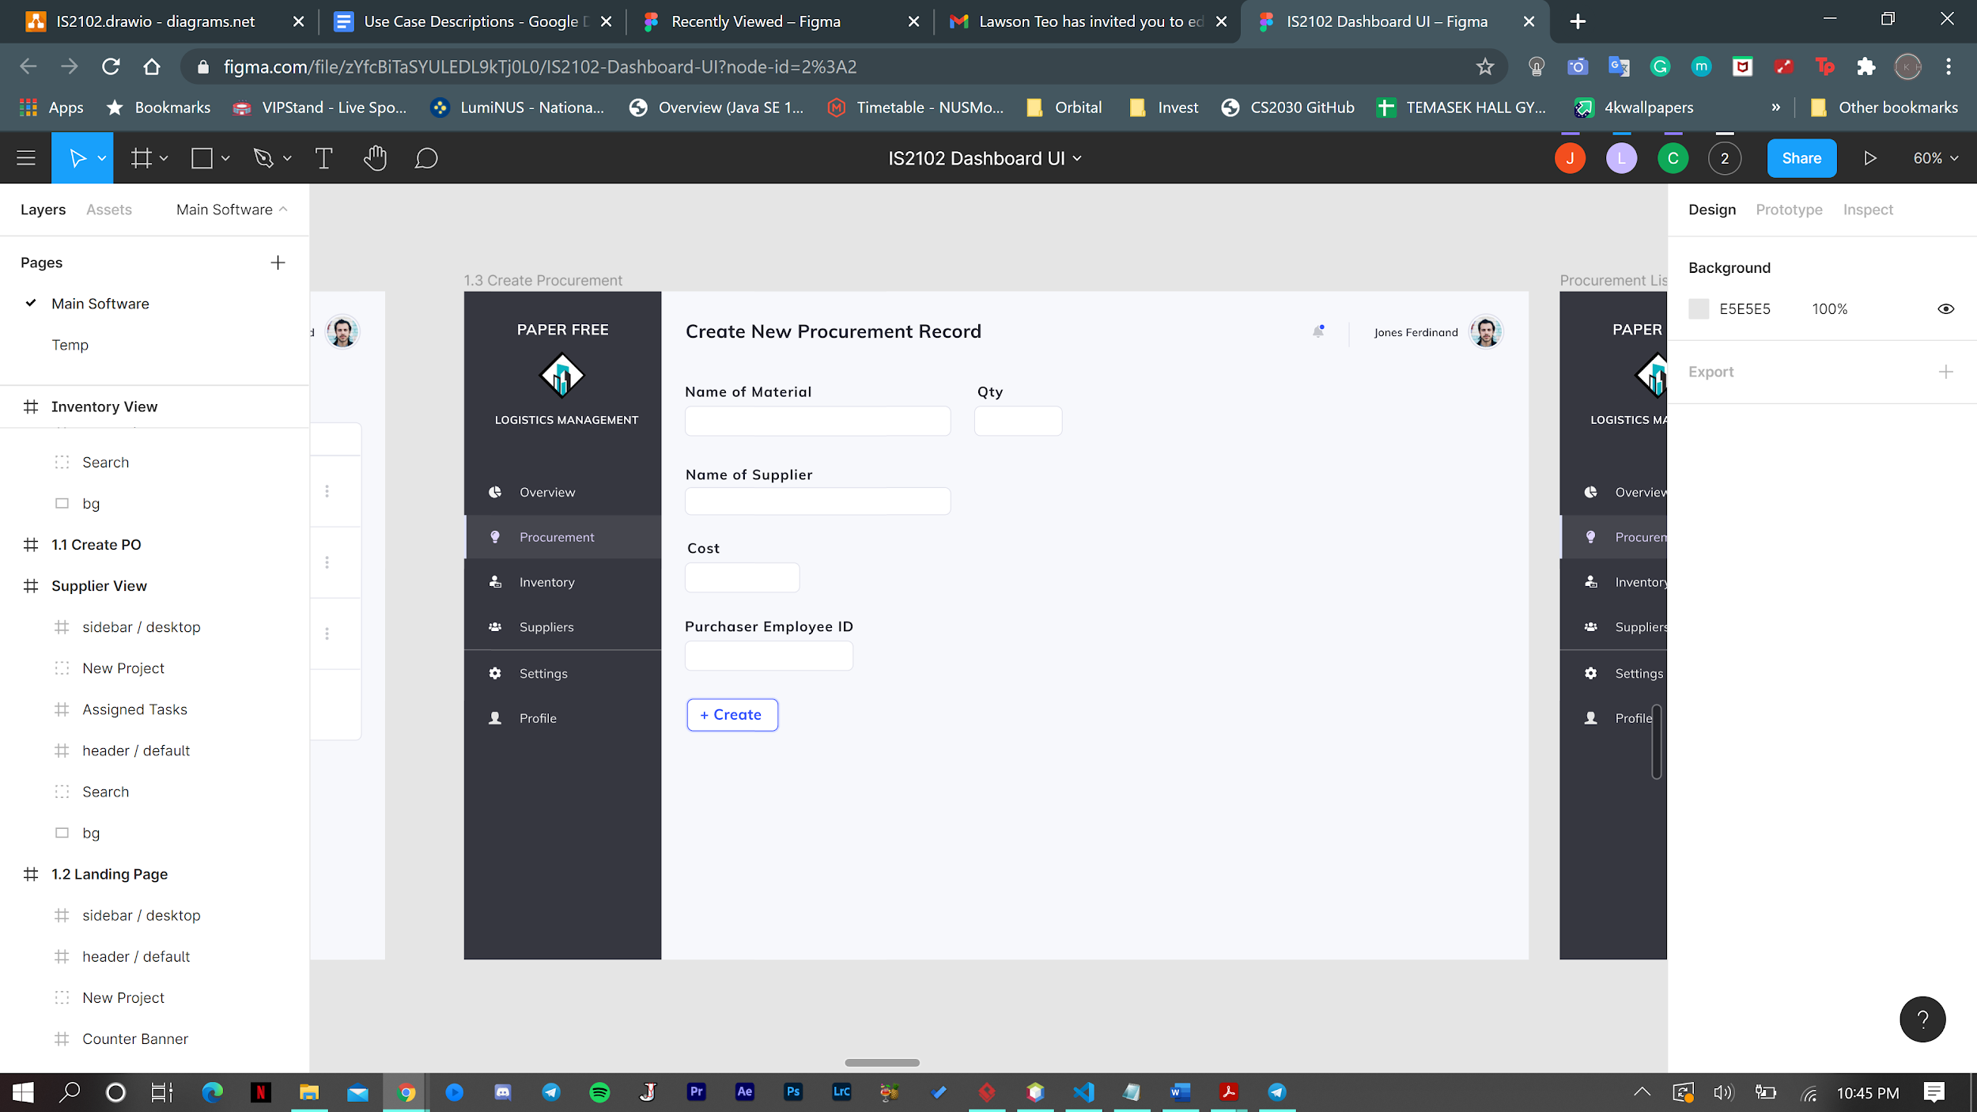

Scenario: Procurement staff Alex wishes to create a procurement record after making an order for several materials from supplier ABC Bricks.

1. Alex clicks on the Procurement tab on the left which redirects him to a page displaying a list of procurement records.
2. Alex clicks on the Add New Record button at the bottom of the page. The system displays a modal window for Alex to enter details of the procurement.
3. Alex enters the details and clicks Create. The system will then save the procurement record and create a purchase order using the details of the procurement record.

#### 

#### **4.3.4.3.2 Request Stock Transfer from Supplier to Warehouse**

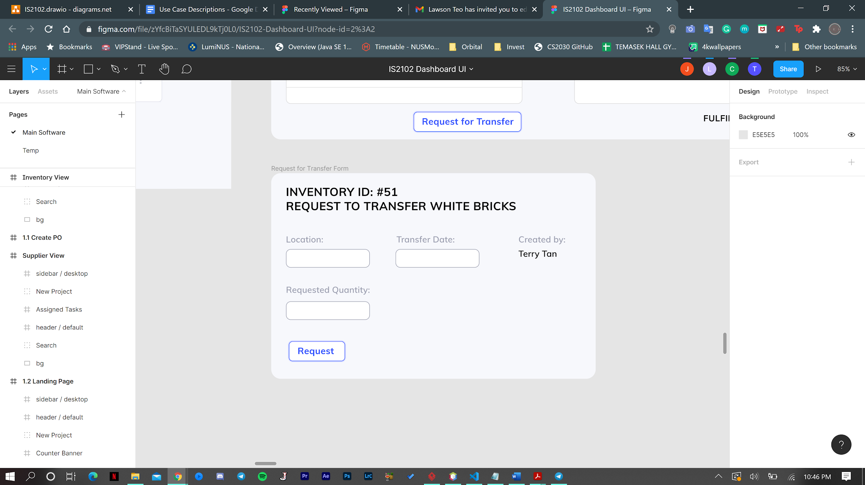

Scenario: Procurement Staff Alex wishes to request a transfer of 900 bricks from ABC Bricks to the Sengkang warehouse.

1. Alex clicks on Suppliers tab on left of page which redirects him to a page displaying a list of all suppliers.
2. Alex searches for ABC Bricks and clicks on it. The system redirects Alex to a page displaying a list of inventory supplied by ABC Bricks.
3. Alex clicks the Request Transfer button beside the bricks record. The system shows a modal window for Alex to input the desired quantity, location and also displays the quantity available for transfer.
4. Alex inputs the desired quantity, transfer date and location for the transfer of bricks and clicks Request.
5. System adds a transfer request record to the database and sends an email to ABC Bricks with the transfer request details.

#### 

#### **4.3.4.3.3 Manage Procurement Status**

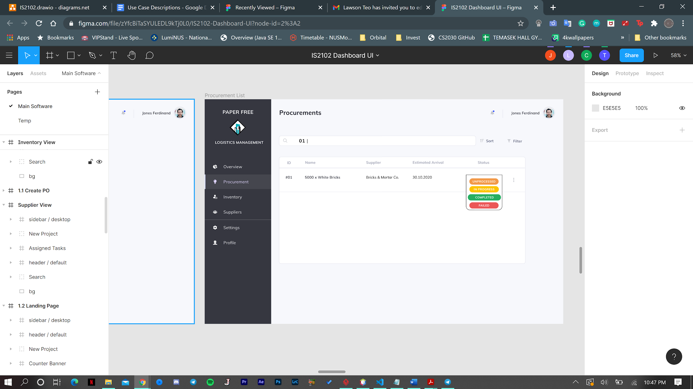

Scenario: Procurement Staff Jones wishes to update an existing procurement status from in progress to completed.

1. Jones clicks the procurement tab on the left and the system redirects him to a page displaying a list of procurement records.
2. Jones searches for a record by ID and clicks the status.
3. A drop-down window of statuses will show, allowing Jones to change the status of the record to completed. Jones clicks on Completed, which closes the window and displays the procurement record with the updated status.

# 

# **4.4 Account and Finance Management Subsystem**

## **4.4.1 Description**

The Accounting and Finance subsystem is a system containing methods to offer funding and process payments for any purchase of supplies done by the Logistics department, purchase of tenders done by Project management department and processing of salaries and distributing the payment to staff in accordance with the information provided by the HR department. The subsystem is also vital in recording all of these actions as transactions to produce periodic financial reports that can be downloaded and viewed by C-Suite, accounting staff and shareholders.

Within payables module, methods are provided for payables staff to create a purchase order to submit to vendors to officially request for suppliers, to record the receiving of goods and its conditions, make payment for said invoices, delete a purchase order in the event that an order is cancelled by Logistics and to view all invoices.

In the receivables module, methods are provided to create a receivable record when a tender is bought and paid for, process the receivables when the services as promised in the tender is completed, and to delete the receivables record as well as view all the vendor receivables records.

In the employee payroll module, methods are provided to create salary payments record for employees, make the necessary payments to the employees, process the CPF contributions that the employer needs to submit to CPF as well as to view all the employee’s salary pages and/or specific employee’s salary page by searching for their name. These salary pages will contain all of the employee’s ID number, name, job role and description, department they belong to, seniority level and their salary payment records.

It is important to note that for every important transaction created in the modules above a common “Transaction” entity will record all the transactions and will be then used for the Reporting module.

Lastly, in the reporting module, methods are provided to view all the reports in a list, view specific reports, generate a financial report and edit a financial report.

## **4.4.2 Business Objectives**

The Accounting and Finance management subsystem seeks to allow the finance department to fund for the purchases done by Logistics and Project Management and ensuring the payments being done is accurate and deserved (Services and goods are received in satisfactory conditions), manage salary payments and ensure they are paid to employees on a timely basis and in the correct amount as well as handle the legality of paying CPF contributions to their respective accounts accurately and on a timely basis and ensure reports are calculated accurately and on a timely basis to be viewed by important stakeholders to the company such as shareholders and C-suite members.

## **4.4.3 Business Assumptions**

We are assuming that all supplies purchased by the Logistics department is only paid for after the supplies are received. However a tender is paid for immediately as soon as a bid is approved by the Project Management subsystem. There is a separation of roles of the users using the 4 modules and no one can interchangeably use the modules. For example, payroll staff who use the payroll module will not be able to access the reporting module. This separation of responsibility is vital in preventing fraud and embezzlement. The receivables module is also not in charge of recording the receivables of sales from customers to whom the finished products (Houses) are sold to. For the payroll creation of salary payment, it is only done once for the first pay of the employee or if the employee’s pay details have been changed. Subsequently the system will calculate the pay automatically at the end of each period and saves the salary payment to the database. The accounting department also generates reports in a quarterly basis, on 30th March, 30th June, 30th September and lastly, 30th December.

## **4.4.4 Business Processes (Usage scenarios)**

### 4.4.4.1 Payables Module

#### 

#### 

#### 

#### **4.4.4.1.1 Create purchase order**

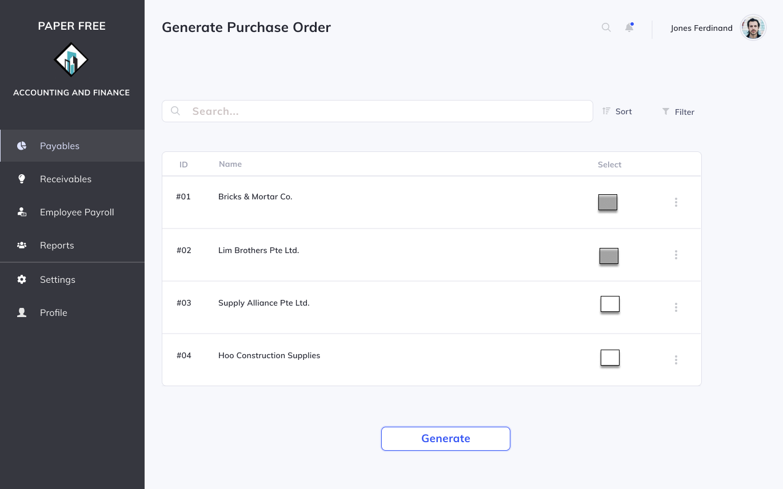

Scenario: Payable Staff Bob views procurement records with UNPROCESSED status that had been created by the Logistics department.

1. Bob clicks on one or multiple procurement records he would like to put in a order for and clicks “Generate” to generate purchase orders
2. Bob reviews the accuracy of details such as item names, quantity, vendor name, cost and delivery address and clicks “Submit”.

#### **4.4.4.1.2 Record receival of goods**

#### 

Scenario: Goods that have been ordered have been received and Payable Staff Bob would like to record it.

1. Bob views all the purchase orders.
2. Bob searches for the item that has been received and checks if the quantity and condition matches the purchase order.
3. After making sure the condition is good and quantity is right, Bob clicks on ‘Received in Good Condition’ to record it.

#### **4.4.4.1.3 Make payment for invoices**

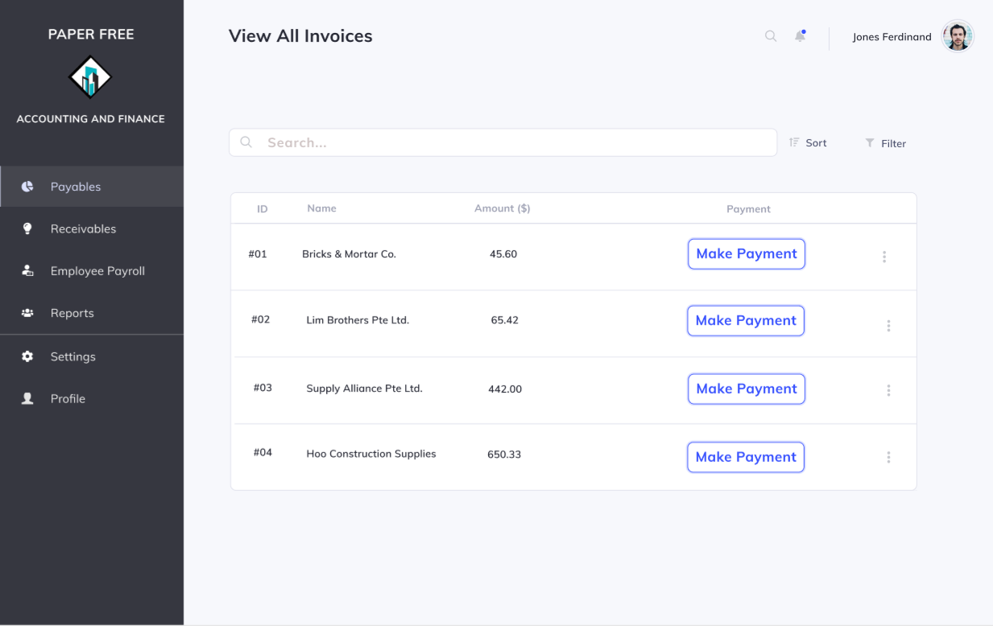

Scenario: Payable Staff Bob navigates to the “Payables” section and clicks on “View all invoice” from the drop-down menu.

1. Bob then filters the invoices by entering a range of dates which indicates the due dates of the invoices. He can also search for specific invoices by entering keywords such as vendor name or item name.
2. Bob checks details of the invoice and presses the “Make payment” button at the side of the screen for the invoice he wants to pay.

#### **4.4.4.1.4 Delete purchase order**

Scenario: Payable Staff Bob wishes to delete a purchase order since the Logistics department decides to cancel their order because they found a better vendor to order items from at a lower cost.

1. Bob selects the purchase order in question.
2. Bob clicks on ‘Delete’ to delete it from the system.

#### **4.4.4.1.5 View all invoices**

Scenario: Payable Staff Bob wants to view all the invoices in the database hence navigate to the invoice section and click view all invoices from the dropdown menu.

#### **4.4.4.1.6 View invoices by vendor name**

Scenario: Payable Staff Bob wants to view a particular vendor’s invoice in the database hence navigate to the invoice section and click view all invoices from the dropdown menu. He then goes to the search bar at the top of the page and enters a vendor’s name and system will return all invoices under that vendor name if any exists.

### 4.4.4.2 Receivables Module

#### **4.4.4.2.1 Create receivable**

Scenario: Receivables Staff Emily checks what tenders have been approved by project management every morning.

1. Emily goes to the “Tenders” and views all approved tenders from the dropdown menu that has not been processed yet by the finance department.
2. She then chooses the tenders that she wants to process and clicks on “Process payment” and the funds will be transferred to vendors of the tenders immediately.

#### **4.4.4.2.2 Process receival of services**

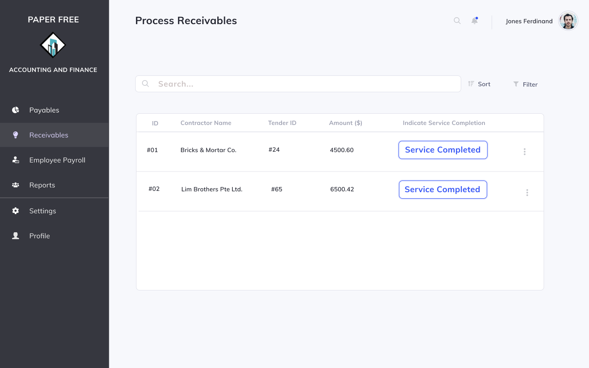

Scenario: The project management department informs Receivables Staff Emily that the contractor of a particular tender has completed the building of the house and the agreements of the tender have been fulfilled.

1. Emily navigates to the “Receivables” section and chooses “Process receival”.
2. She then goes to the search bar and inputs different keywords like the vendor name or the site name to retrieve the particular receivable for the tender for which the work has been completed.
3. She presses “service completed” after picking the correct tender’s vendor receivable.

#### **4.4.4.2.3 Delete receivable**

Scenario: Receivables Staff Emily wishes to delete a receivable because the tender was cancelled or the receivable is not valid.

1. Emily goes to the “Receivable” tab again and chooses “View all receivables”.
2. She searches for the receivable to delete with key words and clicks one.
3. She presses “Confirm” in the confirmation pop-up to delete the receivable.

#### **4.4.4.2.4 View all vendor receivables**

Scenario: Receivables Staff Emily wishes to view all the vendor receivables in the database hence navigates to the receivables tab and and clicks view all receivables from the dropdown menu.

### 4.4.4.3 Employee Payroll Module

#### **4.4.4.3.1 Create salary payment**

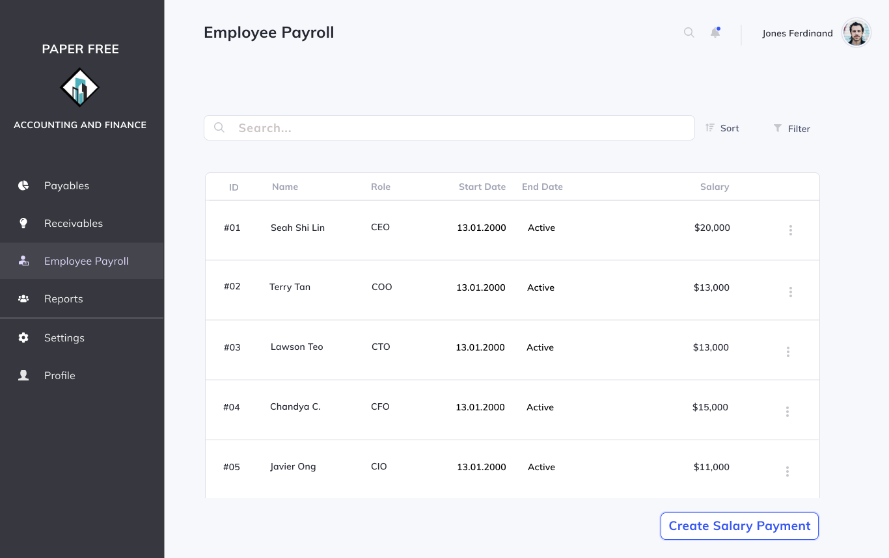

Scenario: Payroll Staff Ben receives work records from the HR staff. These work records contain information on how long employees have worked. This is only done once and subsequently salary payments are automatically calculated by the system at the end of each pay period.

1. He navigates to the payroll tab and clicks on the “Employee Payroll” tab and searches for employeeID.
2. He then enters all the information prompted by the system such as pay period and gross pay if this is the first time creating a salary payment for this employee or the employee’s pay or pay period has been changed. Subsequently all he will have to input is the total hours worked retrieved from the work record.
3. System will create a new salary payment record and save it to the database.

#### **4.4.4.3.2 Make salary payment to employees**

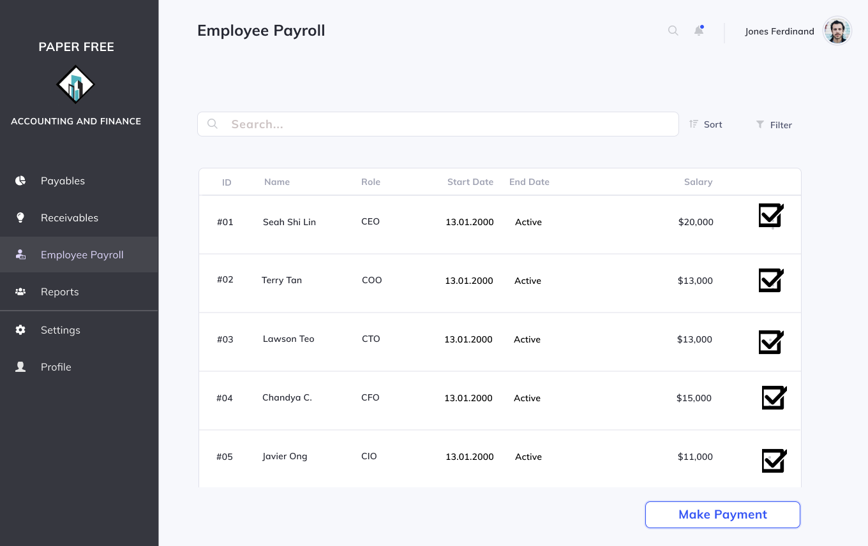

Scenario: It is time to make the payments to the staff in the company. Payroll Staff Ben will now process all the payments.

1. Ben will go to the “Employee Payroll” tab and click on “Make payments”
2. Ben will then input the start date and end date to retrieve all the salary payments that have to be made within these days and chooses all the employees.
3. Ben then clicks on “Make payment” and the system will transfer all the payments to the company.

#### **4.4.4.3.3 Process CPF contributions**

Scenario: Payroll Staff Ben will now have to process the CPF contributions that have to be made by the company for all its employees. He will have to navigate to the CPF section in the dropdown menu under “Employee Payroll”. System will calculate the contributions that need to be made and redirects to the CPF website where employees will make the deposits to employee accounts.

#### **4.4.4.3.4 View all employees’ salary page**

Scenario: Payroll Staff Ben wishes to view all the employees’ salary pages so he chooses the “view all employees” option from the drop down menu under payroll.

#### **4.4.4.3.5 View employee’s salary page by name**

Scenario: Payroll Staff Ben wishes to view all the employees’ salary pages so he chooses the “view all employees” option from the drop down menu under payroll and enters the keyword in the search bar to retrieve the salary page of a particular employee.

### 4.4.4.4 Report Module

#### **4.4.4.4.1 View all reports**

Scenario: Reporting Staff Maria wishes to view all the reports that had been generated so far. She navigates to the “Reports” tab and clicks on the “View all reports” in the dropdown menu.

#### **4.4.4.4.2 View report**

Scenario: Reporting Staff Maria wants to view one or more particular reports in the database.

1. Maria will navigate to the “Search for report” tab under “Reports”
2. She will then choose the period from the dropdown calendar from which the report is desired and all the reports will be returned to her.

#### 

#### **4.4.4.4.3 Generate financial report**

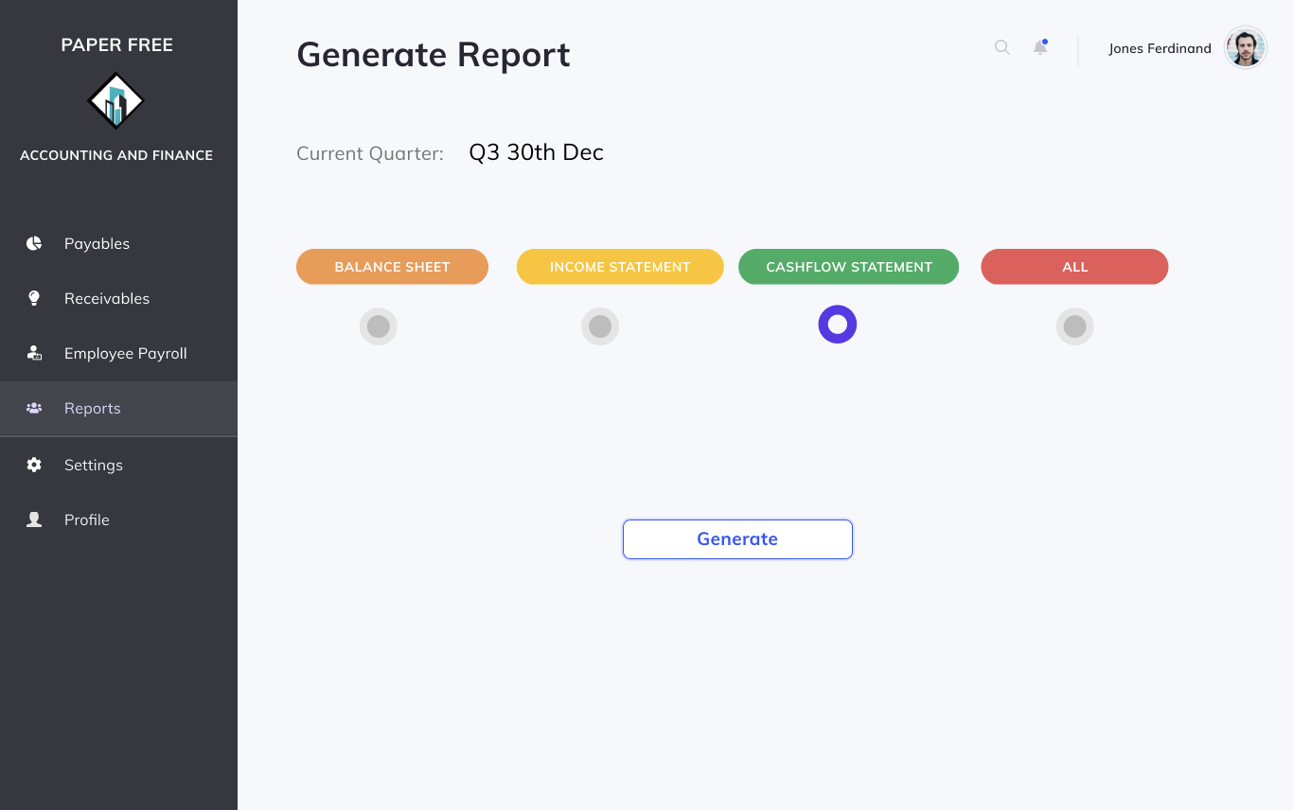

Scenario: Reporting Staff Maria to generate a financial report to summarise transactions done for the quarter.

1. Maria will navigate to the “Reports” tab and click on “Generate report” and choose which type of report to generate: Balance Sheet, Income Statement, Cashflow Statement or All.
2. Maria will check all amounts and information in the report and press “Confirm”.

#### **4.4.4.4.4 Edit financial report**

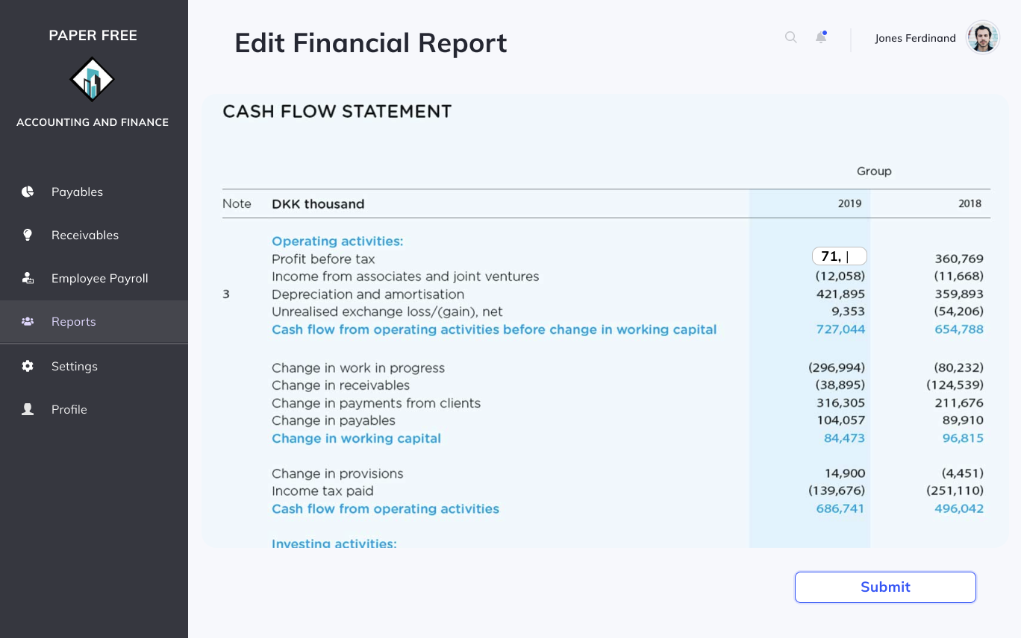

Scenario: Reporting Staff Maria finds an issue in one of the reports after generating the report and confirming it. She will have to make some edits.

1. Maria will navigate to “Reports” and press on “View financial report”.
2. She will then choose which type of report you would like to view and in which period. (Choose at least one of the two)
3. She can now click on “Edit this report” and make necessary changes and click “Submit”.

**Special scenario: If non-Payroll Staffs attempts to access the Payroll system**

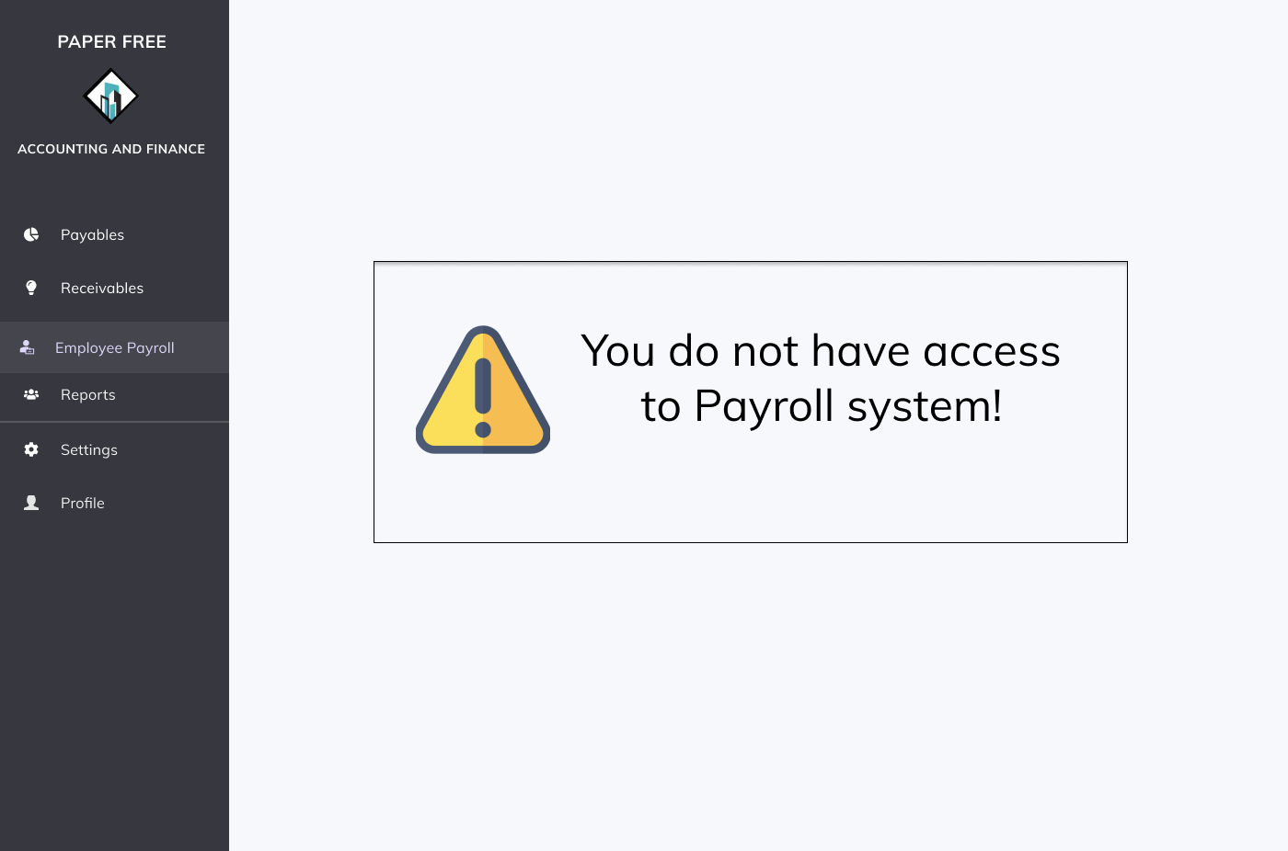

# **4.5 Access Management Subsystem**

## **4.5.1 Description**

The Access Management Subsystem is a system that contains the authentication functions to allow an employee to verify himself and use functions restricted to his user role access levels where they can then carry out their job requirements. Users will be required to use their company email address and password to verify their identity when accessing the system with their account. On top of this, the subsystem also allows users to reset their password if they had forgotten it, edit their user profile and view it.

**4.5.2 Business Objectives**

The Access Management Subsystem exists to ensure verification of employees attempting to access the IT system. It ensures different subsystems and modules in the company’s IT system can only be accessed by those who possess the access rights to it hence ensuring division in roles and preventing fraud.

**4.5.3 Business Assumptions**

We assume that all employees in the company, including part-time workers have their own user accounts in this system. Accounting staff are also split between themselves into 4 different roles: payables staff, receivables staff, payroll staff and reporting staff and they only have access to their own modules once logged in. Lastly all usernames are associated with a valid corporate email hence in case an employee forgets their password they can reset it again through their email accounts.

## **4.5.4 Business Processes**

### 4.5.4.1 Common Access Management Module

#### **4.5.4.1.1 Login**

Scenario: Team Member Mary Tan wants to login to the construction management system.

1. Mary opens the application and inputs her username and password.
2. Mary clicks on the “Login” button at the bottom of the screen.

#### **4.5.4.1.2 Logout**

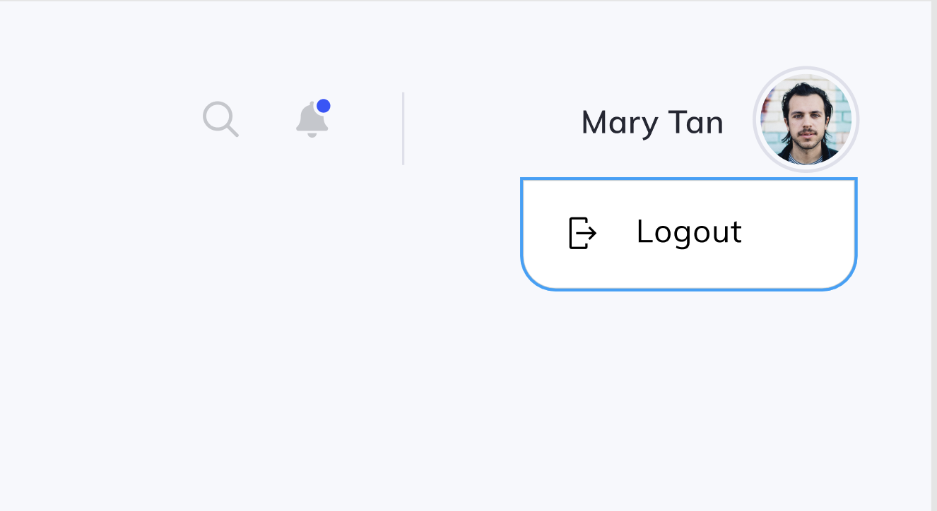

Scenario: Mary wishes to logout of the construction management system.

1. Mary clicks on her account on the top right of the screen.
2. Mary clicks on the “Logout” button.

#### **4.5.4.1.3 Forgot password**

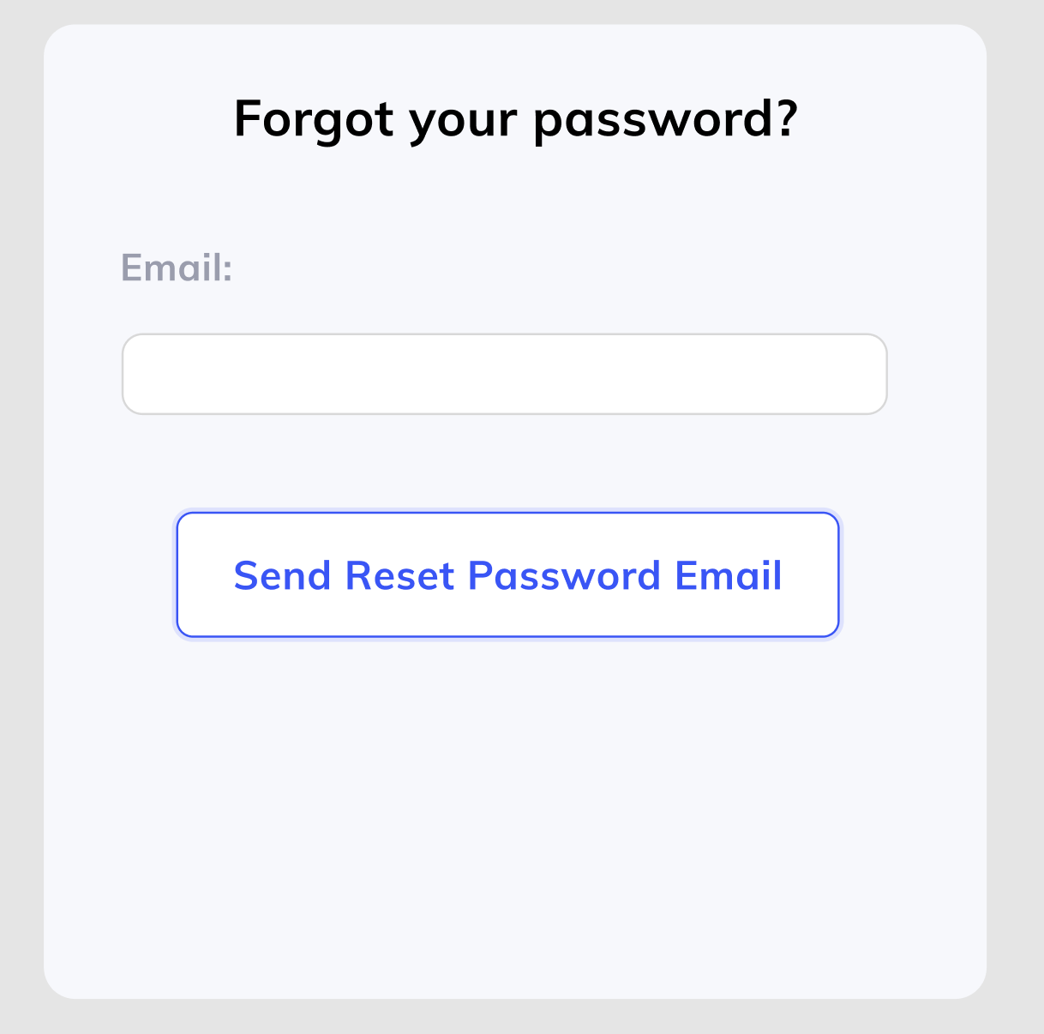

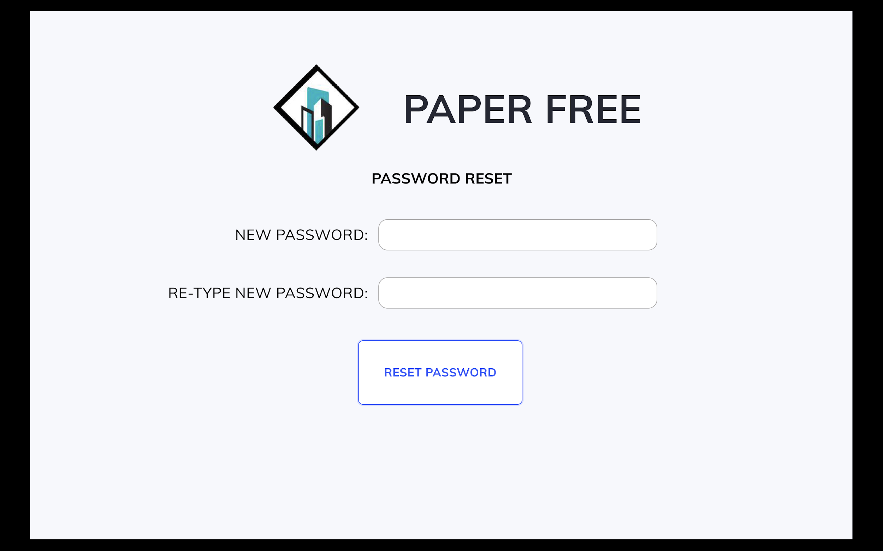

Scenario: Team Member Mary Tan forgets her password and wishes to reset it.

1. Mary clicks on the “Forget password….” prompt at the bottom of the login page.
2. System prompts Mary to input her email address.
3. Mary validates her account and clicks on the reset password link sent to her email.
4. System redirects Mary to reset her password as shown.

#### **4.5.4.1.4 View profile**

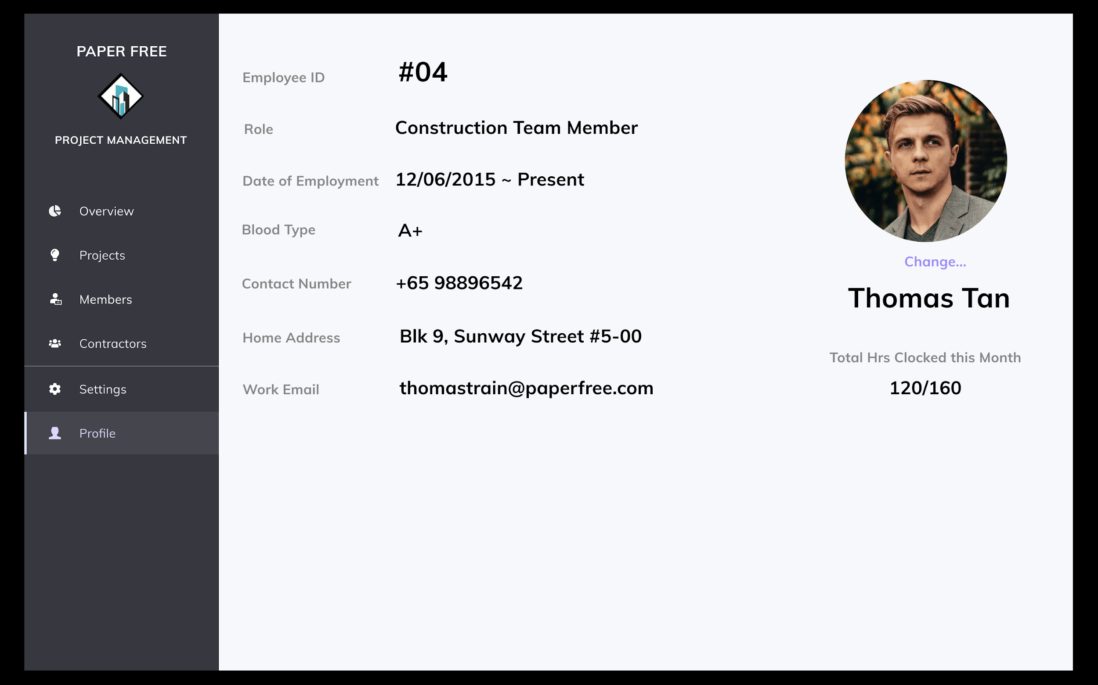

Scenario: Team Member Mary Tan wishes to view her current profile.

1. Mary presses “Profile” tab on the left of the screen.

#### **4.5.4.1.5 Edit profile**

Scenario: Team Member Mary Tan wishes to edit her current profile.

1. Mary presses “Profile” tab on the left of the screen.
2. Mary hovers over the input and double clicks it to make changes to it.

### 4.5.4.2 Attendance Checking Module

#### **4.5.4.2.1 Register for start of work**

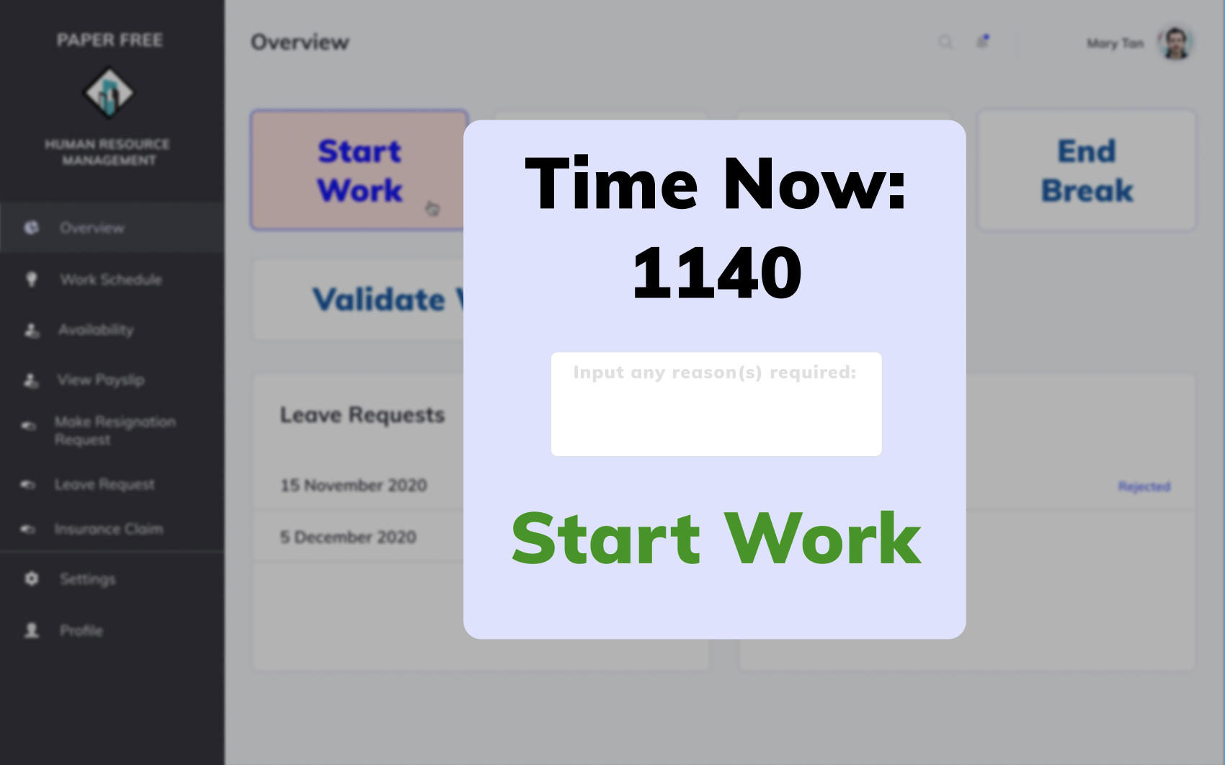

Scenario: Employee (HR Staff) Mary Tan arrives at work and wants to register for the start of work.

1. Employee Mary clicks on the Start Work tab on the top of the screen.
2. System shows the current time as registered by the device used.
3. Mary inputs any reason required for starting work early / late.
4. To confirm the start of work, she presses on the “Start Work” button.
5. System displays confirmation messages that start work has been recorded.

#### **4.5.4.2.2 Register for end of work**

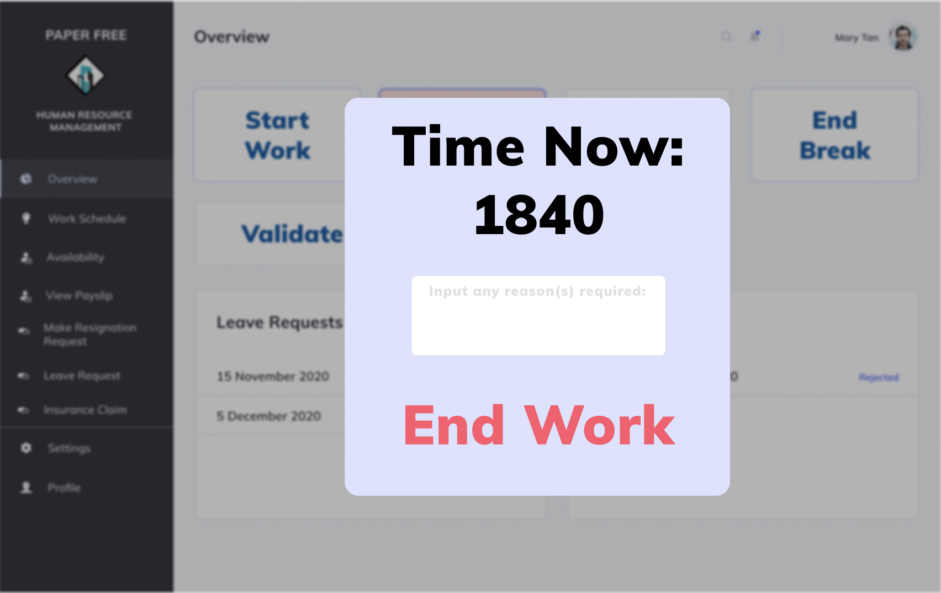

Scenario: Employee (HR Staff) Mary Tan ends work and wants to register for the end of work.

1. Employee Mary clicks on the End Work tab on the left of the screen.
2. System shows the current time as registered by the device used.
3. Mary inputs any reason required for starting work early / late.
4. To confirm the end of work, she presses on the “End Work” button.
5. System displays confirmation messages that end work has been recorded.

#### **4.5.4.2.3 Register for start of break**

Scenario: Employee (HR Staff) Mary Tan starts break and wants to register for the start of break.

1. Employee Mary clicks on the Start Break tab on the top of the screen.
2. System shows the current time as registered by the device used.
3. Mary inputs any reason required for starting break early / late.
4. To confirm the start of break, she presses on the “Start Break” button.
5. System displays confirmation messages that start break has been recorded.

#### **4.5.4.2.4 Register for end of break**

Scenario: Employee (HR Staff) Mary Tan ends break and wants to register for the end of break.

1. Employee Mary clicks on the End Break tab on the left of the screen.
2. System shows the current time as registered by the device used.
3. Mary inputs any reason required for ending break early / late.
4. To confirm the end of break, she presses on the “End Break” button.
5. System displays a confirmation message that the end break has been recorded.

**5. System Functional Requirements Analysis**

# **5.1 Human Resource Management Subsystem**

## **5.1.1 Use Case Diagram**

## 

## **5.1.2 Use Case Description**

### **5.1.2.1 Employee Management Module**

#### **5.1.2.1.1 Retrieve work schedule**

|  |  |  |
| --- | --- | --- |
| Use Case: | Retrieve work schedule | |
| Triggering Event: | Employee uses the application to retrieve his/her work schedule | |
| Brief Description: | Employee inputs specifications for work schedule to be retrieved. System then displays the relevant information. | |
| Actors: | Employee | |
| Pre-conditions: | 1. Employee must be logged in to construction management system 2. Work schedule for the term must be available. | |
| Post-conditions: | - | |
| Flow of Events: | Actor (Employee) | System |
| 1. Selects option to view work schedule.      2. Search for a work schedule to be generated by specifying month and type of work.. | 1.1 System redirects employee to work schedule option page.    2.1 System displays work schedule according to user’s specification. |
| Exception Conditions: | 1. Input by user is invalid. | |

#### 

#### **5.1.2.1.2 Submit availability slots**

|  |  |  |
| --- | --- | --- |
| Use Case: | Submit availability slots | |
| Triggering Event: | A part-time employee uses the application to submit availability slots for work during a specified period. | |
| Brief Description: | Employee fills in required information on the work required – time period (month), available working hours, days requested to be off and preferred available days. The system then logs in this information. | |
| Actors: | Employee | |
| Pre-conditions: | 1. Employee must be logged in to construction management system | |
| Post-conditions: | 1. Relevant availability information must be stored in the system. | |
| Flow of Events: | Actor (Employee) | System |
| 1. User clicks on availability submission.      2. User selects the time period the availability is for – which month is the availability for.    3. User fills in details regarding his/her availability – available working hours, days requested to be off and preferred available days.    4. User confirms availability details.      5. User submits availability slots. | 1.1 System redirects user to the availability submission page.    2.1 System displays month selected by the user.        3.1 System displays availability details input by user.        4.1 System displays a summary of the information input by the user.    5.1 System keeps a record of the availability slots and displays a message indicating the slots have been recorded. |
| Exception Conditions: | 3. User inputs invalid details | |

#### **5.1.2.1.3 Generate payslip preview**

|  |  |  |
| --- | --- | --- |
| Use Case: | Generate payslip review | |
| Triggering Event: | User chooses to generate a payslip for a specified month | |
| Brief Description: | Employee inputs month for payslip to be generated. System then displays a payslip to be reviewed. | |
| Actors: | Employee | |
| Pre-conditions: | 1. Employee must be logged in to construction management system 2. The employee must have a payslip record in the system. | |
| Post-conditions: | - | |
| Flow of Events: | Actor (Employee) | System |
| 1. Employee selects the option to generate payslip review.    2. Employee inputs the required month for the payslip to be generated. | 1.1 System redirects the user to the payslip screen.      2.1 System displays payslip of the specified month. |
| Exception Conditions: | 2. Input by user is invalid | |

#### **5.1.2.1.4 Make resignation request**

|  |  |  |
| --- | --- | --- |
| Use Case: | Make resignation request | |
| Triggering Event: | User chooses to make a resignation request on the application. | |
| Brief Description: | Employee inputs resignation request details – reason for resignation, last date of work and requested remuneration amount. | |
| Actors: | Employee | |
| Pre-conditions: | 1. Employee must be logged in to construction management system | |
| Post-conditions: | 1. System redirects the request to the HR staff with relevant details. | |
| Flow of Events: | Actor (Employee) | System |
| 1. User chooses to make a resignation request.      2. Employee fills in required details - reason for resignation, last date of work and requested remuneration amount.    3. Employee confirms submission of resignation request. | 1.1 System redirects the user to screen to the make resignation request.    2.1 System displays information input by the user.          3.1 System displays confirmation of resignation request made and saves the resignation request details in the database. |
| Exception Conditions: | 2. Input by user is invalid. | |

#### **5.1.2.1.5 Generate worked hours report**

|  |  |  |
| --- | --- | --- |
| Use Case: | Generate worked hours report | |
| Triggering Event: | An employee chooses to generate a report showing their worked hours. | |
| Brief Description: | An employee fills in relevant information for generating the report – month of work. System then generates a report according to information input and displays the report to the user. | |
| Actors: | Employee | |
| Pre-conditions: | 1. Employee must be logged in to construction management system | |
| Post-conditions: | - | |
| Flow of Events: | Actor (Employee) | System |
| 1. Employee selects option to generate work hours report.        2. Employee selects option to generate work hours report and fills in relevant information for generating the report – month of work. | 1.1 System redirects the user to a screen that allows them to generate the report.        2.1 System displays the report according to the employee’s specifications. |
| Exception Conditions: | 1. Input by user is invalid. | |

#### **5.1.2.1.6 Create account for new employee**

|  |  |  |
| --- | --- | --- |
| Use Case: | Create account for new employee | |
| Triggering Event: | HR Staff creates a new employee account | |
| Brief Description: | A HR staff member selects the option to create a new employee account for a new employee. He/she will input relevant information of the employee – employee ID, bank account number, contact number, next-of-kin contact number, first name, last name, username, password, identification number, blood type, employment type as well as employed date. The information is then stored under the user account and a new user account will be created. | |
| Actors: | HR staff | |
| Pre-conditions: | 1. HR staff must be logged in to construction management system | |
| Post-conditions: | 1. New account of the employee will be created and the employee’s details will be stored in the database. | |
| Flow of Events: | Actor (HR Staff) | System |
| 1. HR Staff member selects option to create a new employee account.    2. HR Staff inputs relevant information of the employee – employee ID, bank account number, contact number, next-of-kin contact number, first name, last name, username, password, identification number, blood type, employment type as well as employed date.    3. HR Staff member confirms creation of new employee account. | 1.1 System redirects the user to screen to create a new employee account.    2.1 System stores all relevant information and creates a new employee account.          3.1 System confirms successful creation of a new employee account and displays login credentials for confirmation. |
| Exception Conditions: | 1. Input by user is invalid. | |

#### **5.1.2.1.7 Delete existing employee account**

|  |  |  |
| --- | --- | --- |
| Use Case: | Delete existing employee account | |
| Triggering Event: | HR Staff chooses to delete an existing employee account. | |
| Brief Description: | A HR staff member selects the option to delete an existing account of an employee. He/she will input the employee ID of the employee to be deleted, then confirm if the correct employee has been selected. | |
| Actors: | HR staff | |
| Pre-conditions: | 1. HR staff must be logged in to construction management system 2. The employee account to be deleted must exist. | |
| Post-conditions: | 1. New state of the existing employee account must be saved and pushed into the system. | |
| Flow of Events: | Actor (HR Staff) | System |
| 1. The HR Staff member selects the option to delete an employee account.    2. HR Staff chooses to delete an existing employee account and inputs the employee account ID.    3. HR Staff confirms the deletion of the account. | 1.1 System redirects the user to screen to manage employee accounts.    2.1 System displays employee account’s information and prompts for confirmation.      3.1 System confirms the deletion of the account and shows a confirmation message. |
| Exception Conditions: | 2. Input by user is invalid. | |

#### **5.1.2.1.8 Update existing employee account**

#### 

|  |  |  |
| --- | --- | --- |
| Use Case: | Update existing employee account | |
| Triggering Event: | HR Staff chooses to update an existing employee account. | |
| Brief Description: | A HR staff member selects the option to update an existing account of an employee. He/she will input the employee ID of the employee to be updated, make the relevant changes then confirm the updates before the system saves the changes. | |
| Actors: | HR staff | |
| Pre-conditions: | 1. HR staff must be logged in to construction management system 2. The employee account to be updated must exist. | |
| Post-conditions: | 1. New state of the existing employee account must be saved and pushed into the system. | |
| Flow of Events: | Actor (HR Staff) | System |
| 1. The HR Staff member selects the option to update an employee account.    2. HR Staff chooses to update an existing employee account and inputs the employee account ID.  3. HR Staff makes relevant changes by changing the values of the user - bank account number, contact number, next-of-kin contact number, username, password, identification number or employment type.    4. HR Staff confirms the deletion of the account. | 1.1 System redirects the user to screen to update employee accounts.    2.1 System displays employee account’s information and prompts for changes to be made.      3.1 System confirms the updating of the account and prompts for confirmation.  4.1 System confirms the update of the account and shows a confirmation message. |
| Exception Conditions: | 2. Input by user is invalid.  3. Input by user is invalid. | |

#### **5.1.2.1.9 Approve resignation request**

|  |  |  |
| --- | --- | --- |
| Use Case: | Approve resignation request | |
| Triggering Event: | HR Staff member approves a resignation request. | |
| Brief Description: | A HR staff member views a resignation request. He/she can choose to view the more specific details of the request, then choose to accept. He/she can then input more details regarding the choice made and confirm the status of the request. | |
| Actors: | HR Staff | |
| Pre-conditions: | 1. HR staff must be logged in to construction management system 2. An existing resignation request must be present. | |
| Post-conditions: | 1. Updated state of the resignation request will be updated and pushed into the system. | |
| Flow of Events: | Actor (HR Staff) | System |
| 1. HR Staff selects the option to view resignation requests.    2. HR Staff selects on a specific resignation request and chooses to view the specific details of the request.    3. HR Staff inputs resignation request ID to manage the resignation request.    4. HR Staff chooses to approve the resignation request.  5. HR Staff confirms approval of resignation request. | 1.1 System redirects the user to screen showing all resignation requests.    2.1 System displays all details of the request – reason for resignation, last date requested and requested remuneration amount.    3.1 System shows available options for the user.      4.1 System confirms approval of the resignation request.  5.1 System saves state of approval and shows a confirmation message. |
| Exception Conditions: | - | |

#### **5.1.2.1.10 Reject resignation request**

|  |  |  |
| --- | --- | --- |
| Use Case: | Reject resignation request | |
| Triggering Event: | HR Staff member rejects a resignation request. | |
| Brief Description: | A HR staff member views a resignation request. He/she can choose to view the more specific details of the request, then choose to accept. He/she can then input more details regarding the choice made and confirm the status of the request. | |
| Actors: | HR Staff | |
| Pre-conditions: | 1. HR staff must be logged in to construction management system 2. An existing resignation request must be present. | |
| Post-conditions: | 1. Updated state of the resignation request will be updated and pushed into the system. | |
| Flow of Events: | Actor (HR Staff) | System |
| 1. HR Staff selects the option to view resignation requests.    2. HR Staff selects on a specific resignation request and chooses to view the specific details of the request.    3. HR Staff inputs resignation request ID to manage the resignation request.    4. HR Staff chooses to reject the resignation request.  5. HR Staff confirms rejection of resignation request. | 1.1 System redirects the user to screen showing all resignation requests.    2.1 System displays all details of the request – reason for resignation, last date requested and requested remuneration amount.    3.1 System shows available options for the user.      4.1 System confirms rejection of the resignation request.  5.1 System saves state of rejection and shows a confirmation message. |
| Exception Conditions: | - | |

#### **5.1.2.1.11 Generate workload report**

|  |  |  |
| --- | --- | --- |
| Use Case: | Generate workload report | |
| Triggering Event: | HR staff chooses to generate a report showing the worked hours of the employees. | |
| Brief Description: | HR Staff generates reports by filling in requests and inputs the month. System then generates a report according to information input and displays the report to the user. | |
| Actors: | HR staff | |
| Pre-conditions: | 1. HR staff must be logged in to construction management system 2. Existing records on the worked hours and workload of the different projects must be present in the system. | |
| Post-conditions: | - | |
| Flow of Events: | Actor (HR Staff) | System |
| 1. HR Staff selects the option to generate workload reports.    2. Staff selects the option to generate workload report and fills in the month required for the report. | 1.1 System redirects the user to screen that allows them to generate workload reports.    2.1 System displays the report according to the employee’s specifications. |
| Exception Conditions: | 1. Input by user is invalid. | |

#### **5.1.4.1.12 Generate staff performance report**

|  |  |  |
| --- | --- | --- |
| Use Case: | Generate staff performance report | |
| Triggering Event: | HR staff chooses to generate a report showing the performance of the employees. | |
| Brief Description: | HR Staff fills in relevant information for generating the report – employees involved as well as duration of performance review. System then generates a report according to information input and displays the report to the user. | |
| Actors: | HR staff | |
| Pre-conditions: | 1. HR staff must be logged in to construction management system 2. Existing records on the performance rating and reviews of the different employees must be present in the system. | |
| Post-conditions: | - | |
| Flow of Events: | Actor (HR Staff) | System |
| 1. Staff selects the option to generate staff performance reports.    2. Staff selects the option to generate staff performance reports and fills in relevant information for generating the report – employees involved and duration of performance review. | 1.1 System redirects the user to screen that allows them to generate staff performance reports.    2.1 System displays the report according to the employee’s specifications. |
| Exception Conditions: | 2. Input by user is invalid. | |

### **5.1.2.2 MC / Leave Management Module**

#### **5.1.2.2.1 Request for leave**

|  |  |  |
| --- | --- | --- |
| Use Case: | Request for leave | |
| Triggering Event: | Employee makes a request for leave using the application. | |
| Brief Description: | An employee uses the application to make a leave request. He/she will input the leave request details, including the date of leave, reason for leave, and leave type. He/she will then confirm the details and submit the request to the system. | |
| Actors: | Employee | |
| Pre-conditions: | 1. Employee must be logged in to construction management system | |
| Post-conditions: | 1. Leave request details must be saved into the system and sent over to the HR department for processing. | |
| Flow of Events: | Actor (Employee) | System |
| 1. Employee selects option to make a leave request.    2. Employee inputs relevant details required to make the leave request - date requested, reason for leave and type of leave – medical, maternity, annual or unpaid.    3. Employee confirms leave request to be made. | 1.1 System redirects the user to screen to make leave requests.    2.1 System displays the details and requests for confirmation to submit the leave request.      3.1 System displays a confirmation message that a leave request is made and saves the details into the system. |
| Exception Conditions: | 1. All fields input by the user must be valid. | |

#### **5.1.2.2.2 Check status of leave request(s)**

|  |  |  |
| --- | --- | --- |
| Use Case: | Check status of leave request(s) | |
| Triggering Event: | Employee checks status of leave request(s) | |
| Brief Description: | Employee uses the application to check status of leave request(s). He/she will input the leave request made by indicating the date requested. He/she can remind the HR staff to process the request if it is unprocessed. | |
| Actors: | Employee | |
| Pre-conditions: | 1. Employee must be logged in to construction management system 2. There must be leave request(s) made by the employee before this use case is executed. | |
| Post-conditions: | - | |
| Flow of Events: | Actor (Employee) | System |
| 1. Employee selects option to check status of a leave request.    2. Employee inputs date of leave requested.        3a. If leave is processed, the employee can view whether the leave is approved or rejected.    3b. If leave is unprocessed, the employee can choose to remind HR staff to process the request. | 1.1 System redirects the user to screen to check leave request status.    2.1 System checks for leave requested during date input and displays the leave request status.    3a.1 System displays whether the leave request is approved or rejected.      3b.1 System displays a confirmation message that the reminder is made if the employee chooses to make the reminder. |
| Exception Conditions: | 2. Input by user is invalid. | |

#### **5.1.2.2.3 Submit insurance claim request**

|  |  |  |
| --- | --- | --- |
| Use Case: | Submit insurance claim request | |
| Triggering Event: | Employee wants to submit an insurance claim request | |
| Brief Description: | Employee uses the application to submit an insurance claim request. He/she will input the insurance claim details – type of claim made, date of claim and reason for claim and submit the request to the system. | |
| Actors: | Employee | |
| Pre-conditions: | 1. Employee must be logged in to construction management system | |
| Post-conditions: | 1. Insurance claim request details must be saved into the system and redirected to the relevant insurance company. | |
| Flow of Events: | Actor (Employee) | System |
| 1. Employee selects option to submit an insurance claim request.    2. Employee inputs details of insurance claim request - type of claim made, date of claim and reason for claim.    3a. Employee chooses to edit the claim request.    3b. Employee confirms details of claim request. | 1.1 System redirects the user to screen to request for an insurance claim.    2.1 System displays the information and prompts the user to confirm the details of the claim request.    3a.1 System redirects user back to step 2.    3b.1 System displays a confirmation message that the claim request is made and sends information to the relevant insurance company. |
| Exception Conditions: | 1. Input by user is invalid. | |

#### **5.1.2.2.4 Approve leave request**

|  |  |  |
| --- | --- | --- |
| Use Case: | Approve leave request | |
| Triggering Event: | A HR Staff member approves a leave request. | |
| Brief Description: | A HR staff member views a leave request. He/she can choose to view the more specific details of the request, then choose to accept. He/she can then input more details regarding the acceptance and confirm the status of the request. | |
| Actors: | HR Staff | |
| Pre-conditions: | 1. HR staff must be logged in to construction management system 2. An existing leave request must be present. | |
| Post-conditions: | 1. Updated state of the leave request will be updated and pushed into the system. | |
| Flow of Events: | Actor (HR Staff) | System |
| 1. HR Staff selects the option to view leave requests.    2. HR Staff selects on a specific leave request and chooses to view the specific details of the request.      3. HR Staff inputs leave request ID to manage the leave request.    4. HR Staff chooses to accept the leave request and any extra input if required.  5. HR Staff confirms the acceptance of the leave request. | 1.1 System redirects the user to screen showing all leave requests.    2.1 System displays all details of the request – date requested and type of leave – medical, maternity, paternity, paid or unpaid    3.1 System shows available options for the user.    4.1 System requests for confirmation for acceptance of leave request.  5.1 System displays a confirmation message and updates leave request. |
| Exception Conditions: | 4. Input by user is invalid. | |

#### **5.1.2.2.5 Reject leave request**

|  |  |  |
| --- | --- | --- |
| Use Case: | Reject leave request | |
| Triggering Event: | A HR Staff member rejects a leave request. | |
| Brief Description: | A HR staff member views a leave request. He/she can choose to view the more specific details of the request, then choose to reject. He/she can then input more details regarding the acceptance and confirm the status of the request. | |
| Actors: | HR Staff | |
| Pre-conditions: | 1. HR staff must be logged in to construction management system 2. An existing leave request must be present. | |
| Post-conditions: | 1. Updated state of the leave request will be updated and pushed into the system. | |
| Flow of Events: | Actor (HR Staff) | System |
| 1. HR Staff selects the option to view leave requests.    2. HR Staff selects on a specific leave request and chooses to view the specific details of the request.      3. HR Staff inputs leave request ID to manage the leave request.    4. HR Staff chooses to reject the leave request and any extra input if required.  5. HR Staff confirms the rejection of the leave request. | 1.1 System redirects the user to screen showing all leave requests.    2.1 System displays all details of the request – date requested and type of leave – medical, maternity, paternity, paid or unpaid    3.1 System shows available options for the user.    4.1 System requests for confirmation for rejection of leave request.  5.1 System displays a confirmation message and updates leave request. |
| Exception Conditions: | 4. Input by user is invalid. | |

#### **5.1.2.2.6 Generate report of leave records**

|  |  |  |
| --- | --- | --- |
| Use Case: | Generate report of leave records | |
| Triggering Event: | HR staff chooses to generate a report showing the leave records of the employees. | |
| Brief Description: | HR Staff fills in relevant information for generating the report – employees involved as well as time window of leave requests made. System then generates a report according to information input and displays the report to the user. The HR Staff can choose to filter the results by the statuses of the requests. | |
| Actors: | HR staff | |
| Pre-conditions: | 1. HR staff must be logged in to construction management system 2. Existing records on the leave requests and their final statuses must be present in the system. | |
| Post-conditions: | - | |
| Flow of Events: | Actor (HR Staff) | System |
| 1. HR Staff selects the option to generate a report of leave requests made.      2. HR Staff selects the option to generate leave requests report and fills in relevant information for generating the report – employees involved and time window of leave requests made.    3. HR Staff filters the results of the report according to required specifications – approved or rejected, specific employees, reason for making the leave request and/or type of leave. | 1.1 System redirects the user to screen that allows them to generate leave requests reports.    2.1 System displays the report according to the employee’s specifications.              3.1 System shows new report with information filtered by HR staff’s required inputs. |
| Exception Conditions: | 1. Input by user is invalid. | |

#### **5.1.2.2.7 Generate report of medical claims**

|  |  |  |
| --- | --- | --- |
| Use Case: | Generate report of medical claims | |
| Triggering Event: | HR staff chooses to generate a report showing the medical claims of the employees. | |
| Brief Description: | HR Staff fills in relevant information for generating the report – employees involved as well as time window of claims made. System then generates a report according to information input and displays the report to the user. HR Staff can choose to filter the results by the statuses of the claim. | |
| Actors: | HR staff | |
| Pre-conditions: | 1. HR staff must be logged in to construction management system  2. Existing records on the medical claims and their final statuses must be present in the system. | |
| Post-conditions: | - | |
| Flow of Events: | Actor (HR Staff) | System |
| 1. HR Staff selects the option to generate a report of medical claims.      2. HR Staff selects the option to generate a medical claims report and fills in relevant information for generating the report – employees involved and time window of claims made.    3. HR Staff filters the results of the report according to required specifications – approved or rejected, specific employees or by claim amount. | 1.1 System redirects the user to screen that allows them to generate medical claims reports.    2.1 System displays the report according to the employee’s specifications.              3.1 System shows the new report with information filtered by users’ required inputs. |
| Exception Conditions: | 2. Input by user is invalid. | |

### **5.1.2.3 Attendance Management Module**

#### **5.1.2.3.5 Validate work hours of employees**

|  |  |  |
| --- | --- | --- |
| Use Case: | Validate work hours of employees | |
| Triggering Event: | Construction Team Leader uses the application to validate work hours of employees. | |
| Brief Description: | Construction Team Leader will first input the employees (Construction Team Members) to be checked and validated. The system will show the employees and their submitted records of work, and the Team Leader will be able to validate or invalidate the records. This confirmation will then be recorded into the system. | |
| Actors: | Construction Team Leader | |
| Pre-conditions: | 1. Construction Team Leader must be logged in to construction management system 2. Existing work records must be present in the system already. | |
| Post-conditions: | 1. The status of the work records will be recorded into the system. | |
| Flow of Events: | Actor (Construction Team Leader) | System |
| 1. Team Leader chooses to validate the work hours of employees.      2. Team Leader inputs employee(s) to be checked and the date(s) to be validated.    3. Team Leader can select to validate or invalidate the number of worked hours. Any special remarks for their choice can be input into the system as well.    4. Team Leader confirms validation of the worked hours. | 1.1 System prompts Team Leader to input the users to be checked and the date of matter.    2.1 System displays the relevant employee information and their declared worked hours for the requested dates.    3.1 System displays the different statuses and remarks made by the Team Leader for the employees and prompts for confirmation.      4.1 System displays a confirmation message indicating the response has been saved and updates the status of the work hours in the database. |
| Exception Conditions: | - | |

#### **5.1.2.3.6 Generate report of late-coming**

|  |  |  |
| --- | --- | --- |
| Use Case: | Generate report of latecoming | |
| Triggering Event: | HR staff chooses to generate a report showing the punctuality and latecoming of employees. | |
| Brief Description: | HR Staff fills in relevant information for generating the report – department and employees involved as well as time window to be checked. System then generates a report according to information input and displays the report to the user. HR Staff can choose to filter the results by specifying users or late/punctual status. | |
| Actors: | HR staff | |
| Pre-conditions: | 1. HR Staff must be logged in to construction management system 2. Existing records on latecoming and punctuality must be present in the system. | |
| Post-conditions: | - | |
| Flow of Events: | Actor (HR Staff) | System |
| 1. HR Staff selects the option to generate a report of latecoming.      2. HR Staff selects option to generate latecoming report and fills in relevant information for generating the report – department and employees involved and time window to be checked.    3. HR Staff filters the results of the report according to required specifications – specific employees and/or punctual or late statuses. | 1.1 System redirects the user to screen that allows them to generate latecoming reports.      2.1 System displays the report according to the HR Staff’s specifications.            3.1 System shows the new report with information filtered by users’ required inputs. |
| Exception Conditions: | 2. Input by user is invalid. | |

#### **5.1.2.3.7 Generate report of overtime**

|  |  |  |
| --- | --- | --- |
| Use Case: | Generate report of overtime | |
| Triggering Event: | HR staff chooses to generate a report showing the overtime hours of employees. | |
| Brief Description: | HR Staff fills in relevant information for generating the report – employees involved as well as time window to be checked. System then generates a overtime report according to information input and displays the report to the HR Staff. | |
| Actors: | HR staff | |
| Pre-conditions: | 1. HR Staff must be logged in to construction management system 2. Existing records on the overtime hours must be present in the system. | |
| Post-conditions: | - | |
| Flow of Events: | Actor (HR Staff) | System |
| 1. HR Staff selects the option to generate a report of overtime.    2. HR Staff selects the option to generate overtime hours review report and fills in relevant information for generating the report – employees involved and time window to be checked. | 1.1 System redirects the user to screen that allows them to generate overtime reports.    2.1 System displays the report according to the employee’s specifications. |
| Exception Conditions: | 2. Input by user is invalid. | |

#### **5.1.2.3.8 Collate work hours for each employee**

|  |  |  |
| --- | --- | --- |
| Use Case: | Collate work hours for each employee | |
| Triggering Event: | HR staff chooses to collate work hours of each employee. | |
| Brief Description: | HR Staff selects the option to collate work hours for an employee. He/she will input the employee ID, followed by selecting the time period to be collated. He/she can choose to collate work hours across a department and according to the type of man hours – overtime / normal. | |
| Actors: | HR staff | |
| Pre-conditions: | 1. HR Staff must be logged in to construction management system 2. Existing records on the worked hours of each employee must be present in the system. | |
| Post-conditions: | - | |
| Flow of Events: | Actor (HR Staff) | System |
| 1. HR Staff selects the option to collate work hours of each employee.    2. HR Staff indicates a specific employee by inputting the specific employee ID.    3. HR Staff confirms employee selected and selects time period to be collated.      4. HR Staff can choose to collate multiple employees’ work hours across a department and specify work hours – overtime / normal. | 1.1 System redirects HR Staff to a page that allows them to collate work hours.    2.1 System displays the employee and prompts HR Staff to confirm the employee selection.    3.1 System processes the information and displays the worked hours of the employee according to specified time period.    4.1 System shows work hours of the different employees and specified in the HR Staff’s specifications. |
| Exception Conditions: | 2. Input by user is invalid. | |

## 

## **5.1.3 Simplified Class Diagram for Employee Management Module**

### **5.1.3.1 Simplified Entity Class Diagram**

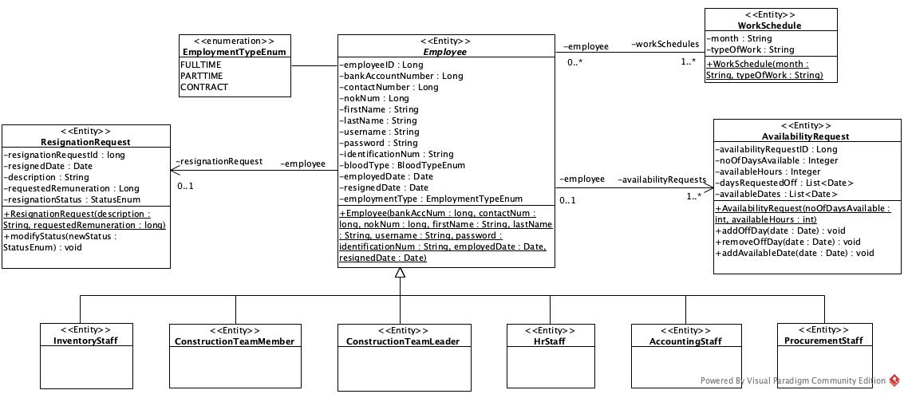

### **5.1.3.2 Simplified Non-Entity Class Diagram**

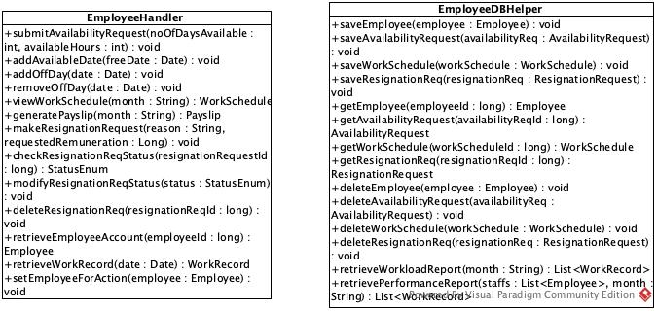

## **5.1.4 Simplified Class Diagram for MC / Leave Management Module**

### **5.1.4.1 Simplified Entity Class Diagram**

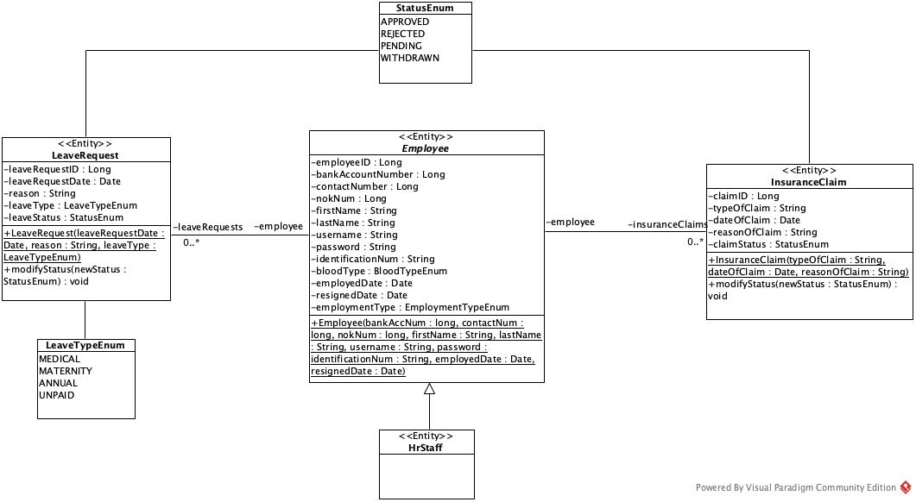

### **5.1.4.2 Simplified Non-Entity Class Diagram**

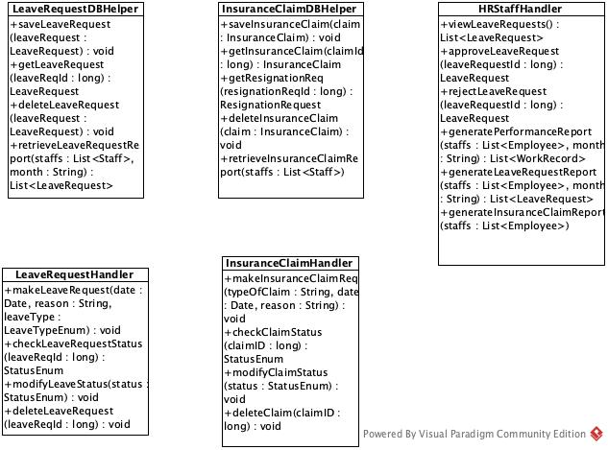

## **5.1.5 Simplified Class Diagram for Attendance Management Module**

### **5.1.5.1 Simplified Entity Class Diagram**

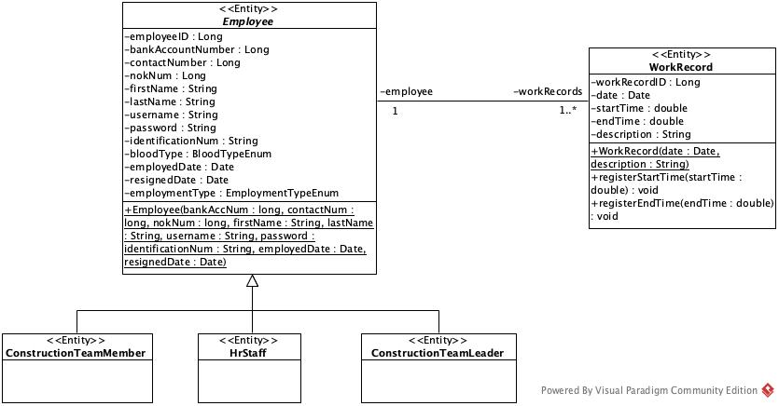

### 

### **5.1.5.2 Simplified Non-Entity Class Diagram**

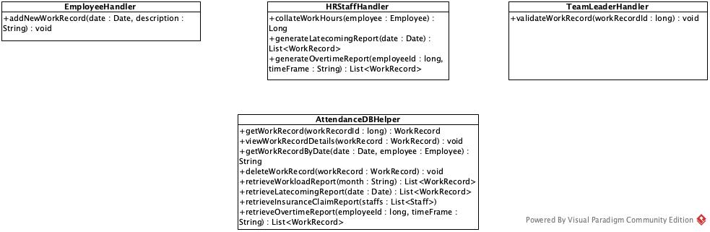

# **5.2 Project Management Subsystem**

## **5.2.1 Use Case Diagram**

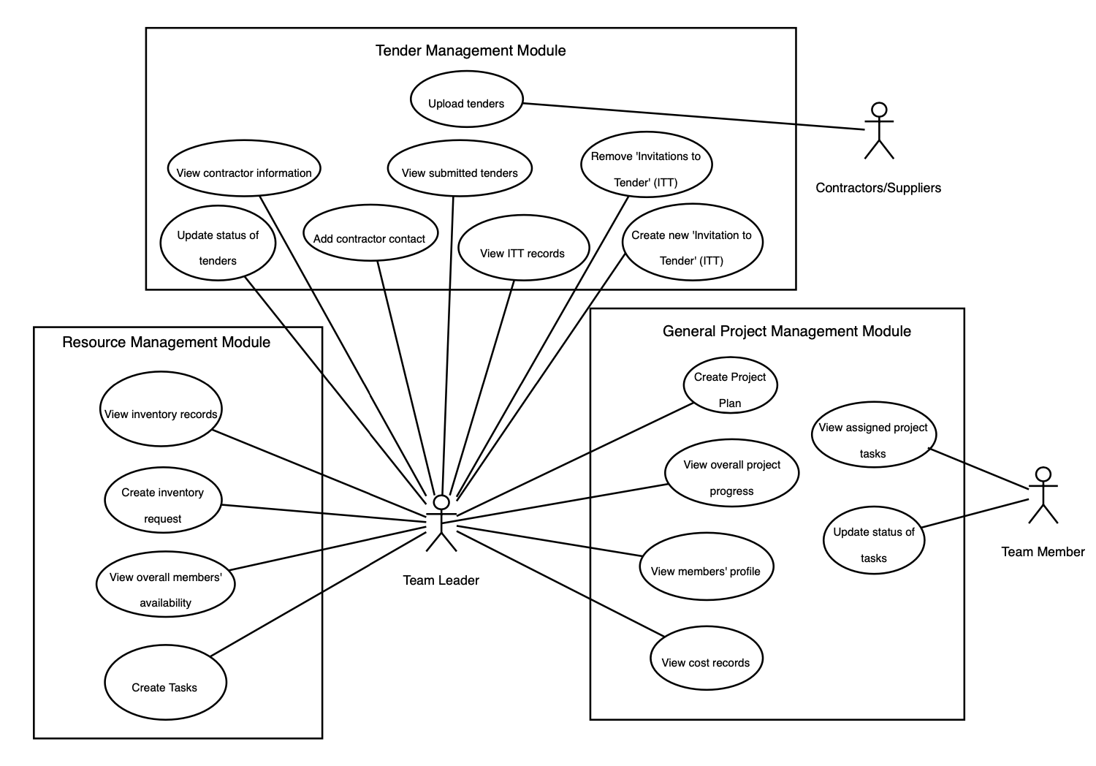

## **5.2.2 Use Case Description**

### **5.2.2.1 General Project Management Module**

#### **5.2.2.1.1 Create Project Plan**

|  |  |  |
| --- | --- | --- |
| **Use Case:** | Create Project Plan | |
| **Triggering Event:** | The Construction Team Leader wants to create an overall project plan | |
| **Brief Description:** | When the team leader creates a project plan, he can specify the overall specifications and description of the project. | |
| **Actors:** | Construction Team Leader | |
| **Preconditions:** | 1. Construction Team leader must be logged into the Construction Management System | |
| **Postconditions:** | A project plan record is created | |
| **Flow of Events:** | Actor | System |
| 1. Click on Create New Project  2. Enters the title, description, time period, location of the construction project. | 1.1 Displays a new page which prompts the Team Leader to enter the title, description, time period, budget and location of the construction project.  2.1 Creates new project plan file  2.2 Displays project plan creation success |
| **Exception Conditions:** | 2. Invalid details entered | |

#### **5.2.2.1.2 View Overall Project Progress**

|  |  |  |
| --- | --- | --- |
| **Use Case:** | View Overall Project Progress | |
| **Triggering Event:** | Construction Team Leader wants to check on the progress of the project | |
| **Brief Description:** | The Team Leader can select on a specific project plan and view how many tasks are completed. | |
| **Actors:** | Construction Team Leader | |
| **Preconditions:** | 1. Team leader must be logged into the Construction Management System 2. Project Plan record must exist in the database | |
| **Postconditions:** | - | |
| **Flow of Events:** | Actor | System |
| 1. Selects a specific project plan  2. Select “View project progression” in the project plan file | 1.1 Displays the specifications of the project  2.1 Displays all in progress, completed and uncompleted tasks  2.2 Displays a tabulation of progress based on completed tasks in terms of percentage |
| **Exception Conditions:** | - | |

#### **5.2.2.1.3 View Team Members’ Profile**

|  |  |  |
| --- | --- | --- |
| **Use Case:** | View Team Members’ Profile | |
| **Triggering Event:** | The Construction Team Leader wants to view the profile of the member | |
| **Brief Description:** | The Team Leader is able to view personal details and productivity statistics of the team member. | |
| **Actors:** | Construction Team Leader | |
| **Preconditions:** | 1. Team leader must be logged into the Construction Management System | |
| **Postconditions:** | - | |
| **Flow of Events:** | Actor | System |
| 1. Selects the “Member” tab  2. Selects a member | 1.1 Displays a list of all Construction Team Members  2.1 Displays the team member’s information which includes his date of employment, blood type, contact number, home address(es), total work hours clocked |
| **Exception Conditions:** | - | |

#### **5.2.2.1.4 View Cost Records**

|  |  |  |
| --- | --- | --- |
| **Use Case:** | View Cost Records | |
| **Triggering Event:** | The Construction Team Leader wants to view the cost records of projects. | |
| **Brief Description:** | The team leader is able to access a list of records containing the cost of all projects. | |
| **Actors:** | Construction Team Leader | |
| **Preconditions:** | 1. Team leader must be logged into the Construction Management System | |
| **Postconditions:** | - | |
| **Flow of Events:** | Actor | System |
| 1. Search for cost record by entering keywords  2. Selects a cost record | 1.1 Displays a list of all cost records associated to the keywords  2.1 Displays the cost of materials, transport, engaging third-party contractors, and other miscellaneous costs. |
| **Exception Conditions:** | 1. No cost records matches that keyword | |

#### **5.2.2.1.5 View Assigned Project Tasks**

|  |  |  |
| --- | --- | --- |
| **Use Case:** | View Assigned Project Tasks | |
| **Triggering Event:** | The Construction Team member wants to view which tasks he/she is being assigned to. | |
| **Brief Description:** | The team member is able to view which tasks they are being assigned to and the details of that task. | |
| **Actors:** | Construction Team member | |
| **Preconditions:** | 1. Team member must be logged into the Construction Management System | |
| **Postconditions:** | - | |
| **Flow of Events:** | Actor | System |
| 1. Selects “Overview”  2. Selects a particular task | 1.1 Displays list of all task  2.1 Displays task’s date of assignment, deadline, names of teammates working on the same task, title, instructions and status of the task (in progress, completed or uncompleted) |
| **Exception Conditions:** | 1. No tasks matches that keyword | |

#### **5.2.2.1.6 Update Status of Tasks**

|  |  |  |
| --- | --- | --- |
| **Use Case:** | Update Status of Tasks | |
| **Triggering Event:** | The Construction Team Member wants to update the progression of his/her assigned task. | |
| **Brief Description:** | When there is progression on a task, a team member can navigate into the task to update his/her progression. | |
| **Actors:** | Construction Team member | |
| **Preconditions:** | 1. Team member must be logged into the Construction Management System | |
| **Postconditions:** | An updated status is recorded in the database | |
| **Flow of Events:** | Actor | System |
| 1. Select a task  2. Select either the in progress, completed or uncompleted status option | 1.1 Displays the status of the task along with other task details  2.1 Updates the status of the task by storing the updated status in the database  2.2 Displays the updated status |
| **Exception Conditions:** | - | |

### **5.2.2.2 Tender Management Module**

#### **5.2.2.2.1 Create new “Invitation to Tender” (ITT)**

|  |  |  |
| --- | --- | --- |
| **Use Case:** | Create new “Invitation to Tender” (ITT) | |
| **Triggering Event:** | Company wants to create an ITT for contractors/suppliers to submit tenders for their upcoming construction project. | |
| **Brief Description:** | When a project requires outsourcing, the project leader can choose to create either an open or selective ITT with the and upload the project specifications on to the system to notify contractors/suppliers. | |
| **Actors:** | Construction Team leader | |
| **Pre-conditions:** | 1. Team leader must be logged into the Construction Management System 2. The team leader must have an ITT document with project specifications ready. 3. If it is a selective ITT, contractors’ contact information must be available in the database. | |
| **Post-conditions:** | 1. A new pending ITT will be created and stored in the system. | |
| **Flow of Events:** | Actor | System |
| 1. The team leader creates a new ITT with pending status by uploading the document.  2. The team leader chooses the option between an open ITT or a selective ITT.  3. If the team leader chooses open ITT, proceed to Step 4.  3a. If the team leader chooses selective ITT, he/she will select the intended recipients of the ITT.  4. Team leader reviews and confirms the ITT. | 1.1 Displays a prompt for the team leader to select between open or selective ITT.  2.1 If the user selects open ITT, display the confirmation page.  2.2 If the user selects selective ITT, display the company's contractor/supplier database.  3a.1 System will display the confirmation page.  4.1. System creates a new itt record in the database  4.2 System generates a website URL and sends it to the recipients via email |
| **Exception Conditions:** | 1. Document upload fails | |

#### **5.2.2.2.2 View Invitation to Tender (ITT) Record**

|  |  |  |
| --- | --- | --- |
| **Use Case:** | View Invitation to Tender (ITT) Record | |
| **Triggering Event:** | Company wants to view an ITT. | |
| **Brief Description:** | The company can revisit the ITT in the database to view information about the ITT and its status. | |
| **Actors:** | Construction Team leader | |
| **Pre-conditions:** | 1. Team leader must be logged into the Construction Management System 2. There must be an ITT in the database. | |
| **Post-conditions:** | - | |
| **Flow of Events:** | Actor | System |
| 1. The team leader selects ‘View ITTs’.  2. The team leader selects an ITT | 1.1 Displays a list of all ITTs with the brief information of their current status, and the number of submitted tenders in accordance to that ITT.  2.1 Display specific information on the ITT as well as the submitted tenders for that particular ITT. |
| **Exception Conditions:** | - | |

#### **5.2.2.2.3 Remove Invitation to Tender (ITT)**

|  |  |  |
| --- | --- | --- |
| **Use Case:** | Remove Invitation to Tender (ITT) | |
| **Triggering Event:** | Company wants to delete ITT from the website. | |
| **Brief Description:** | The company wishes to cancel the ITT and remove it from the website. | |
| **Actors:** | Construction Team leader | |
| **Pre-conditions:** | 1. Team leader must be logged into the Construction Management System 2. There must be a pending ITT in the database. 3. User must be viewing a specific ITT (See Use Case PM2.2) | |
| **Post-conditions:** | 1. Status of ITT is changed from pending to cancelled. | |
| **Flow of Events:** | Actor | System |
| 1. The team leader selects ‘Delete ITT’.  2. If the team leader confirms his decision to remove the ITT, he clicks confirm.  2a. If the team leader decides to cancel the removal, he clicks cancel. | 1.1 Prompts a confirmation popup to ask if the user really intends to remove the ongoing ITT.  2.1 System removes the pending ITT from the website.  2.2 System changes the status of the ITT to cancelled.  2a.1 Returns to the list view of ongoing ITTs. |
| **Exception Conditions:** | - | |

#### **5.2.2.2.4 Update Status of Tenders**

|  |  |  |
| --- | --- | --- |
| **Use Case:** | Update Status of Tenders | |
| **Triggering Event:** | Team leader wants to update the status of a submitted tender from a contractor. | |
| **Brief Description:** | The team leader can review tenders and choose to accept or reject the submitted tenders. | |
| **Actors:** | Construction Team leader | |
| **Pre-conditions:** | 1. Team leader must be logged into the Construction Management System 2. There must be an ITT in the database. 3. There must be a tender submitted. 4. User must be viewing a specific ITT (See Use Case PM2.2) | |
| **Post-conditions:** | 1. ITT status is changed from ‘Pending’ to ‘Completed’. 2. Tender status is changed from ‘Pending’ to ‘Rejected’ or ‘Accepted’. | |
| **Flow of Events:** | Actor | System |
| 1. The team leader views an ITT.  2. The team leader selects a tender from the list of tenders.  3. If the team leader is satisfied with the company’s tender, he accepts it.  3a. If the team leader is not satisfied with the tender, he rejects the tender and goes back to Step 2. | 1.1 Displays a list of tenders and which company is it submitted by.  2.1 Display tender information uploaded by contractors/suppliers as well as their company information.  3.1 System attaches contractor details to the ITT.  3.2 System updates the status of the tender to ‘Accepted’.  3.2 System sends a confirmation email to the winner of the tender.  3.2 System changes ITT status from pending to completed  3a.1 System updates the status of tender to rejected.  3a.1a System sends a rejected email to the company that submitted the tender.  3a.2 Display list of tenders submitted by contractors/suppliers. |
| **Exception Conditions:** | - | |

#### **5.2.2.2.5 Add Contractor Contact**

|  |  |  |
| --- | --- | --- |
| **Use Case:** | Add Contractor Contact | |
| **Triggering Event:** | Company wants to add a new contractor’s contact into the database. | |
| **Brief Description:** | When the team leader has a new contractor/supplier that has been sourced and he/she wants to work with, he/she can add the contact information of the contractor/supplier into the database for ease of contact. | |
| **Actors:** | Construction Team leader | |
| **Pre-conditions:** | - | |
| **Post-conditions:** | 1. Team leader must be logged into the Construction Management System 2. Database for contractors logs a new entry. | |
| **Flow of Events:** | Actor | System |
| 1. Click on ‘Add New Contractor’.  2. Enter Company Name, Company Email, Company Address, Company Contact Number. | 1.1 Display registration form which prompts team leader to enter the contractor’s Company Name, Company Email, Company Address, and Company Contact Number.  2.1 Display dialog box to show successful addition of contact. |
| **Exception Conditions:** | 1. Invalid information is added into the registration form. | |

#### **5.2.2.2.6 View Contractor Information**

|  |  |  |
| --- | --- | --- |
| **Use Case:** | View Contractor Information | |
| **Triggering Event:** | Team leader wants to view a contractor’s information. | |
| **Brief Description:** | The team leader can look for specific contact information of a contractor in the database. | |
| **Actors:** | Construction Team leader | |
| **Pre-conditions:** | 1. Team leader must be logged into the Construction Management System 2. Company database must have contractors’ information. | |
| **Post-conditions:** | - | |
| **Flow of Events:** | Actor | System |
| 1. Click ‘View Contractors’. aaaa  2. Selects a contractor whose details he wants to view | 1.1 Display list of contractors in the company’s database.  2.1 Display specific information of the contractor, such as Company Name, Company Information, Company Contact Number, Company Email, Company Address, and projects worked with our company. |
| **Exception Conditions:** | - | |

#### **5.2.2.2.7 Submit Tender**

|  |  |  |
| --- | --- | --- |
| **Use Case:** | Submit Tender | |
| **Triggering Event:** | Contractor wants to submit a tender for an ITT. | |
| **Brief Description:** | Contractors can submit their tenders for any ITT they have been contacted for by uploading their tender onto our website. | |
| **Actors:** | Contractor | |
| **Pre-conditions:** | 1. Contractor must have a tender document ready. | |
| **Post-conditions:** | 1. Tender is added to the system database. | |
| **Flow of Events:** | Actor | System |
| 1. If it is an open ITT, the contractor visits our ITT webpage by clicking on a URL link from our main web page or any of our advertising channels.  1a. If it is a selective ITT, the contractor visits our webpage by clicking on a private URL link sent to their email.  2. Click on ‘Upload’.  3. Contractor fills in required information and click on ‘Submit’. | 1.1 Display web page with ITT specifications and upload button.  1a.1 Display web page with ITT specifications and upload button.  2.1 Display form for contractor to fill in Company Name, Company Contact Number, Company Email, and allow contractor to upload a tender document.  3.1 System attaches company information to the particular tender document, and adds the tender into the database in correspondence to the ITT. |
| **Exception Conditions:** | - | |

### 5.2.2.3 Resource Management Module

#### **5.2.2.3.1 View Inventory Records**

|  |  |  |
| --- | --- | --- |
| **Use Case:** | View Inventory Records | |
| **Triggering Event:** | The team leader wants to view the inventory records | |
| **Brief Description:** | When a team leader or inventory staff wishes to check the inventory, they can view a list of all inventory records. | |
| **Actors:** | Construction Team leader | |
| **Preconditions:** | 1. Team leader must be logged into the Construction Management System | |
| **Postconditions:** | - | |
| **Flow of Events:** | Actor | System |
| 1. Search inventory records by entering keywords  2. Selects the item | 1.1 Displays list of inventory items associated to the keywords  2.1 Displays the inventory name, quantity and date of purchase of the inventory |
| **Exception Conditions:** | 1. Inventory item is not found, given the search keywords | |

#### **5.2.2.3.2 Create Inventory Request**

|  |  |  |
| --- | --- | --- |
| **Use Case:** | Create Inventory Request | |
| **Triggering Event:** | The team leader wants to request for inventory materials required for the project | |
| **Brief Description:** | When the team leader needs certain materials required for the project, he/she can request for the materials. | |
| **Actors:** | Construction Team Leader | |
| **Preconditions:** | 1. Team leader must be logged into the Construction Management System | |
| **Postconditions:** | A material request is created and a record stored in the database | |
| **Flow of Events:** | Actor | System |
| 1. Searches for the materials needed using keywords  2. Selects the specific material  3. Enters purpose of request and quantity needed | 1.1 Displays a list materials associated to the keywords  2.1 Prompts the team leader to enter purpose of request and quantity needed  3.1 Creates a pending status material request that awaits the approval of the inventory staff  3.2 Displays material request creation success |
| **Exception Conditions:** | 1. Material is not found, given the search keywords | |

#### **5.2.2.3.3 View Overall Members’ Availability**

|  |  |  |
| --- | --- | --- |
| **Use Case:** | View Overall Members' Availability | |
| **Triggering Event:** | Team Leader wants to assign tasks to members and needs to know the availability of members | |
| **Brief Description:** | The team leader can access a list of current status of members, whether they are available or occupied | |
| **Actors:** | Construction Team Leader | |
| **Preconditions:** | 1. Team leader must be logged into the Construction Management System | |
| **Postconditions:** | - | |
| **Flow of Events:** | Actor | System |
| 1. Selects view team members availability | 1.1 Displays a list of member’s availability status (available or occupied) at the current time |
| **Exception Conditions:** | - | |

#### **5.2.2.3.4 Create Tasks**

|  |  |  |
| --- | --- | --- |
| **Use Case:** | Create Tasks | |
| **Triggering Event:** | The Construction Team Leader wants to create tasks within a project for a Team Member. | |
| **Brief Description:** | The Team Leader can select a particular project, create a task and thereafter assign it to team members. | |
| **Actors:** | Construction Team Leader | |
| **Preconditions:** | 1. Team leader must be logged into the Construction Management System | |
| **Postconditions:** | A new task is created and a record is stored in the database | |
| **Flow of Events:** | Actor | System |
| 1. Select create task  2. Enters the prompt details | 1.1 Prompts team leader to enter date of assignment, deadline, ID of members to assign the task to, title, instructions and status of the task (in progress, completed or uncompleted)  2.1 Creates task file  2.2 Display task creation success |
| **Exception Conditions:** | - | |

## **5.2.3 Simplified Class Diagram for General Project Management Module**

### **5.2.3.1 Simplified Entity Class Diagram**

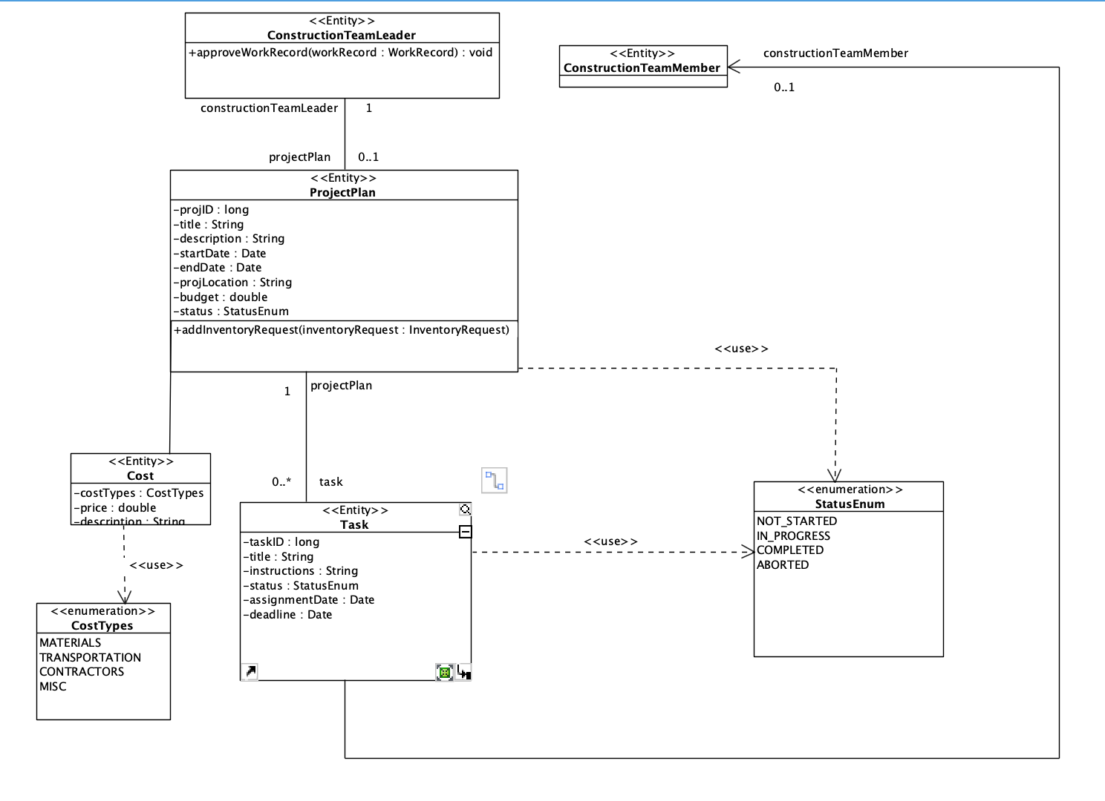

### **5.2.3.2 Simplified Non-Entity Class Diagram**

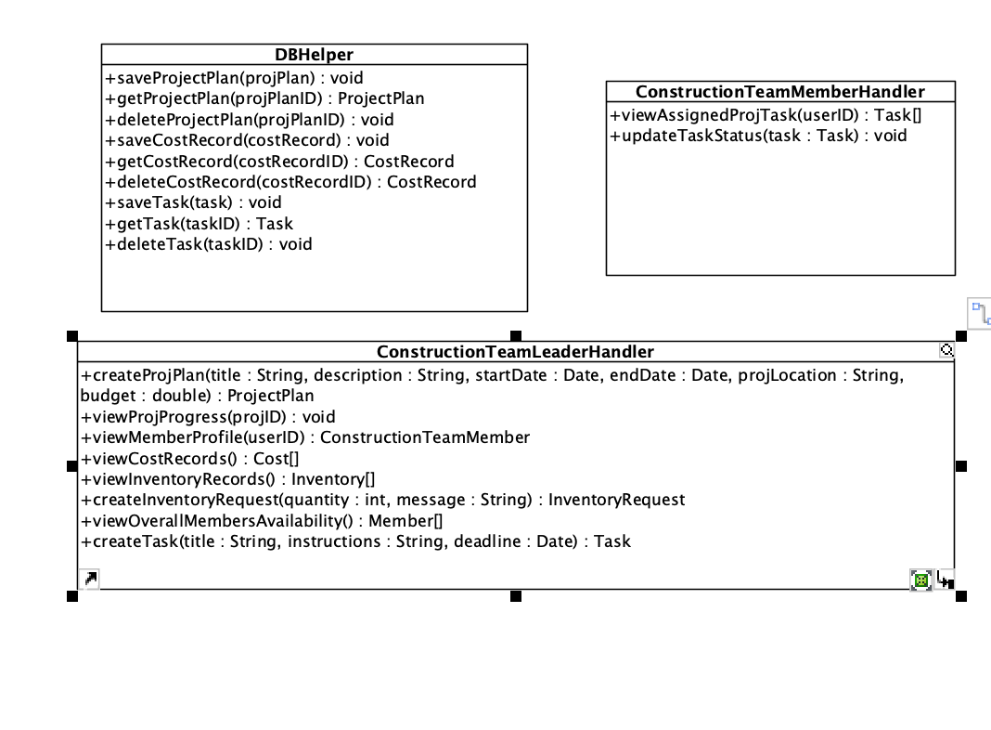

## **5.2.4 Simplified Class Diagram for Tender Management Module**

### 5.2.4.1 Simplified Entity Class Diagram

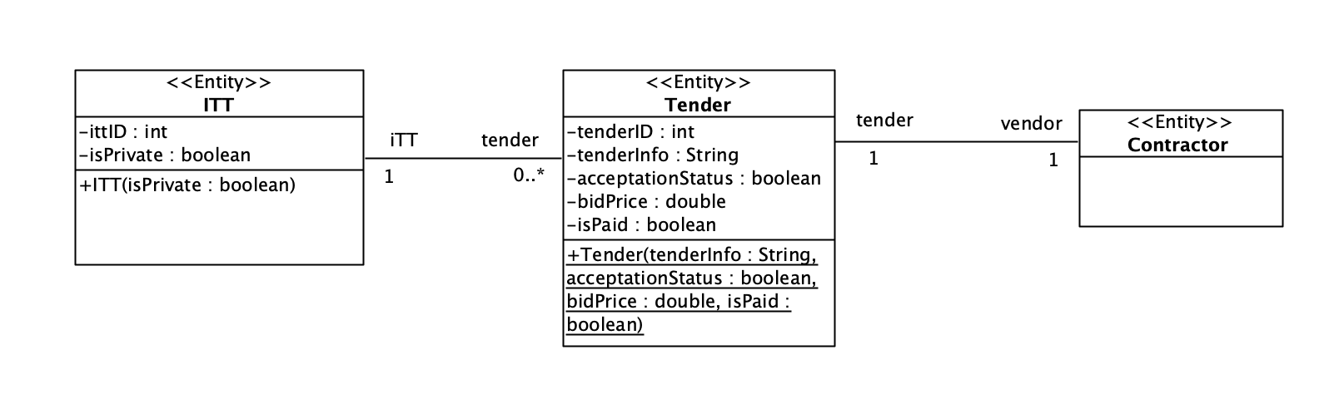

### 5.2.4.2 Simplified Non-Entity Class Diagram

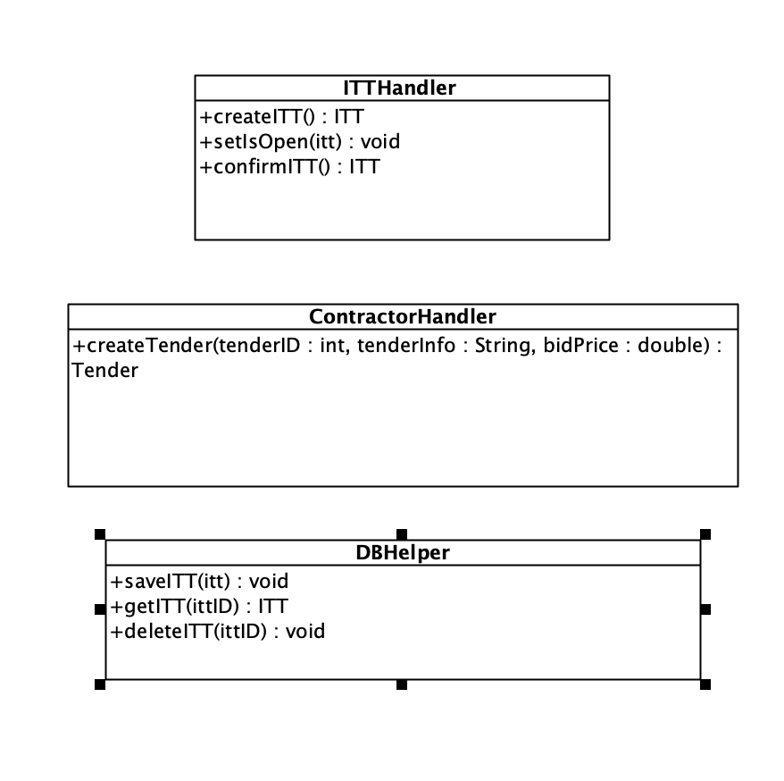

## **5.2.5 Simplified Class Diagram for Resource Management Module**

### 5.2.4.1 Simplified Entity Class Diagram

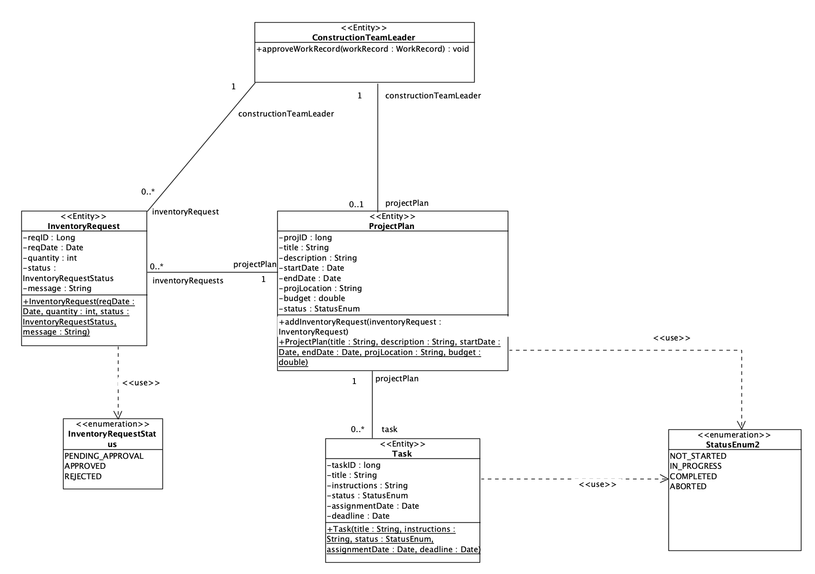

### 5.2.4.2 Simplified Non-Entity Class Diagram

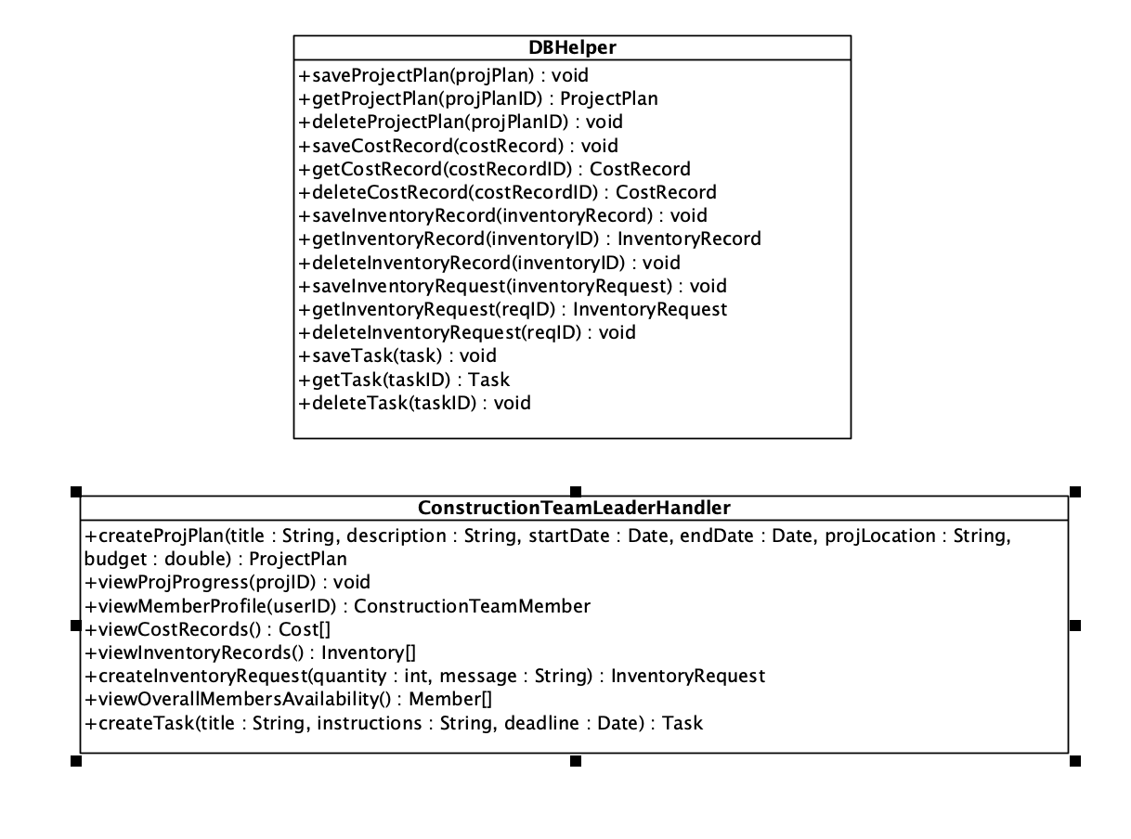

# **5.3 Logistics Management Subsystem**

## **5.3.1 Use Case Diagram**

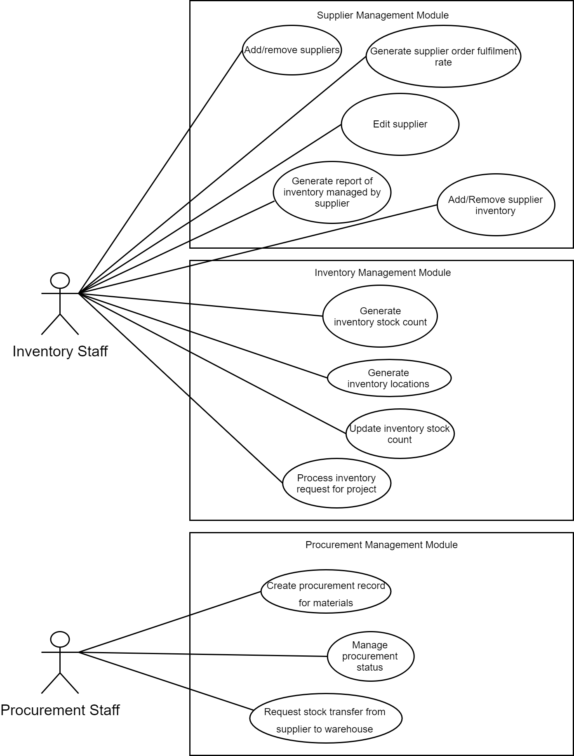

## **5.3.2 Use Case Description**

### 5.3.2.1 Supplier Management Module

#### **5.3.2.1.1 Generate Report of Inventory Managed by Supplier**

|  |  |  |
| --- | --- | --- |
| **Use Case:** | Generate report of inventory managed by supplier | |
| **Triggering Event:** | Inventory Staff wants to generate report of inventory managed by a supplier | |
| **Brief Description:** | Inventory Staff searches for supplier managed by the company and selects from list of results to retrieve list of inventory and their details managed by selected supplier | |
| **Actors:** | Inventory Staff | |
| **Pre-conditions:** | 1. Inventory Staff must be logged in to construction management system | |
| **Post-conditions:** | - | |
| **Flow of Events:** | **Actor** | **System** |
| 1. Search for supplier using name    2. Select supplier from list of search results | 1.1 Displays list of search results  2.1 Retrieves list of inventory and inventory details managed by selection from database    3. Displays list of all inventory managed by selected supplier |
| **Exception Conditions:** | 1. Invalid name in input | |

#### **5.3.2.1.2 Add Supplier**

|  |  |  |
| --- | --- | --- |
| **Use Case:** | Add supplier | |
| **Triggering Event:** | Inventory Staff wants to add a new supplier associated with the company | |
| **Brief Description:** | Inventory Staff enters details of supplier to be added and system records it on to the database | |
| **Actors:** | Inventory Staff | |
| **Pre-conditions:** | 1. Inventory Staff must be logged in to constructoin management system | |
| **Post-conditions:** | New supplier record is created | |
| **Flow of Events:** | **Actor** | **System** |
| 1. Enter supplier details (name, contact number, website, email) into system | 1.1 Saves a record of new supplier into database  2. Informs user once record is successfully saved |
| **Exception Conditions:** | 1. Supplier already associated with company in database | |

#### **5.3.2.1.3 Edit Supplier**

|  |  |  |
| --- | --- | --- |
| **Use Case:** | Edit supplier | |
| **Triggering Event:** | Inventory Staff wants to edit the details of a supplier | |
| **Brief Description:** | Inventory Staff searches for supplier managed by the company and selects from list of results to edit | |
| **Actors:** | Inventory Staff | |
| **Pre-conditions:** | 1. Inventory Staff must be logged in to construction management system 2. Supplier record must exist in database | |
| **Post-conditions:** | Supplier record is updated with new details in database | |
| **Flow of Events:** | **Actor** | **System** |
| 1. Search for supplier using id or name    2. Select supplier from list of search results to edit    3. Makes changes to respective fields | 1.1 Displays list of suppliers currently working with company  2.1 Displays fields for user to edit    3.1 Updates supplier record in database with new changes  4. Informs user that changes has been successfully made |
| **Exception Conditions:** | 1. Invalid name in input  2. Invalid values entered into fields | |

#### **5.3.2.1.4 Add Supplier Inventory**

|  |  |  |
| --- | --- | --- |
| **Use Case:** | Add supplier inventory | |
| **Triggering Event:** | Inventory Staff wants to add inventory supplied by a supplier | |
| **Brief Description:** | Inventory Staff searches for supplier managed by the company and selects from list of results to add inventory to that supplier | |
| **Actors:** | Inventory Staff | |
| **Pre-conditions:** | 1. Inventory Staff must be logged in to construction management system 2. Supplier record must exist in database | |
| **Post-conditions:** | Supplier record is updated with new inventory in database | |
| **Flow of Events:** | **Actor** | **System** |
| 1. Search for supplier using name    2. Select supplier from list of search results to add inventory for    3a. Adds existing inventory item  3b. Creates and add new inventory item with name to supplier inventories | 1.1 Displays list of suppliers currently working with company  2.1 Prompts user to add existing inventory item or create new inventory item    3a.1 Updates supplier record with supplier associated to chosen inventory item  3b.1 Saves new inventory item to database  3b.2 Updates supplier record with supplier associated to created inventory item  4. Informs user of successful addition of inventory to supplier |
| **Exception Conditions:** | 1. Invalid name in input  3b. Inventory item already associated with supplier | |

#### **5.3.2.1.5 Remove Supplier**

|  |  |  |
| --- | --- | --- |
| **Use Case:** | Remove supplier | |
| **Triggering Event:** | Inventory Staff wants to remove a supplier associated with the company | |
| **Brief Description:** | Inventory Staff searches for supplier managed by the company and selects from list of results to remove association with them | |
| **Actors:** | Inventory Staff | |
| **Pre-conditions:** | 1. Inventory Staff must be logged in to construction management system 2. Supplier record must exist in database | |
| **Post-conditions:** | Supplier status is changed to not associated in database | |
| **Flow of Events:** | **Actor** | **System** |
| 1. Search for supplier using name    2. Select supplier from list of search results to remove | 1.1 Displays list of suppliers currently working with company  2.1 State of supplier changed to unassociated with company in database    3. Informs user supplier has been removed from company |
| **Exception Conditions:** | 1. Invalid name in input | |

#### **5.3.2.1.6 Remove Supplier Inventory**

|  |  |  |
| --- | --- | --- |
| **Use Case:** | Remove supplier inventory | |
| **Triggering Event:** | Inventory Staff wants to remove inventory supplied by a supplier | |
| **Brief Description:** | Inventory Staff searches for supplier managed by the company, selects supplier, selects from list of inventory supplied by supplier to remove | |
| **Actors:** | Inventory Staff | |
| **Pre-conditions:** | 1. Inventory Staff must be logged in to construction management system 2. Supplier record must exist in database | |
| **Post-conditions:** | Supplier record is updated with remaining inventory in database | |
| **Flow of Events:** | **Actor** | **System** |
| 1. Search for supplier using name    2. Select supplier from list of search results to removed inventory from    3. Select inventory to remove from supplier | 1.1 Displays list of suppliers currently working with company  2.1 Displays list of inventories supplied by supplier    3.1 Removes inventory selected from supplier record  4. Saves updated supplier record into database  5. Informs user of successful removal of inventory from supplier |
| **Exception Conditions:** | 1. Invalid name in input | |

#### **5.3.2.1.7 Generate Supplier Order Fufilment Rate**

|  |  |  |
| --- | --- | --- |
| **Use Case:** | Generate supplier order fulfilment rate | |
| **Triggering Event:** | Procurement Staff wants to generate fulfilment rate achieved by a supplier | |
| **Brief Description:** | Procurement Staff enters details of a supplier to retrieve data from and system generates the order fulfilment rate achieved by that supplier | |
| **Actors:** | Procurement Staff | |
| **Pre-conditions:** | 1. ProcurementStaff must be logged in to construction management system 2. Supplier must be associated with this company in database | |
| **Post-conditions:** | - | |
| **Flow of Events:** | **Actor** | **System** |
| 1. Enter supplier name | 1.1 Retrieve past procurement record for vendor  2. Calculates order fulfilment rate based on completed and failed procurement records  3. Displays order fulfilment rate to user |
| **Exception Conditions:** | 1. Invalid name in input | |

### 5.3.2.2 Inventory Management Module

#### **5.3.2.2.1 Generate Inventory Stock Count**

|  |  |  |
| --- | --- | --- |
| **Use Case:** | Generate inventory stock count | |
| **Triggering Event:** | Inventory Staff wants to generate stock count for a particular inventory item | |
| **Brief Description:** | Inventory Staff enters type of inventory and system tallies total stock count from all warehouses for that item | |
| **Actors:** | Inventory Staff | |
| **Pre-conditions:** | 1. Inventory Staff must be logged in to construction management system 2. Inventory record must exist in database | |
| **Post-conditions:** | - | |
| **Flow of Events:** | **Actor** | **System** |
| 1. Search for an inventory by name | 1.1 Retrieves stock count from all warehouses item is stored in  2. Calculates total stock count for inventory and displays to the user |
| **Exception Conditions:** | 1. Invalid name | |

#### **5.3.2.2.2 Generate Inventory Locations**

|  |  |  |
| --- | --- | --- |
| **Use Case:** | Generate inventory locations | |
| **Triggering Event:** | Inventory Staff wants to generate location details for a particular inventory item | |
| **Brief Description:** | Inventory Staff enters type of inventory and system returns a list of locations the item is held at along with the stock count at each location | |
| **Actors:** | Inventory Staff | |
| **Pre-conditions:** | 1. Inventory Staff must be logged in to construction management system 2. Inventory record must exist in database | |
| **Post-conditions:** | - | |
| **Flow of Events:** | **Actor** | **System** |
| 1. Search for an inventory by name | 1.1 Retrieves locations for the item and stock count at each location from database  2. Displays list of locations and stock count at each location to the user |
| **Exception Conditions:** | 1. Invalid name | |

#### **5.3.2.2.3 Update Inventory Stock Count**

|  |  |  |
| --- | --- | --- |
| **Use Case:** | Update inventory stock count | |
| **Triggering Event:** | Inventory Staff wants to update the stock count for an inventory item | |
| **Brief Description:** | Inventory Staff chooses an inventory item and the location where its stock will be updated and updates it by entering the new quantity value | |
| **Actors:** | Inventory Staff | |
| **Pre-conditions:** | 1. Inventory Staff must be logged in to construction management system 2. Inventory record must exist in database | |
| **Post-conditions:** | Inventory in database updated with new stock count | |
| **Flow of Events:** | **Actor** | **System** |
| 1. Search for an inventory item by name    2. Select location where stock count is to be updated  3. Enter updated stock count | 1.1 Retrieves and display a list of locations item is held in  2.1 Prompts user to enter updated stock count in selected location  3.1 Saves new stock count at selected location to database |
| **Exception Conditions:** | 1. Invalid name  3. Invalid stock count | |

#### **5.3.2.2.4 Process Inventory Request for a Project**

|  |  |  |
| --- | --- | --- |
| **Use Case:** | Process inventory request for a project | |
| **Triggering Event:** | Inventory Staff wants to process inventory request for a project | |
| **Brief Description:** | Inventory Staff views ongoing requests for inventory for different projects and can choose to approve or decline the request | |
| **Actors:** | Inventory Staff | |
| **Pre-conditions:** | 1. Inventory Staff must be logged in to construction management system 2. Inventory request record must exist in database | |
| **Post-conditions:** | Status of inventory in database changed to reserved and cannot be reserved for another project | |
| **Flow of Events:** | **Actor** | **System** |
| 1. Views and select a request from a list of inventory requests to process    2a. Rejects the request with reason for rejection  2b. Approves the request | 1.1 Retrieves request from database and displays to user the type and quantity of inventory requested  2a.1 Updates status of inventory request to rejected  2a.2 Updates message of request with reason for rejection  2a.3 Saves the updated inventory request to database  2a.4 Send an email to inform construction team leader who created the request of rejection along with reason  2b.1 Updates status of inventory request to approved  2b.2 Quantity requested will be marked as reserved in the database  2b.3. Saves the updated inventory request to database  2b.4 Send an email to inform construction team leader who created the request of approval |
| **Exception Conditions:** | 2a.1 Available stock count of inventory lower than requested amount | |

### 5.3.2.3 Procurement Management Module

#### **5.3.2.3.1 Create Procurement Record for Materials**

|  |  |  |
| --- | --- | --- |
| **Use Case:** | Create procurement record for materials | |
| **Triggering Event:** | Procurement staff | |
| **Brief Description:** | Procurement staff creates an procurement record after submitting order of materials to a supplier | |
| **Actors:** | Procurement staff | |
| **Pre-conditions:** | 1. Procurement staff must be logged in to construction management system | |
| **Post-conditions:** | A procurement record is added to the database | |
| **Flow of Events:** | **Actor** | **System** |
| 1. Enter details of order including name of material ordered, quantity ordered, name of Supplier, total cost, date of order, details of employee who made the order | 1.1 Order details added as a record in the database with default status set to be in progress  2. Purchase order created and saved to database  3. User is notified of successful creation of procurement record |
| **Exception Conditions:** | 1. Invalid details in input | |

#### **5.3.2.3.2 Request Stock Transfer From Supplier to Warehouse**

|  |  |  |
| --- | --- | --- |
| **Use Case:** | Request stock transfer from supplier to warehouse | |
| **Triggering Event:** | Procurement staff wants to generate a request for stocks to be delivered from supplier to warehouse | |
| **Brief Description:** | Procurement staff chooses a supplier and selects the inventory and inputs the quantity and location for the stock to be delivered to | |
| **Actors:** | Procurement staff | |
| **Pre-conditions:** | 1. Procurement staff must be logged in to construction management system 2. Supplier record must exist in database | |
| **Post-conditions:** | Transfer request record is added to database | |
| **Flow of Events:** | **Actor** | **System** |
| 1. Searches for supplier by name    2. Select supplier from list  3. Select inventory item  4. Input quantity and location for stock to be delivered to | 1.1 Retrieves list of suppliers associated with company from database and displays to user  2.1 Displays list of available inventory carried by supplier  3.1 Request user to input desired quantity and location for stocks to be delivered to  4.1 Saves a new transfer request record in the database  5. Sends email of request to supplier for processing |
| **Exception Conditions:** | 4. Invalid quantity input by user | |

#### **5.3.2.3.3 Manage Procurement Status**

|  |  |  |
| --- | --- | --- |
| **Use Case:** | Manage procurement status | |
| **Triggering Event:** | Procurement staff wants to update the status of a procurement record | |
| **Brief Description:** | Procurement staff selects a procurement record to update and makes the changes to the current status of it | |
| **Actors:** | Procurement staff | |
| **Pre-conditions:** | 1. Procurement staff must be logged in to construction management system 2. Procurement record must exist in database | |
| **Post-conditions:** | Status of procurement record is changed in database | |
| **Flow of Events:** | **Actor** | **System** |
| 1. Searches for procurement record by id    2a. Update status to completed  2b. Updates status to failed | 1.1 Displays details of procurement record  2a.1 Purchase order record is created under receivables subsystem  2a.2 Updates status to procurement record and saves it to the database  2b.1 Updates status of procurement record to failed and saves it to database  3. Informs the user of change to record |
| **Exception Conditions:** | - | |

## 

## 

## 

## **5.3.3 Simplified Class Diagram for Supplier Management Module**

### **5.3.3.1 Simplified Entity Class Diagram**

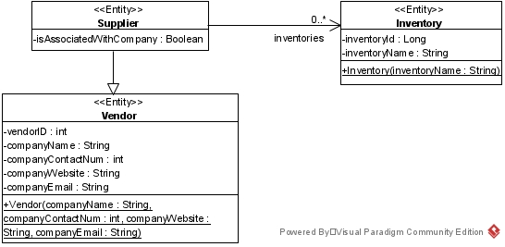

### **5.3.3.2 Simplified Non-Entity Class Diagram**

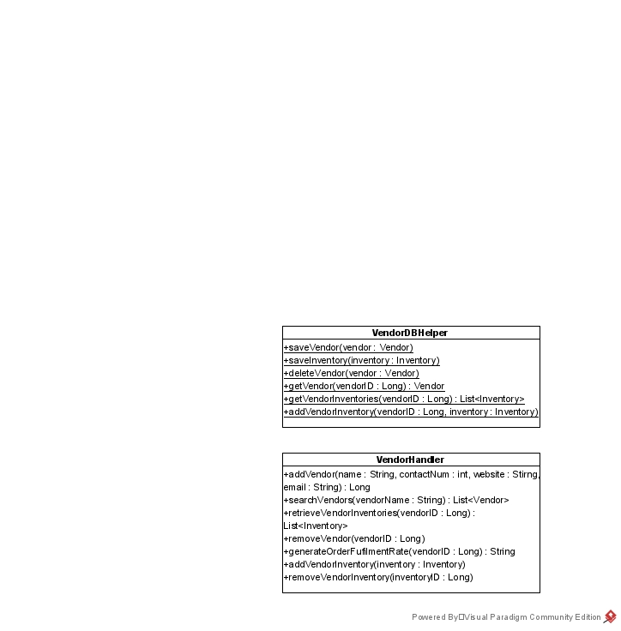

## 

## **5.3.4 Simplified Class Diagram for Inventory Management Module**

### 5.3.4.1 Simplified Entity Class Diagram

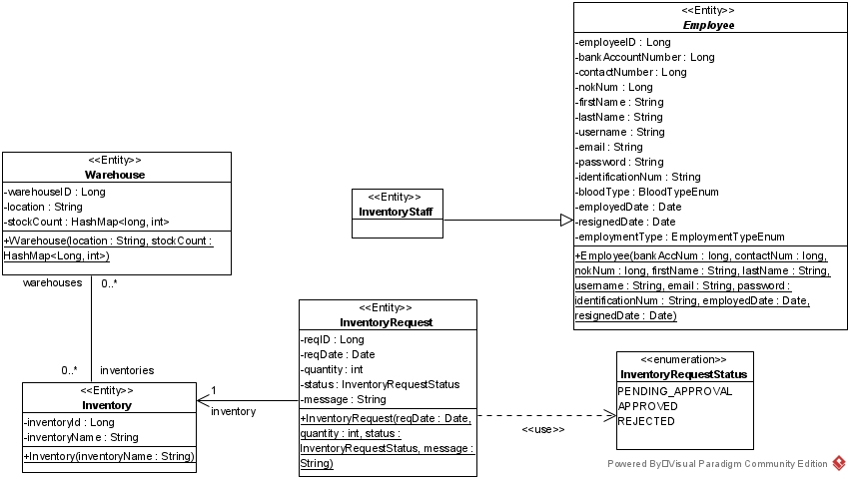

### 

### 

### 

### 5.3.4.2 Simplified Non-Entity Class Diagram

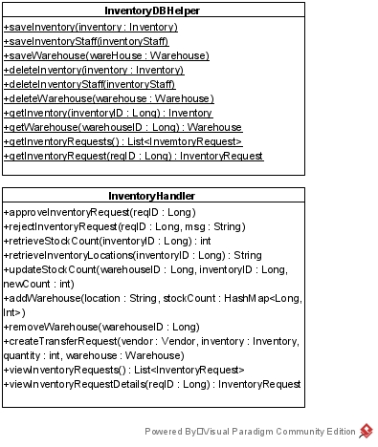

## **5.3.5 Simplified Class Diagram for Procurement Management Module**

### 5.3.5.1 Simplified Entity Class Diagram

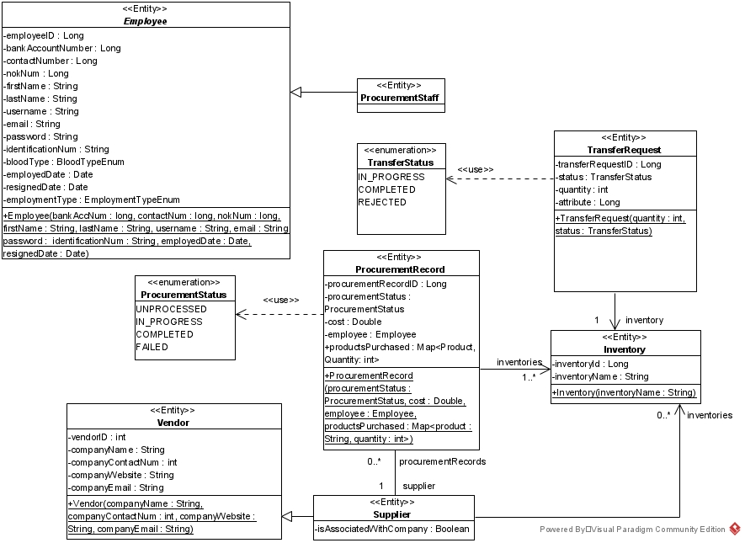

### 5.3.5.2 Simplified Non-Entity Class Diagram

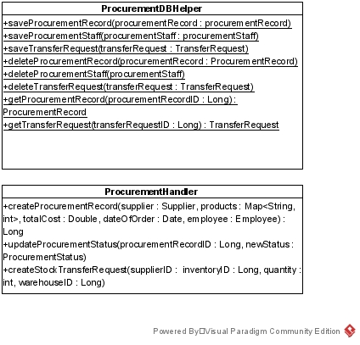

# **5.4 Account and Finance Management Subsystem**

## **5.4.1 Use Case Diagram**

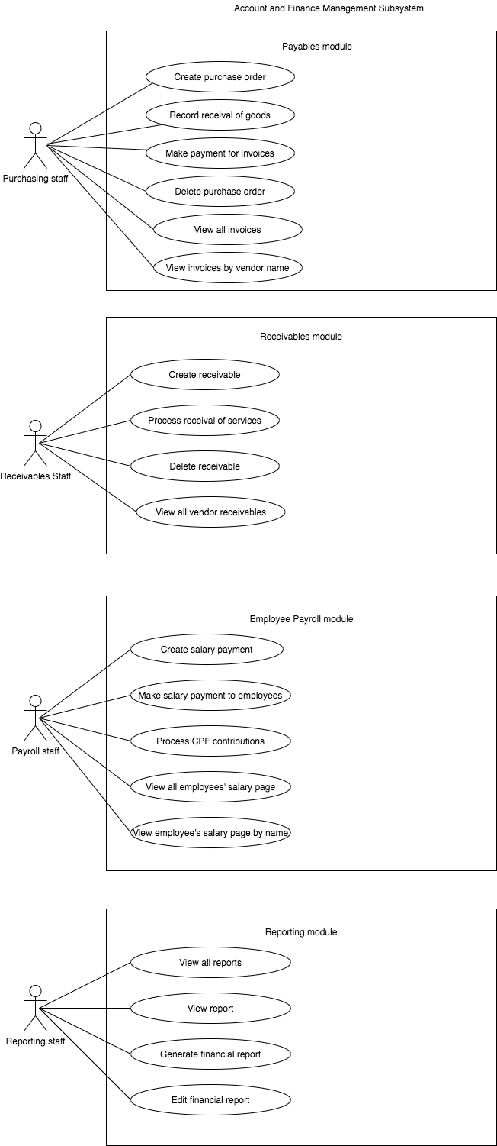

## **5.4.2 Use Case Description**

### 5.4.2.1 Payables Module

#### **5.4.2.1.1 Create Purchase Order**

|  |  |  |
| --- | --- | --- |
| **Use Case:** | Create Purchase Order | |
| **Triggering Event:** | Logistics department sends procurement records to the payables department. | |
| **Brief Description:** | When logistics personnel need to purchase a service or goods they will submit a procurement record with ‘UNPROCESSED’ status to the Accounting department which will then be processed and the order will be placed. | |
| **Actors:** | Payables staff. | |
| **Pre-conditions:** | 1. Payables staff is logged into the Construction Management System 2. Valid procurement records exist in the database. 3. Valid vendors exist in the database. 4. Transaction created. | |
| **Post-conditions:** | 1. Payables staff is logged into the Construction Management System 2. Status of procurement record changed. | |
| **Flow of Events:** | Actor | System |
| 1 Selects “Purchase orders” and navigate to “View all pending procurement records” and click on the procurement records the user wishes to process.  2 Staff reviews the vendor details, item/service details, order quantity and price and confirms purchase order. | 1.1 System retrieves procurement records with UNPROCESSED status and generates PO for selected records with the details given in it.    2.1 System sends purchase order to specified vendor and saves the purchase order in the database. The status of the procurement record is changed to IN_PROGRESS. |
| **Exception Conditions:** | - | |

#### **5.4.2.1.2 Record Receival of Goods**

|  |  |  |
| --- | --- | --- |
| **Use Case:** | Record Receival of Goods. | |
| **Triggering Event:** | Payables staff wants to record the success of the delivery of goods/services. | |
| **Brief Description:** | Upon receiving goods from suppliers or services from contractors, change the status of procurement order to COMPLETED or FAILED in accordance to the condition of goods received. | |
| **Actors:** | Payables staff | |
| **Pre-conditions:** | 1. Payables staff is logged into the Construction Management System 2. Authorizing purchase orders for the received goods must exist in the database. | |
| **Post-conditions:** | 1. Status of procurement record changed. 2. Vendor Invoice generated. 3. Transaction created. | |
| **Flow of Events:** | Actor | System |
| 1. Select “Purchase orders” and click on “view all purchase orders”.  2. Search for specific purchase orders using keywords such as vendor name or item name.  3. Select the purchase order for which the goods have been delivered for.  3a Click “Received in good condition” if goods received are received in good condition and the total amount on the vendor invoice matches the total amount in purchase order.  3b Click on “Received in incomplete conditions” if goods quality does not match expectation or the quantity does not match the quantity on purchase order. | 1.1 Retrieve all purchase orders for which the procurement record status is IN_PROGRESS.  2.1 Retrieve all purchase orders for which the vendor name matches user input or item name matches user input.  3a.1 System changes status of procurement record to COMPLETE.  3a.2 System generates a vendor invoice and saves it to the database.  3a.3 Creates a transaction and save to the database.  3b.1 Change status of procurement record  corresponding to purchase order to FAILED. Create a transaction and save to the database. |
| **Exception Conditions:** | - | |

#### **5.4.2.1.3 Make Payment for Invoices**

|  |  |  |
| --- | --- | --- |
| **Use Case:** | Make Payment for Invoices | |
| **Triggering Event:** | Payables staff wishes to make payment for invoices. | |
| **Brief Description:** | Payables staff will check which invoices are about to be due soon and make the necessary payments everyday. Alternatively staff can also choose specific invoices to make payments for. | |
| **Actors:** | Payables staff | |
| **Pre-conditions:** | 1. Payables staff is logged into the Construction Management System 2. Valid invoice exists in the database and payment has not been made for it yet. | |
| **Post-conditions:** | 1. Status of invoice is changed. 2. Transaction created. | |
| **Flow of Events:** | Actor | System |
| 1. Selects the “Invoices” tab and clicks on “View all invoice” from the drop-down menu.  2. Filters the invoices by entering a range of dates which indicates the due dates of the invoices. Payable staff can also search for specific invoices by entering keywords such as vendor name or item name.  3. User selects the invoice(s) to make payment for  4. User checks details and clicks “make payment”. | 1.1 Displays a list invoices due for the days specified.  2.1 System retrieves all invoices that match the filter.  3.1 System displays the details of the invoices chosen.  4.1 System checks if the amount specified in the invoice matches the amount on its purchase order.  4.1a If the amount matches, the system transfers the specified amount to supplier/contractor, creates transactions and save to database, updates the status of invoice, sends successful transfer of payment email to the vendor and displays the “Payment successful” message. |
| **Exception Conditions:** | 4.1 Amount on invoice does not match the amount in purchase order.  4.1a Insufficient funds. | |

#### **5.4.2.1.4 Delete Purchase Order**

|  |  |  |
| --- | --- | --- |
| **Use Case:** | Delete Purchase Order | |
| **Triggering Event:** | Payables staff wishes to delete a purchase order. | |
| **Brief Description:** | If an order is cancelled, the purchase order will have to be deleted from the database. | |
| **Actors:** | Payables staff | |
| **Pre-conditions:** | 1. Payables staff is logged into the Construction Management System 2. Valid purchase order exists in the database. | |
| **Post-conditions:** | - | |
| **Flow of Events:** | Actor | System |
| 1. Navigate to “Purchase orders” and click on “view all purchase orders”.  2. Search for specific purchase orders using keywords such as vendor name or item name.  3. User chooses the purchase order to be deleted and clicks the “Delete” button. | 1.1 Retrieve all purchase orders for which the procurement record status is IN_PROGRESS.  2.1 Retrieve all purchase orders for which the vendor name matches user input or item name matches user input.  3.1 System removes the purchase order from the database. |
| **Exception Conditions:** |  | |

#### **5.4.2.1.5 View All Invoices**

|  |  |  |
| --- | --- | --- |
| **Use Case:** | View All Invoices | |
| **Triggering Event:** | Payables staff wishes to view all the invoices. | |
| **Brief Description:** | Payables staff is able to view all the invoices in the database. | |
| **Actors:** | Payables staff | |
| **Pre-conditions:** | 1. Payables staff is logged into the Construction Management System | |
| **Post-conditions:** | - | |
| **Flow of Events:** | Actor | System |
| 1. Payable staff selects the ‘Payable’ tab | 1.1 System displays a list of invoices |
| **Exception Conditions:** |  | |

#### **5.4.2.1.6 View invoices by vendor name**

|  |  |  |
| --- | --- | --- |
| **Use Case:** | View invoices by vendor name | |
| **Triggering Event:** | Payables Staff wishes to view an invoice | |
| **Brief Description:** | Payables Staff can view a specific invoice under a particular vendor. | |
| **Actors:** | Payables staff | |
| **Pre-conditions:** | 1. Payables staff is logged into the Construction Management System | |
| **Post-conditions:** | - | |
| **Flow of Events:** | Actor | System |
| 1. Select the ‘Payables’ tab  2. Search for specific purchase orders by entering vendor name. | 1.1 System displays a list of invoices  2.1a If vendor name exists in database and has invoices attached to it, retrieve all invoices for which the vendor name matches user input and displays it  2.1b If vendor name exists but there are not invoice attached to it, display “No invoices under this vendor” message  2.1c If vendor name does not exist in database display “Vendor does not exist. Try again” message. Go back to step 2. |
| **Exception Conditions:** |  | |

### 5.4.2.2 Receivables Module

#### **5.4.2.2.1 Create Receivable**

|  |  |  |
| --- | --- | --- |
| **Use Case:** | Create Receivable | |
| **Triggering Event:** | Tender approved and purchased from contractor. | |
| **Brief Description:** | When a tender bid is approved by project management, until the services are complete it is considered a receivable. Therefore, the accounting department will pay for the tender and create a receivable record to track it. | |
| **Actors:** | Receivable staff | |
| **Pre-conditions:** | 1. Receivable staff is logged into the Construction Management System 2. Vendor exists in the vendor management database. | |
| **Post-conditions:** | 1. Transaction created. | |
| **Flow of Events:** | Actor | System |
| 1 Select “Tenders” and choose “View approved tenders” from the dropdown menu.  2 Choose tender(s) to process and click “Process payment” | 1.1 Displays all approved tenders that have not been processed yet  2.1 System will transfer the amounts specified in the tenders to corresponding vendors, create a vendor receivable record containing the Tender details and initialize to “UNRECEIVED” status, create transaction for accounts receivable and save it in the database. |
| **Exception Conditions:** | 2.1 Insufficient funds | |

#### **5.4.2.2.2 Process Receival of Services**

|  |  |  |
| --- | --- | --- |
| **Use Case:** | Process Receival of Services | |
| **Triggering Event:** | Completion of services specified in tender agreement by contractor. | |
| **Brief Description:** | Upon receiving completed services from contractors, change the receivables status and create a transaction to record it. | |
| **Actors:** | Receiving staff | |
| **Pre-conditions:** | 1. Receivable staff is logged into the Construction Management System 2. Valid vendor receivable for services received must exist. | |
| **Post-conditions:** | 1. Transaction created and saved to database | |
| **Flow of Events:** | Actor | System |
| 1. Select “Receivables” tab and select “Process receival”  2 Search for desired receivable with keywords such as vendor name or site name.  3. Select the desired receivable record and click “Service completed”. | 1.1 System displays all receivables records with “UNRECEIVED” status.  2.1 Return all receivables that match user input. If it does not match, return the page with all invoices.  3.1 System changes status of vendorReceivable to “RECEIVED”. Transaction is created and saved to the database. |
| **Exception Conditions:** | - | |

#### **5.4.2.2.3 Delete receivable**

|  |  |  |
| --- | --- | --- |
| **Use Case:** | Delete receivable | |
| **Triggering Event:** | Receivable staff chooses to delete a receivable record. | |
| **Brief Description:** | Receivable staff is able to delete a receivable record. | |
| **Actors:** | Receivable staff | |
| **Pre-conditions:** | 1. Receivable staff is logged into the Construction Management System 2. Receivable record exists in the database. | |
| **Post-conditions:** | 1. Transaction created. | |
| **Flow of Events:** | Actor | System |
| 1 Navigate to “Receivables” and click on “View all receivables”. Search for desired receivable with keywords.  2 Choose desired receivable and click on the “Delete” button beside it. | 1.1 System retrieves all receivables in a database that matches the keywords.  2.1 System removed receivable from database and creates transaction and saves to database. |
| **Exception Conditions:** | - | |

#### **5.4.2.2.4 View all vendor receivables**

|  |  |  |
| --- | --- | --- |
| **Use Case:** | View all vendor receivables | |
| **Triggering Event:** | Receivable staff chooses to view all vendor receivables in the database. | |
| **Brief Description:** | Receivable staff chooses to view all vendor receivables in the database. | |
| **Actors:** | Receivable staff | |
| **Pre-conditions:** | 1. Receivables staff is logged into the Construction Management System | |
| **Post-conditions:** | - | |
| **Flow of Events:** | Actor | System |
| 1 Navigate to “Receivables” and click on “View all receivables”. | 1.1 System retrieves all receivables in a database. |
| **Exception Conditions:** | - | |

### 5.4.2.3 Employee Payroll Module

#### **5.4.2.3.1 Create Salary Payment**

|  |  |  |
| --- | --- | --- |
| **Use Case:** | Create Salary Payment | |
| **Triggering Event:** | Work records submitted from HR department | |
| **Brief Description:** | When the work records are submitted by the HR department, record employee’s contributions and pay in an online payroll register. | |
| **Actors:** | Payroll staff | |
| **Pre-conditions:** | 1. Payroll staff is logged into the Construction Management System 2. Valid Employee ID exists. | |
| **Post-conditions:** | 1. PDF version of payroll register available. | |
| **Flow of Events:** | Actor | System |
| 1. Select “Employee Payroll” and click on “Create payment” and search for the employee ID.  2. Click on “Create new salary payment” and enter the following information into the register: pay period, pay date, regular hours, overtime hours, pay rate, gross pay, bonus, CPF deductions/employee contribution, net pay, bank details and click submit. | 1.1a If employee ID exists, redirect to employee’s salary page.  1.1b If employee ID does not exist, return “Employee does not exist. Try again!” message to user. Go back to step 1.  2.1 New salary payment record saved in database. Transaction created and saved in database. |
| **Exception Conditions:** | - | |

#### **5.4.2.3.2 Make salary payment to employees**

|  |  |  |
| --- | --- | --- |
| **Use Case:** | Make salary payment to employees | |
| **Triggering Event:** | Payroll staff chooses to make payment for employee. | |
| **Brief Description:** | Payroll staff chooses to make payment for employee. | |
| **Actors:** | Payroll staff | |
| **Pre-conditions:** | 1. Payroll staff is logged into the Construction Management SystemValid employee ID must exist. 2. Valid payroll register must exist for employee | |
| **Post-conditions:** | 1. Employees bank accounts deposited with their pay. 2. Direct deposit order id generated. | |
| **Flow of Events:** | Actor | System |
| 1. Select “Employee Payroll”, click on “Make payment” and search for employees for whom payment has to be made by a certain range of dates by inputting start date and end date of the range, inclusive on both ends.  2. Click on “Make payment for all” button or deselect payments not wished to be made manually and click “make payment for all”. | 1.1 System displays all salary payments that are due to be made in the date range.  2.1 System transfers funds specified in the salary payment record to corresponding employees. |
| **Exception Conditions:** | - | |

#### **5.4.2.3.3 Process CPF contributions**

|  |  |  |
| --- | --- | --- |
| **Use Case:** | Process CPF contributions | |
| **Triggering Event:** | CPF contribution successfully deposited into employee’s CPF accounts. | |
| **Brief Description:** | When the net pay after CPF deductions are made for a batch of employees in the same pay period, staff makes the CPF contributions to the CPF board through the “e-submit” method. | |
| **Actors:** | Payroll staff | |
| **Pre-conditions:** | 1. Payroll staff is logged into the Construction Management System 2. Salary transfer made successfully. 3. All employee IDs are valid. | |
| **Post-conditions:** |  | |
| **Flow of Events:** | Actor | System |
| 1. Select “Employee Payroll” and click on “CPF” and choose the range of employees salary payment has been made for. | 1.1 System calculates total CPF contribution for all employees and redirects to CPF website. |
| **Exception Conditions:** | - | |

#### **5.4.2.3.4 View All Employees’ Salary Page**

|  |  |  |
| --- | --- | --- |
| **Use Case:** | View all employees’ salary page | |
| **Triggering Event:** | User wishes to view the employee's salary page. | |
| **Brief Description:** | User wishes to view the employee's salary page which contains all the previous salary payments made and employee’s details. | |
| **Actors:** | Payroll staff. | |
| **Pre-conditions:** | 1. Payroll staff is logged into the Construction Management System 2. Employee exists in the database. | |
| **Post-conditions:** |  | |
| **Flow of Events:** | Actor | System |
| 1. Select “Employee Payroll” and click on “View all Employees” from the dropdown menu. | 1.1 System displays all employee’s salary pages. |
| **Exception Conditions:** | - | |

#### **5.4.2.3.5 View Employee’s Salary Page by name**

|  |  |  |
| --- | --- | --- |
| **Use Case:** | View Employee’s Salary Page by name. | |
| **Triggering Event:** | Payroll staff wishes to view the employee's salary page. | |
| **Brief Description:** | Payroll staff is able to view the particular employee's salary page which contains all the previous salary payments made and employee’s details. | |
| **Actors:** | Payroll staff. | |
| **Pre-conditions:** | 1. Payroll staff is logged into the Construction Management System 2. Employee name exists in the database. | |
| **Post-conditions:** |  | |
| **Flow of Events:** | Actor | System |
| 1 Select “Employee Payroll” and click on “View all employee” from the dropdown menu.  2 Search for employee’s name with keywords. | 1.1 System displays all employee’s salary pages.  2.1 If the employee name exists, the system returns all salary pages with a name that matches input.  2.2 If the employee name does not exist, return “Employee does not exist. Try again.” |
| **Exception Conditions:** | - | |

### 5.4.2.4 Reporting Module

#### **5.4.2.4.1 View all Reports**

|  |  |  |
| --- | --- | --- |
| **Use Case:** | View all Reports | |
| **Triggering Event:** | Staff to view all reports generated thus far. | |
| **Brief Description:** | The list will return all the reports that are available in the database for all periods. | |
| **Actors:** | Reporting Staff | |
| **Pre-conditions:** | 1. Reporting staff is logged into the Construction Management System | |
| **Post-conditions:** | - | |
| **Flow of Events:** | Actor | System |
| 1. Select the “Reports” tab and click on “View all reports” | 1.1 Retrieve all reports and display them with their periods shown. |
| **Exception Conditions:** | - | |

#### **5.4.2.4.2 View Report**

|  |  |  |
| --- | --- | --- |
| **Use Case:** | View Report | |
| **Triggering Event:** | Staff wishes to view particular report | |
| **Brief Description:** | Staff is able to view a report in the system. | |
| **Actors:** | Reporting Staff | |
| **Pre-conditions:** | 1. Reporting staff is logged into the Construction Management System | |
| **Post-conditions:** | - | |
| **Flow of Events:** | Actor | System |
| 1. Select the “Search for report” tab under “Reports” and choose the period from the dropdown calendar from which the report that is desired. | 1.1a Display all reports of desired type that fall under that date from the database if it exists.  1.1b Return “No report generated for this period” if a report does not exist for the period. |
| **Exception Conditions:** | - | |

#### **5.4.2.4.3 Generate Financial Report**

|  |  |  |
| --- | --- | --- |
| **Use Case:** | Generate Financial Report | |
| **Triggering Event:** | Reporting staff wants to generates a financial report | |
| **Brief Description:** | Generates all 3 types of financial reports: Income Statement, Balance Sheet and Cash flow statement | |
| **Actors:** | Reporting Staff | |
| **Pre-conditions:** | 1. Reporting staff is logged into the Construction Management System | |
| **Post-conditions:** | - | |
| **Flow of Events:** | Actor | System |
| 1. Select the “Reports” tab and click on “Generate report” and choose which type of report to generate: Balance Sheet, Income Statement, Cashflow Statement or All.  2. Check all amounts and information in report and click “Confirm” | 1.1 Retrieve all transactions and inventory of material generated required reports.  2.1 Displays the report generated and adds it to the database. |
| **Exception Conditions:** | - | |

#### **5.4.2.4.4 Edit Financial Report**

|  |  |  |
| --- | --- | --- |
| **Use Case:** | Edit Financial Report | |
| **Triggering Event:** | Staff to edit reports if there are any changes to be made. | |
| **Brief Description:** | If by any system error employee needs to manually edit the report they can do so. | |
| **Actors:** | Reporting Staff | |
| **Pre-conditions:** | 1. Reporting staff is logged into the Construction Management System 2. Reports to be edited exist in the database. | |
| **Post-conditions:** | - | |
| **Flow of Events:** | Actor | System |
| 1. Select the “Reports” tab and click on “View financial report”. Choose which type of report you would like to view and in which period. (Choose at least one of the two)  2. Click on “Edit this report” and make necessary changes and click “Submit” | 1.1a Displays desired reports that fall under that date from the database if it exists.  1.1b Displays “No report generated for this period” if a report does not exist for the period.  2.1 System calculates if the numbers tally.  2.2a If they do, the report will be saved successfully.  2.2b If numbers do not tally, go back to step 2 and re-edit the report. |
| **Exception Conditions:** | - | |

## **5.4.3 Simplified Class Diagram for Payables Module**

### **5.4.3.1 Simplified Entity Class Diagram**

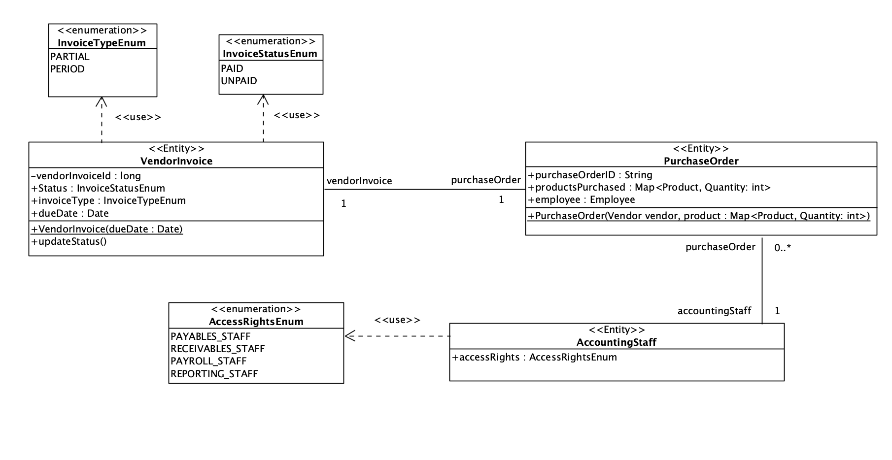

**5.4.3.2 Simplified Non-Entity Class Diagram**

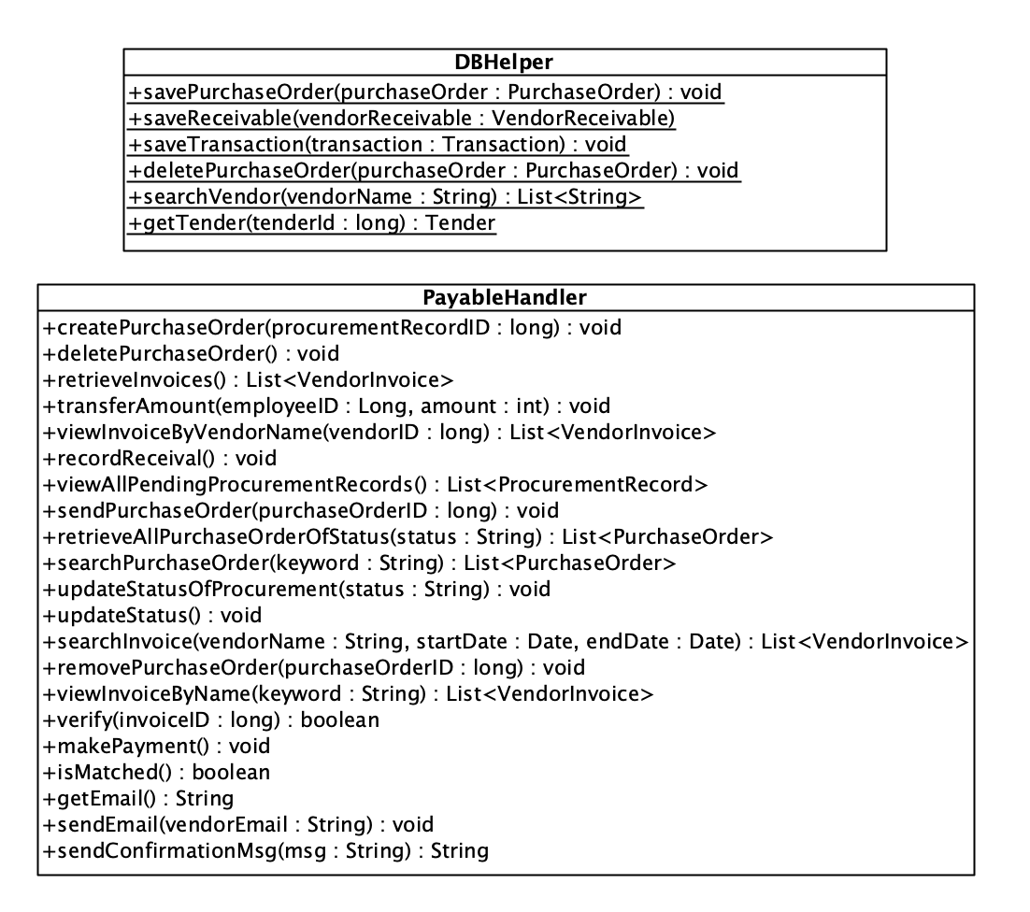

## **5.4.4 Simplified Class Diagram for Receivables Module**

### 5.4.4.1 Simplified Entity Class Diagram

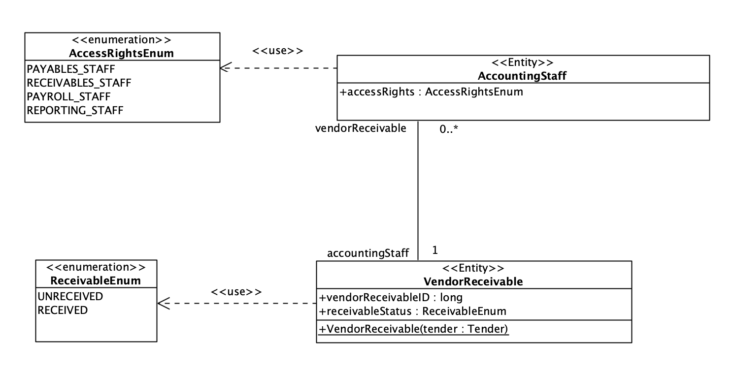

### 5.4.4.2 Simplified Non-Entity Class Diagram

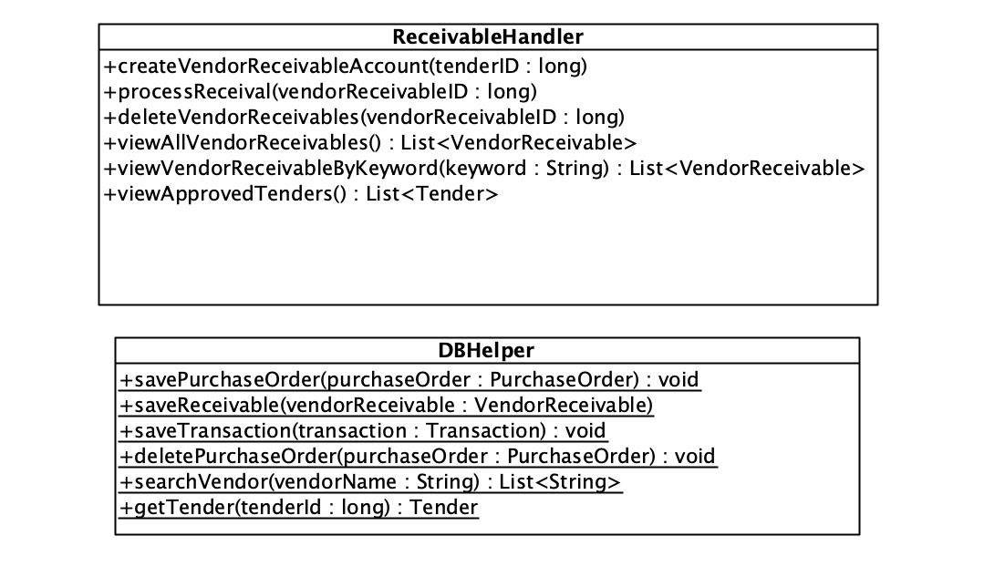

## **5.4.4 Simplified Class Diagram for Employee Payroll Module**

### 5.4.4.1 Simplified Entity Class Diagram

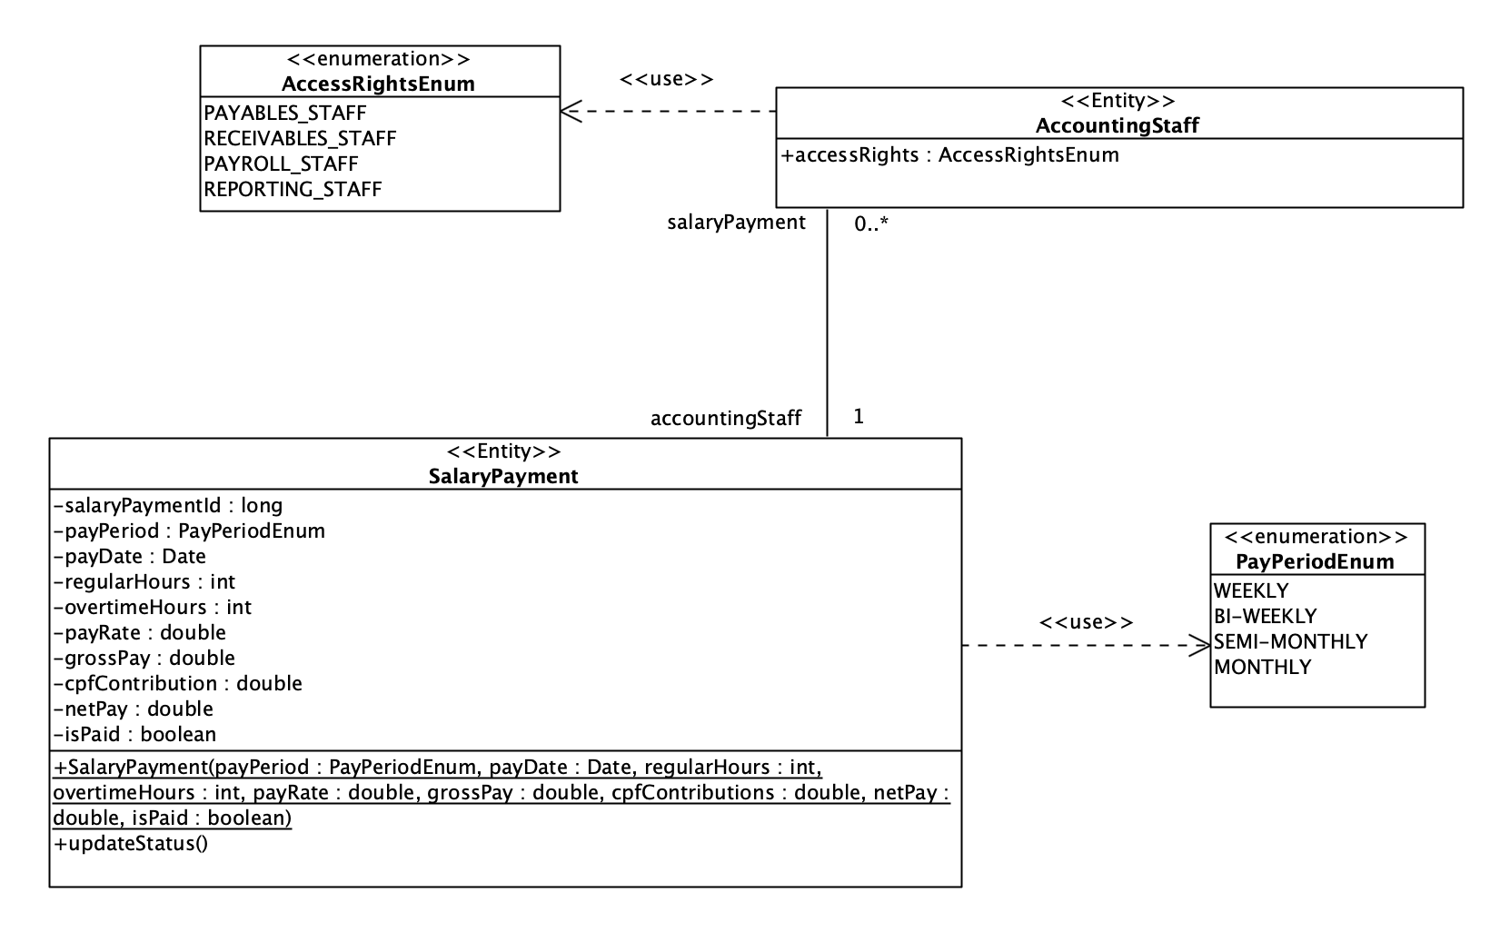

### 5.4.4.2 Simplified Non-Entity Class Diagram

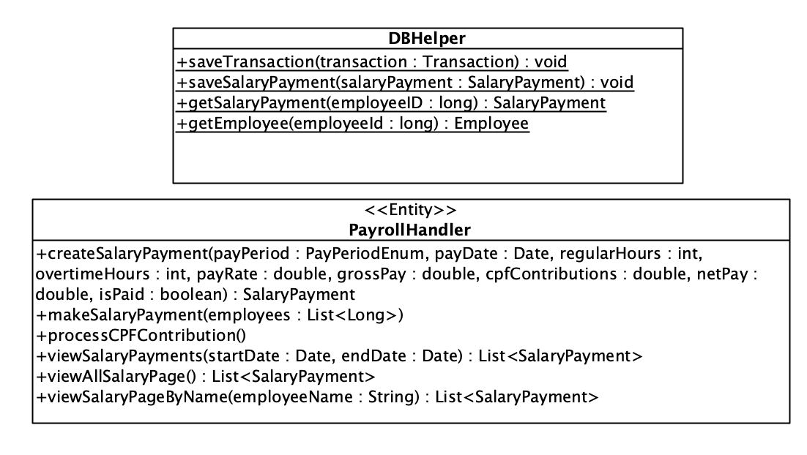

## **5.4.5 Simplified Class Diagram for Report Module**

### 5.4.5.1 Simplified Entity Class Diagram

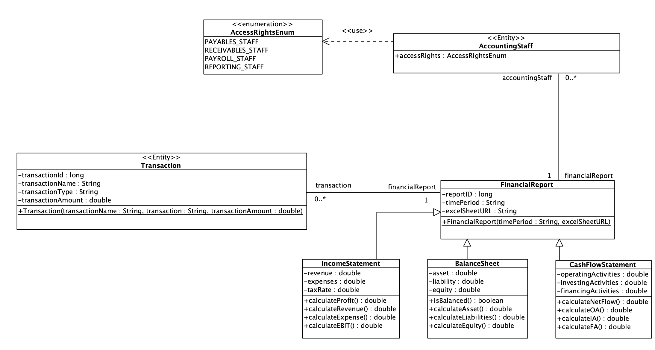

### 5.4.5.2 Simplified Non-Entity Class Diagram

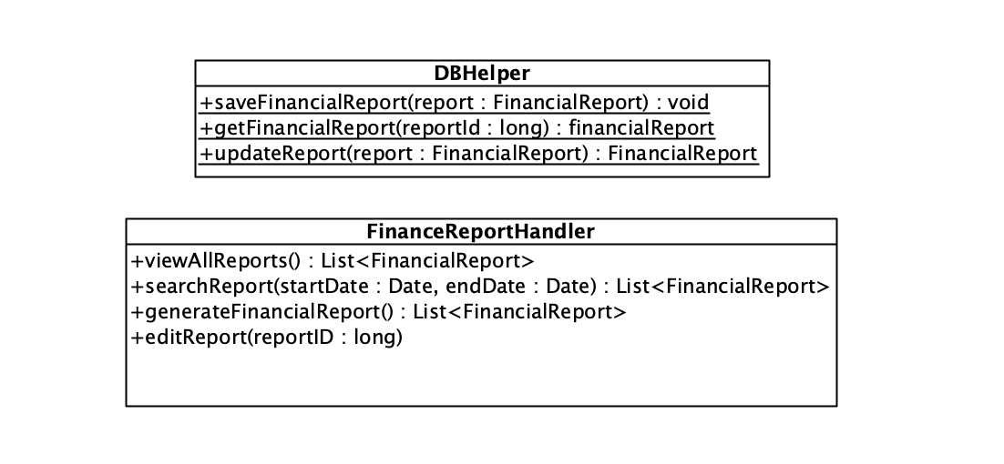

# **5.5 Access Management Subsystem**

## **5.5.1 Use Case Diagram**

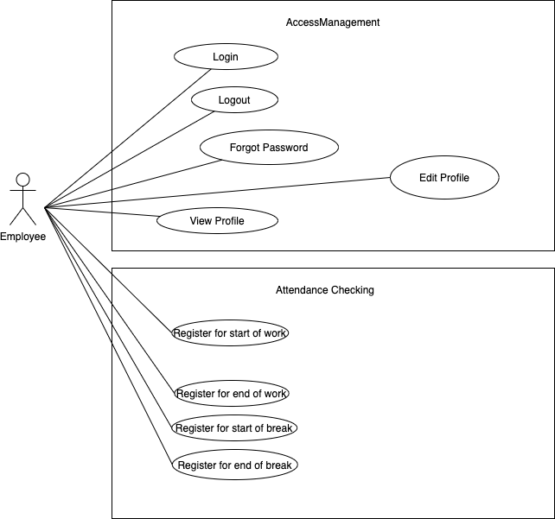

## **5.5.2 Use Case Description**

### 5.5.2.1 Common Access Management Module

#### **5.5.2.1.1 Login**

### 

|  |  |  |
| --- | --- | --- |
| Use Case: | Login | |
| Triggering Event: | Employee to login to their accounts in the system. | |
| Brief Description: | Existing employee logs into system by keying in their username and password and attempts to login. | |
| Actors: | Employee | |
| Pre-conditions: | 1. User has an existing account in the database. | |
| Post-conditions: | - | |
| Flow of Events: | Actor | System |
| 1. Employee navigates to the “login” button. 2. Employee enters username and password. | 1.1 System redirects to the login page.  2.1 If password matches the username in the database, the system redirects to the user profile.  2.2 If password does not match the username in the database, system returns “Wrong password/username! Try again.” message. Go back to step 2 and try again. |
| Exception Conditions: | - | |

Assumptions:

1. Users are allowed to attempt to login an unlimited number of times.

#### **5.5.2.1.2 Logout**

### 

|  |  |  |
| --- | --- | --- |
| Use Case: | Logout | |
| Triggering Event: | Employee chooses to log out. | |
| Brief Description: | Employee chooses to log out of their account. | |
| Actors: | Employee | |
| Pre-conditions: | 1. Employee is already logged in. | |
| Post-conditions: | - | |
| Flow of Events: | Actor | System |
| 1. Employee presses the “logout” button in the top right corner of the page. | 1.1 System logs employee out. |
| Exception Conditions: | - | |

#### **5.5.2.1.3 Forgot password**

|  |  |  |
| --- | --- | --- |
| Use Case: | Forget password | |
| Triggering Event: | Employee needs to change/reset password | |
| Brief Description: | In the event that an employee forgets their password or wishes to reset it, they can perform this use case to rest their password. | |
| Actors: | Employee | |
| Pre-conditions: | 1. Employee has an existing account and knows their username. | |
| Post-conditions: | 1. The password associated with the username changes in the database. | |
| Flow of Events: | Actor | System |
| 1. Navigate to the login page and click “Forget Password” below the “Enter password” section.  2. Employee redirects to email and clicks on the link to change password.  3. Employee inputs new password and confirms new password. | 1.1 System prompts user to input email.  2.1 System redirects employee to webpage to change password.  3.1 System saves and updates the password of the employee in the database and shows a confirmation message. |
| Exception Conditions: | - | |

#### **5.5.2.1.4 View profile**

### 

|  |  |  |
| --- | --- | --- |
| Use Case: | View profile | |
| Triggering Event: | Employee chooses to view their profile. | |
| Brief Description: | Employee wishes to view on his/her profile. He/She selects on option to view profile and system shows his/her profile details. | |
| Actors: | Employee | |
| Pre-conditions: | 1. An account for the employee exists. 2. Employee is logged in. | |
| Post-conditions: | - | |
| Flow of Events: | Actor | System |
| 1. Employee to click on the user icon in the top right hand corner and choose “Profile” from the dropdown menu. | 1.1 System navigates to the user's profile page. |
| Exception Conditions: | - | |

#### **5.5.2.1.5 Edit profile**

### 

|  |  |  |
| --- | --- | --- |
| Use Case: | Edit profile | |
| Triggering Event: | User chooses to edit their profile. | |
| Brief Description: | User has profile details he/she wish to edit. He/She selects on their profile and makes any necessary changes. | |
| Actors: | Employee | |
| Pre-conditions: | 1. An account for the user exists. 2. User is logged in. | |
| Post-conditions: | - | |
| Flow of Events: | Actor | System |
| 1. User to click on the user icon in the top right hand corner and choose “Profile” from the dropdown menu.  2. User makes any necessary changes to the profile. | 1.1 System navigates to user’s profile page.  2.1 System saves changes made. |
| Exception Conditions: | - | |

### 5.5.2.2 Attendance Checking Module

#### **5.5.2.2.1 Register for start of work**

|  |  |  |
| --- | --- | --- |
| Use Case: | Register for start of work | |
| Triggering Event: | An employee uses the application to register for the start of work. | |
| Brief Description: | An employee uses the application to register for the start of work. He/she can include reasons for coming early or late accordingly. | |
| Actors: | Employee | |
| Pre-conditions: | 1. The employee must be logged into the system before proceeding. | |
| Post-conditions: | 1. Details of date and time as well as reasons will be pushed into the system. | |
| Flow of Events: | Actor (Employee) | System |
| 1. Employee selects option to register for start of work.      2. Employee confirms start time and inputs reason for being late/early.      3. Employee confirms details of register. | 1.1 System redirects the user to screen to register for the start of work.    2.1 System displays the date and time and details input by user and prompts for confirmation.    3.1 System shows a confirmation message and logs the information into the system. |
| Exception Conditions: | 1. Input by user is invalid. | |

#### **5.5.2.2.2 Register for end of work**

|  |  |  |
| --- | --- | --- |
| Use Case: | Register for end of work | |
| Triggering Event: | An employee uses the application to register for the end of work. | |
| Brief Description: | An employee uses the application to register for the end of work. He/she can include reasons for ending early or late accordingly. | |
| Actors: | Employee | |
| Pre-conditions: | 1. The employee must be logged into the system before proceeding. | |
| Post-conditions: | 1. Details of date and time as well as reasons will be pushed into the system. | |
| Flow of Events: | Actor (Employee) | System |
| 1. Employee selects option to register for end of work.      2. Employee confirms end time and inputs reason for being late/early.      3. Employee confirms details of register. | 1.1 System redirects the user to screen to register for the end of work.    2.1 System displays the date and time and details input by user and prompts for confirmation.    3.1 System shows a confirmation message and logs the information into the system. |
| Exception Conditions: | 1. Input by user is invalid. | |

#### **5.5.2.2.3 Register for start of break**

|  |  |  |
| --- | --- | --- |
| Use Case: | Register for start of break | |
| Triggering Event: | An employee uses the application to register for the start of break. | |
| Brief Description: | An employee uses the application to register for the start of break. He/she can include reasons for coming early or late accordingly. | |
| Actors: | Employee | |
| Pre-conditions: | 1. The employee must be logged into the system before proceeding. | |
| Post-conditions: | 1. Details of date and time as well as reasons will be pushed into the system. | |
| Flow of Events: | Actor (Employee) | System |
| 1. Employee selects option to register for start of break.      2. Employee confirms start time and inputs reason for being late/early.      3. Employee confirms details of register. | 1.1 System redirects the user to screen to register for the start of break.    2.1 System displays the date and time and details input by user and prompts for confirmation.    3.1 System shows a confirmation message and logs the information into the system. |
| Exception Conditions: | 1. Input by user is invalid. | |

#### **5.5.2.2.4 Register for end of break**

|  |  |  |
| --- | --- | --- |
| Use Case: | Register for end of break | |
| Triggering Event: | An employee uses the application to register for the end of break. | |
| Brief Description: | An employee uses the application to register for the end of break. He/she can include reasons for ending early or late accordingly. | |
| Actors: | Employee | |
| Pre-conditions: | 1. The employee must be logged into the system before proceeding. | |
| Post-conditions: | 1. Details of date and time as well as reasons will be pushed into the system. | |
| Flow of Events: | Actor (Employee) | System |
| 1. Employee selects option to register for end of break.      2. Employee confirms end time and inputs reason for being late/early.      3. Employee confirms details of register. | 1.1 System redirects the user to screen to register for the end of break.    2.1 System displays the date and time and details input by user and prompts for confirmation.    3.1 System shows a confirmation message and logs the information into the system. |
| Exception Conditions: | 1. Input by user is invalid. | |

## **5.5.3 Simplified Class Diagram for Common Access Management Module**

### **5.5.3.1 Simplified Entity Class Diagram**

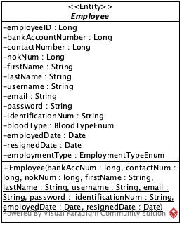

### **5.5.3.2 Simplified Non-Entity Class Diagram**

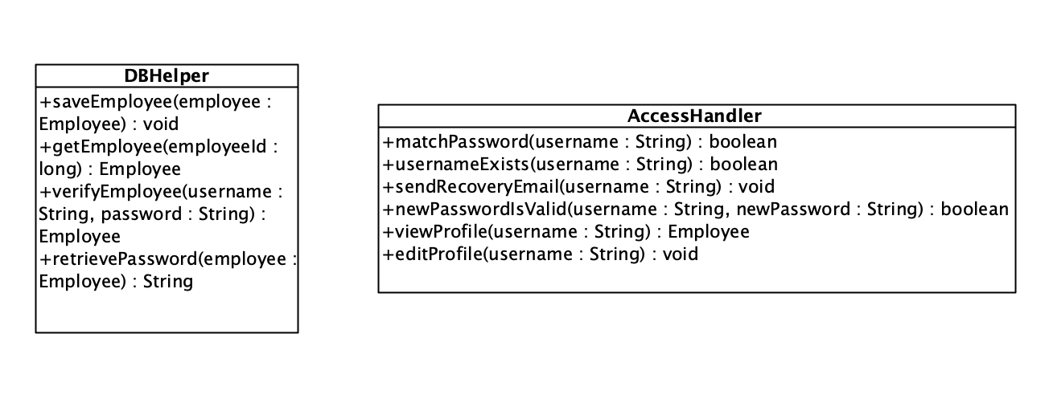

## **5.5.4 Simplified Class Diagram for Attendance Checking Management Module**

### 5.5.4.1 Simplified Entity Class Diagram

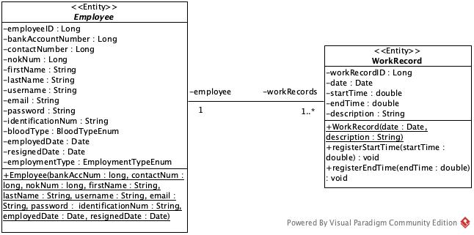

### 5.5.4.2 Simplified Non-Entity Class Diagram

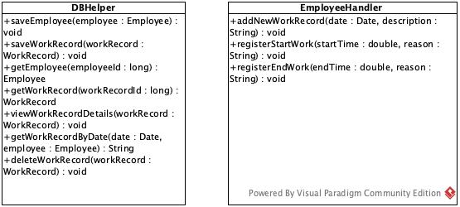

# **5.6 6 Most Complex Sequence Diagrams**

## **5.6.6.1 Create ITT**

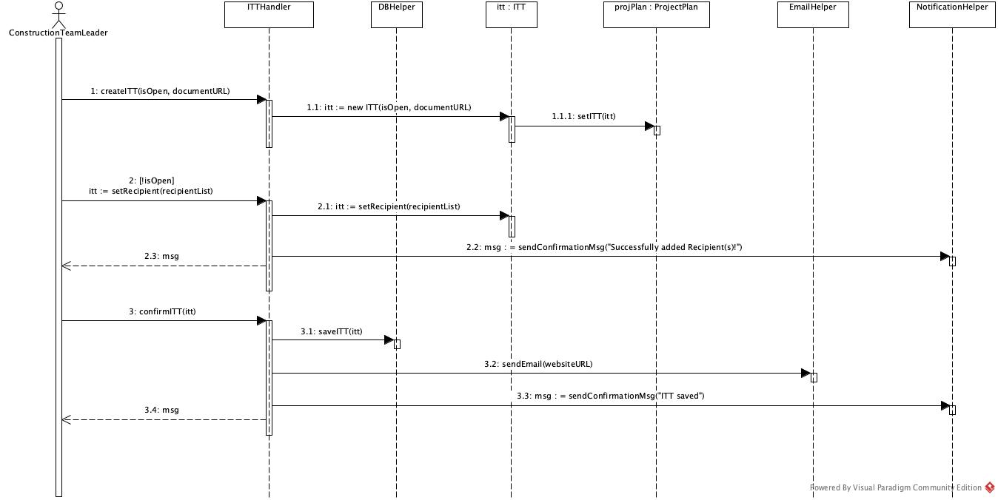

## **5.6.6.2 Process Inventory Request**

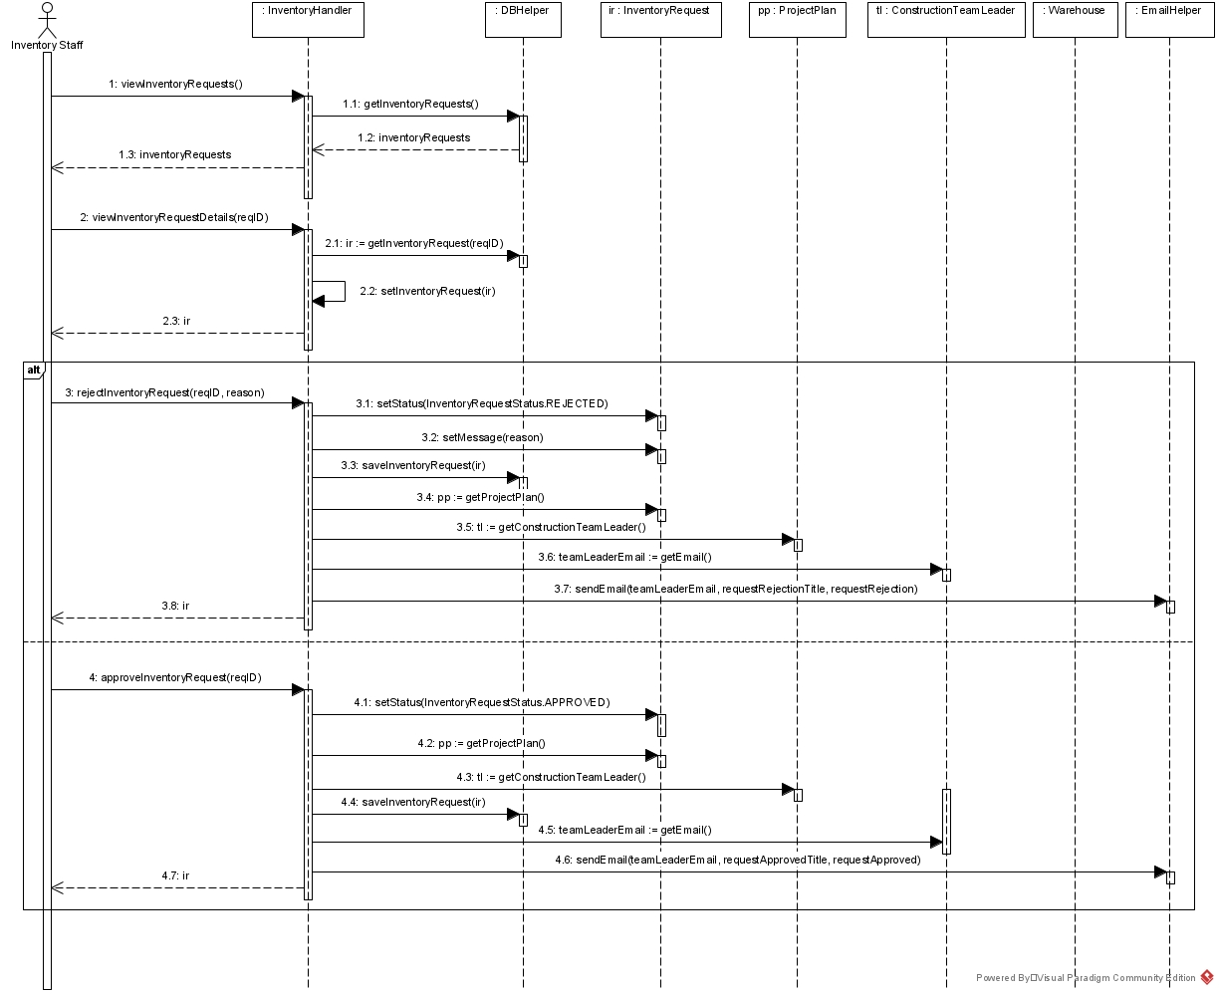

## **5.6.6.3 Request Stock Transfer From Supplier**

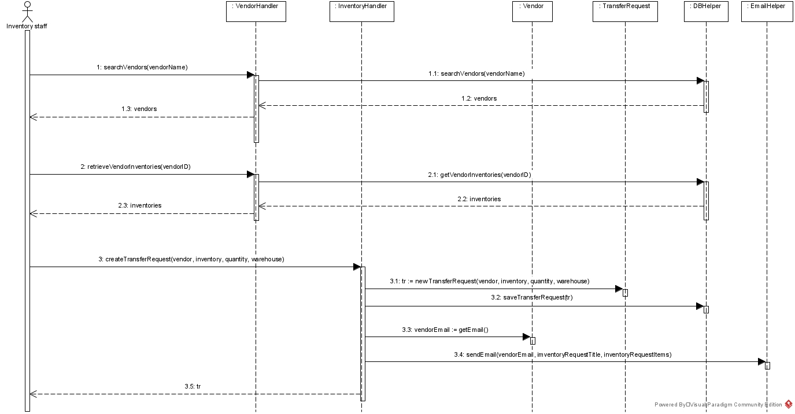

## **5.6.6.4 Validate hours of employees**

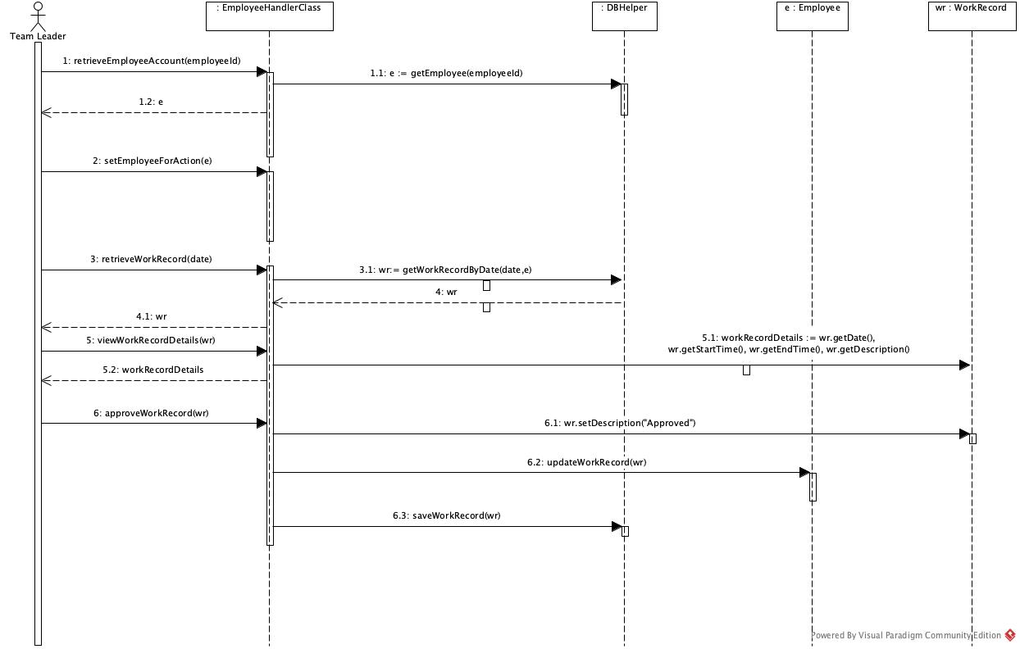

## **5.6.6.5 Make payment for invoices**

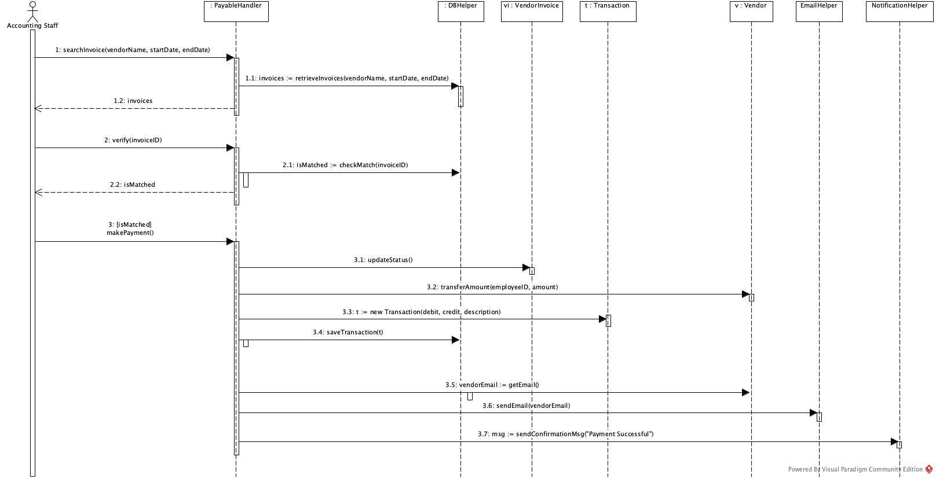

## **5.6.6.6 Approve Resignation Request**

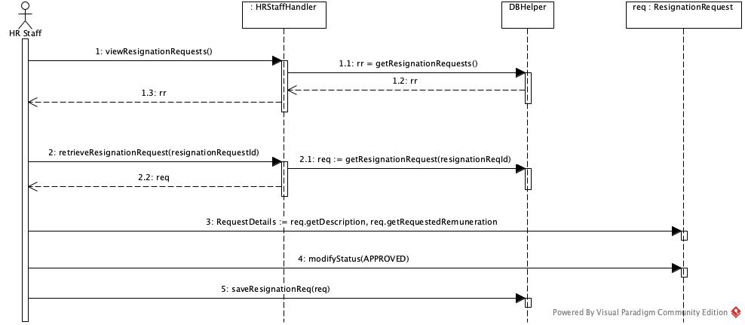

**6. Conclusion**

The BRD details our ideas for the Paper Free Construction Management System. Our solutions make use of a clearly-defined subsystem architecture where the different departments in the construction company can make use of a singular enterprise system to relay information. Hence, this system greatly assists daily operations to be more streamlined and integrated across the company. With this centralized system, we will be able to help companies reduce administrative errors and increase cost savings.

The system also relies on an intuitive and user-friendly interface which allows all users to be able to interact and make full use of its functions. For instance, signing in for work is drastically simplified. Employees now just have to log in and with a click of a button, they are registered for the day. This removes the need for a physical time card and physical accounting of timings. The intuitive interface, coupled with a centralized system strongly assists in boosting productivity levels and efficiency within a company.

To summarise, we believe that our system will be a beneficial asset to any large-scale construction companies that are looking to automate and simplify their processes across all departments.